Requirements to the functionality of the app:

-User must be able to choose a single video and play/pause/stop

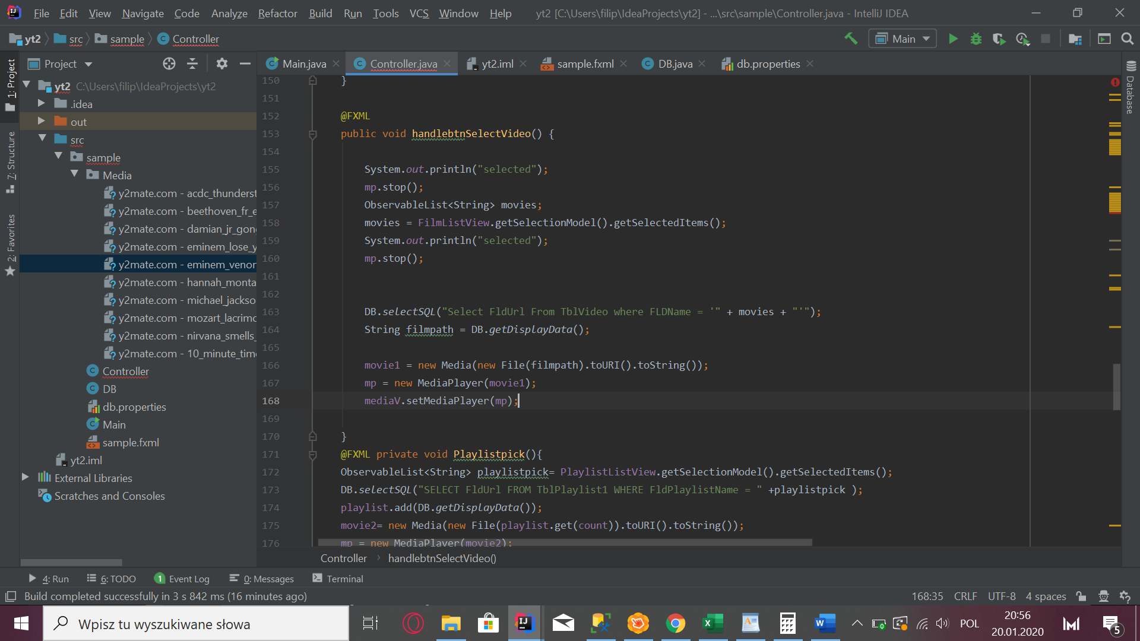

When user pick video from ListView and we take video url that have this same title =

DB.*selectSQL*("Select FldUrl From TblVideo where FLDName = '" + movies + "'");  
String filmpath = DB.*getDisplayData*();

When we take url we are giving it to mediaplayer =

movie1 = new Media(new File(filmpath).toURI().toString());  
mp = new MediaPlayer(movie1);  
mediaV.setMediaPlayer(mp);

Then we can play, pause or stop the video =

@FXML  
private void handlebuttonPlay(){  
 mp.play();  
  
}  
@FXML  
private void handlebuttonStop(){  
 mp.stop();  
}  
@FXML  
private void handlebuttonPause(){  
 mp.pause();  
}

* User must be able to create new playlist

User enter the name of the playlist then push button “Create playlist”

* @FXML private void btnCreatePlaylist(){  
   playlistcount++;  
   String playlistname = txtAddPlaylistName.getText();  
   txtAddPlaylistName.setText("Done");  
   DB.*insertSQL*("Insert into TblListOfPlayList(FldID,FldName) Values('"+playlistcount+"','"+playlistname+"')");  
  }

We take this name give her unique ID and insert it with her name to SQL database

* Adding videos to playlist

User select from ListView with Playlist where he want to add video

@FXML public void SelectPlaylist(){  
 Playlist = ListOfPlaylist1.getSelectionModel().getSelectedItems();  
 DB.*selectSQL*("Select FldID from TblListOfPlayList where FldName ='"+Playlist+"'");  
 String PlaylistID = DB.*getDisplayData*();  
 PlayListID = Integer.*parseInt*(PlaylistID);  
}

and then pick video from ListView with videos and then “click” button “Add Video”

@FXML private void AddVideoToPlaylist(){  
 ObservableList<String> movies;  
 movies = FilmListView1.getSelectionModel().getSelectedItems();  
 for(String m:movies)  
 {  
 if(m.equalsIgnoreCase(Film1Title)){  
 DB.*insertSQL*("Insert into TblPlaylist1(FldVidoID,FldPlayListID) Values('1','"+PlayListID+"')");  
 }

Then we insert this video into DB with his ID and Playlist ID

* User must be able to edit/delate playlist

User select (“SelectPlaylist”) Playlist and now we got playlist ID Delating playlist =

@FXML private void DelatePlaylist(){  
 DB.*deleteSQL*("Select \* from TblPlaylist1 where PlaylistID = '"+PlayListID+"'");

When user want to delate he must select playlist that he wants to edit and then movie that he want delate and press button “Delate Video”

@FXML private void DelateVideo(){  
 ObservableList<String> movies;  
 movies = FilmListView1.getSelectionModel().getSelectedItems();  
 DB.*deleteSQL*("Select VideoID from TblPlaylist1 where FldPlayListID = '"+PlayListID+"'");  
 }  
}

Database :

