**README**

The software application is programmed in z-Tree version 4.1.11, but it works in the upper versions too. Nevertheless, it is not possible to run a treatment in older versions of z-Tree (<4.1.0).

**Important note**: **It is licensed under the GNU GPL v3.**

In order to run a treatment, please follow the following steps:

1. Store the .ztt file and the z-leaf file in the same folder.
2. Check the compatibility of the software versions as well as the compatibility of the .ztt file and the z-leaf file.
3. Open the .ztt file (DEEP_RISK.ztt or DEEP_TIME.ztt) and the z-leaf.
4. Background → Number of subjects (set the number of subjects that you want).



1. Run → Start Treatment.



**Preparing the favorite version of the DEEP software**

It is possible to change the provided version of the DEEP software from DEEP 12 to any other preferred version (e.g., DEEP 5). We provide an instructions about how to do it below:

1. Open the .ztt file (DEEP_RISK.ztt or DEEP_TIME.ztt).
2. Click on the DEEP_MAIN_RISK stage (or DEEP_MAIN_TIME if you want to adjust DEEP_TIME.ztt).

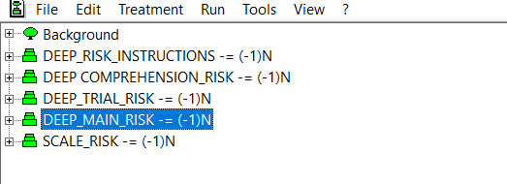

1. Click on the subjects.do program in the DEEP_MAIN_RISK stage (or DEEP_MAIN_TIME if you want to adjust DEEP_TIME.ztt).

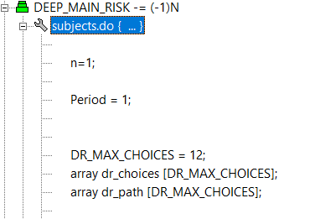

1. Change the DR_MAX_CHOICES = 12 to DR_MAX_CHOICES = 5, if you want to set it to DEEP 5.

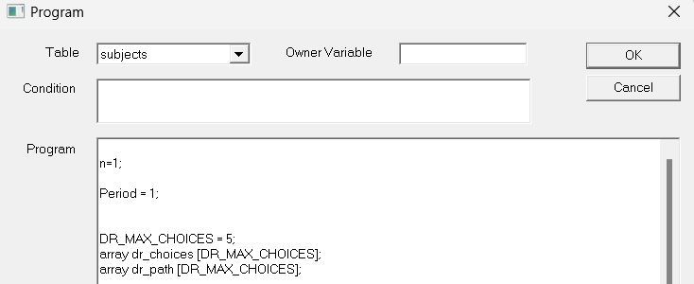

1. Click OK in the program, and the treatment can be started on F5.