ASSIGNMENT A1

Analysis and Design Document

Student: Goron Filip

**Group: E_30432**

Table of Contents

1. Requirements Analysis 3

1.1 Assignment Specification 3

1.2 Functional Requirements 3

1.3 Non-functional Requirements 3

2. Use-Case Model 3

3. System Architectural Design 3

4. UML Sequence Diagrams 3

5. Class Design 3

6. Data Model 3

7. System Testing 3

8. Bibliography 3

1. Requirements Analysis

# Assignment Specification

The assignment was to write an application that handles certain needs of a Bank.

# Functional Requirements

The application has to be able to handle two kinds of users, Administrators and Employees. Administrators can perform CRUD operations on employees and create reports.

Employees would be able to perform CRUD operations on clients and their accounts. They would also handle money transfer and paying bills.

# Non-functional Requirements

Easy to be used.

2. Use-Case Model

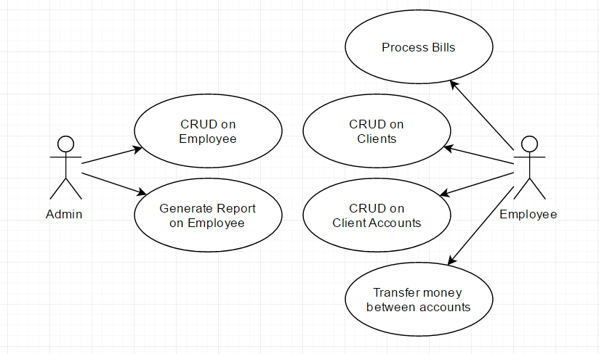

Use case: Create Client

Level: user-goal level

Primary actor: Employee

Main success scenario: New client created in the Database

Extensions: Client already existent or data invalid

3. System Architectural Design

**3.1 Architectural Pattern Description**

Layers architectural pattern was used. The Presentation logic handles Data input/output for the user. The Logic Layer handles the computations and other operations. The Database layer does operations on the Database.

**3.2 Diagrams**

Package Diagram

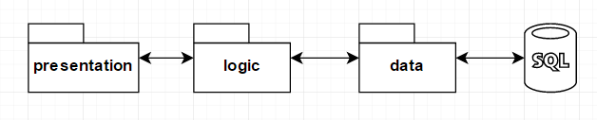

Deployment Diagram

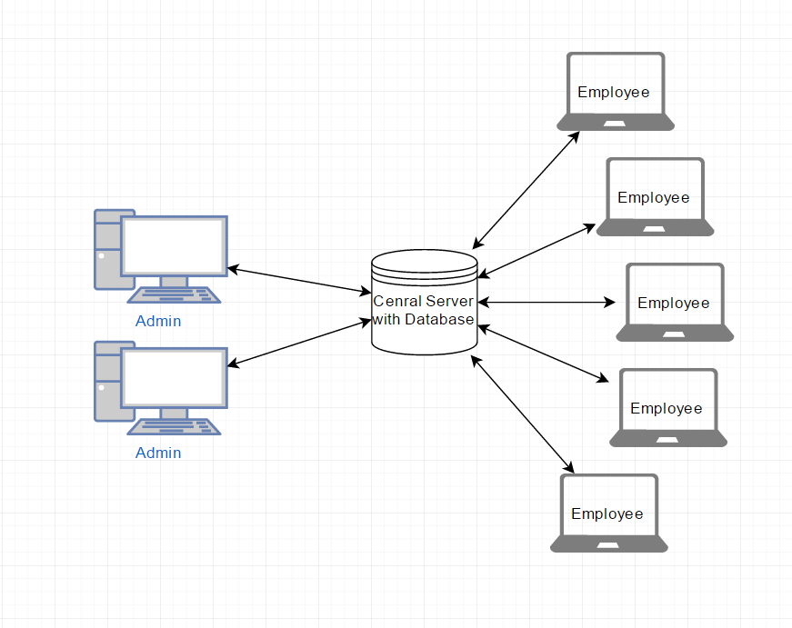

4. UML Sequence Diagrams

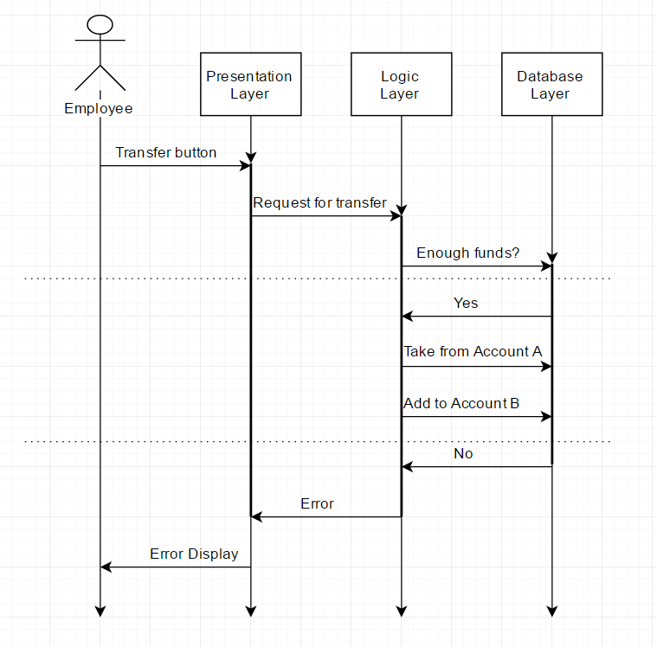

5. Class Design

**5.1 Design Patterns Description**

[Describe briefly the used design patterns.]

**5.2 UML Class Diagram**

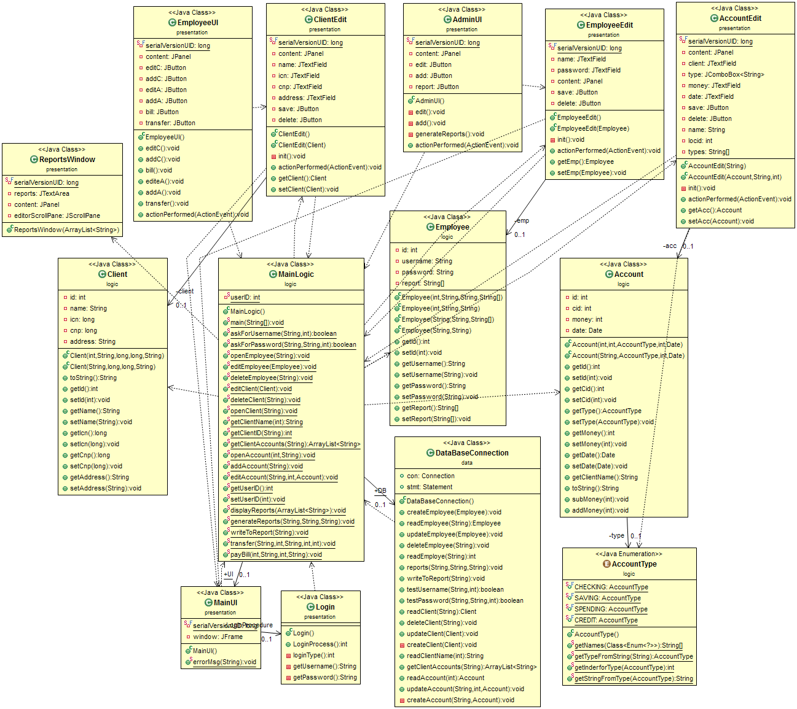

6. Data Model

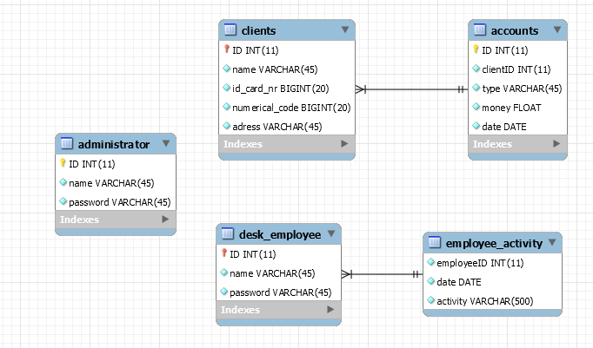

There is a Table for each Abstract Entity in the App. They all contain field important to their respective real life representations. The application also has classes that can be initialized to contain all or some fields.

7. System Testing

Unit and integration testing were done for each method or set of method the represented an operation. They mostly consisted on how the app handled the constraints it was given and if the operations on the Database yielded the results expected.

8. Bibliography

<https://www.tutorialspoint.com/>

<https://www.w3schools.com/>

<https://docs.oracle.com/javase/7/docs/api/>

<http://stackoverflow.com/>