1. Install

You will need Java Runtime Environment

<https://java.com/en/download/>

Then you will need to install MySQL Workbench

<https://dev.mysql.com/downloads/workbench/>

In the MySQL Workbench you will run the provide SQL script to generate the Database.

After these Steps you will just run the executable Jar file named Bank.

1. Login data:

Demo Admin:

Username: admin, Password: adminpass

Demo Employee:

Username: emp, Password: emppass

Demo Clients:

client, richC

1. Login

To start the application you DoubleClick the executable jar called Bank

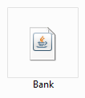

A window will open and you will have to choose as whether to log in as an Admin or a normal Employee.

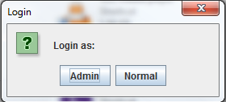

After choosing you will be required to enter you username and password. 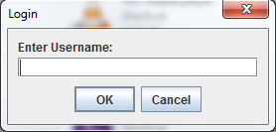 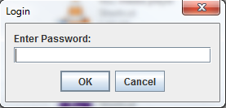

If the inputs are correct then the respective operating window will open.

1. Admin

The following window will open, from which you will be able to operate:

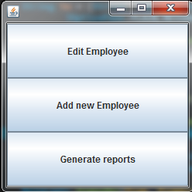

* 1. Edit employee

Once the Edit Employee button is pressed, a window will open, requesting the name of the Employee you want to Read/Update.

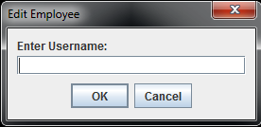

If the name exists in the database them a window of following format will appear:

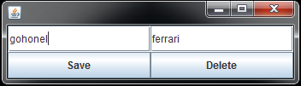

From here you can see the info; edit and press the save button, or delete the Employee from the Database altogether.

* 1. Add employee

Pressing the Add Employee button will open an already familiar window:

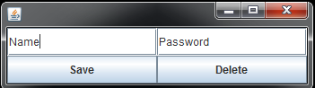

Just introduce the data and save the new Employee.

* 1. Generate reports

To generate reports for an Employee just press the button then

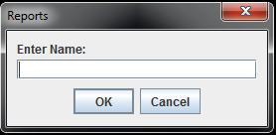

Enter the name for the Employee you want to see the reports for,

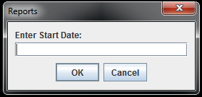 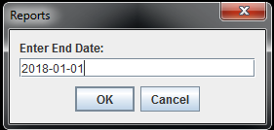

Then just set the Start and End date with the following format: YYYY-MM-DD

A window like this will then appear:

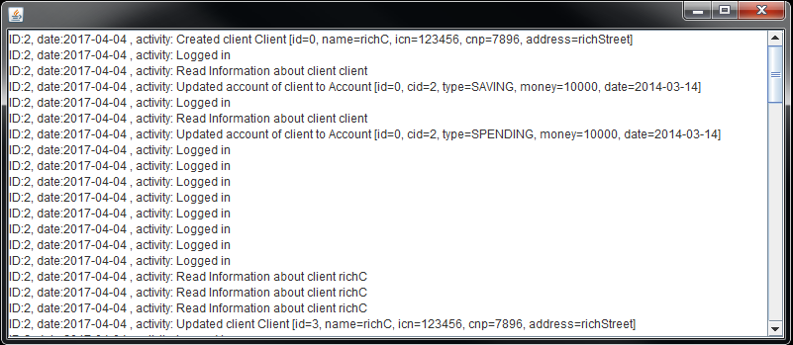

1. Normal Employee

This is the starting window for the normal Employee

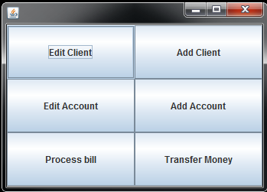

* 1. Edit Client

You start by entering the clients name:

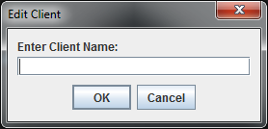

Then you have access to read, edit and delete the respective Client.

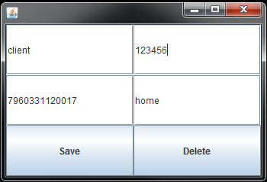

* 1. Add Client

Add Client will open a window where you fill in the Info for a new Client and then save it.

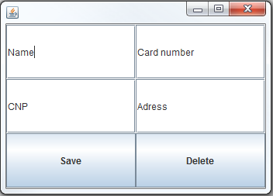

* 1. Edit Account

To edit an account first you must choose a Client, so you will introduce a name. Afterward you choose the account of the client that you want to operate on.

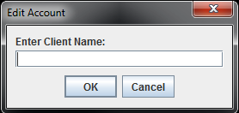 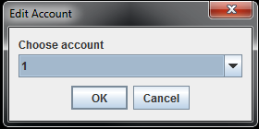

Then data window of the Account will open

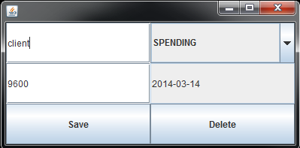

* 1. Add account

Again, first you choose a client



And then fill in the data, the date will be inserted automatically.

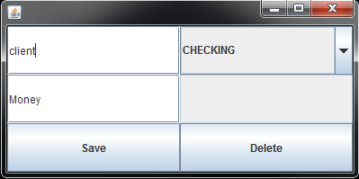

* 1. Pay Bill

Here 4 easy steps: Choose Client🡪Choose Account🡪Choose Biller🡪Introduce sum

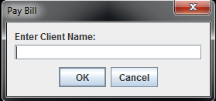 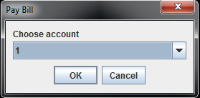 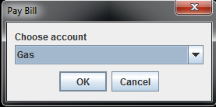 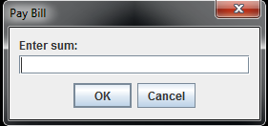

* 1. Transfer money

To transfer money you must intorduce client name and account for both giver and recepient. And the introduce the sum to be transferred. 