# RDF

Resource Description Framework (RDF) is a general description framework for describing web sources. It is a basis for semantic web. RDF is a general frame for the description, exchange and reuse of metadata, it assigns a semantic to a web sources. RDF can be represented as a graph or triplet.

For graphs – subject and object are nodes and predicates are edges. On the other hand, triplets are described as – source, property and value. Triplet in official terminology express some facts about the source. Claim consist of three pieces that together create a sentence: subject 🡪 predicate 🡪 object. Within this statement, the source is a subject identified by URI (or IRI), property is a predicate (what we say about the source) and value is a object. Predicates that we used for describing a source comes from so-called schemas – that are vocabularies or ontologies. Examples can be Dublin Core (DC) or Friend of a Friend (foaf) metadata standards.

RDF syntax have various type of formats that are called serialization formats. Among these formats are for example Turtle, N-Quads, N-Triplets and JSON-LD.

## JSON-LD

JSON-LD is a RDF syntax for describing linked data using JSON format. JSON-LD is both JSON document and RDF document, but it have some differences with RDF. First, JSON-LD properties can be URIs (or IRIs) or blank nodes whereas in RDF properties must be URIs (or IRIs). This means that RDF datasets can be serialized by JSON-LD. On the contrary, it is not possible. Second, JSON-LD object lists are part of data model whereas RDF objects are part of vocabulary. And last one, RDF values are either literals or language-tagged strings whereas JSON-LD also supports JavaScript native types, that are numbers, Booleans and strings.

[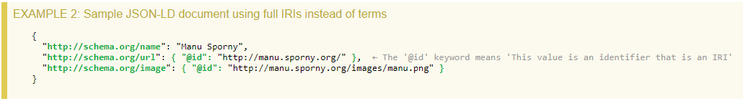](https://www.w3.org/TR/json-ld/)

Figure example of json-ld document

Figure 1 example of json-ld document 1