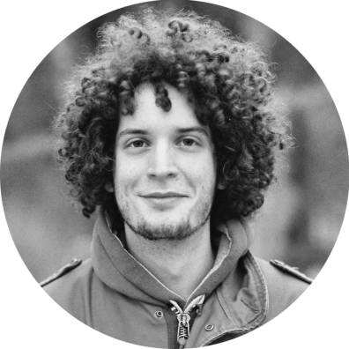

Landing Pages

Usability Testing

UX/UI Design

Unity

Adobe XD

Wordpress

Photoshop

Sketch

React

git

JavaScript

jQuery

Experience working with companies, agencies and webpreneurs from all around the globe helping them bring their designs to life building large scale websites, writing and maintaining modular and scaleable HTML/SCSS/JS with focus on responsive design, performance, accesibility. Once I finish the implementation of static websites I do the CMS integrations making sure to create an awesome user experience for non developers to easily change website content later on. I’m interested in large SCSS architectures, CSS and Javascript animations, semantics and SVG.

<https://filiprastovic.com>

2008-2012

General course.

Novi Sad

**“Svetozar Marković” Gymnasium**

Bootstrap

SCSS

CSS3

HTML5

I grew up in Sremska Kamenica, suburban neighborhood of Novi Sad, where I also finished elementary school. As a kid I would spend my time making toys, reading comics, epic fantasy novels and playing video games. During high school, I played guitar in the school orchestra, worked on technical support and special effects for the school theatre and designed bunch of animated powerpoint presentations. During college I started developing small video games as a hobby and began my career as a freelancer utilizing everything I’ve learned through education and on my own. I’m passionate about technology and developing creative solutions to whichever problem I come across. I’m an avid reader and music lover.

filiporastovic

filiporastovic@gmail.com

Skype

Email

**Rastovic**

HTML/CSS/JavaScript /WordPress/

**Front-End Web Developer**

**HOBBIES AND INTERESTS**

**EXPERIENCE**

**PROFESSIONAL SKILLS**

**EDUCATION**

Filip Rastovic

filiporastovic@gmail.com

GAME   
DEVELOPMENT

GUITAR

CLASSIC LITERATURE

**2012 - present**

Department of applied computer science and informatics. I have understanding of data structures, computer architecture, object oriented programming, design patterns, software engineering methodologies and web development concepts. I’m also familiar with HCI concepts, machine learning and web security.

OUTDOORS

COMPUTERS

TRAVELS

**Faculty of Technical Sciences**

2012-2016

Computing and Control Engineering

CONTACT

Year of Birth

1993

English / Serbian

Languages

PROFILE

Name

Filip Rastovic

**Rastović**

**Filip**

Professional

**Resume**