

Computer Games Development CW208
GDD
Year IV

[Filip Rusiecki]
[C00250721]

[Date of Submission]

[Declaration form to be attached]

Contents

Acknowledgements 4
Game Overview 5
Feature Set 5
General Features 5
Multiplayer Features 5
Editor 5
Gameplay 5
The Game World 6
Overview 6
The Physical World 6
Overview 6
Key Locations 6
Travel 6
Scale 6
Objects 6
Weather 6
Day and Night 6
Time 7
Rendering System 8
Overview 8
2D/3D Rendering 8
Camera 8
Overview 8
Camera Detail #1 8
Camera Detail #2 8
Game Engine 9
Overview 9
Game Engine Detail #1 9
Water 9
Collision Detection 9
The World Layout 10
Overview 10
World Layout Detail #1 10
World Layout Detail #2 10
Game Characters 11
Overview 11
Creating a Character 11
Enemies and Monsters 11
User Interface 11
Overview 11
User Interface Detail #1 11
User Interface Detail #2 11
Weapons 12
Overview 12
Weapons Details #1 12
Weapons Details #2 12
Musical Scores and Sound Effects 12
Overview 12
Red Book Audio 12
3D Sound 12
Sound Design 12
Single-Player Game 13
Overview 13
Single Player Game Detail #1 13
Single Player Game Detail #2 13
Story 13
Hours of Gameplay 13
Victory Conditions 13
Multiplayer Game 13
Overview 13
Max Players 14
Servers 14
Customization 14
Internet 14
Game Sites 14
Persistence 14
Saving and Loading 14
Character Rendering 15
Overview 15
Character Rendering Detail #1 15
Character Rendering Detail #2 15
World Editing 15
Overview 15
World Editing Detail #1 15
World Editing Detail #2 15
References 16

Acknowledgements
We would like to thank the following people who assisted in completing this project including;
John Doe of ACME who kindly agreed to …
I would also like to thank #### Solutions for use of ….

Anything in red still need to be changed

Game Overview
The genre of the game is a VR survival game in which you will have to survive the monsters that will come attacking you.
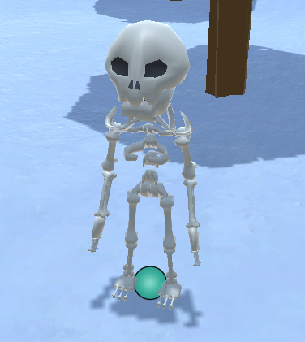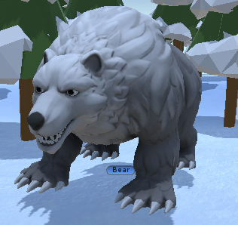
The player will also experience hunger/ thirst mechanic, the player will have to eat regularly in game and drink in order to survive. To add more experiences to the game the player will also experience Temperature system. The players main goal in the game is to craft / repair the plane they arrived in which crashed our player is stuck in a unknow frozen land in which it constantly snows. The frozen island our player is found on is unknown and it’s surrounded by freezing ocean which never ends. The frozen land has some structures and areas which the player will be able to explore as the game is open world that player can explore.
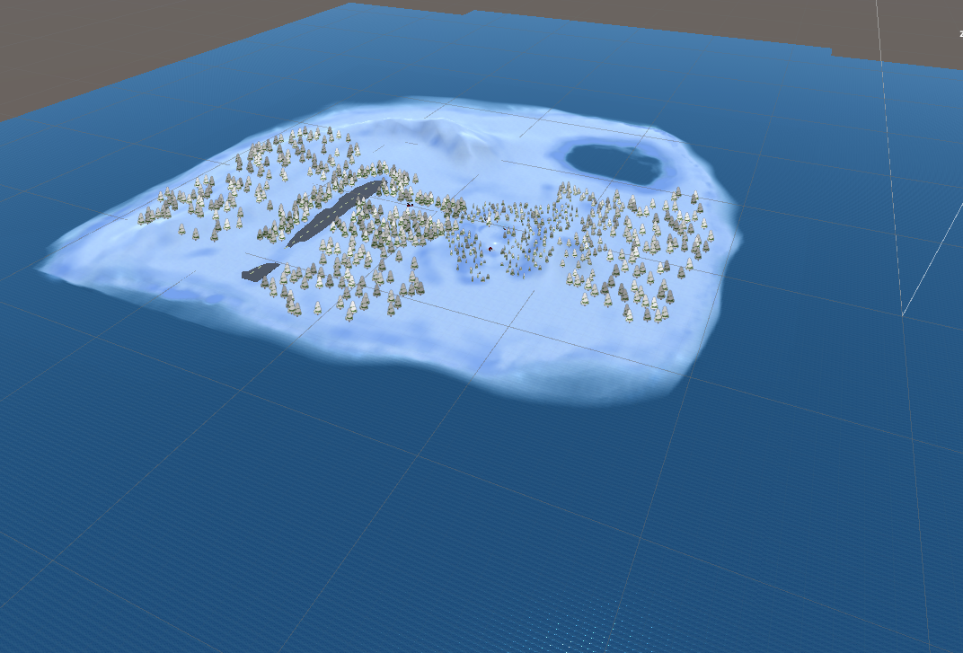

The game will also challenge the player by adding a day and night cycle in which the night will be more harder to survive than day. The temperatures will lower during night which could cause the player to lose the game to hypothermia levels as player will require to stay warm or have better clothing that will provide warmth to the player.
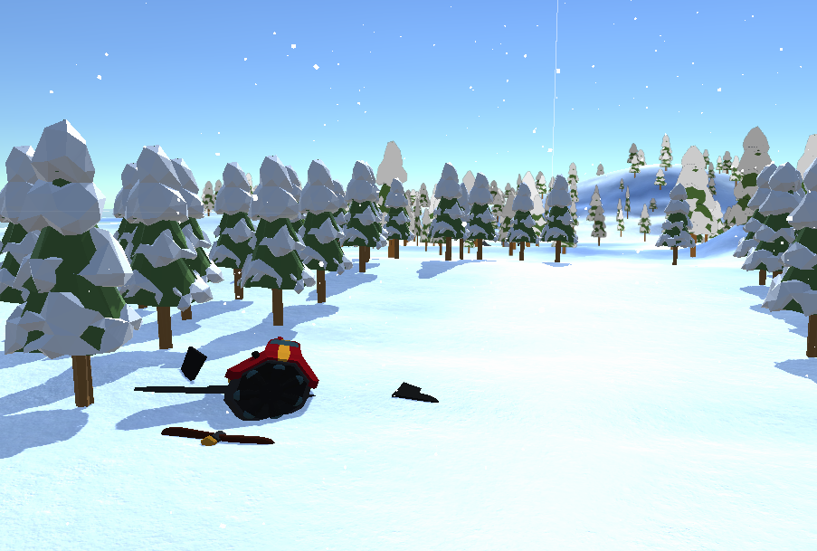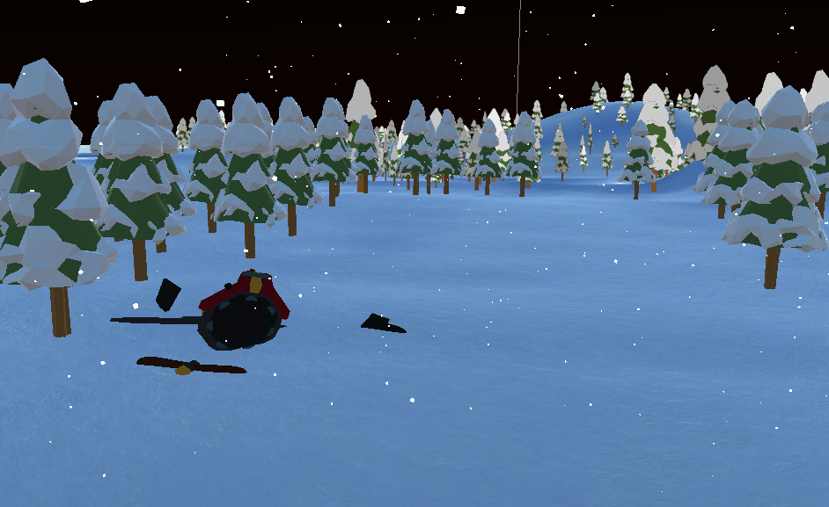
The player will be able to control only the main character of the game as well as the plane that will be crafted at the end of the game.
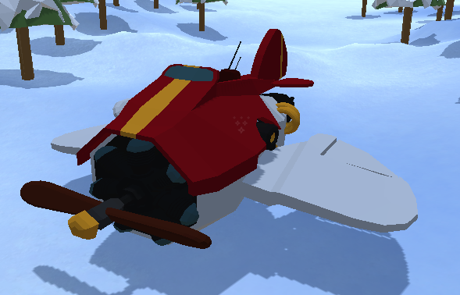

Why make this game?
Survival game genre has been on the market for a long while yet always brining something new to excite people and making the companies have competition on which survival game is better yet always surprising players by brining something different to the market. Some survival games after realising they end up doing a version of the game for a VR which always attracts new players or players that have already played their game on a non-VR platform. With my game being made in VR I want to bring my own game to a great standard that will have some new features that will make my game unique.
I really would like to research and try making games in VR. In spare time I develop games which I want to release on steam platform. Making a VR game would allow me to get more knowledge and help me create a future game that I would want to publicly release. Also this would open a window in my amount of experience in making games in virtual reality. It would also help me to improve my environment building skills which was always my passion.

Feature Set

General Features
The game will provide a Huge World to explore
Day/Night cycle
Temperature system along with hunger and thirst.
Plane controller(flying plane)
3D VR gameplay
32-bit color

Gameplay
List stuff here that is key to the gameplay experience
List a lot of stuff here
Hey, if you got nothing here, is this game worth doing?

The Game World

Overview
Plane that player can control
The player will be able to craft and control a plane and fly it how ever they will wish to.
Survival mechanic
Player will have to gather food / water to keep surviving.
Advanced AI
Player will encounter enemies which will be smart and try to dodge players attacks.
Building
The player will be able to craft / build and place buildings down for shelter.

The Physical World

Overview
Describe an overview of the physical world. Then start talking about the components of the physical world below in each paragraph.
The following describes the key components of the physical world.

Key Locations
Starting area – Here the player will get to know the basic movement and combat, player will learn controls here that will be essential for the game. The player will get introduced to the mechanics of the game also such as temperature, food, thirst, health and stamina.
Plane Field – Here the player will be able to craft the plane which then will be used by the player to fly the plane.
Frozen Lake – Here the player will be able to find some food and some gear.
Small random house’s / shacks – these houses / places will be scattered randomly on map and the player will be able to loot these places for gear of food.

Travel
The crater / player will be able to walk with the VR touchpad.
When the player will reach the end game the player will then be able to fly the plane.

Scale
Describe the scale that you will use to represent the world. Scale is important!

Objects
Describe the different objects that can be found in the world.
See the “Objects Appendix” for a list of all the objects found in the world.

Weather
The world we will be in will have cold weather non stop, in which player will have to look out for temperatures to keep their character warm. During the night time the weather will get colder. At some points there will be a snow blizzard that will raise the temperatures and will make the survivability harder.

Day and Night
The game will have a day and night cycle. During the daytime the temperatures will be low and during the temperatures will get higher making the game harder. The player will experience more enemies during night-time also.

Time
Describe the way time will work in your game or whatever will be used. Focus game timeline with three engaging minutes of gameplay. Create a timeline bubble and narrative for this. Each minute builds to an event and within each minute a series of engaging events occur. The tree minutes should where crescendo to a large event.

Rendering System

Overview

Give an overview of how your game will be rendered and then go into detail in the following paragraphs.

2D/3D Rendering

Describe what sort of 2D/3D rendering engine will be used.

Camera

Overview

Describe the way the camera will work and then go into details if the camera is very complicated in sub sections.

Camera Detail #1

The camera will move around like this and that.

Camera Detail #2

The camera will sometimes move like this in this special circumstance.

Game Engine

Overview

The game engine I will be using is Unity.
Unity is a cross platform game engine that was created by Unity Technologies, it was released on June 2005, over the years the game engine has been build upon and expanded into a solid game engine that helps to create games. It supports a variety of platforms such as mobile, console, desktop and VR. Inside Unity you can create both 3D and 2D games as well as interactive simulations and any other experiences that a developer can think of.
While making a game in unity everything can be customized by custom scripts that user can write using any IDE that user is used to or wants to use such as visual studio.
The scripts that are written must be written in C#.

Game Engine Detail #1

The game engine will keep track of everything in the world like such and such.

Water

There will be water in the world that looks awesome, and our game engine will handle it beautifully.

Collision Detection

Our game engine handles collision detection really well. It uses the such and such technique and will be quite excellent. Can you see I am having a hard time making up stupid placeholder text here?

The World Layout

Overview

Provide an overview here.

World Layout Detail #1

World Layout Detail #2

World Layout Detail #2
World Layout Detail #2

Game Characters

Overview

Over of what your characters are.

Creating a Character

How you create or personalize your character.

Enemies and Monsters

Describe enemies or monsters in the world or whomever the player is trying to defeat. Naturally this depends heavily on your game idea but generally games are about trying to kill something.

User Interface

Overview
Provide some sort of an overview to your interface and same as all the previous sections, break down the components of the UI below.

User Interface Detail #1
User Interface Detail #1

User Interface Detail #2
User Interface Detail #2

Weapons

Overview

Overview of weapons used in game.

Weapons Details #1
Weapons Details #1

Weapons Details #2
Weapons Details #2

Musical Scores and Sound Effects

Overview

This should probably be broken down into two sections but I think you get the point.

Red Book Audio

If you are using Red Book then describe what your plan is here. If not, what are you using?

3D Sound

Talk about what sort of sound APIs you are going to use or not use as the case may be.

Sound Design

Take a shot at what you are going to do for sound design at this early stage. Hey, good to let your reader know what you are thinking.

Single-Player Game

Overview

Describe the single-player game experience in a few sentences.

Here is a breakdown of the key components of the single player game.

Single Player Game Detail #1

Single Player Game Detail #2

Story

Describe your story idea here and then refer them to an appendix or separate document which provides all the details on the story if it is really big.

Hours of Gameplay

Talk about how long the single-player game experience is supposed to last or what your thoughts are at this point.

Victory Conditions

The player will win the single player game by not dying, as the player dies, they have to reset the game as it gives the survival aspect and drives the player to play smartly and strategize.
The players goal will be to craft the plane from broken parts and be able to fly away from the frozen island before dying.

Multiplayer Game

Overview

Persistence

Describe if your world is persistent or not.

Saving and Loading

Explain how you can save a multiplayer game and then reload it. If you can or why this is not possible.

Character Rendering

Overview

Provide an overview as to how your characters will be rendered. You may have decided to include this elsewhere or break it out to provide more detail to a specific reader.
References

Book
Author(s) - family name, initials. (Year). Title of book. Edition. Place of publication: Publisher.
[1] Doe, B. (2013). C++ for Game Developers. Indianapolis: John Wiley & Sons.
Report
Author(s) - family name, initials. (Year). Title of report. Edition. Place of publication: Publisher. (Series and vol./no.).
[2] Burrows, D., et al. (2012). Global Trends: Alternative Worlds. Washington: National Intelligence. (Office of the Director of National Intelligence).

Web-site
Author(s) - family name, initials. (Year, month day). Title of document. [Online]. (URL). Place of publication: Publisher. (Date accessed).
[4] de Valk, J. (2014, May 12). AI for Games. [Online]. (URL https://www.somesite.com/articles/1234/). (Accessed 12 February 2014).

