**Question 1:**

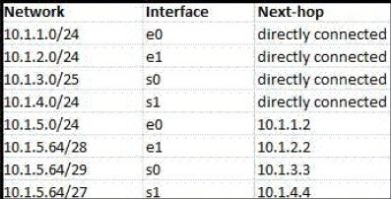

According to the routing table, where will the router send a packet destined for 10.1.5.65? Why?

The 10.1.5.65 Ip address belongs to the last 3 rows

When we match it with the prefix we get so the next hop will be to 10.1.3.3

**Question 2:**

Classless Inter-domain Routing (CIDR) receives a packet with address 131.23.151.76. The router’s routing table has the following entries:

Prefix Output Interface Identifier

131.16.0.0/12 3

131.28.0.0/14 5

131.19.0.0/16 2

131.22.0.0/15 1

The identifier of the output interface on which this packet will be forwarded is ___1___. Why?

1st entry in tables gives us mask of 12 bits of network, the rest of the bits which is 20 is host

131.23.151.76 = 131.16.0.0 and the last entry is 131.22.0.0/15 with a mask of 255.254.0.0 and 131.23.151.76 = 131.22.0.0.

We use longest prefix match to get proper answer between 1 and 3

Ans= 1

**Question 3:**

Consider the following routing table of a router.

| **PREFIX** | **NEXT HOP** |
| --- | --- |
| 192.24.0.0/18 | D |
| 192.24.12.0/22 | B |

Consider the following three IP addresses, what their next hop will be?

1. 192.24.6.0
2. 192.24.14.32
3. 192.24.54.0

First prefix is 255.255.192.0 = 11111111.11111111.11000000.00000000

Second prefix is 255.255.192.0 = 11111111.11111111.11111100.00000000

For the first ip we have 192.24.0.0/18 we can use bitwise and subnet mask to get 192.24.0.0

Ans 1 = D

Ans 2 = B

Ans 3 = D

**Question 4:**

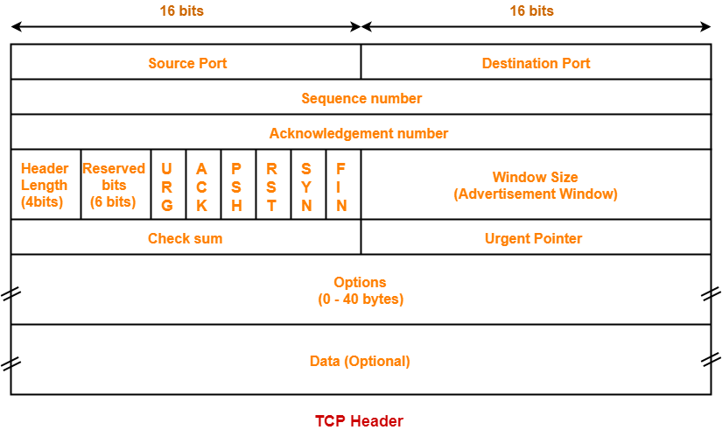Draw an TCP header. Capture packets using wireshark and explain the fields for a particular TCP packet captured. Try to explain the purpose of each field.

10.4.31.32

149.153.106.153

2626660765

32 bytes

3280248030

Flags below:

 64240















unverified

0

12 bytes

N/A

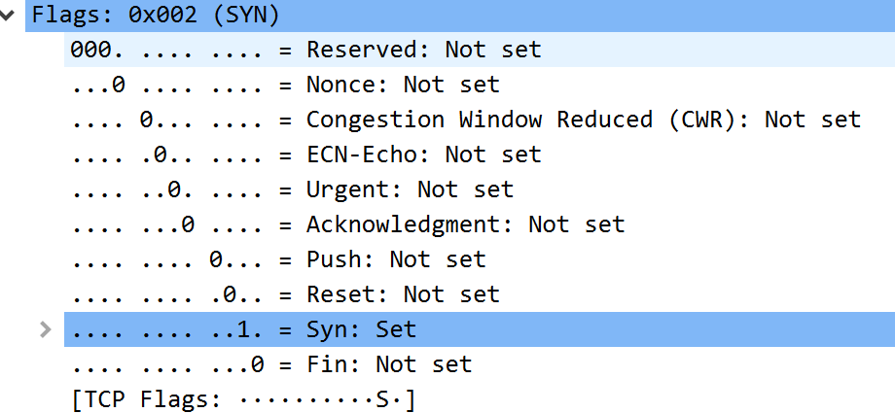**Flags:**

**Source Port:** port from sending device

**Destination Port:** receiving device port

**Sequence Number:** The device that is giving the tpc connection needs to choose random sequence number and then that number will increment in relation to the number of transmitted bytes.

**Acknowledgement number:** The receiving device has an acknowledgement number and then that number will increment in relation to the number of transmitted bytes.

**Header Length (4bits):** Length of header.

**Reserved bits (6bits):** Reserved field is always set to 0

**Control Flags:** The tpc uses 9 control flags to manage the data flow during specific situations.

**Window size(advertisement window):** The sending device creates a checksum and receiving device can use that checksum to check for errors.

**Options:** This slot provides instructions to the devices on the network also can provide / use to dedicate the path that datagram should take.

**Data(optional):** The data is actual content such as a value or a string of letters.

**Question 5:**

Draw an UDP header. Capture packets using wireshark and explain the fields for a particular UDP packet captured. Try to explain the purpose of each field.

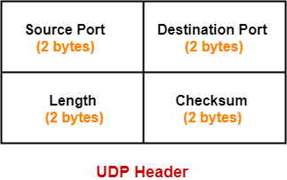

Domain 53

53873

46

0x6b76

**Source Port(2 bytes):** port from sending device this flied can also be set to 0 when the destination does not need to reply to the sender.

**Destination Port(2 bytes):** receiving device port and also the port can be between 0 and 65,535.

**Length(2 bytes):** This specifies the number of bytes making up the udp header.

**Checksum(2 bytes):** This helps to verify the integrity of the packet header and payload.

**References :**



