**CSC122F2020StacksQueues**

**Author:** Filip Segota

**Problem summary:**

This is simulation of towel factory and its process of creating and building towels. Builders and buyers are in a queue, while towels are in the stack. Builders and buyers are going simultaneously until there’s no more process to be done.

**List of requirements:**

* The program has been written with a linked list implementation for the queues and an array implementation for the stack. Need to switch that and write an array implementation for the queue (which does not move elements when items are added or deleted) and a linked list implementation for the stack. Need to implement their interfaces.
* Creating the remaining exception classes.
* Need to add output statements to the Assembly class to show the events as they happen.
* Should develop a number of test files to supplement the one provided to adequately test the program.
* Don't forget to update all comments and add any appropriate helper methods (even if this code does not use them).
* **EXTRA CREDIT:** Add code the Assembly to handle the exceptions from the stacks and queues (DID THIS)

**List of steps:**

* Program runs through AssemblyDriver.java.
* It prompt user for a name of a file and then create object of Assembly class and run its method run().
* The run() method is constantly checking if the simulation is over and if not it goes through its process.
* Program gets builders and buyers from the queue and depending on if the person is builder or buyer, it creates and add, or buy and remove given amount of towels from the stack.
* If the stack of towels is full and builder tries to create more towels, program displays that stack is full and that builder is going to the end of the queue of builders. Same thing happens if buyer tries to buy towel from an empty stack.

**Testing report:**

I did test of classes using jGrasp debugger and workbench. You can see pictures of testing results.

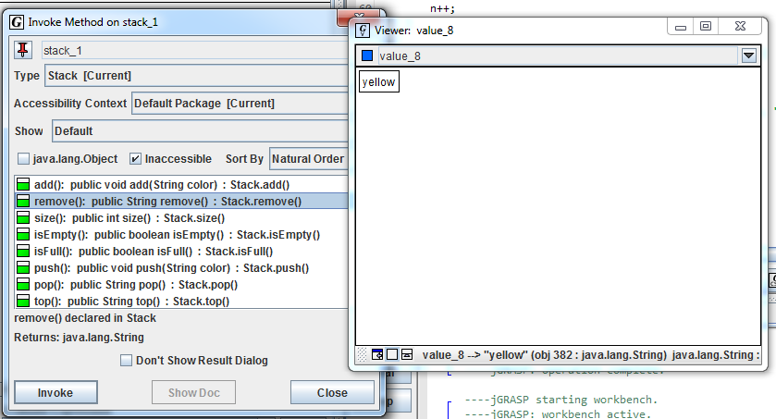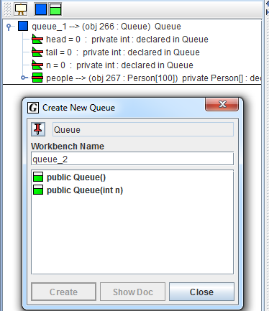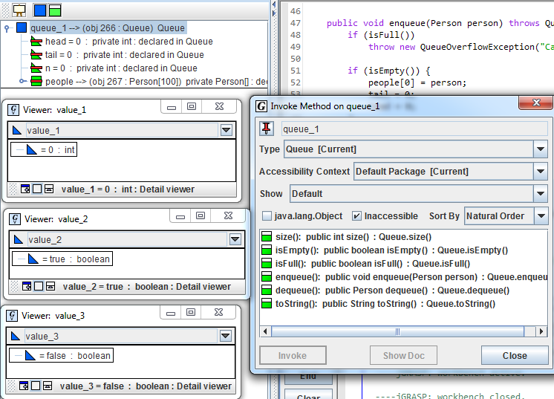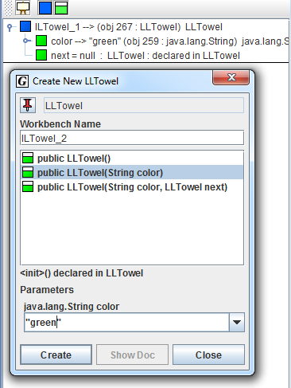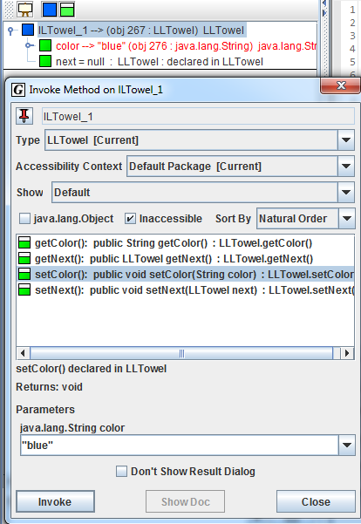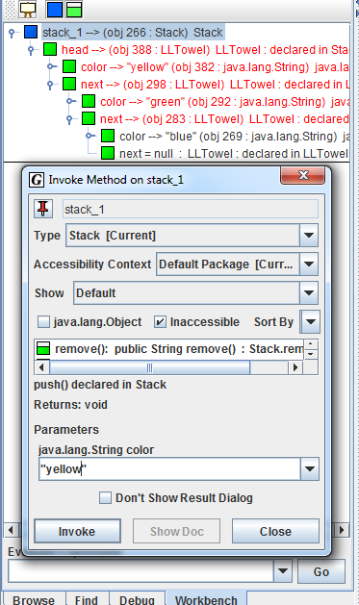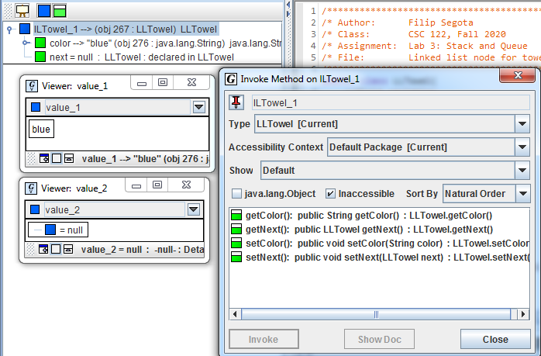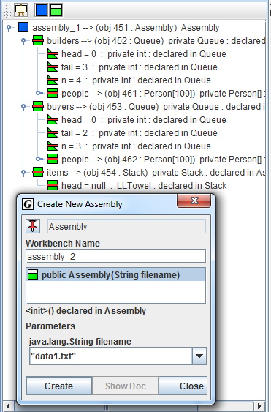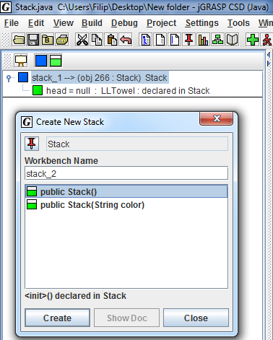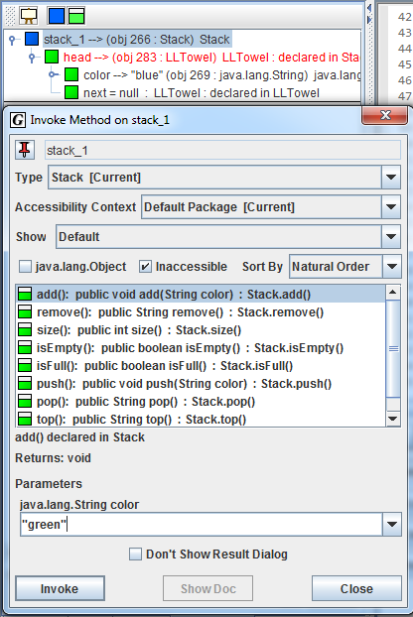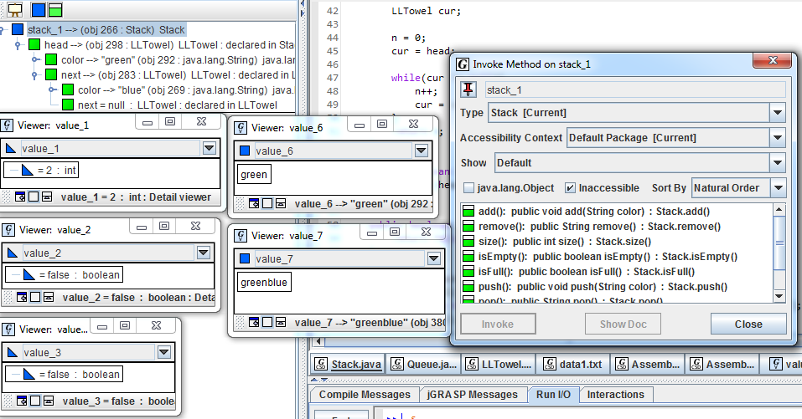

----jGRASP exec: java AssemblyDriver  
M

§MWhat is the name of the file with the initial data?  
¼¼§Mdata1.txt  
MM§MBuilder Tom created 5 green towels.  
MM§MInput any key to continue...  
¼¼§Ms  
MM§MBuyer Luke bought 4 towels.  
MM§MInput any key to continue...  
¼¼§Ms  
MM§MBuilder Tim created 3 blue towels.  
MM§MInput any key to continue...  
¼¼§Ms  
MM§MBuyer Linda bought 4 towels, but there's no towels left in a stack of towels. Buyer was added to the end of the queue of buyers with 6 towels left to buy.  
MM§MInput any key to continue...  
¼¼§Ms  
MM§MBuilder Tammy created 2 blue towels.  
MM§MInput any key to continue...  
¼¼§Ms  
MM§MBuyer Lucy bought 2 towels, but there's no towels left in a stack of towels. Buyer was added to the end of the queue of buyers with 2 towels left to buy.  
MM§MInput any key to continue...  
¼¼§Ms  
MM§MBuilder Tanna created 6 white towels.  
MM§MInput any key to continue...  
¼¼§Ms  
MM§MBuyer Linda bought 6 towels.  
MM§MInput any key to continue...  
¼¼§Ms  
MM§MThere's no towels left nor builders to build more towels. The simulation is over.  
MM§MInput any key to finish...  
¼¼§Ms

**Time:** 4hr

**Two things I learned:**

* + - * I learned about exceptions
      * I learned even more about stacks and queues.