<Study number>

Figure 14.2-1.3 (Page 1 of 17)

Scatter plot of LDL-C change from baseline vs PCSK9 change from baseline

Pharmacodynamic analysis set

Visit: 10 , Time: 336 , Day: 10

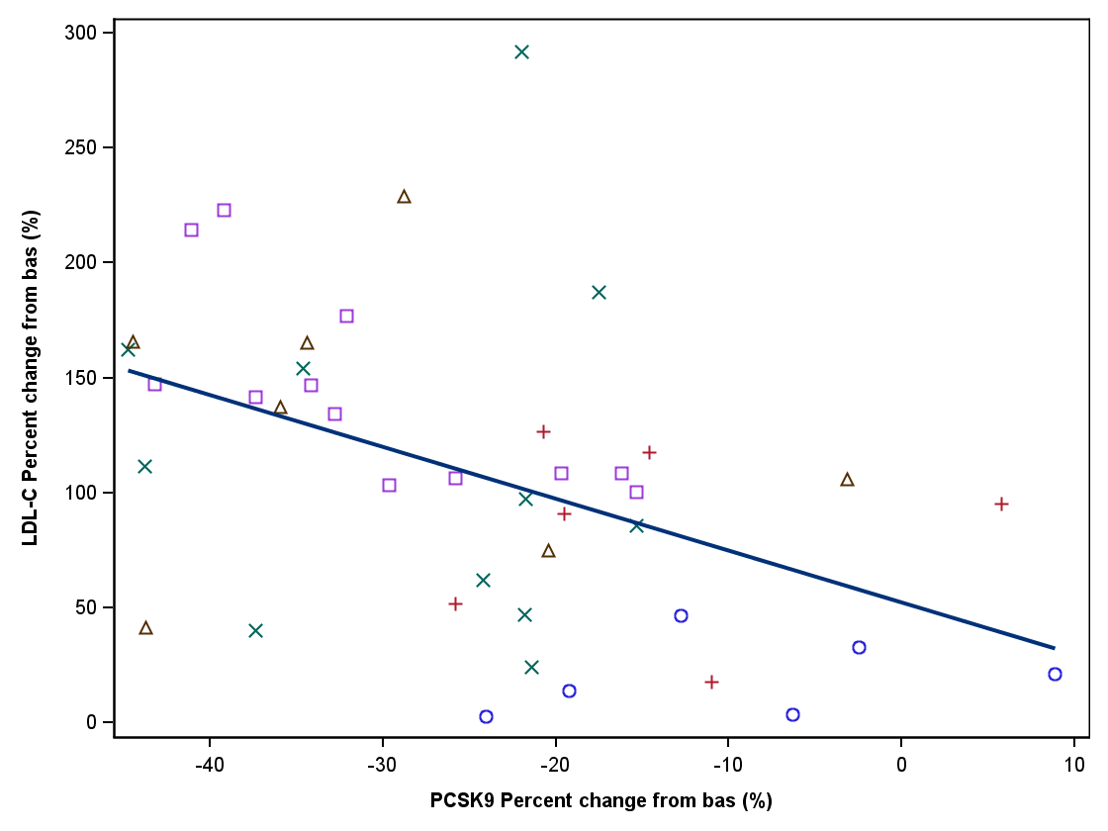

Program: C:\Users\xd00002.CLINDOM\Desktop\clinxport\report (Novartis template)\pgm_cp\p_pkfigtest3.sas 16DEC2011:11:27 IA3 - Draft

<Study number>

Figure 14.2-1.3 (Page 2 of 17)

Scatter plot of LDL-C change from baseline vs PCSK9 change from baseline

Pharmacodynamic analysis set

Visit: 11 , Time: 504 , Day: 11

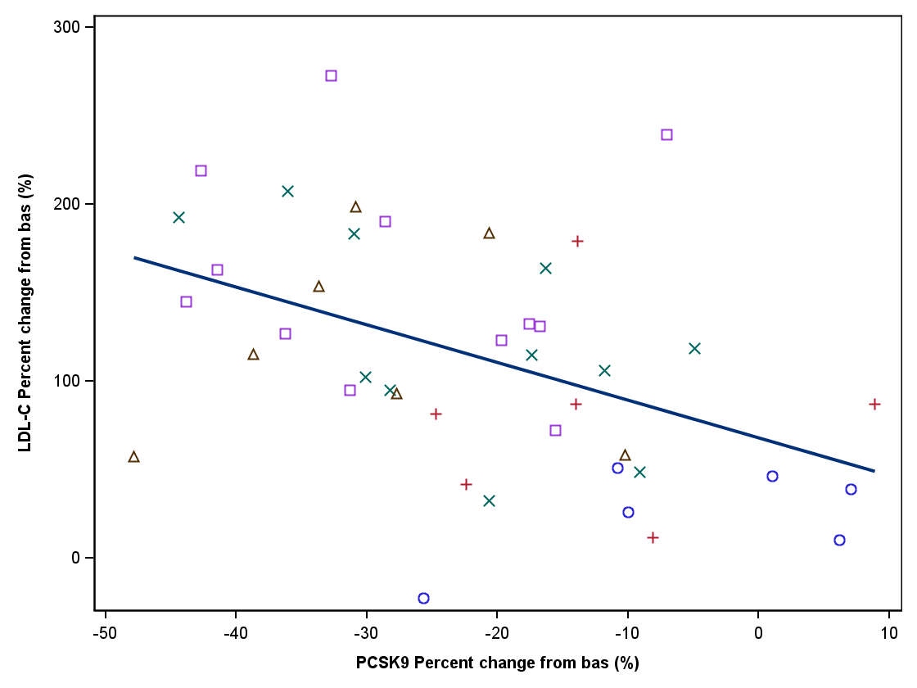

Program: C:\Users\xd00002.CLINDOM\Desktop\clinxport\report (Novartis template)\pgm_cp\p_pkfigtest3.sas 16DEC2011:11:27 IA3 - Draft

<Study number>

Figure 14.2-1.3 (Page 3 of 17)

Scatter plot of LDL-C change from baseline vs PCSK9 change from baseline

Pharmacodynamic analysis set

Visit: 12 , Time: 672 , Day: 12

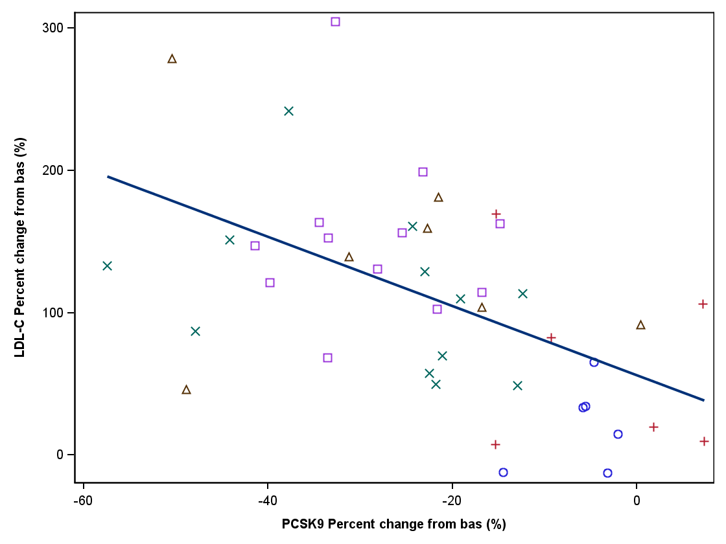

Program: C:\Users\xd00002.CLINDOM\Desktop\clinxport\report (Novartis template)\pgm_cp\p_pkfigtest3.sas 16DEC2011:11:27 IA3 - Draft

<Study number>

Figure 14.2-1.3 (Page 4 of 17)

Scatter plot of LDL-C change from baseline vs PCSK9 change from baseline

Pharmacodynamic analysis set

Visit: 13 , Time: 100 , Day: 13

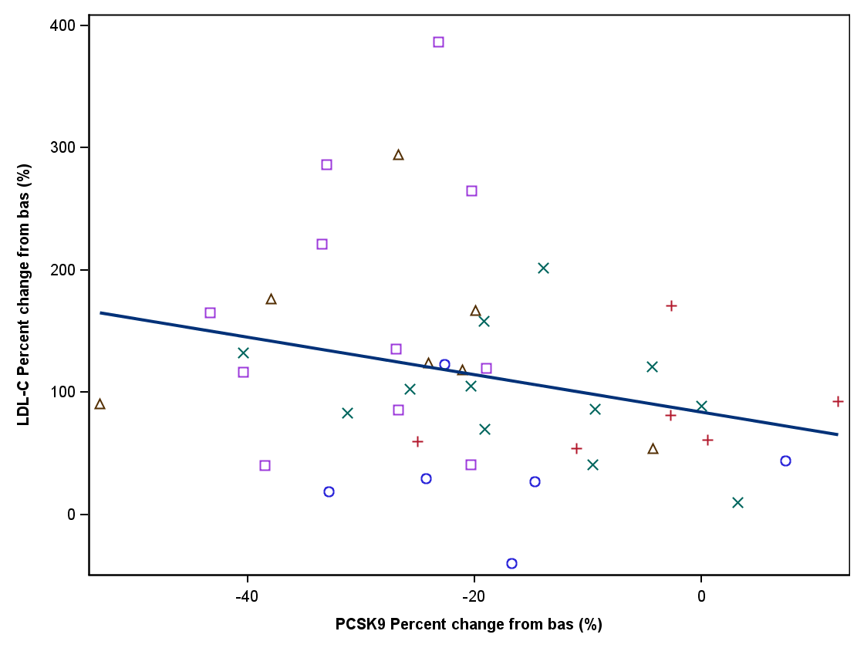

Program: C:\Users\xd00002.CLINDOM\Desktop\clinxport\report (Novartis template)\pgm_cp\p_pkfigtest3.sas 16DEC2011:11:27 IA3 - Draft

<Study number>

Figure 14.2-1.3 (Page 5 of 17)

Scatter plot of LDL-C change from baseline vs PCSK9 change from baseline

Pharmacodynamic analysis set

Visit: 14 , Time: 134 , Day: 14

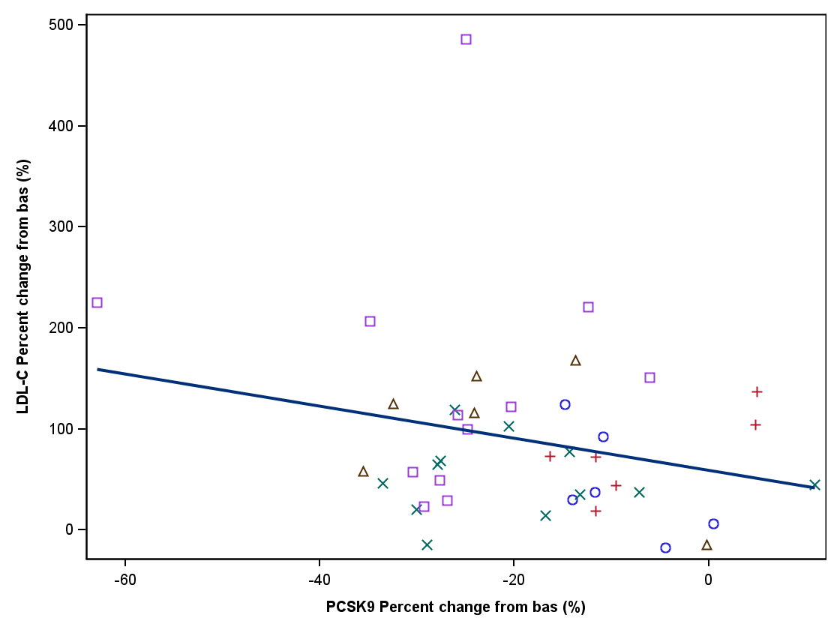

Program: C:\Users\xd00002.CLINDOM\Desktop\clinxport\report (Novartis template)\pgm_cp\p_pkfigtest3.sas 16DEC2011:11:27 IA3 - Draft

<Study number>

Figure 14.2-1.3 (Page 6 of 17)

Scatter plot of LDL-C change from baseline vs PCSK9 change from baseline

Pharmacodynamic analysis set

Visit: 15 , Time: 168 , Day: 15

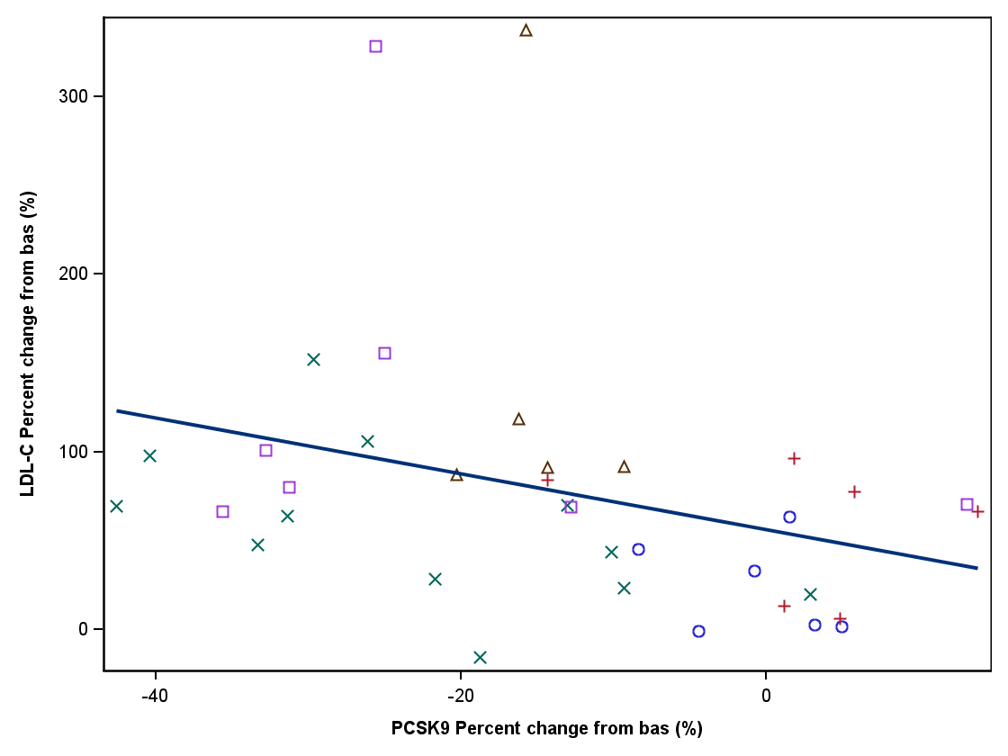

Program: C:\Users\xd00002.CLINDOM\Desktop\clinxport\report (Novartis template)\pgm_cp\p_pkfigtest3.sas 16DEC2011:11:27 IA3 - Draft

<Study number>

Figure 14.2-1.3 (Page 7 of 17)

Scatter plot of LDL-C change from baseline vs PCSK9 change from baseline

Pharmacodynamic analysis set

Visit: 16 , Time: 201 , Day: 16

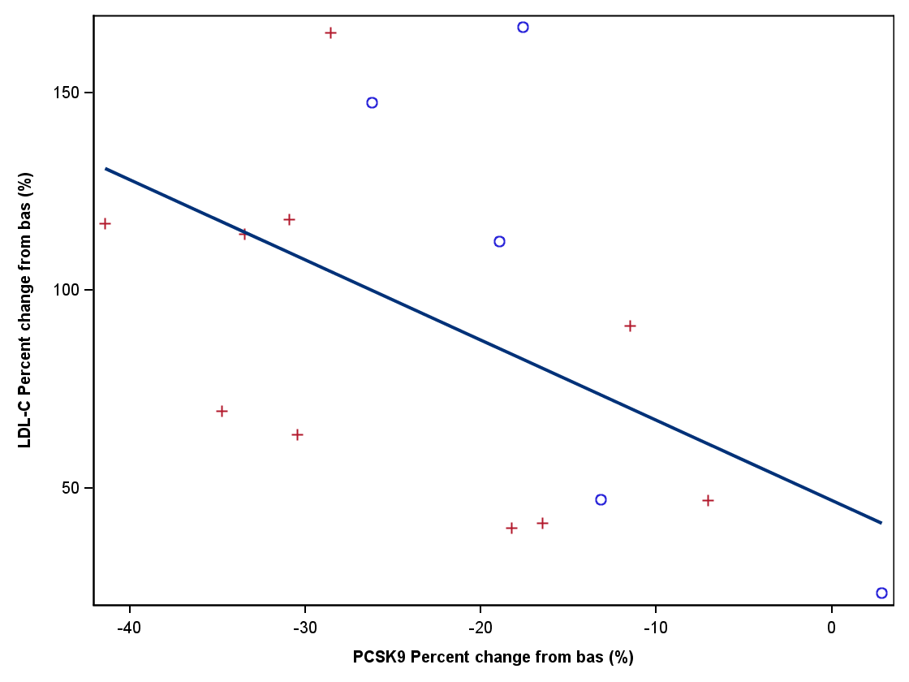

Program: C:\Users\xd00002.CLINDOM\Desktop\clinxport\report (Novartis template)\pgm_cp\p_pkfigtest3.sas 16DEC2011:11:27 IA3 - Draft

<Study number>

Figure 14.2-1.3 (Page 8 of 17)

Scatter plot of LDL-C change from baseline vs PCSK9 change from baseline

Pharmacodynamic analysis set

Visit: 16 , Time: 201 , Day: 777

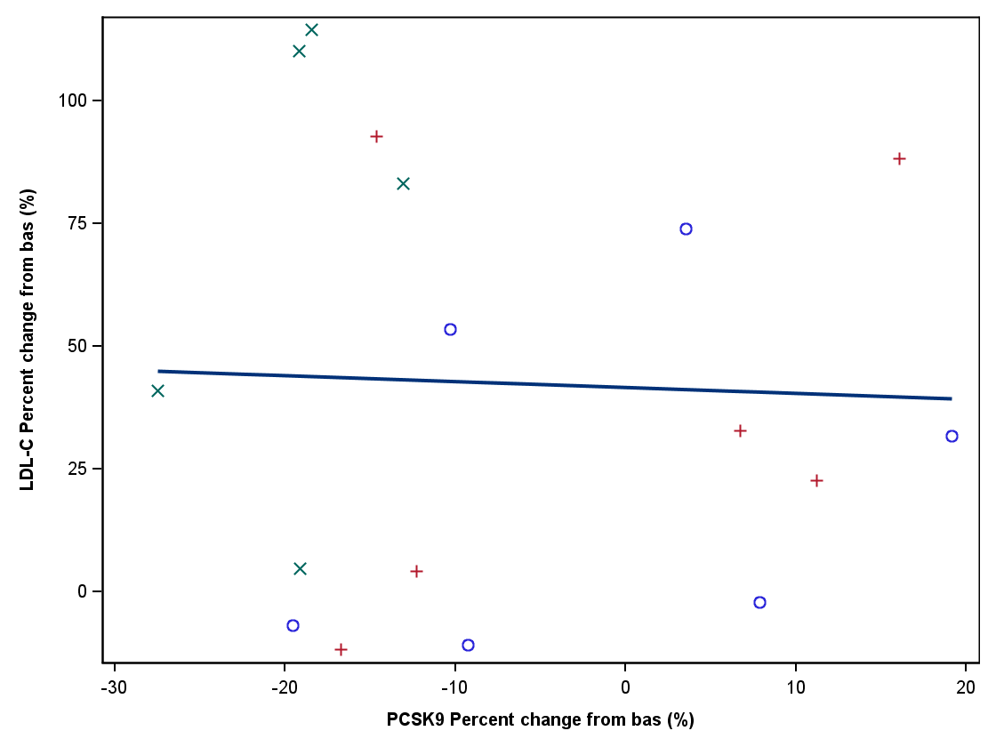

Program: C:\Users\xd00002.CLINDOM\Desktop\clinxport\report (Novartis template)\pgm_cp\p_pkfigtest3.sas 16DEC2011:11:27 IA3 - Draft

<Study number>

Figure 14.2-1.3 (Page 9 of 17)

Scatter plot of LDL-C change from baseline vs PCSK9 change from baseline

Pharmacodynamic analysis set

Visit: 17 , Time: 268 , Day: 17

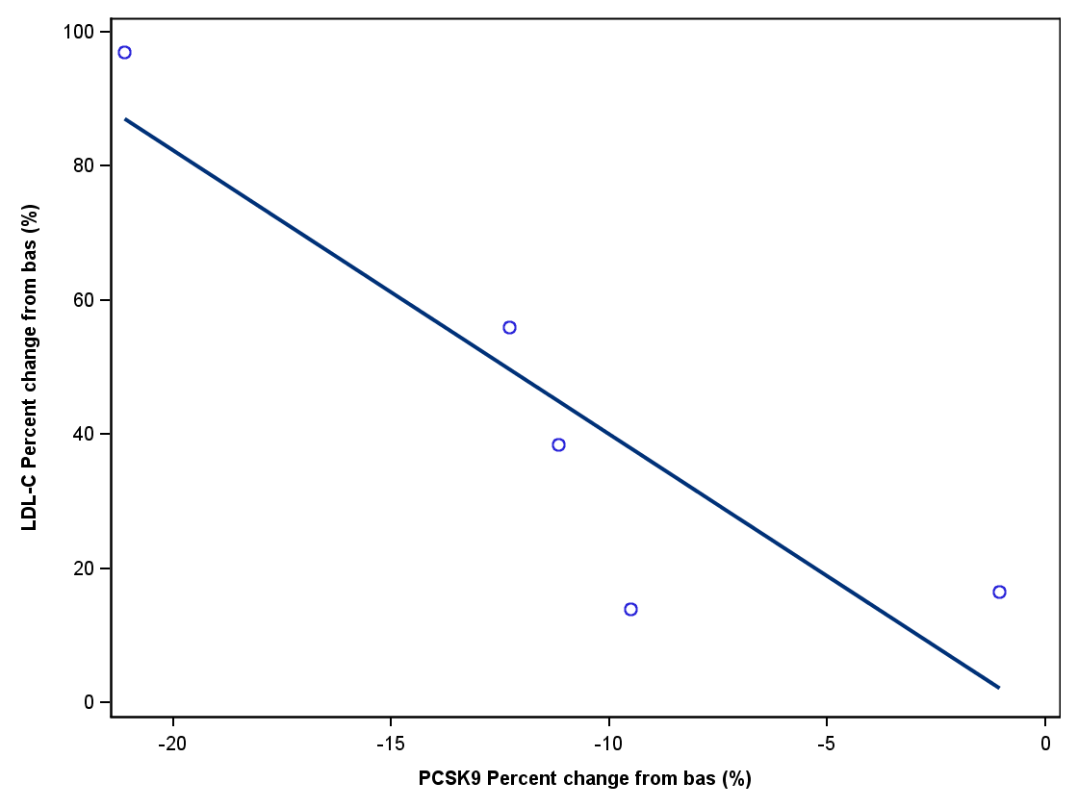

Program: C:\Users\xd00002.CLINDOM\Desktop\clinxport\report (Novartis template)\pgm_cp\p_pkfigtest3.sas 16DEC2011:11:27 IA3 - Draft

<Study number>

Figure 14.2-1.3 (Page 10 of 17)

Scatter plot of LDL-C change from baseline vs PCSK9 change from baseline

Pharmacodynamic analysis set

Visit: 3 , Time: 12 , Day: 3

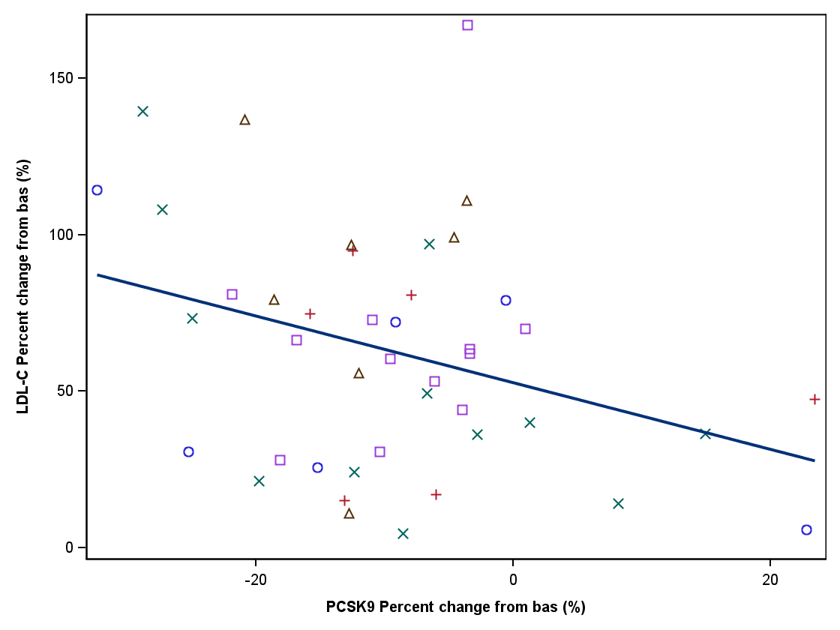

Program: C:\Users\xd00002.CLINDOM\Desktop\clinxport\report (Novartis template)\pgm_cp\p_pkfigtest3.sas 16DEC2011:11:27 IA3 - Draft

<Study number>

Figure 14.2-1.3 (Page 11 of 17)

Scatter plot of LDL-C change from baseline vs PCSK9 change from baseline

Pharmacodynamic analysis set

Visit: 3 , Time: 4 , Day: 3

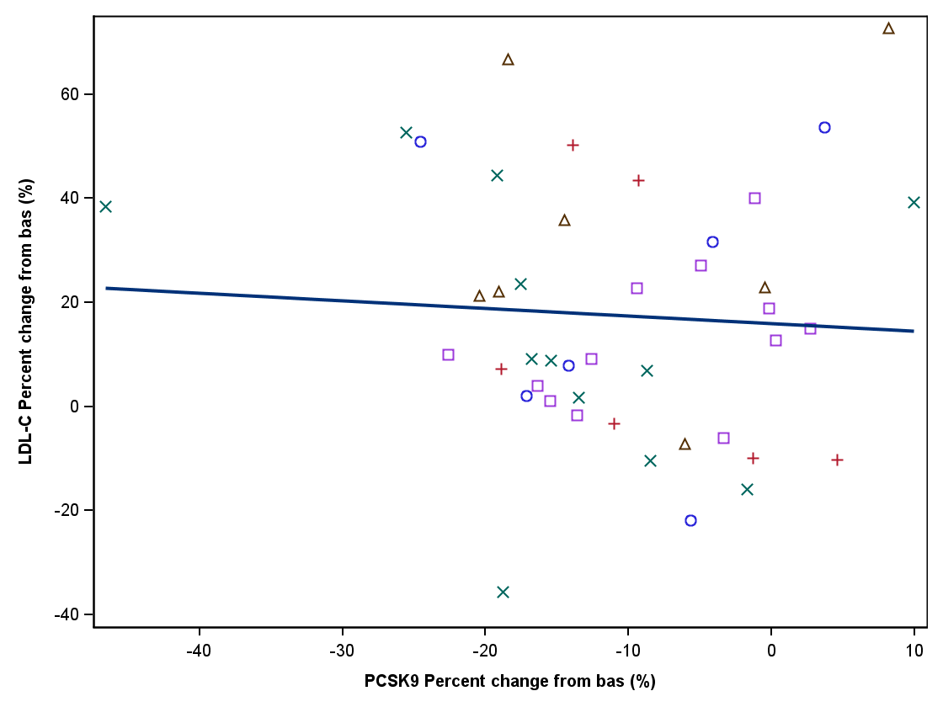

Program: C:\Users\xd00002.CLINDOM\Desktop\clinxport\report (Novartis template)\pgm_cp\p_pkfigtest3.sas 16DEC2011:11:27 IA3 - Draft

<Study number>

Figure 14.2-1.3 (Page 12 of 17)

Scatter plot of LDL-C change from baseline vs PCSK9 change from baseline

Pharmacodynamic analysis set

Visit: 3 , Time: 8 , Day: 3

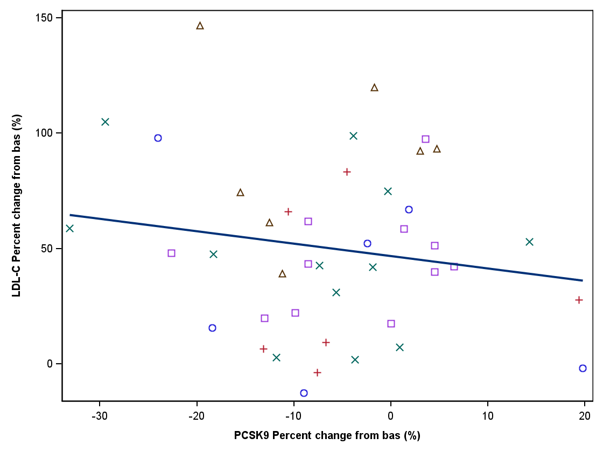

Program: C:\Users\xd00002.CLINDOM\Desktop\clinxport\report (Novartis template)\pgm_cp\p_pkfigtest3.sas 16DEC2011:11:27 IA3 - Draft

<Study number>

Figure 14.2-1.3 (Page 13 of 17)

Scatter plot of LDL-C change from baseline vs PCSK9 change from baseline

Pharmacodynamic analysis set

Visit: 4 , Time: 24 , Day: 4

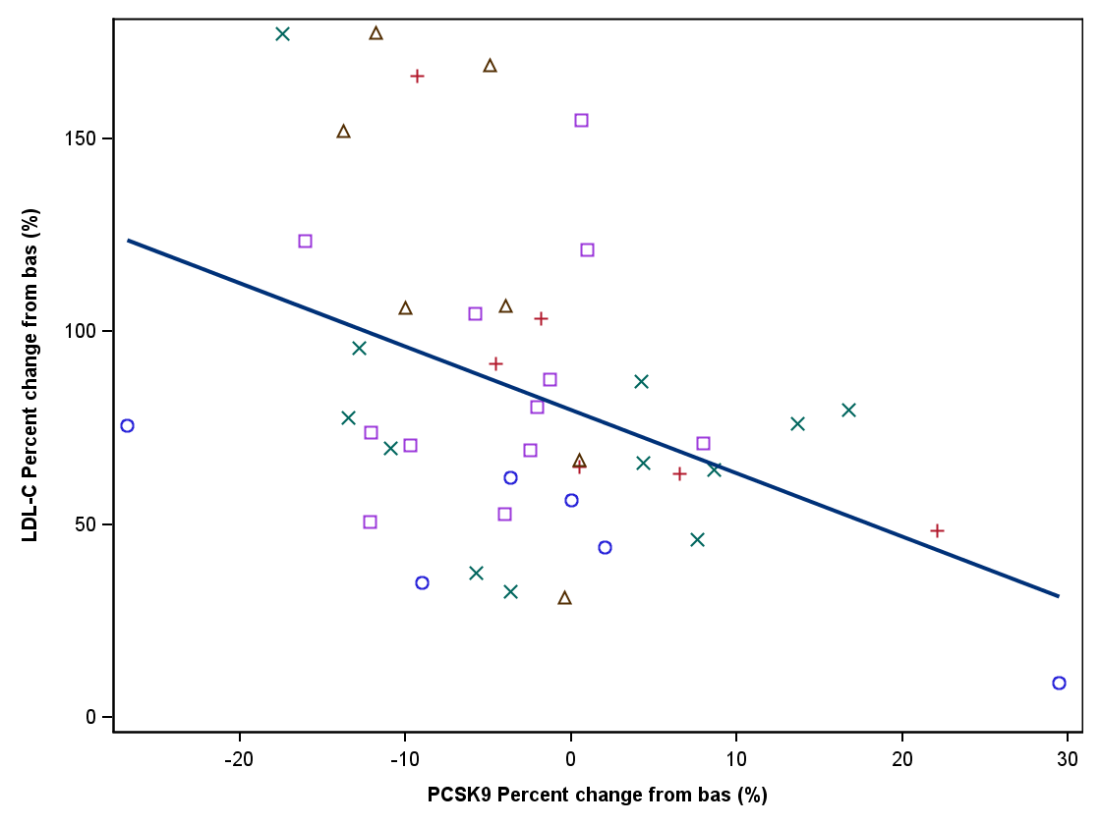

Program: C:\Users\xd00002.CLINDOM\Desktop\clinxport\report (Novartis template)\pgm_cp\p_pkfigtest3.sas 16DEC2011:11:27 IA3 - Draft

<Study number>

Figure 14.2-1.3 (Page 14 of 17)

Scatter plot of LDL-C change from baseline vs PCSK9 change from baseline

Pharmacodynamic analysis set

Visit: 5 , Time: 48 , Day: 5

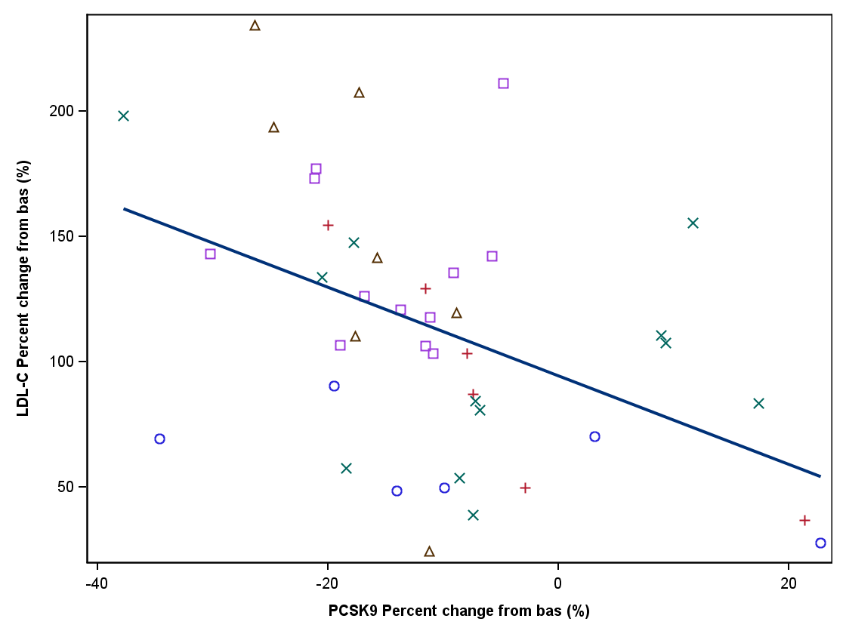

Program: C:\Users\xd00002.CLINDOM\Desktop\clinxport\report (Novartis template)\pgm_cp\p_pkfigtest3.sas 16DEC2011:11:27 IA3 - Draft

<Study number>

Figure 14.2-1.3 (Page 15 of 17)

Scatter plot of LDL-C change from baseline vs PCSK9 change from baseline

Pharmacodynamic analysis set

Visit: 7 , Time: 96 , Day: 7

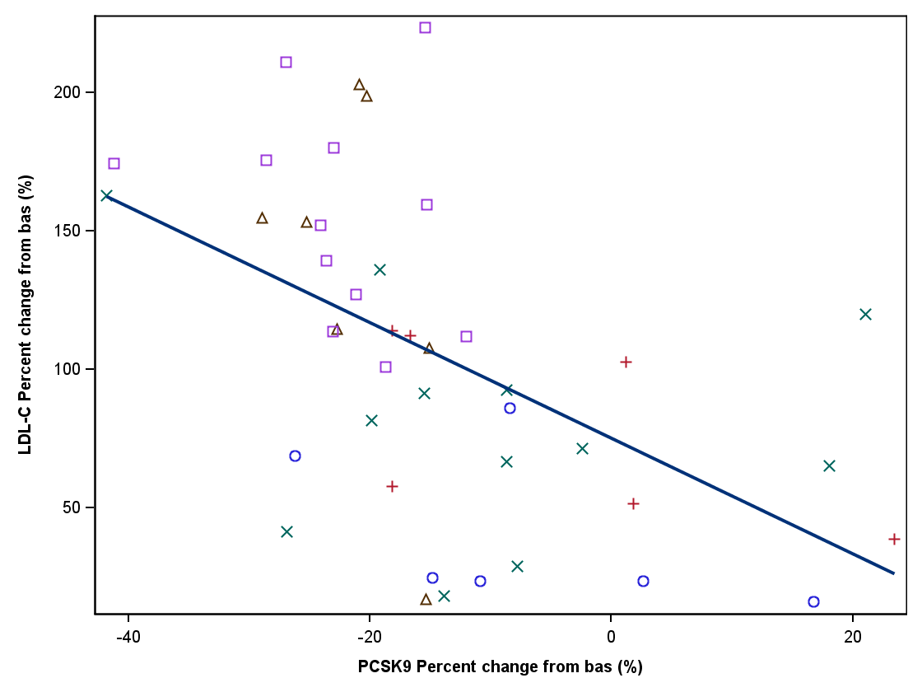

Program: C:\Users\xd00002.CLINDOM\Desktop\clinxport\report (Novartis template)\pgm_cp\p_pkfigtest3.sas 16DEC2011:11:27 IA3 - Draft

<Study number>

Figure 14.2-1.3 (Page 16 of 17)

Scatter plot of LDL-C change from baseline vs PCSK9 change from baseline

Pharmacodynamic analysis set

Visit: 8 , Time: 168 , Day: 8

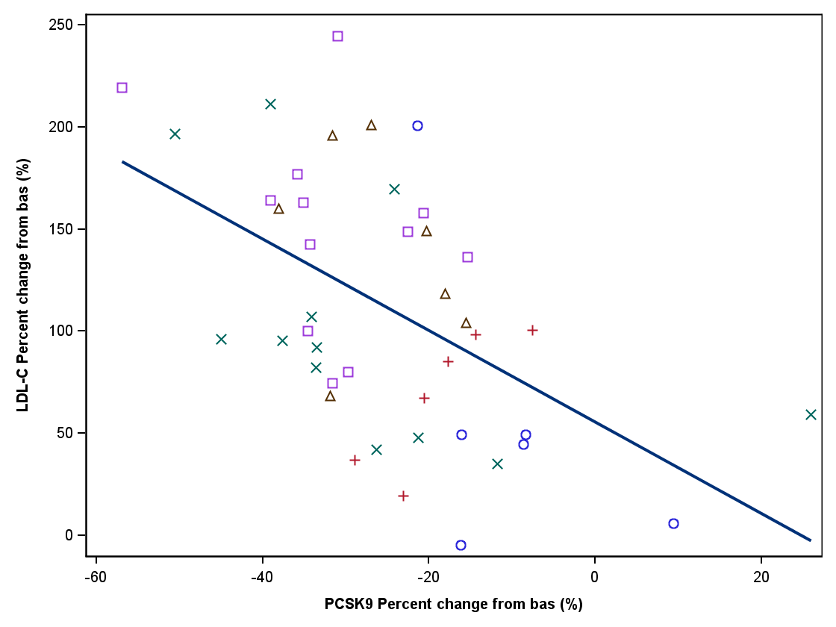

Program: C:\Users\xd00002.CLINDOM\Desktop\clinxport\report (Novartis template)\pgm_cp\p_pkfigtest3.sas 16DEC2011:11:27 IA3 - Draft

<Study number>

Figure 14.2-1.3 (Page 17 of 17)

Scatter plot of LDL-C change from baseline vs PCSK9 change from baseline

Pharmacodynamic analysis set

Visit: 9 , Time: 240 , Day: 9

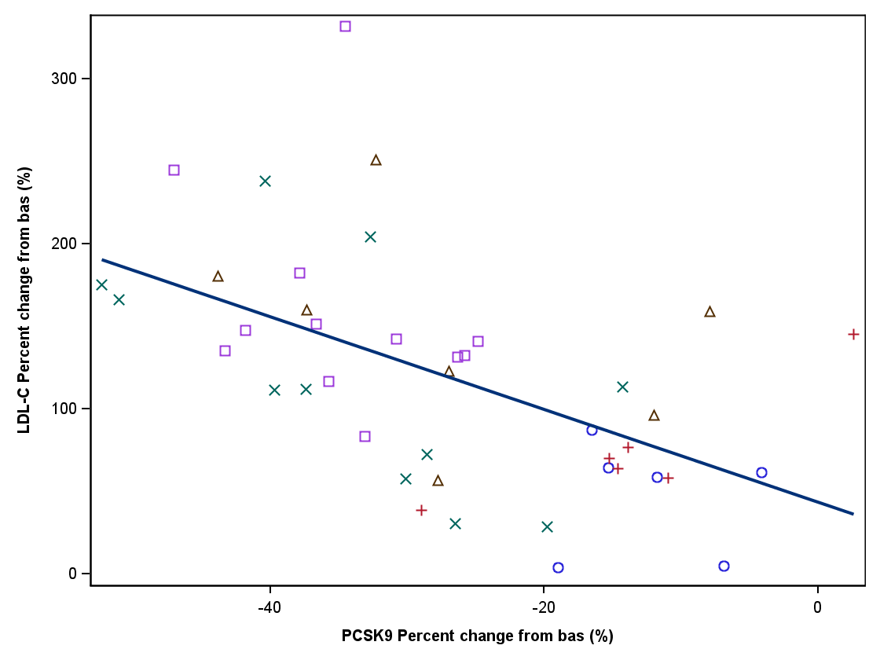

Program: C:\Users\xd00002.CLINDOM\Desktop\clinxport\report (Novartis template)\pgm_cp\p_pkfigtest3.sas 16DEC2011:11:27 IA3 - Draft