**Uvod**

Najkorišćeniji upiti su oni koji pribavljaju podatke preko SELECT komande. Povećanjem količine podataka nije svejedno kako je upit napisan. Pored poznavanja SQL sintakse programer mora poznavati specifičnosti, prednosti i mane DBMS-a nad kojim se izvršava upit. Pored je prepravljanja upita na raspolaganju su tehnike dodavanje indeksa, pogleda, statistika itd.

Ovaj rad se bavi analizom jednog kompleksnog SQL upita, koji sadrži preko 10 spojeva sa tabelama koje sadrže nekoliko stotina hiljada podataka. Ovaj SQL upit prikazuje rezultate testiranja proizvoda, kao i neke njegove osnovne karakteristike.

ER dijagram baze je dat na sledećoj slici.

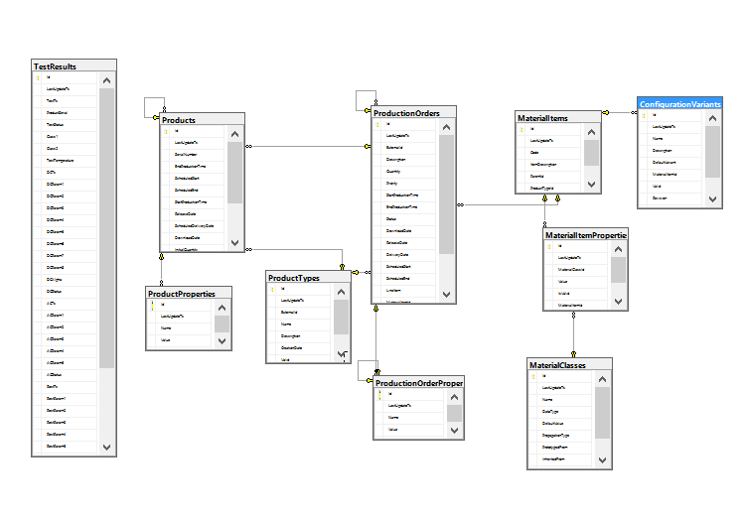

Iako ne postoji strani ključ između tabela TestResults i Products i tabela ConfigurationVariantItems i ProductionOrderProperties, postoji veza koja se koristi u SQL upitu koji se analizira.

Baza sadrži 10 tabela:

**TestResults** – 712.718 podataka

**Products** – 697.625 podataka

**ProductProperties** – 3.486.173 podatka

**ProductionOrders** – 642 podatka

**ProductionOrderProperties** – 11.151 podatka

**ProductTypes** – 6 podataka

**MaterialItems** – 105 podataka

**MaterialItemProperties** – 337 podataka

**MaterialClasses** – 5 podataka

**ConfigurationVariants** – 219 podataka

Zbog velike količine podataka upit je morao da pribavlja stranicu po potrebi.

**Inicijalno stanje**

Inicijalni SQL je imao mogućnost paging-a, ali zbog slabih performansi i nemogućnosti filtriranja i sortiranja morao je biti prepravljen.

U nastavku se nalazi inicijalni query

SELECT distinct

ppo.ExternalId as Operation,pop1.Value AS Batch,pop2.Value AS BatchType,

pp6.Value AS BatchSegment, pp7.Value AS BatchLot, pop3.Value AS PowderCharge,

cv.Name AS TestPlan,cv.Revision AS TestPlanRevision,cvMI.code AS Material,

cvMI.ItemDescription AS MaterialDescription, mip1.Value AS VaristorType,

mip2.Value AS VarDiameter, mip3.Value AS VarHeight, TestResult.*

FROM (select * FROM (

SELECT ROW_NUMBER () OVER (order by temp.ProductSerial) AS rn, temp.* FROM

(Select distinct top 100 percent TestResults.* from

Products

join ProductTypes on Products.ProductTypeId = ProductTypes.Id and ProductTypes.Name = 'Varistor'

join TestResults on Products.SerialNumber = TestResults.ProductSerial and TestResults.Valid = 1, ProductionOrders, ProductionOrderProperties WHERE

ProductionOrderProperties.Name = 'MOBatch' and

Products.ProductionOrderId = ProductionOrders.Id and ProductionOrders.Id = ProductionOrderProperties.ProductionOrderId

order by TestResults.ProductSerial asc

) as temp

) as temp2

where temp2.rn between {0} and {1}

) TestResult

left join Products p on TestResult.ProductSerial = p.SerialNumber

left join ProductionOrders po on po.Id = p.ProductionOrderId

left join ProductionOrders ppo on ppo.Id = po.ParentId

left join ProductionOrderProperties popTestPlan on po.Id = popTestPlan.ProductionOrderId and popTestPlan.Name = 'TestPlanId'

left join ProductionOrderProperties pop1 on po.ParentId = pop1.ProductionOrderId and pop1.Name = 'MOBatch'

left join ProductionOrderProperties pop2 on po.ParentId = pop2.ProductionOrderId and pop2.Name = 'ProductionVersion'

left join ProductionOrderProperties pop3 on po.ParentId = pop3.ProductionOrderId and pop3.Name = 'PowderCharge'

left join ProductProperties pp6 on p.ParentId = pp6.ProductId and pp6.Name = 'SegmentName'

left join ProductProperties pp7 on p.ParentId = pp7.ProductId and pp7.Name = 'LayerName'

left join ConfigurationVariants cv on CAST (popTestPlan.Value as bigint) = cv.Id

left join MaterialItems cvMI on cv.MaterialItemId = cvMI.id

left join MaterialItemProperties mip1 on cvMI.id = mip1.MaterialItemId and mip1.MaterialClassId in (select Id from MaterialClasses where Name = 'Var_Typ')

left join MaterialItemProperties mip2 on cvMI.id = mip2.MaterialItemId and mip2.MaterialClassId in (select Id from MaterialClasses where Name = 'Diameter')

left join MaterialItemProperties mip3 on cvMI.id = mip3.MaterialItemId and mip3.MaterialClassId in (select Id from MaterialClasses where Name = 'Height')

Izvršavanje ovog upita za prvu straincu, veličine 400 reda, traje 20 sekunde.

**Modifikovanje SQL upita**

Inicijalni SQL upit je morao biti prepravljen kako bi filtriranje i sortiranje bilo podrzano.

Umesto 4 ugnježdena SELECT upita, modifikovani SQL upit ima samo jedan SELECT.

U nastavku se nalazi modifikovani SQL upit

Select

ppo.ExternalId as Operation,pop1.Value AS Batch,pop2.Value AS BatchType,

pp6.Value AS BatchSegment,pp7.Value AS BatchLot,pop3.Value AS PowderCharge,

cv.Name AS TestPlan,cv.Revision AS TestPlanRevision,cvMI.code AS Material,

cvMI.ItemDescription AS MaterialDescription,mip1.Value AS VaristorType,

mip2.Value AS VarDiameter,mip3.Value AS VarHeight, t.*

from

TestResults t

join Products prod on t.ProductSerial = prod.SerialNumber

join ProductTypes pt on pt.Id = prod.ProductTypeId and pt.Name = 'Varistor'

join ProductionOrders prodOrder on prodOrder.Id = prod.ProductionOrderId

join ProductionOrders ppo on ppo.Id = prodOrder.ParentId

join ProductionOrderProperties pop1 on pop1.ProductionOrderId = prodOrder.Id and pop1.Name = 'MOBatch'

join ProductionOrderProperties pop2 on pop2.ProductionOrderId = prodOrder.Id and pop2.Name = 'ProductionVersion'

join ProductionOrderProperties pop3 on pop3.ProductionOrderId = prodOrder.Id and pop3.Name = 'PowderCharge'

left join ProductProperties pp6 on (pp6.ProductId = prod.ParentId and pp6.Name = 'SegmentName')

left join ProductProperties pp7 on (pp7.ProductId = prod.ParentId and pp7.Name = 'LayerName')

left join ProductionOrderProperties TestPlan on prodOrder.Id = TestPlan.ProductionOrderId and TestPlan.Name = 'TestPlanId'

left join ConfigurationVariants cv on CAST (TestPlan.Value as bigint) = cv.Id

left join MaterialItems cvMI on cv.MaterialItemId = cvMI.id

left join MaterialItemPropertIes mip1 on cvMI.id = mip1.MaterialItemId and mip1.MaterialClassId in (select Id from MaterialClasses where Name = 'Var_Typ')

left join MaterialItemPropertIes mip2 on cvMI.id = mip2.MaterialItemId and mip2.MaterialClassId in (select Id from MaterialClasses where Name = 'Diameter')

left join MaterialItemProperties mip3 on cvMI.id = mip3.MaterialItemId and mip3.MaterialClassId in (select Id from MaterialClasses where Name = 'Height')

WHERE

t.valid = 1

{2}

order by {3} t.Id

OFFSET {0} ROWS

FETCH NEXT {1} ROWS ONLY;

Izvršavanje modifikovanog upita traje isto kao i izvršavanje inicijalnog, 20 sekunde.

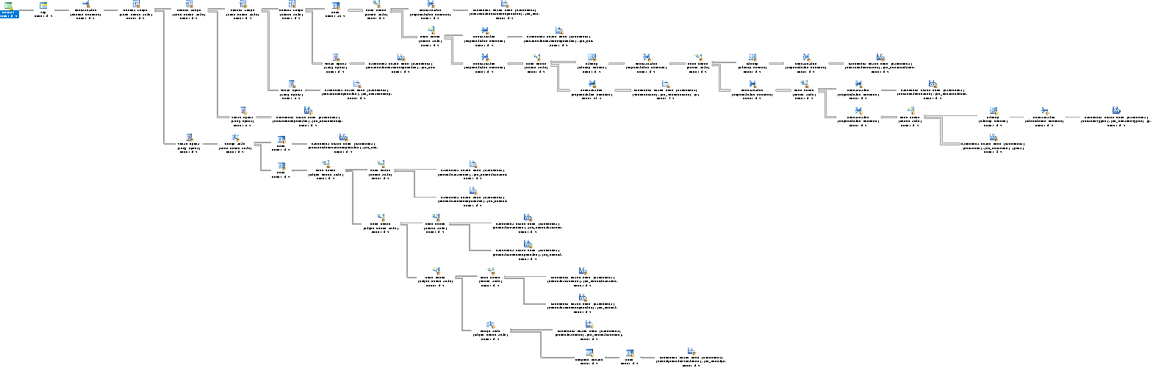Test plan modifikovanog SQL upita je dat na sledecoj slici:

**Dodatna optimizacija upita kod paging-a**

Kod paging se može iskoristiti tehnika optimizacija upita, gde se u prvom delu upita izvlače primarni ključevi željenih tabela a u drugom delu upita konkretni podaci na osnovu izvučenih primarnih ključeva.

Ova tehnika najviše povećava performance upita kada se upit koristi prilikom paging-a i kada upit selektuje mnogo kolona.

Pribavljanje prve stranice pomoću SQL upita opisanog u 2. poglavlju se ovom tehnikom može ubrzati za 30%.

Ubrzanje ovom tehnikom je sve veće kako raste redni broj zahtevane stranice. Tako npr. kod 26. stranice dobija se ubrzanje od 34%.

A ubrzanje kod 1251. stranice je 200%, tj. ovom tehnikom se upit izvršava 3 puta brže.

Ova tehnika se može primeniti i kada se podaci prikupljaju preko View-a, mada su ubrzanja manja nego kod klasičnog SQL upita, ubrzanja i dalje postoje.

Ubrzanje kod 1251. stranice preko View-a je 113%.

Tehnika je detaljnije opisana na sajtu:

<https://sqlperformance.com/2015/01/t-sql-queries/pagination-with-offset-fetch>

Na sledećoj strani se nalazi izgled SQL upita koji koristi ovu tehniku

with TestIds as (Select t.Id as TestResultId, ppo.Id as OperationId, pop1.Id AS BatchId,

pop2.Id AS BatchTypeId, pp6.Id AS BatchSegmentId, pp7.Id AS BatchLotId, pop3.Id AS PowderChargeId, cv.Id AS TestPlanId, cvMI.Id AS MaterialId, mip1.Id AS VaristorTypeId,

mip2.Id AS VarDiameterId, mip3.Id AS VarHeightId

from

TestResults t

join Products prod on t.ProductSerial = prod.SerialNumber

join ProductionOrders prodOrder on prodOrder.Id = prod.ProductionOrderId

join ProductionOrders ppo on ppo.Id = prodOrder.ParentId

left join ProductionOrderProperties TestPlan on prodOrder.Id = TestPlan.ProductionOrderId and TestPlan.Name = 'TestPlanId'

left join ConfigurationVariants cv on CAST (TestPlan.Value as bigint) = cv.Id

left join MaterialItems cvMI on cv.MaterialItemId = cvMI.id

left join MaterialItemPropertIes mip1 on cvMI.id = mip1.MaterialItemId and mip1.MaterialClassId in (select Id from MaterialClasses where Name = 'Var_Typ')

left join MaterialItemPropertIes mip2 on cvMI.id = mip2.MaterialItemId and mip2.MaterialClassId in (select Id from MaterialClasses where Name = 'Diameter')

left join MaterialItemProperties mip3 on cvMI.id = mip3.MaterialItemId and mip3.MaterialClassId in (select Id from MaterialClasses where Name = 'Height')

join ProductionOrderProperties pop1 on pop1.ProductionOrderId = prodOrder.Id and pop1.Name = 'MOBatch'

join ProductionOrderProperties pop2 on pop2.ProductionOrderId = prodOrder.Id and pop2.Name = 'ProductionVersion'

join ProductionOrderProperties pop3 on pop3.ProductionOrderId = prodOrder.Id and pop3.Name = 'PowderCharge'

left join ProductProperties pp6 on (pp6.ProductId = prod.ParentId and pp6.Name = 'SegmentName')

left join ProductProperties pp7 on (pp7.ProductId = prod.ParentId and pp7.Name = 'LayerName')

WHERE

t.valid = 1 {2}

order by {3} t.Id

OFFSET {0} ROWS

FETCH NEXT {1} ROWS ONLY)

Select

ppo.ExternalId as Operation, pop1.Value AS Batch, pop2.Value AS BatchType, pp6.Value AS BatchSegment, pp7.Value AS BatchLot, pop3.Value AS PowderCharge, cv.Name AS TestPlan,

cv.Revision AS TestPlanRevision, cvMI.code AS Material, cvMI.ItemDescription AS MaterialDescription, mip1.Value AS VaristorType, mip2.Value AS VarDiameter,

mip3.Value AS VarHeight, t.*

from

TestIds ids

join TestResults t on t.Id = ids.TestResultId

join ProductionOrders ppo on ppo.Id = ids.OperationId

join ProductionOrderProperties pop1 on pop1.Id = ids.BatchId

join ProductionOrderProperties pop2 on pop2.Id = ids.BatchTypeId

join ProductionOrderProperties pop3 on pop3.Id = ids.PowderChargeId

left join ProductProperties pp6 on pp6.Id = ids.BatchSegmentId

left join ProductProperties pp7 on pp7.Id = ids.BatchLotId

left join ConfigurationVariants cv on cv.Id = ids.TestPlanId

left join MaterialItems cvMI on cvMI.Id = ids.MaterialId

left join MaterialItemPropertIes mip1 on mip1.Id = ids.VaristorTypeId

left join MaterialItemPropertIes mip2 on mip2.Id = ids.VarDiameterId

left join MaterialItemProperties mip3 on mip3.Id = ids.VarHeightId

order {3} by t.Id

OPTION (FORCE ORDER);

**Views**

Pored klasičnih view-eva, SQL server podržava jos 3 različite vrste view-a:

* Indexed Views
* Partitioned Views
* System Views

System view se koristi za meta podatke SQL server, a partitioned view se koristi kod distribuiranih baza, gde se različiti delovi podataka nalaze na različitim SQL serverima. Tako da se ova dva view-a ne mogu koristiti za dati upit koji se analizira.

**Standardni View**

Pribavljanje podataka pomoću klasičnog SELECT upita nad view-om ima slabije performance nego izvršavanje modifikovanog SQL upita, zato što kod modifikovanog SQL upita imamo razne tehnike ubrzanja koje nisu iskorišćene kod View-a (npr. pribavljanje prvo primarnih ključeva pa kasniji join radi pribavke podataka, force-ovanje ordera query optimizeru itd.).

Kada se ove tehnike primene i nad View-om, tada razlike u performansama su zanemarljive.

To je zato što standardni view koristi SQL upit pomoću kog je generisan prilikom pribavljanja podataka, a taj upit se ne može dalje ubrzati bez indeksa.

**Indexed View**

Indexed View se kreira tako što se standardnom View-u dodaje jedan jedinstveni klasterovani index. Takođe, View mora biti kreiran pomoću „WITH SCHEMABINDING“ opcije.

Indexed View ima velika ograničenja za SQL upit pomoću kog se generiše, neka od tih ograničenja su da SELECT upit ne sme sadržati:

* COUNT, DISTINCT, ROWSET, MIN, MAX, ORDER BY, TOP, OFFSET
* Join-ovanje istih tabela više puta (self-joins)
* OUTER join-ove (LEFT, RIGHT, FULL)
* Common table expressions
* Itd.

Detaljnije informacije o tome kako se kreira Indexed View kod SQL servera se mogu naći na sajtu:

<https://msdn.microsoft.com/en-us/library/ms191432.aspx>