**Treetening**

**Game Design Document**

**Autor: Filipe António Semedo Mesquita**

**February, 2025**

**Covilhã**

**INDEX**

* **What is “Treetening”?** --------------------------------------------------------- **1**
* **Design Pillars: What is Central to the experience?** --------------------- **2**
* **Market and Audience** ---------------------------------------------------------- **2**
* **Core Gameplay** ------------------------------------------------------------------- **2**
* **Controls** ---------------------------------------------------------------------------- **4**
* **Gameplay Balance & Pacing** -------------------------------------------------- **5**
* **Art Style** ---------------------------------------------------------------------------- **5**
* **Setting & World** ------------------------------------------------------------------ **5**
* **Narrative** --------------------------------------------------------------------------- **5**
* **Image Credits** --------------------------------------------------------------------- **6**

**What is “Treetening”?**

Uma imagem com Animação, Desenho animado, ficção, Jogo de pc

Os conteúdos gerados por IA poderão estar incorretos.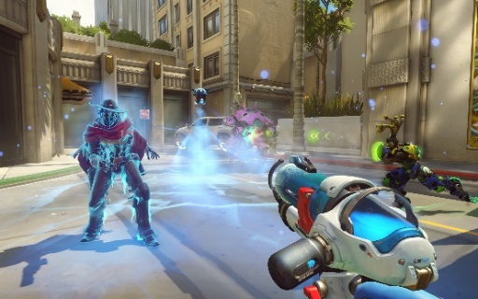Treetening is a singleplayer fps (first person shooter) casual game where the player has access to a variety of different weapons to take Down trees and collect its roots. These contain a special crystal which the player must sell in order to get money and upgrade his arsenal so he can take down even more trees. All this while planting new seeds so the destroyed plants can be replaced. The game’s art style is low poly, something like “Grow Home”, and the gameplay remembers “Overwatch” shooting experience, with each weapon feeling unique.

Grow Home Overwatch

**Design Pillars: What is Central to the Experience?**

|  |  |
| --- | --- |
| **Power** | **Advancement and Completion** |
| As the player upgrades his weapons, he becomes more powerful, thus obtaining a feeling of satisfaction. | The game revolves around upgrading weapons to get more power. Because of this, as the player acquires each unlockable in the game, he will get a satisfying sense of completion. |

**Market and Audience**

The game is a final degree project and will also serve as personal practice in the area of ​​game development and content in a personal portfolio. Initially there are no intentions of profiting from it.

The game revolves around taking down trees. Some people may associate it with deforestation and decide not to play it. These people may be within a large age range, therefore affecting the possible game audience. However, the target audience is teen-adult players (roughly 15–35 years old).

**Core Gameplay**

The game follows the standard fps controls, move the player with WASD and control the camera with the mouse.

The left mouse button will shoot, to reload the weapon the player uses the R key and with the F key he interacts with the environment. Also, the scroll/keyboard numbers wheel change through the weapons.

To acquire seeds, new weapons and upgrades the player has access to a shop.

**LIST OF WEAPONS AND UPGRADES:**

* Air Shotgun – a shotgun that shoots 2 rounds of wind before needing to be reloaded and damages trees in a cone;

**Upgradable:**

* Damage;
* Cone range.
* Rocket Gloves – a pair of boxing gloves with rockets in the back that the player wears to give powerful punches;

**Upgradable:**

* Damage;
* Punching Speed.
* 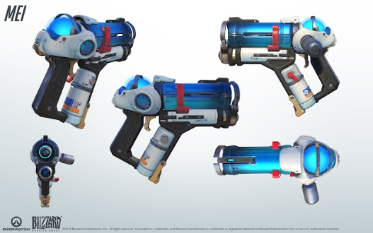CryoFeller – a pistol-like weapon (similar

to Mei’s Endothermic Blaster from

Overwatch) that freezes several trees

in front of it and has something like an

axe blade in the handle to give the final

blow to the trees;

**Upgradable:**

* Temperature; Mei’s Endothermic Blaster
* Freezing Area.
* Bomber Planes – paper planes with a bomb attached that explodes when collides with something;

**Upgradable:**

* Damage;
* Explosion Radius.
* Saw hat – a hat that is thrown in a straight line and comes back to the player

(something like when Mario

throws Cappy in Super Mario

Odyssey), the hat has blades in the sides

And rotates to apply damage.

**Upgradable:**

* Damage;
* Hat Speed. Mario and Cappy

More weapons and upgrades may be developed in the future, but this list is considered the MVP (Minimum Viable Product) version for the base game.

**LIST OF SEEDS:**

* Pine tree – its seeds are cheaper, growing time is fast and is easier to take down, however its root is not that valuable;
* Mahogany– more expensive seeds, slower growing time and harder to take down, however its root is more valuable.

More seeds may be developed in the future, but this list is considered the MVP (Minimum Viable Product) version for the base game.

To plant the seeds that were acquired in the shop, the player interacts with a machine that will dispose seeds for him in the field in a random place inside the appropriate area (like the auto feeders from Slime Rancher).

Uma imagem com Jogo de pc, captura de ecrã, Software de videojogos, Videojogo de estratégia

Os conteúdos gerados por IA poderão estar incorretos.

Slime Rancher auto feeder

**Controls**

**In the world:**

* WASD – move the player;
* MOUSE – move the camera;
* MOUSE 1 – shoot;
* MOUSE 2 – secondary shot (when applicable);
* SCROLL WHEEL – cycle through the weapons;
* KEYBOARD NUMBERS – select and change weapons;
* R – reload weapon;
* F – interact with the environment;
* ESC – pause the game and open the pause menu;

**In the menus:**

* MOUSE 1 – select;
* ESC – back;

**Gameplay Balance & Pacing**

The player has the freedom to buy as many seeds in the shop as he wants, because of this there must be a limit for the number of seeds the “auto planter” can have planted ate the same time, so that the world doesn’t get “overpopulated” with trees.

One problem that must be taken into consideration is the possibility for the player to run out of trees and money, therefore not being able to keep progressing. One solution for this can be some cheap trees being planted randomly without the need for seeds.

**Art Style**

The whole game follows a low poly art style. Just like “Grow Home”.

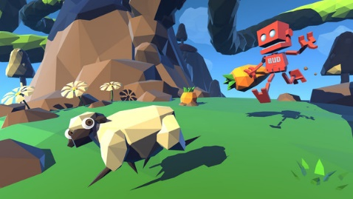

Even the weapon icons in the menus and

HUD, are intended to be small

photographs of the 3D models.

Grow Home

**Setting & World**

The game will take place in an open but limited area. Something like a farm, with the shop and auto planter being placed in one corner of the field.

**Narrative**

This is a casual game without any explicit narrative. Apart from the tutorial, where the player gets introduced to the value of the tree roots and the gameplay mechanics, there’s no idea of implementing any voice lines or dialogs.

Image Credits

* Grow Home -> [https://store.steampowered.com/app/323320/Grow_Home](https://store.steampowered.com/app/323320/Grow_Home%20)  -- **1**
* Overwatch -> <https://www.cnet.com/reviews/overwatch-preview/> -------------- **1**
* Mei’s Endothermic Blaster -> <https://www.reddit.com/r/translator/comments/4x6s42/chinese_english_meis_endothermic_blaster_from/#lightbox> --------------------------------------------------- **3**
* Mario and Cappy -> <https://www.ign.com/articles/2017/10/26/super-mario-odyssey-review> --------------------------------------------------------------------------------- **3**
* Slime Rancher auto feeder -> <https://slimerancher.fandom.com/wiki/Corral_(Slime_Rancher)?file=CorralAutofeeder.png> --------------------------------------------------------------------------------------- **4**