***The Restaurant – Implemented Solution’s Life Cycles***

*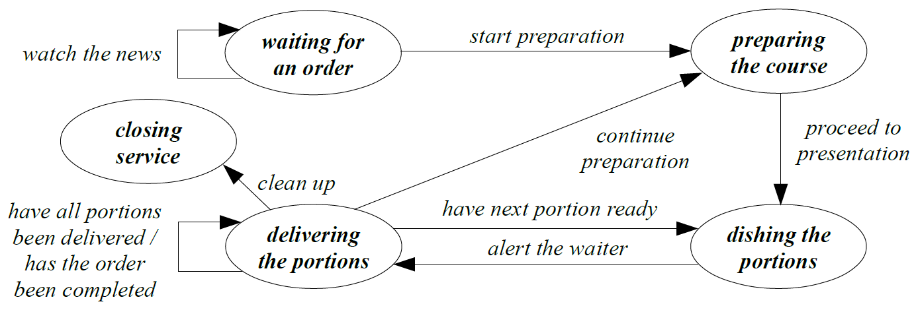Chef Life Cycle*

*Waiter Life Cycle*

***Presenting the menu***

***Taking the order***

*Get the pad*

*Return to the bar*

*Salute the client*

*Hand the note to the chef*

*Look around /*

*Say goodbye*

*Return to the bar*

***Placing the order***

***Appraising situation***

*Collect portion*

*Return to the bar*

*Prepare the bill*

*Deliver portion /*

*have all clients*

*been served /*

*collect portion*

*Return to the bar*

***Receiving payment***

***Processing the bill***

***Waiting for portion***

*Presente the bill*

*Student Life Cycle*

*Walk*

*a bit*

*Inform*

*companion*

*Read the menu*

*Enter*

***Selecting the courses***

***Taking a seat at the table***

***Going to the Restaurant***

*Prepare the order*

*Exit*

*Exit*

*Should have arrived earlier*

*Has everybody finished /*

*Signal the waiter*

*Start eating*

*End eating*

*Join the talk*

*Join the talk*

*Prepare*

*the order /*

*Has everybody chosen /*

*Cal the waiter /*

*Describe*

*the order*

*Honour the bill*

***Enjoying the meal***

***Chatting with companions***

***Organizing the order***

***Going home***

***Paying the bill***