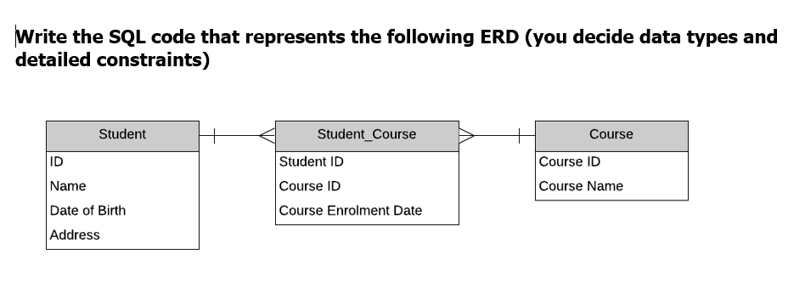

CREATE TABLE Student(

student_ID numeric(9) primary key not null

, student_name varchar(128) not null

, dateofBirth date not null

, student_address varchar(256) not null);

CREATE TABLE Course(

course_ID varchar(6) primary key not null,

course_name varchar(256) not null);

CREATE TABLE Student_Course(

student_ID numeric(9) not null

, course_ID varchar(6) not null

, course_enrolment_date date not null

PRIMARY KEY(student_ID, course_ID)

, CONSTRAINT stdId_fk FOREIGN KEY (student_ID) REFERENCES Student(student_ID)

, CONSTRAINT courseId_fk FOREIGN KEY (course_ID) REFERENCES Course(course_ID));