Index
Introduction
Importations
Data Exploration
- Duplicates
- Histograms
- Box Plots
- Correlation
Data Preprocessing
Future Steps
Conclusion
References
Appendix

Customers Segmentation in Airlines Industry: Data Mining Approach
Introduction
In today's business environment, analysing data is crucial in order to achieve success and improved outcomes, specially when dealing with a very competitive industry.
This project focuses on the company Amazing International Airlines Inc. (AIAI) seeking personalized services and marketing strategies for their customers.
The objective of this project is to group customers according to their economic contribution through a Value-Based Segmentation, analysing purchasing habits and travel behaviours through a Behavioural Segmentation, and finally, categorizing customers by age, occupation, or any other relevant attributes and patterns.
Temos de ter isto no relatório que são tb os passos da 1º entrega.
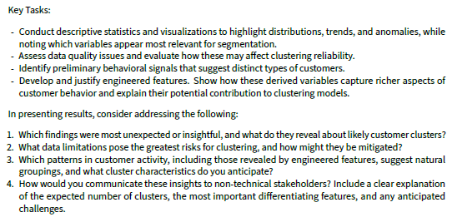
Importations

