Machine Learning Project
Deliverable 1 – Structure and Rationale

Group 31
Miguel Caramelo 20258378
Mariana Freitas 2025
Filipe Esteves 20250470
Vitória Lopes 20250435

- Introduction and Data Exploring
This projects’ objective is to build a Machine Learning Model that predicts the price of cars. To complete the objective, two datasets were given: a train dataset and a test dataset. The train dataset will be used to implement the models, the test dataset will be used to test the former.
First step was to visualize the data at hand to have a general idea of: what information we had to analyse, initial takeaways from the data, as well as what could be wrong within the data itself. Using the features head(), tail(), info() and dtypes, we were able to know what the next steps would be.
- Cleaning and Preprocessing

  - Inconsistencies and Duplicates
For an initial cleaning we proceeded with the following corrections and assumptions within the data:
- Dropped the duplicates.
- The typos were corrected from all categorical columns.
- ‘previousOwners’ column had its’ negative values substituted with 0.
- For ‘tax’, ‘mileage’, ‘mpg’ and ‘engineSize’ the incorrect values were nearly insignificant however they were considered NaN and further filled with the appropriate technique.
- ‘hasDamage’ is a dummy variable, where we considered already filled values as damaged cars, and the rest (NaNs) as non-damaged cars.

  - Visual Representations
In order to understand and analyse each variable individually, we represented them visually by building histograms, box plots and bar plots. The distribution analysis revealed significant skewness across several numerical variables. Price, mileage, tax, and mpg are right-skewed, indicating the presence of a few extreme values, while ‘year’ and ‘engineSize’ are more concentrated, reflecting the dominance of recent and mid-range vehicles in the dataset. The boxplots confirmed the existence of numerous outliers, especially in ‘price’, ‘mileage’, and ‘tax’, which were later addressed through capping. For categorical variables, ‘Brand’, ‘fuelType’, and ‘transmission’ display balanced distributions, though ‘model’ is highly dispersed, with some models appearing far more frequently than others [Figure 1 – check annex].
To obtain the correlations between all numerical variables, we also built a heatmap [Figure 2 – check annex]. The Spearman correlation shows that price is positively related to year and ‘engineSize’ and negatively related to ‘mileage’ and ‘mpg’. This means newer cars with larger engines and lower mileage tend to be more expensive. Strong negative correlation between ‘year’ and ‘mileage’ confirms that newer cars usually have fewer kilometers. Other variables, such as ‘paintQuality%’, ‘previousOwners’, and ‘hasDamage’, show negligible correlations, suggesting low predictive value.
  - Outliers
Afterwards, we conducted an outlier analysis using the Interquartile Range (IQR) method to assess the dispersion of numerical variables and identify extreme values. To preserve data quality while avoiding distortion from unrealistic entries, upper caps were applied to selected variables: ‘mileage’ (200,000), ‘engineSize’ (6), and ‘previousOwners’ (4). Observations exceeding these thresholds were removed, resulting in 82.51% of the data retained. As for ‘tax’, an upper bound was also introduced, although, the observations above it were winsorized to the maximum accepted value.
  - Missing Values
Filling in the missing values was the next step. For each variable we considered filling the data with different measures. For ‘Brand’ these values were filled considering the model of the car (as it is unique for every brand). The variable ‘mileage’ was filled by the local median of variables ‘Brand’, ‘model’ and ‘year’. The variable ‘tax’ was filled based on the ‘model’ and ‘fuelType’. The column ‘engineSize’ was filled based on ‘Brand’, ‘model’ and ‘year’. For the variables ‘transmission’, ‘fuelType’, and ‘paintQuality%’, missing values were imputed using a K-Nearest Neighbors (KNN) approach. For each variable, a tailored set of predictors was used to identify the most similar observations. This method allowed us to preserve realistic relationships between categorical and numerical features while maintaining dataset consistency.
  - Feature Engineering
We developed five new variables:
- ‘car_age’: represents how old the car is.
- ‘mileage_per_year’: represents the car’s usage per year.
- ‘is_eco’: dummy variable, represents if the car is environmentally friendly or not.
- ‘is_luxury’: dummy variable, represents if the car’s is one of the most expensive brands or not.
- ‘mileage_bin’: discretizes mileage into 5 intervals representing typical usage stages.
- ‘tax_to_engine_ratio’: checking energy efficiency.
- ‘age_squared’: to catch non-linear relationships.

- Feature Selection
Afterwards, we must select the variables to include in our predictive models. Four different methods were applied to evaluate the relevance of both numerical and categorical variables, including wrapper and embedded methods.
For numerical variables, the data were first scaled to ensure comparability across features. Between MinMaxScaler and StandardScaler, the latter was chosen as it produced more balanced and approximately normal distributions without excessively compressing the range of values [Figure 3 – check annex]. The Spearman correlation heatmap revealed that ‘paintQuality%’, ‘previousOwners’, and ‘hasDamage’ showed little to no correlation with the target, while ‘car_age’ and ‘year’, as well as ‘mileage’ and ‘mileage_per_year’, were highly correlated [Figure 4 – check annex]. To further refine the selection, Recursive Feature Elimination (RFE) with a Linear Regression estimator was applied to identify the optimal feature subset and reduce overfitting. The method selected nine features as the most relevant, achieving an R² score of 0.799, indicating that approximately 79.9% of the variation in car prices can be explained by these variables. Lastly, using the embedded method, Lasso Regression, ‘paintQuality%’, ‘hasDamage’ and ‘previousOwners’ seem less important than their remaining predictors as its’ coefficient reaches approximately zero.
For categorical variables, the Chi-Square Test of Independence at a 5% significance level was used to assess their relationship with the target variable. The results indicated that all variables showed a statistically significant association with price and was therefore considered non-essential for the final model.
- Machine Learning Models
With the Feature Selection section, we were able to keep the following variables: ‘Brand’, ‘model’, ‘transmission’, ‘fuelType’, ‘tax’, ‘mpg’, ‘engineSize’, ‘age_squared, ‘is_eco’, ‘is_luxury’, as well as ‘tax_to_engine_ratio’. Before applying the models, all numeric variables were scaled, ‘model’ was encoded using Target Encoder and all non-metric features left were also encoded but using One-Hot Encoder, as these models can only receive numeric data.
We developed three different types of regressors. The simplest ones used were, Linear Regression, Lasso Regression, Ridge Regression and ElasticNet (EN), combining penalizations from both Ridge and Lasso. By comparing the regression metrics, especially Median Absolute Error (reasonable value) and Mean Absolute Error (extremely large), we concluded that the models are highly outlier sensitive, creating a large overfit and, therefore, not appropriate for the objective in hand. Moreover, we tried adjusting the scaling method to RobustScaler, highly indicated for data with a large extreme value proportion. The metrics improved slightly yet still aren’t close to a good result.
The Random Forest Regressor (one of our best performing models) achieved an R² of 0.86 on the training set and 0.81 on the validation set, indicating moderate overfitting and limited generalization capacity. The relatively high error values (MAE ≈ 2524, RMSE ≈ 4170) suggest that the model captures some nonlinear relationships but remains unstable and sensitive to data variation.

Annex:
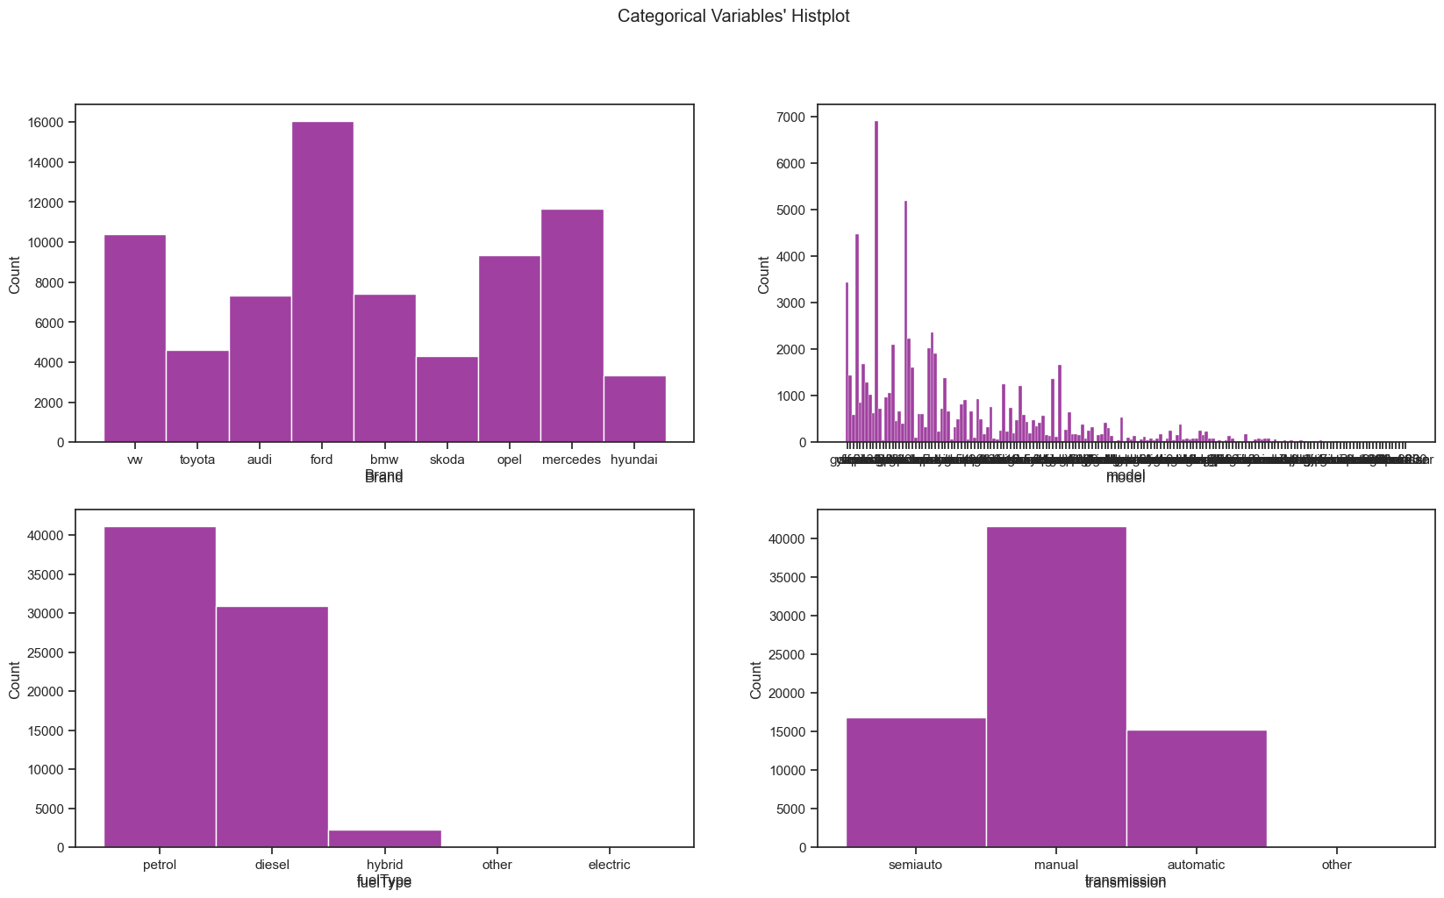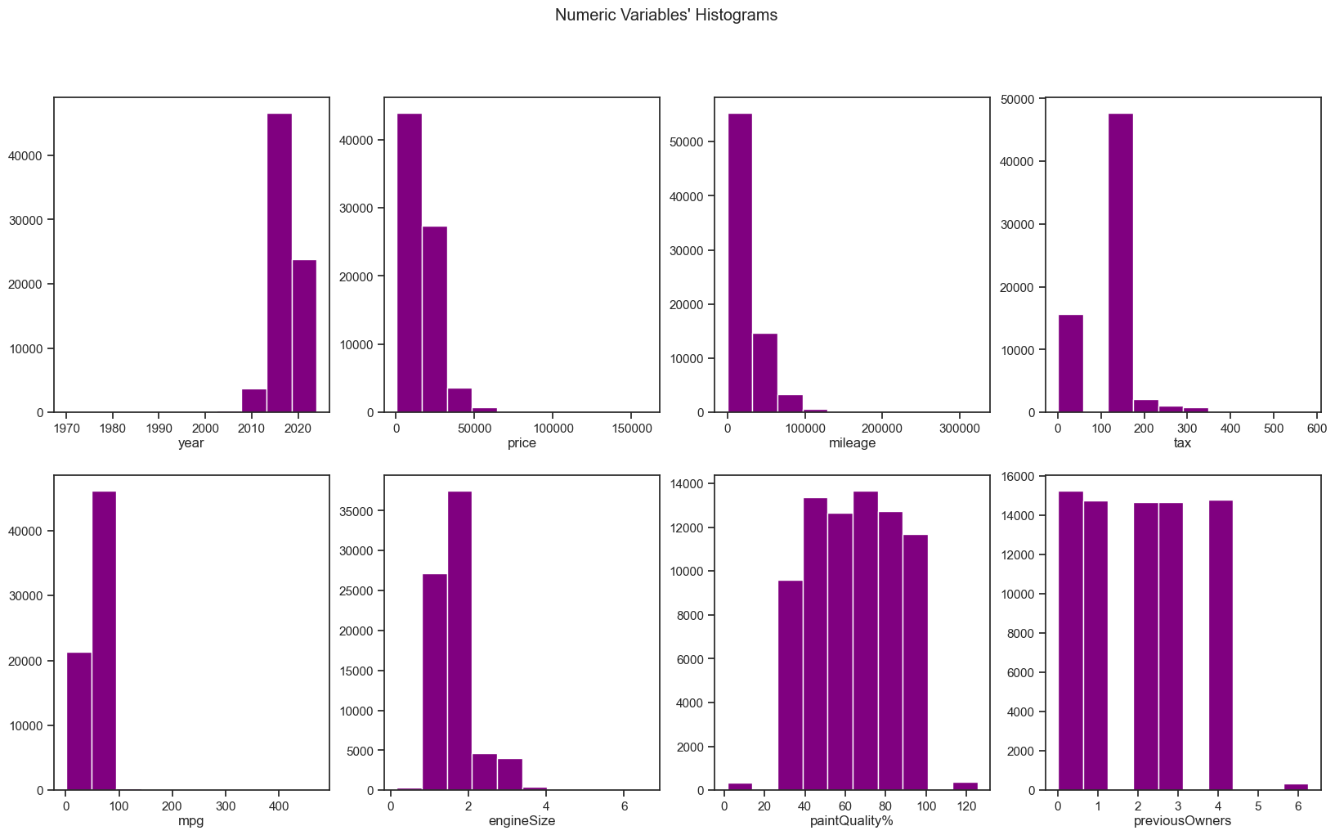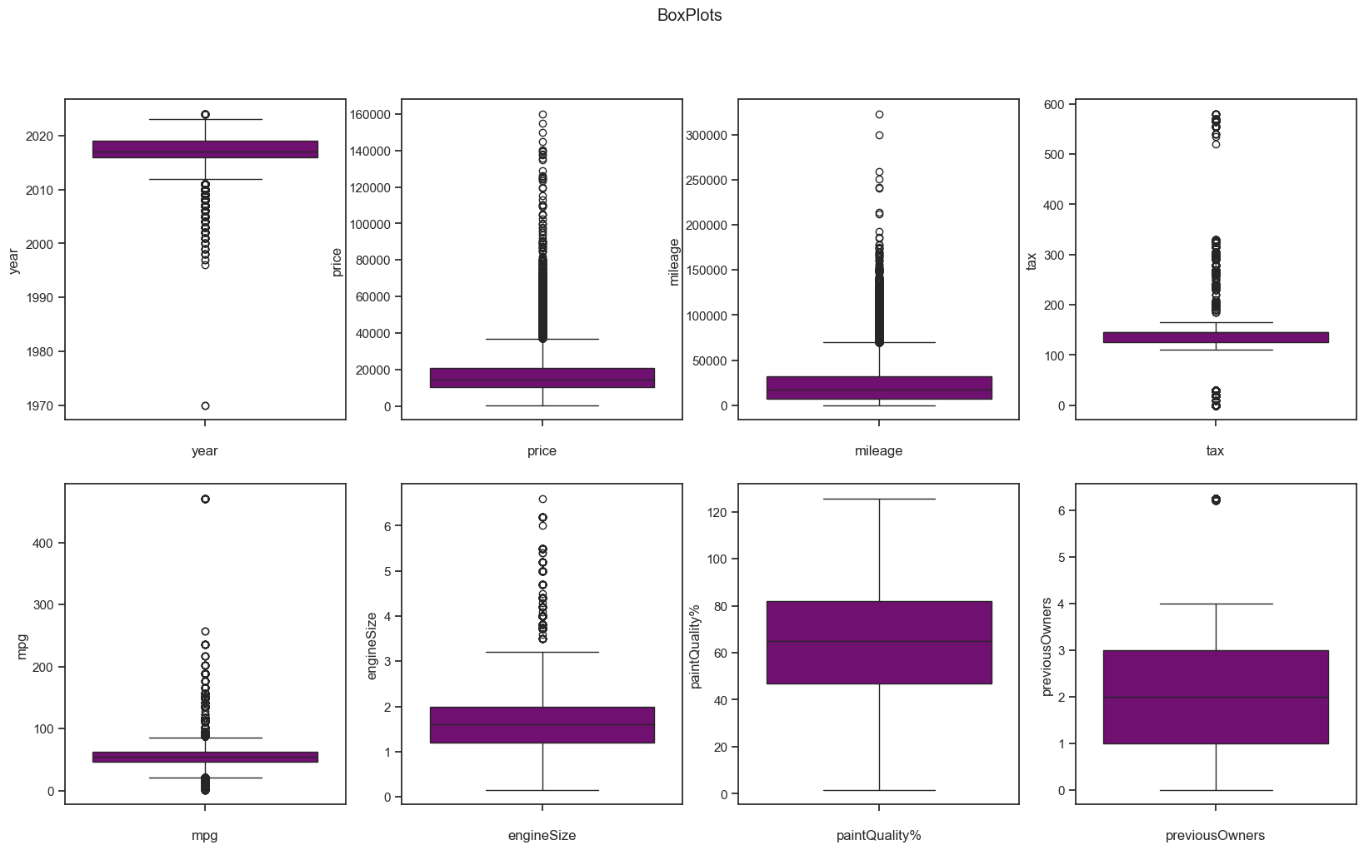
Figure 1 – Bar Plot, Histogram and Boxplot of features given.
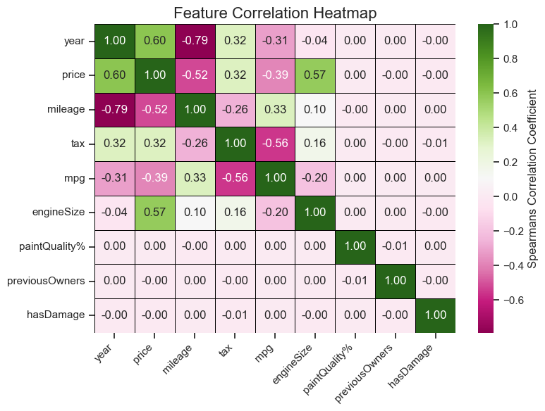
Figure 2 – Heatmap of Spearman Correlation in Numeric Features.
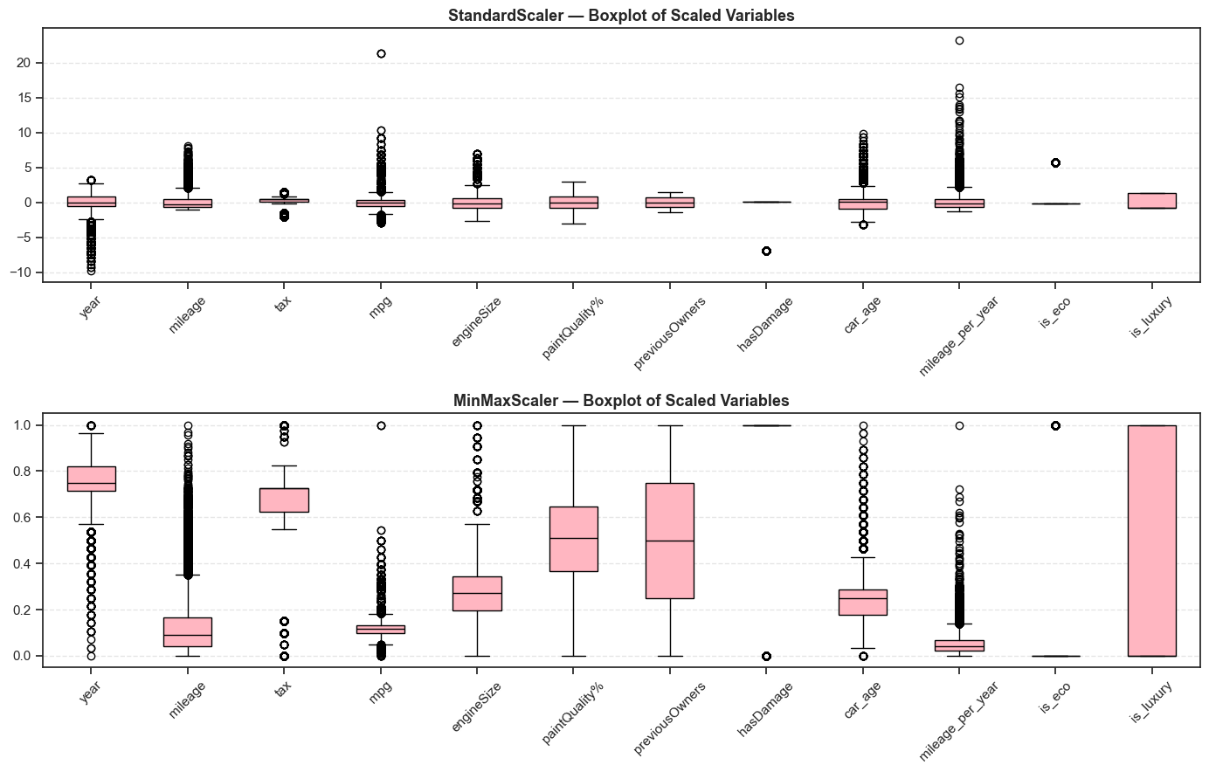
Figure 3 – Boxplot of Standard Scaled and MinMax Scaled features.
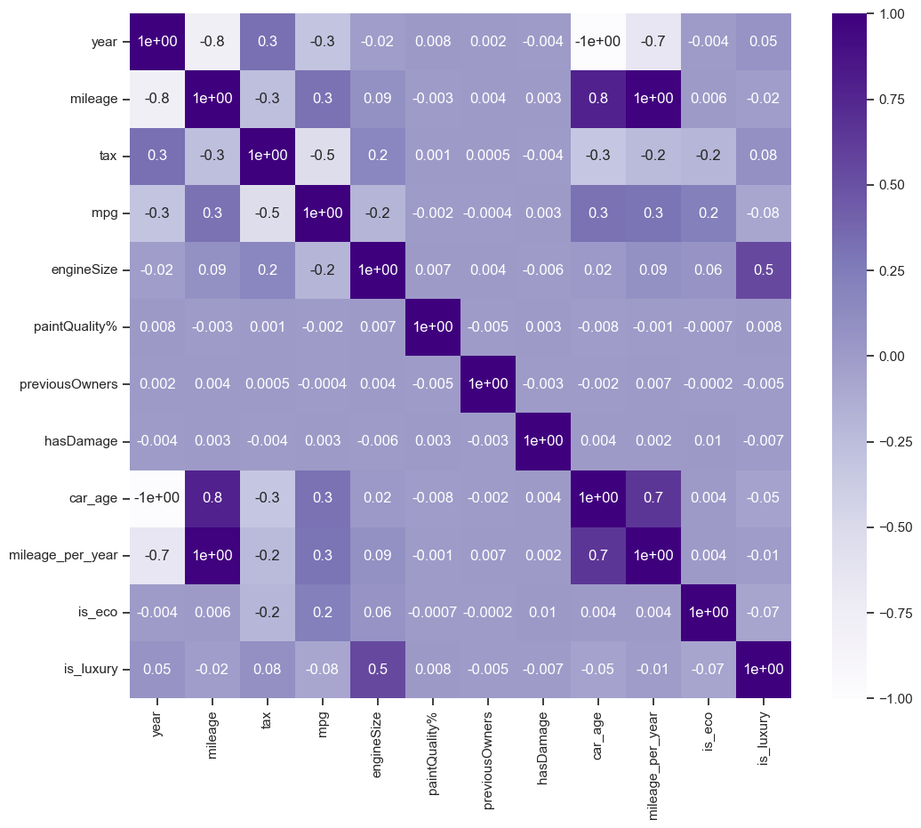
Figure 4 – Heatmap of Spearman Correlation for all features to assess significancy.
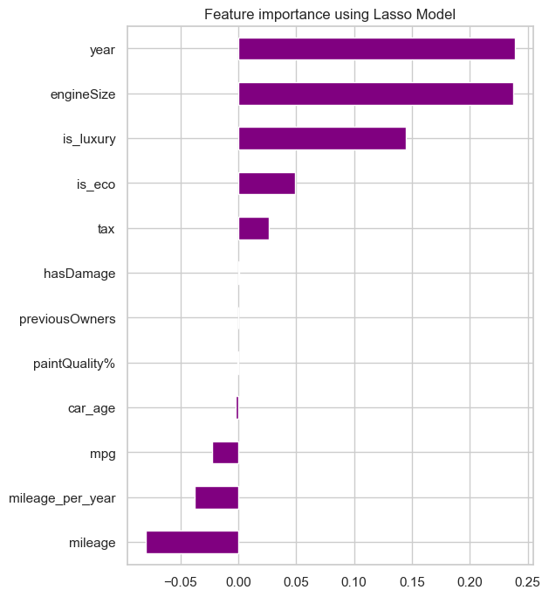
Figure 5 – Feature importance using LassoCV represented.

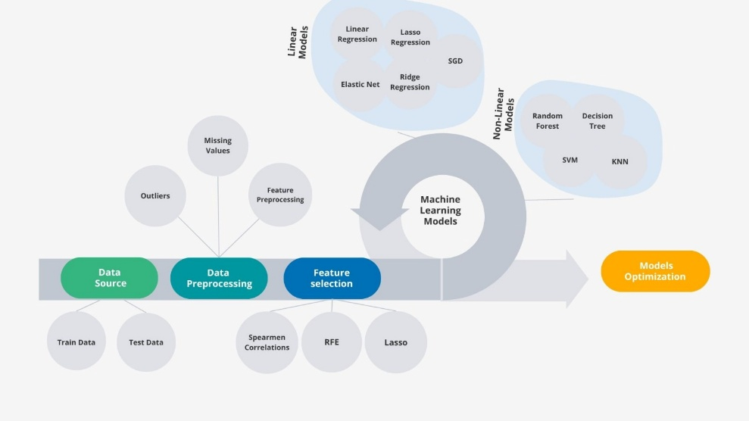
Figure 5 – Flowchart of the machine learning project.

Bibliography:
- https://scikit-learn.org

