# Exercise: Git and GitHub

Problems for exercises and homework for the ["Software Technologies" course @ SoftUni](https://softuni.bg/trainings/4326/software-technologies-september-2023).

## Register a GitHub Profile

Register for a free **developer account at GitHub**: <http://github.com>/

Add a screenshot to your profile here:

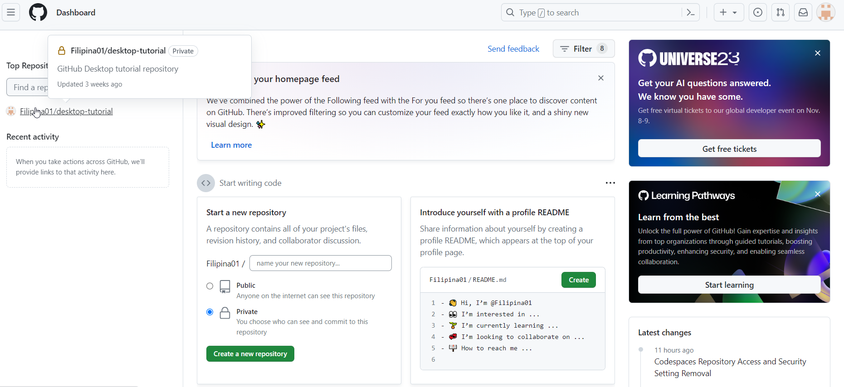

## Clone a Repo

Navigate to <https://github.com/SoftUni>. Find a repo that you like. We have books that might of interest to you. Clone a repo of your choice in your profile.

Provide a picture of the cloned repo here:

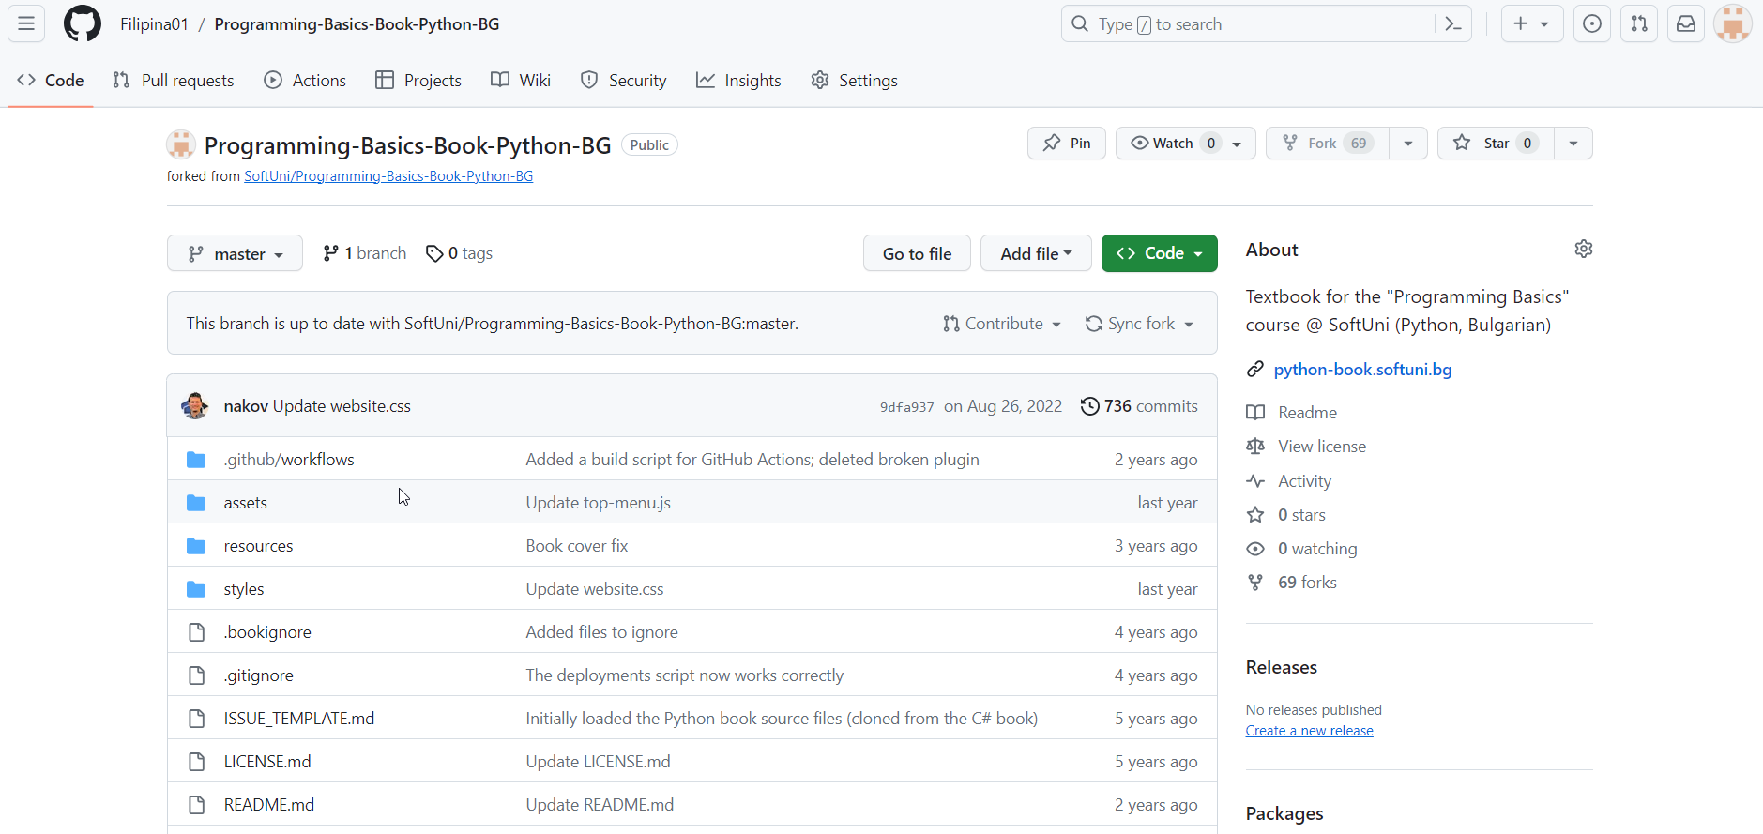

## Download a local copy of the repo to your computer

Using GitBash or GitHub Desktop, download a local copy of the repo to your computer.

Add a picture of the folder h

