Supplementary Material SM1
We documented how the computational choice of lower truncation of r₀ = 1 m impacts P₃₂ calculations. Figure S1 shows the distributions of all fracture sets without fractures with a radius smaller than 1 m and hexagons where P₂₁ was calculated. In this work, P₃₂ was derived from P₂₁ as follows equation:
$P_{32}=\frac{4}{π}P_{21}$ [1]
Given the minimum fracture length adopted in the DFN simulations, we compared the fracture intensity P₃₂ obtained from the adopted DFN parameters with the corresponding P₃₂ after excluding fractures with radii smaller than 1 m, to quantify the effect of this truncation,
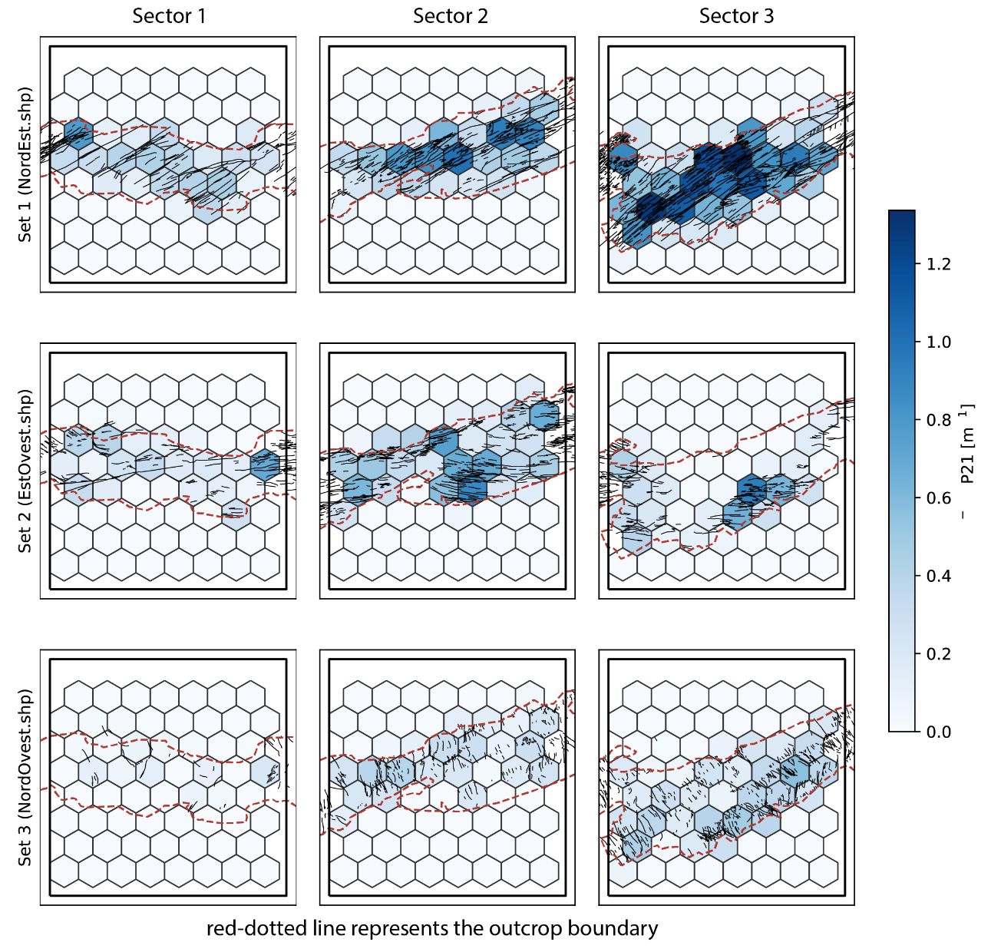
For the total fracture network, the resulting loss of P₃₂ is 0% in Sector 1, 4.5% in Sector 2, and 6.7% in Sector 3. Thus, the 1 m truncation removes less than 7% of the total fracture intensity in all sectors. However, the effect is not uniform across fracture sets, with the largest reduction in Set 3 in Sector 3, where P₃₂ decreases by about 15%. Table S1 reports the corresponding values for each sector and fracture set.

Figure S1. Spatial distribution of fracture intensity (P₂₁) for the three fracture sets across the three structural sectors. Hexagonal cells are colored by their P₂₁ value (m⁻¹). The red dashed line represents the boundary of the studied outcrop.

sector | set | P32 | P21 | P32 without <1 m | diff % without <1 m
Sector 1 | 1 | 0.33 | 0.260182 | 0.33 | 0.386
Sector 1 | 2 | 0.22 | 0.169368 | 0.22 | -1.979
Sector 1 | 3 | 0.06 | 0.049831 | 0.06 | 0
Sector 1 | tot | 0.61 |  | 0.61 | 0
Sector 2 | 1 | 0.48 | 0.366794 | 0.47 | -2.705
Sector 2 | 2 | 0.42 | 0.319131 | 0.41 | -3.255
Sector 2 | 3 | 0.21 | 0.147529 | 0.19 | -10.552
Sector 2 | tot | 1.11 |  | 1.07 | -3.604
Sector 3 | 1 | 0.74 | 0.564243 | 0.72 | -2.917
Sector 3 | 2 | 0.3 | 0.220439 | 0.28 | -6.443
Sector 3 | 3 | 0.3 | 0.198252 | 0.25 | -15.859
Sector 3 | tot | 1.34 |  | 1.25 | -6.716
Table S1. Summary of fracture percentage loss of P₃₂ for each fracture set in each sector.

We evaluated the sensitivity of effective permeability to the parameters of the aperture–size relation (Eq. 3 in the main text) using one realization per sector (Fig. S2). The coefficient γ controls the magnitude of permeability. At the same time, changes in the scaling exponent β have a greater effect on the hydraulic contribution of large fractures. In particular, since permeability scales with γ³, the tested range (γ = 5.0 × 10⁻⁶ to 5.0 × 10⁻³) spans about nine orders of magnitude (Fig. S1A), while ratios between sectors and directions remain unchanged. Increasing the exponent β from 0.3 to 1 increases permeability non-linearly, mainly between β = 0.5 and β = 1 (Fig. S2B), because in the linear model (b ∝ r) the largest fractures carry most of the flow. Notably, the anisotropy is preserved for all values of β and increases with β (K_{xx}/K_{yy} from 4.6–5.9 at β = 0.3 to 7.2–8.4 at β = 1), as more weight is given to the large fractures of sets 1 and 2. In both cases, the relative ordering of permeability among sectors and the preferential flow within the XZ plane are preserved.

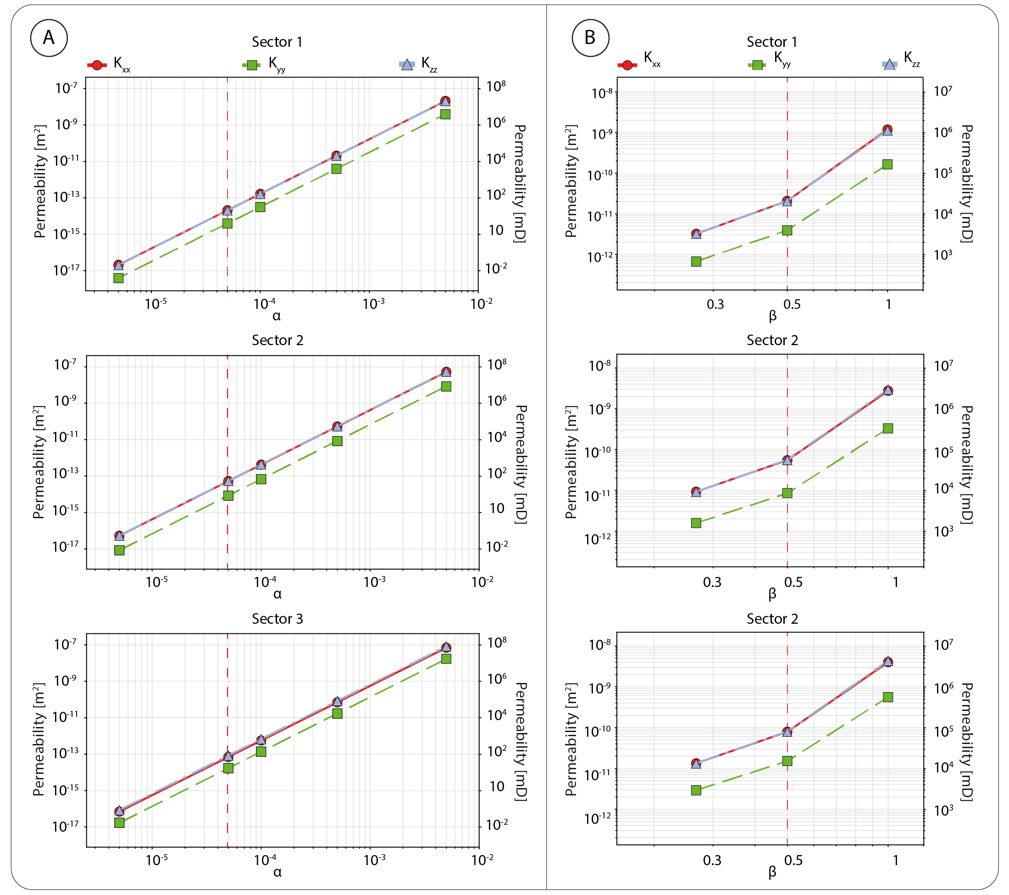
Figure S2. Sensitivity of effective permeability to the parameters of the aperture–size relation in the three sectors (one realization per sector). A) Variation of the coefficient γ at fixed β = 0.5. B) Variation of the exponent β at fixed γ. The red dotted line marks the values used in the main simulations.

