**Edge detection and segmentation of lesion in MR images**

**Introduction to images and MRI**

Images are defined as functions in either 2 or 3 dimensions, where every point in space is associated to an intensity value. In black and white images, the intensity ranges in levels of gray and is usually comprised in between [0, 255], equivalent to [black, white].

The technique of nuclear magnetic resonance imaging is mostly used for soft tissues and produces a gray image by associating to every pixel (or voxel) the average magnetic resonance characteristic value.

A very important technique used in the MR imaging field is the “image segmentation”, meant to discretize between different tissues, and group together homogenous ones, to label and characterize them. In brain images the most common categories are white matter, gray matter, and cerebrospinal fluid. This is why the intensity distribution of an adult brain MRI usually shows three main peaks. However, segmentation is widely used for the analysis of brain features, such as the identification of tumors and other abnormal bodies.

This technique is mostly used to identify “image features”, the distinctive characteristics of an object detected in the MRI. Their segmentation relies on statistical parameters of either first or second order. The first order descriptors are the intensity, mean, median, and standard deviation of the pixel values, and are useful when intensities of the object and its background differ to a large extent. The second order are computed using gray level cooccurrence matrix.

Edges are typically detected by thresholding the first and second order spatial derivatives of the intensities.

**Pre-processing**

In order to perform image segmentation on an MRI slice or volume, the main pre-processing steps entail removing the bias field, the parts of the image with non-brain tissue and image registration.

The bias field is a low-frequency artifact mainly produced by the spatial inhomogeneity of the magnetic field and causes intensity variations within homogeneous tissues. It can be removed by manual labeling or a low-pass filter.

The parts that are detected through the magnetic resonance technique but do not belong to the three main brain tissue classes, are removed before segmentation using probabilistic atlases based on prior information.

Lastly, the image registration step entails including other information or analysis to learn about the patient’s health.

**Segmentation methods**

Image segmentation methods on MRIs can be manual, intensity-based, atlas-based, surface-based, and hybrid methods.

The manual method entails the collaboration of a human operator who segments and labels the image of interest, “slice-by-slice”. It is an accurate technique, although affected by human errors and time-consuming.

Intensity-based methods refer to the segmentation via individual classification of pixels into the tissue classes, based on their intensity. Histograms of all of the voxels are fitted with a Gaussian function, so that the probability of an intensity corresponding to a tissue class can be predicted.

It can be performed by setting thresholds for the classes, which is fast but sensitive to noise and intensity inhomogeneities, or through a region growing method to extract a connected region of the image which consists of groups of pixels with similar intensities. Starting with a seed point that belongs to the object of interest and examining all neighboring pixels, the method adds them to the growing region, if their intensities are similar enough. This technique is sensitive to the initialization of the seed point.

Some classification methods can also be used as intensity-based procedures. Supervised classification trains the model with previous manually segmented images and implements automatic segmentation. The kNN classifier bases the prediction on the majority of the closest training data; the Bayesian classifier models the probabilistic relationships between the attribute set and the class variables, which are then used for estimating the class probability of the unknown variable.

Unsupervised methods classify images into clusters of pixels with similar intensities without using training images, using the available image data to cluster pixels and estimate the properties of each tissue class. The main clustering methods are either hard classification methods, like k-means, which forces each pixel to belong to just one of the three classes, or soft, such as, fuzzy c-means, and the expectation maximization method that allow pixels to belong to multiple classes.

The atlas-based methods rely on previous atlas or template of the human brain for reference in the segmentation procedure. They are similar to classifier methods but are implemented in the spatial domain rather than in the feature space.

The surface-based methods use active contours which are deformable models that use closed parametric curves to detect region boundaries, using the influence of external forces (of the image attributes) and internal forces (of the surface regularity). Multiphase active contours are an advanced technique that uses the same principal on multiple regions of an image.

Hybrid methods combine the techniques listed above and others to improve the results.

An example of a hybrid method is Otsu’s method which obtains an intensity threshold that separates pixels into two classes, by minimizing intra-class intensity variance, which we have included in our workflow, discussed below.

**Validation of MRI segmentation**

The validity of this techniques can be evaluated by comparing their results to the so-called “ground truth”, which in brain MRI analysis, is usually made by physicians who manually analyze and segment anatomical structures of interest. The Dice coefficient quantifies the overlap between the MRI segmentation and the given “ground truth”.

The future research will likely focus on developing more accurate and noise-robust methods, and on improving their computational speed.

**Code**

In our implementation, we tried applying the techniques we were provided in the papers and in class to achieve a successful segmentation of a lesion, visible in a brain MRI. The data we have is a brain MRI scan of a patient’s head, from which we extracted the sagittal slice number . In this slice, the brain lesion appears to be a circular lighter portion of the image. The function treat_slice was created in order to extract the cross-sectional area and the boundaries of the object of interest. After cropping the image around the lesion, the function performs seven steps. First, it enhances the image by multiplying the image histogram and a pseudo- function, especially designed to increase the contrast between the white portions against the darker background. The second step is filling. The matlab function imfill automatically fills the holes detected in the image, where a hole is defined as a dark area surrounded by a lighter one. Afterwards, the code includes the matlab function imbinarize, which creates a binary image from a grayscale image by using the Otsu’s method discussed above. Furthermore, the matlab function getpts allows us to choose a starting point for a seed-like algorithm that returns the coordinates of the pixels belonging to the region of interest, which in our case is the brain lesion.

Next, the function limits the dimension of the object for further computations and sets them using the parameters from the first one.

The following step (get_object_vector) saves the new vector using the matlab function bwselect which returns a binary image obtained by selecting all the pixels of value 1 connected to the selected starting point, which we defined as the hand-picked pixel of getpts. Moreover, the step includes saving the linear indices of the non-zero elements of the resulting image. Finally, the 2-D image segmentation on the chosen slice is obtained, the lesion’s area is computed, and its important dimensional parameters are saved (mean, standard deviation, and boundaries, both on the x and z-axis)

To compute the volume of the lesion from the sagittal perspective, we chose to start from the 135th slice and move in the two directions of the y-axis, so through adjacent slices, from there. In order to identify the slices containing the lesion, we analyzed with treat_slice the coronal view corresponding to the parameter obtained from the 135th slice and assumed that the lesion’s dimension is at its maximum, since it’s close to a geoid-like shape, limiting the y boundaries on the sagittal . We apply the treat_slice function on every sagittal slice until we have travelled 3 times the standard deviation obtained in the coronal slice.

However, in this looped procedure, no manual clicking is expected, since the starting point for getpts is set at the weighted average of the center of gravity of previous slices By summing all the automatically computed areas, we obtain an estimation of the volume equal to 17.8

Our attempt to apply the same implementation on the axial view, was able to produce a realistic result, although with evident errors in exactly three slices, where the imfill function detects a much larger area than the real one The final volume estimation is 29.35 .

The main challenge associated to the segmentation of this brain lesion is due to the tissue density of the vascular structures close to the mass. These cause estimation errors when they appear to be very close and merge with the object of interest. The perspective chosen to apply the estimation, however, does not influence the results as much.

|  |  |
| --- | --- |
| Volume estimate [cm^3] | Voxels # |
| 17.8 (sagittal) | 14427 |
|  |  |
| Volume estimate [cm^3] | **Voxels #** |
| 29.35 (axial) | 23860 |

In our case the results appear to be very different, but it is important to note that the implementation works almost seamlessly except for three slices that cause the difference in the estimations

Lastly, if noise is added, the code’s performance, as expected, worsens its results, but still returns a value not that far off from the sagittal estimation.

The volume appears to be similar in dimensions but with a much bumpier surface.

However, the addition of a gaussian noise with a variance of 0.1 does not reach a definite value.

Another problem related to automated image segmentation is the inter-operator and intra-operator variability, meaning that two functions or two implementations of the same function can obtain different results. In order to limit this problem, our workflow’s degrees of freedom were only related to the cropping of the image and the choice of the initial slice, which is performed after the volume exploration.

|  |  |  |  |  |  |
| --- | --- | --- | --- | --- | --- |
| Noise Type | μ | σ^2 | Volume estimate [cm^3] | | Voxels # |
| Gaussian | 0 | 0.001 | | 17.9562 | 14593 |
| Gaussian | 0 | 0.01 | | 17.999 | 14622 |
| Gaussian | 0 | 0.1 | | / | / |

|  |  |  |  |
| --- | --- | --- | --- |
| Noise Type | Density | Volume estimate  [cm^3] | Voxels # |
| S&P | 0.01 | 17.7077 | 14391 |
| S&P | 0.1 | 17.1638 | 13949 |
| S&P | 0.2 | 16.4944 | 13405 |

(2)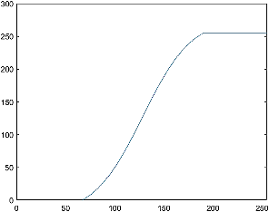

(4)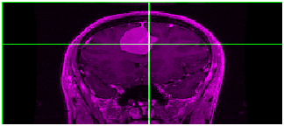

(6)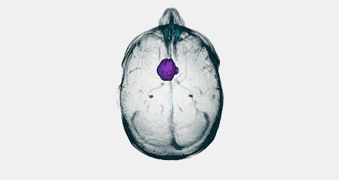

(7)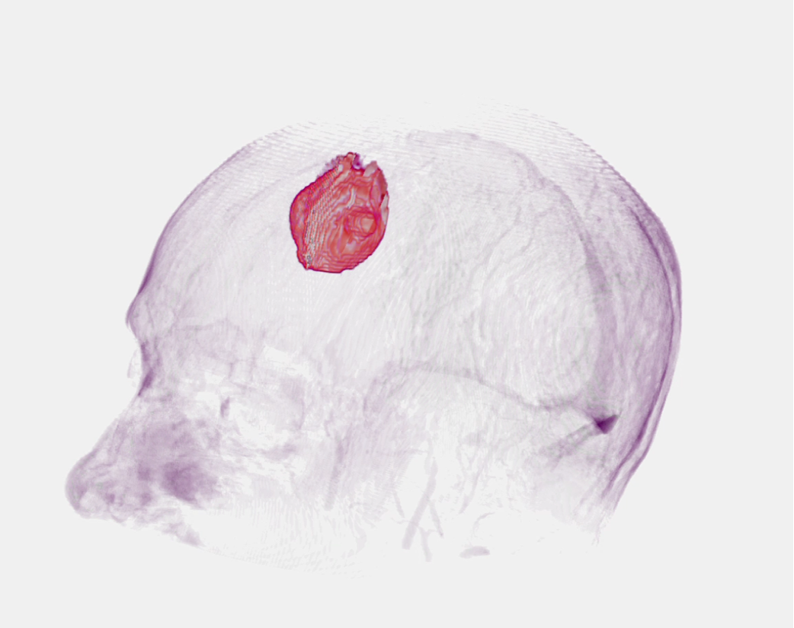

(8)