Isoni Filippo APPELLO 08/07/2026
1 The majority classifier predicts class 1, psoriasis, with accuracy of 31%, to compare with the other methods’ predictions on test set I should see what the majority classifier predicts on the test set, but I have verified that by splitting with createDataPartition the accuracy on the whole dataset and on the test set is the same.
2 I have chosen with cross validation the knn model with k=20, it gets an accuracy of approximately 88%, and a kappa statistics of 0.84. I notice that the sensitivity is low for classes 4 and 6 and lower than the others for class 2.
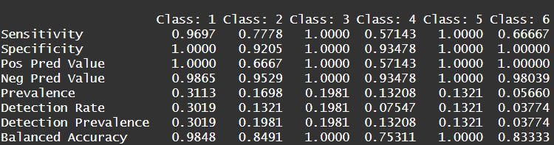
3 I selected the built the tree with complexity parameter equal to 0.015 that has 5 splits, since it was the one with the lowest xerror and xstd.
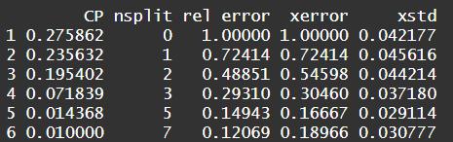
It gets 89% accuracy on test set, with kappa equal to 0.86, but the specificity for classes 4 and 6 is even lower than for the knn
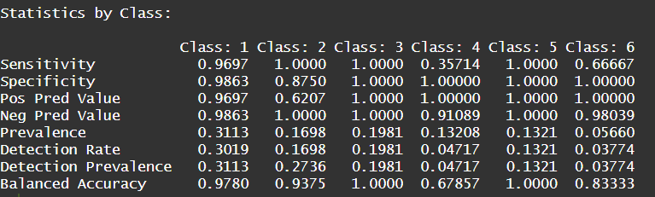
If we look at the tree we see that in the first split the variable clubbing_rete_ridges separates almost perfectly the class 1 from the others in the training data (on the left node there are all trn data with class = 1) with the threshold >= 0.5, then in the second split vacuolisation_damage_basal_layer with a threshold >= 0.5 separates perfectly class 3 from the others (on left child node there are all trn data with class equal to 3) in the 3rd split fibrosis_papillary_dermis with a threshold <0.5 separates the class 5 from the others in trn data almost perfectly, it is at the right child node.
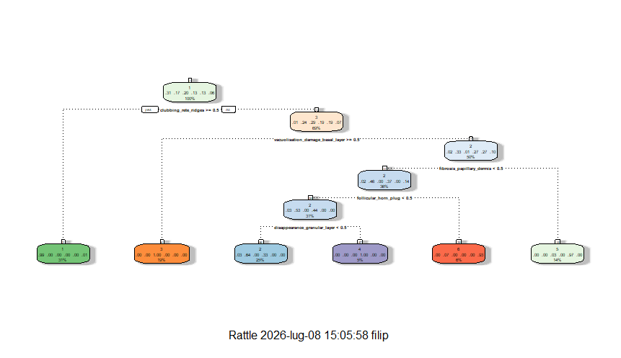
4 Nb model with kernels (got an higher CV accuracy and kappa) selected by cross validation got a tst accuracy of 86% with a kappa of 0.83, the worst of the 3 models. Also it gets high specificity for class 6, but fails to predict almost all of the positive cases for class 4.
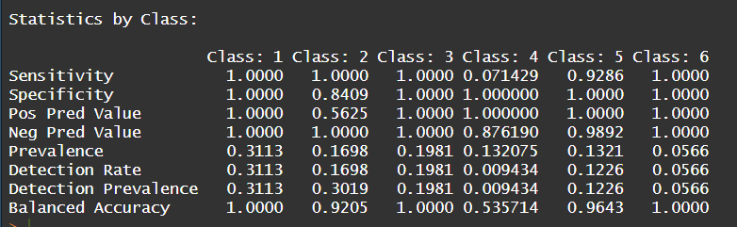
I look at the plots of the densities for the variables corresponding to the first 3 splits of the tree.

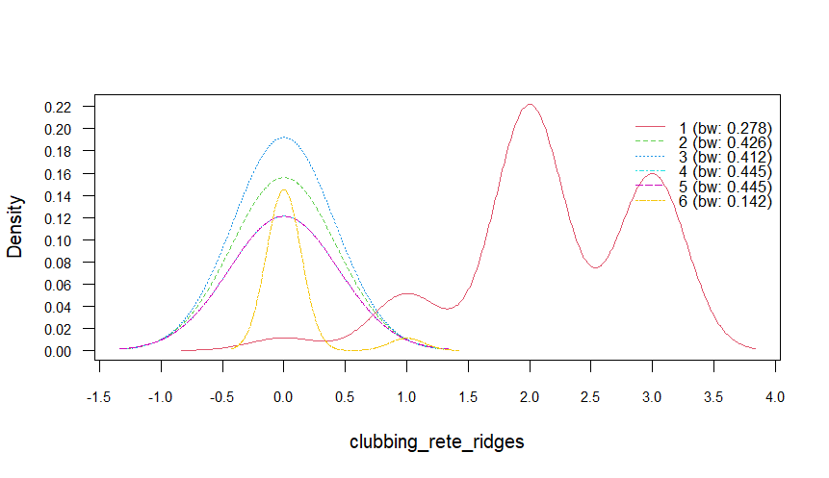
The only estimated density not overlayed is the one relative to class 1, this confirms that this variable is useful to ditinguish class 1from others, otherwise it predicts class 3 as in the tree because here the density relative to class 3 is the highest among the other densities for low values of the variable.
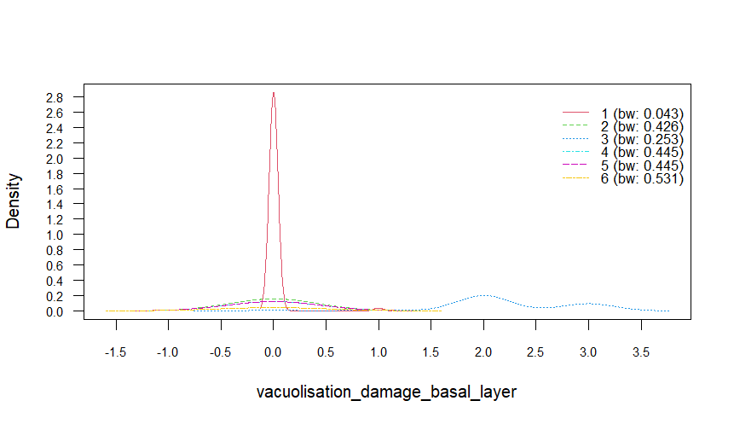
Here I can see that the density detached from the other is the one relative to class 3, so also this plot confirms that this variable separates class 3 from the others. Otherwise it predicts class 1 or two depending if the value of the variable is near 0 or near plus/minus 0.5. Considering that the tree splitted all the observations of class 1 in the 1st split at the left child node I can consider also this behaviour similar to the one of the tree.
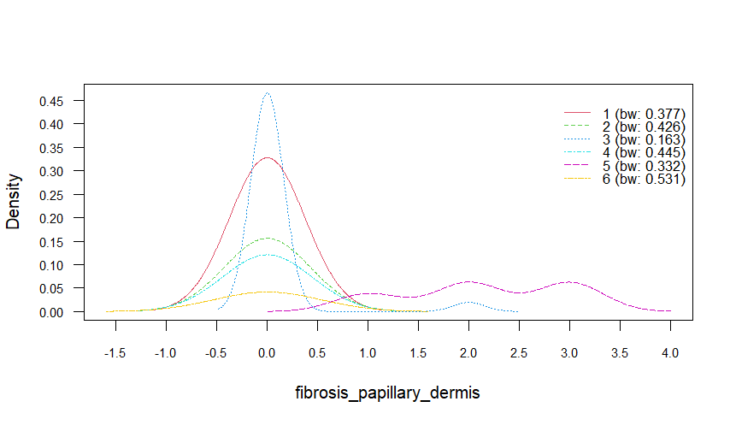
In the last plot we see that this variable is able to distinguish class 5 from the others because the detached density is the one relative to class 5, with peaks that cluster at high values of the variable. Otherwise for lower values of the variable it will predict class 3 or 1, or 2 not considering classes 3 or 1, which reflects the behaviour of the tree since at the 3rd split I hadn’t any observation of classes 1 or 3 at the node.

5 LDA got a test accuracy of approximately 86%, with a kappa of 0.82, the worst method until now, but since they are not large diffrences I can consider this as noise. As for the other methods it struggles in finding the positive cases for classes 4 and 6, the sensitivity and specificity for class 2 are still high, but nota s much as for the other classes.
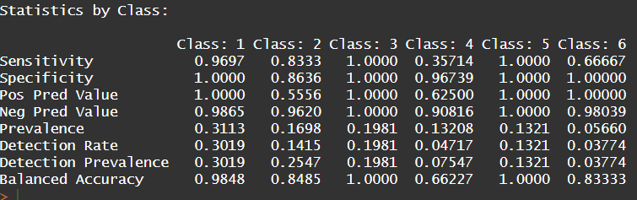
Looking at the proportion of distinction explained by the first 3 discriminant directions I see that
Together they explain approximately 0.91 of the total distinction, so I can discard the last 2 discriminant directions since above of 90% of the distinction is explained by the first 3 discriminant directions.
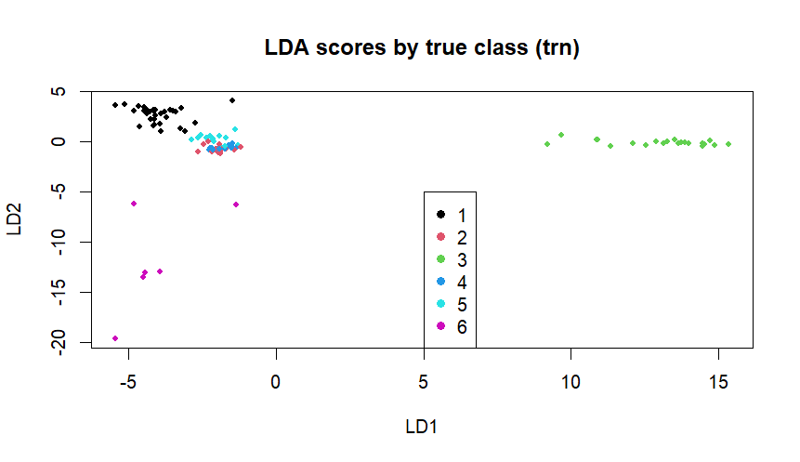
Here I can see that classes 1 3 and 6 pretty well separated, while classes 5, 4 and 2 overlap strongly
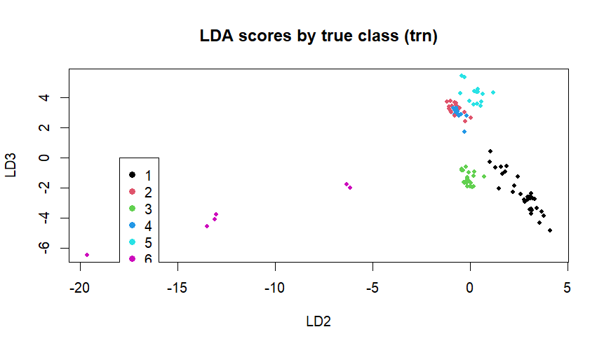
Notice that on both the plot the true class is considered on tst , non on trn as it is written.
Here I can see that classes 4 and 2 overlap strongly while the other classes are pretty well separated. I can also notice on the two plot that class 6 do not form a round cluster but it is elongated on directions not corresponding to the discriminant axes, maybe the covariance of class 6 is not similar to the one of the other classes and this is the reason why the LDA still struggles to find positive cases for class 6. The overlapping of classes 2 and 4 on both the planes explaines why class 4 is hard to distinguish from class 2, so I suppose that what happens within each method is that some of the positive cases of class 4 are classified as class 2 and this is the reason why the specificity for class 2 of the tree, the nb model and the LDA model is lower than the other specificities. It is still high since the only negative cases I struggle to find are the ones belonging to class 4.
At first I consider vacuolisation_damage_basal layer, we see that the coefficient is near to 0 for LD2 and near to 1.2 for LD1, I notice that for values near 0 of LD2 of the 1st plot I have some classes, but I have only class 3 for positive values of LD1 and LD2 near 0, looking at the 2nd plot instead I see that I have class 3 for values close to 0 of LD2 and between 0 and -1 for LD3, this is reflected by the coefficients, so this variable is confirmed to be able to distinguish class 3
Considering clubbing_rete_ridges on the LD3 vs LD2 plot I see that class 1 cluster for negative values of LD3 and for slightly positive values of LD2, which is reflected by the coefficients, also for the first plot the class one clusters for slightly positive values of LD2 and slightly negative (less than for LD3 before) values of LD1, so also in this case the coefficients show that this variable is able to distinguish class 1
Considering fibrosis_papillary_dermis I see that on the plot the class 5 cluster at low negative values of LD1 and values of LD2 near 0, the LD1 coefficient do not reflect this exactly since it is positive, but the situation changes on the 2nd plot were class 5 clusters at near 0 values for LD2 and positive values for LD3 which is reflected by the coefficients, so also in this case I can say that this variable is able to distinguish class 5.

