Filiz GÖZET

151805045

FUZZY LOGIC PROJECT

Making pERFECT MEDIUM BOILED EGGS

Fuzzy Logic For Making Perfect

Medium Boiled Eggs

***Abstract:*** In the real world many times we encounter a situation when we can’t determine whether the state is true or false. At this point fuzzy logic comes to play. Fuzzy Logic (FL) is a method of reasoning that resembles human reasoning. The approach of FL imitates the way of decision making in humans that involves all intermediate possibilities between digital values YES and NO. So it provides a very valuable flexibility for reasoning. The proposed system is an attempt to apply fuzzy logic techniques to find the best medium boiled egg, based on the size of the egg and cooking time. The system takes these parameters as inputs, fuzzified by using knowledge base rules and finally provides a single output. All the parameters are controlled and calibrated by the fuzzy logic toolbox and Matlab programming. Also used SciKit which is a fuzzy logic toolbox in python.

**1.Introduction**

People have eaten eggs for thousand of years. Eggs contains several vitamins and minerals that are essentail parts of a healtful diet. Besides having high protein and mineral, it is inexpensive and this makes it indispensable for breakfast. People have different ways to cook their eggs. Boiling, frying, steaming etc. But one of them is one of the most troublesome method. It is boiling. There are two conditions to boil a good egg. First your eggs should be fresh and second you need to boil the egg according to how you want to eat it. This is a big problem and I believe that the egg discussions my family have at breakfast are taking place in other families as well because it is quite hard to adjust the medium boiled egg setting. Your egg may be overcooked or undercooked when you want to make medium boiled-eggs. To avoid all these problems, I tried to find the best middle-boiled egg using fuzzy logic, depending on the given egg size and cooking time.

**2.Methodology and Development of Fuzzy Inference Systems**

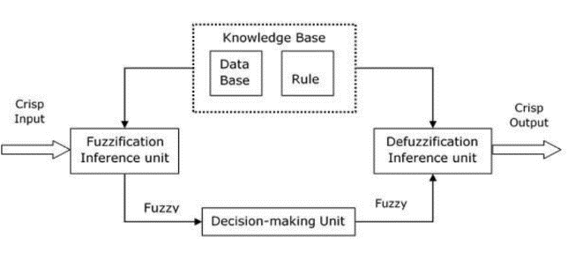**Rule Base** - It contains fuzzy IF-THEN rules.

**Database** - It defines the membership functions of fuzzy sets used in fuzzy rules.

**Decision-making Unit** - It performs operation on rules.

**Fuzzification Interface Unit** - It converts the crisp quantities into fuzzy quantities.

**Defuzzification Interface Unit** - It converts the fuzzy quantities into crisp quantities. Following is a block diagram of fuzzy interference system.

**Steps for Computing the Output**

Following steps need to be followed to compute the output from this FIS −

**Step 1** - Set of fuzzy rules need to be determined in this step.

**Step 2** - In this step, by using input membership function, the input would be made fuzzy.

**Step 3** - Now establish the rule strength by combining the fuzzified inputs according to fuzzy rules.

**Step 4** - In this step, determine the consequent of rule by combining the rule strength and the output membership function.

**Step 5** - For getting output distribution combine all the consequents.

**Step 6** - Finally, a defuzzified output distribution is obtained.

**3.Data Collection and Rule Creation**

After determining our inputs and outputs, we need to collect data to create membership functions and rules. For this study, I cooked 23 eggs with different weights and cooking times.

* First I measured all eggs with mini kitchen scale one by one.
* Then, I tried to give cooking times which I could see three different states(soft boiled, medium boiled, hard boiled) of eggs with the same or similar weight.
* Finally I took photos of the eggs and takes notes about their weights and cooking times. I wanted to calculate only these two values, so I kept the amount of water and the amount of fire at the same level for each egg.

yiyecek, tablo, yumurta, tabak içeren bir resim

Açıklama otomatik olarak oluşturulduyiyecek, yumurta, tablo, bardak içeren bir resim

Açıklama otomatik olarak oluşturuldu

yiyecek, yumurta, iç mekan, çanak içeren bir resim

Açıklama otomatik olarak oluşturulduyiyecek, tabak, yumurta, tablo içeren bir resim

Açıklama otomatik olarak oluşturulduyiyecek, tablo, bardak, iç mekan içeren bir resim

Açıklama otomatik olarak oluşturuldu

50 g - 15 min

48 g - 13 min

50 g – 11.7 min min

49 g - 8:53 min min

50 g - 9:55 min

yiyecek, tablo, yumurta, oturma içeren bir resim

Açıklama otomatik olarak oluşturulduyiyecek, tablo, iç mekan, yumurta içeren bir resim

Açıklama otomatik olarak oluşturulduyiyecek, tablo, tabak, yumurta içeren bir resim

Açıklama otomatik olarak oluşturulduyiyecek, tablo, tabak, çanak içeren bir resim

Açıklama otomatik olarak oluşturulduyiyecek, çanak, tablo, iç mekan içeren bir resim

Açıklama otomatik olarak oluşturulduyiyecek, donut, tablo, bardak içeren bir resim

Açıklama otomatik olarak oluşturulduyiyecek, yumurta, tablo, çanak içeren bir resim

Açıklama otomatik olarak oluşturulduyiyecek, tablo, iç mekan, yumurta içeren bir resim

Açıklama otomatik olarak oluşturuldutablo, yiyecek, yumurta, tabak içeren bir resim

Açıklama otomatik olarak oluşturuldutablo, yiyecek, yumurta, tabak içeren bir resim

Açıklama otomatik olarak oluşturulduyiyecek, tablo, tabak, iç mekan içeren bir resim

Açıklama otomatik olarak oluşturulduyiyecek, tablo, tabak, çanak içeren bir resim

Açıklama otomatik olarak oluşturulduyiyecek, tablo, muz, oturma içeren bir resim

Açıklama otomatik olarak oluşturuldu tablo, yiyecek, tabak, oturma içeren bir resim

Açıklama otomatik olarak oluşturulduyiyecek, tabak, iç mekan, muz içeren bir resim

Açıklama otomatik olarak oluşturulduyiyecek, tablo, yumurta, tabak içeren bir resim

Açıklama otomatik olarak oluşturulduyiyecek, tablo, yumurta, tabak içeren bir resim

Açıklama otomatik olarak oluşturuldu

55 g - 12.5 min min

58 g - 11.9 min min

55 g - 13:30 min min

59 g - 15 min min

60 g - 11.8 min min

48 g - 12.1 min min

48 g - 14 min min

49 g - 13.8 min min

50 g - 11.6 min min

53 g - 14 min min

61 g - 11.8 min min

61 g - 13 min

41 g - 11.8 min min

60 g - 10 min min

54 g - 17 min min

49 g - 14:30 min min

53 g - 11.7 min min

After the the membership function for input variable i.e. EggSize, BoilingTime and for output i.e. EggType has been added to it. Nine IF AND THEN rules between input and output membership function has been defined and added these rule list to EggType fuzzy inference system.

**Rules are:**

IF (eggsize is small) AND (boilingtime is low) THEN (eggtype is softboiled)

IF (eggsize is small) AND (boilingtime is medium) THEN (eggtype is mediumboiled)

IF (eggsize is small) AND (boilingtime is high) THEN (eggtype is hardboiled)

IF (eggsize is medium) AND (boilingtime is low) THEN (eggtype is softboiled)

IF (eggsize is medium) AND (boilingtime is medium) THEN (eggtype is mediumboiled)

IF (eggsize is medium) AND (boilingtime is high) THEN (eggtype is hardboiled)

IF (eggsize is big) AND (boilingtime is low) THEN (eggtype is softboiled)

IF (eggsize is big) AND (boilingtime is medium) THEN (eggtype is mediumboiled)

IF (eggsize is big) AND (boilingtime is high) THEN (eggtype is hardboiled)

MATLAB has lots of tools. One of them is Fuzzy Logic Toolbox. The toolbox supplies a fuzzy inference engine with inputs that execute fuzzy system as a stand-alone application or can be embedded in an external application.

**Working of FIS**

The working of the FIS consists of the following steps:

1. A fuzzification unit supports the application of numerous fuzzification methods, and converts the crisp input into fuzzy input.
2. A knowledge base - collection of rule base and database is formed upon the conversion of crisp input into fuzzy input.
3. The defuzzification unit fuzzy input is finally converted into crisp output.

***Table 1 :*** *Input parameters for egg boiling system*

|  |  |  |
| --- | --- | --- |
| Parameters | Desirable Ranges | Acceptable Ranges |
| Egg Size | 49.4 - 56.77 g | 41 - 62 g |
| Boiling Time | 10 - 14 min | 8 - 20 min |

***Table 2 :*** *The ranges of**input membership functions*

|  |  |  |  |
| --- | --- | --- | --- |
| Parameters | Small/Low | Medium/Medium | Big/High |
| Egg Size | 41 - 50.45 g | 49.4 - 56.77 g | 55.7 - 62 g |
| Boiling Time | 8 – 12.17 min | 10 - 14 min | 13.7 - 20 min |

***Table 3 :*** *The output effect on egg*

|  |  |  |  |
| --- | --- | --- | --- |
| Parameters | Soft Boiled | Medium Boiled | Hard Boiled |
|  | 0<x<50 | 45<x<55 | 50<x<100 |

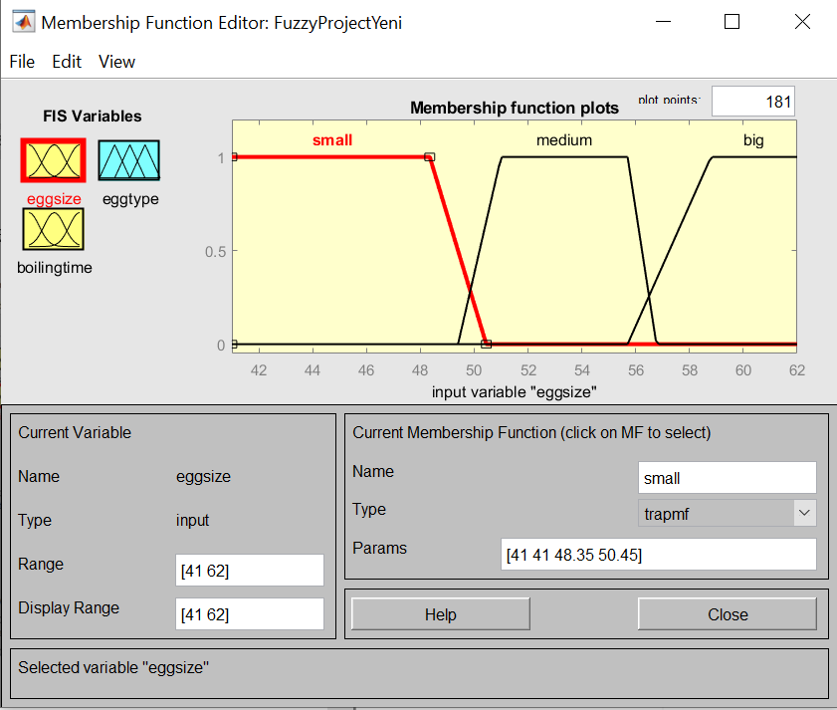**Input Variables**

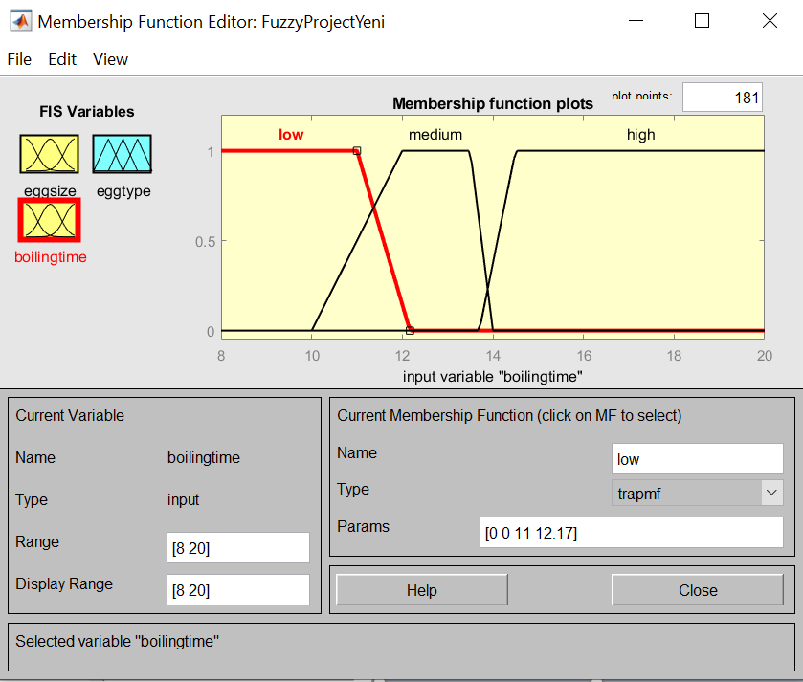

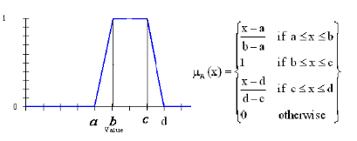

I prefer to use trapezodial shape as a membership function for both inputs and output. Because these shapes are simple and more flexible.

**Output Variable Surface View**

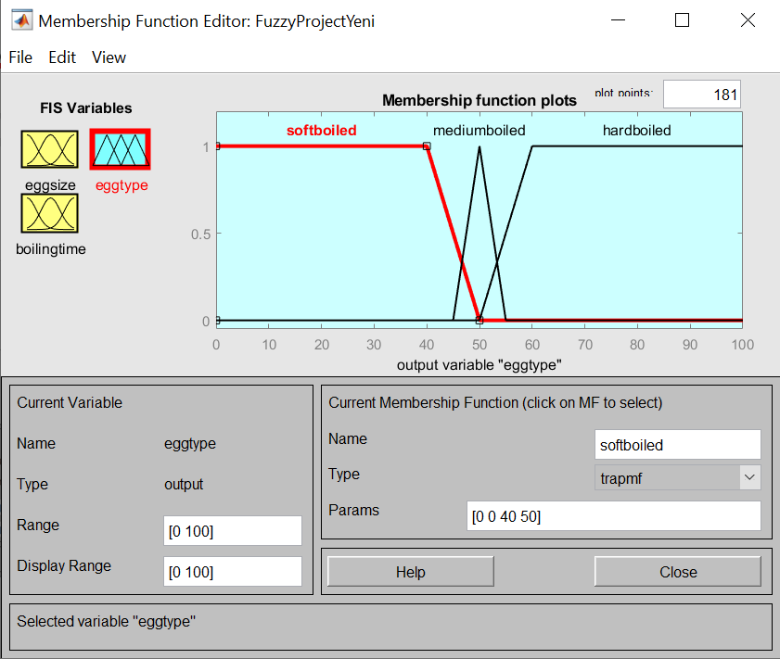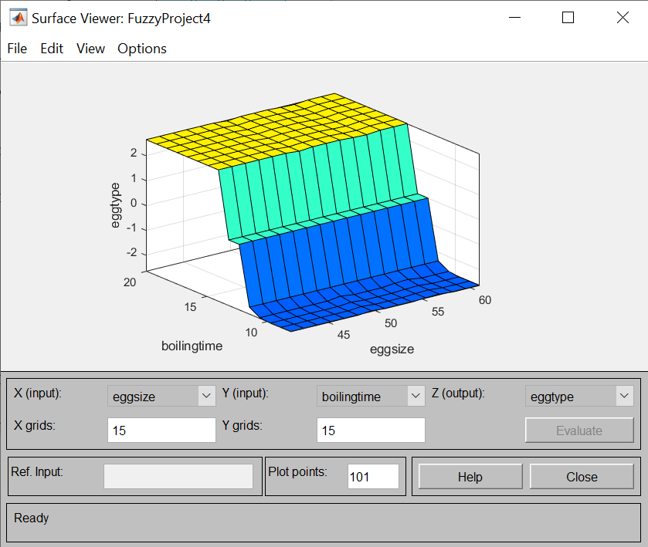

**4.Results in Simulink**

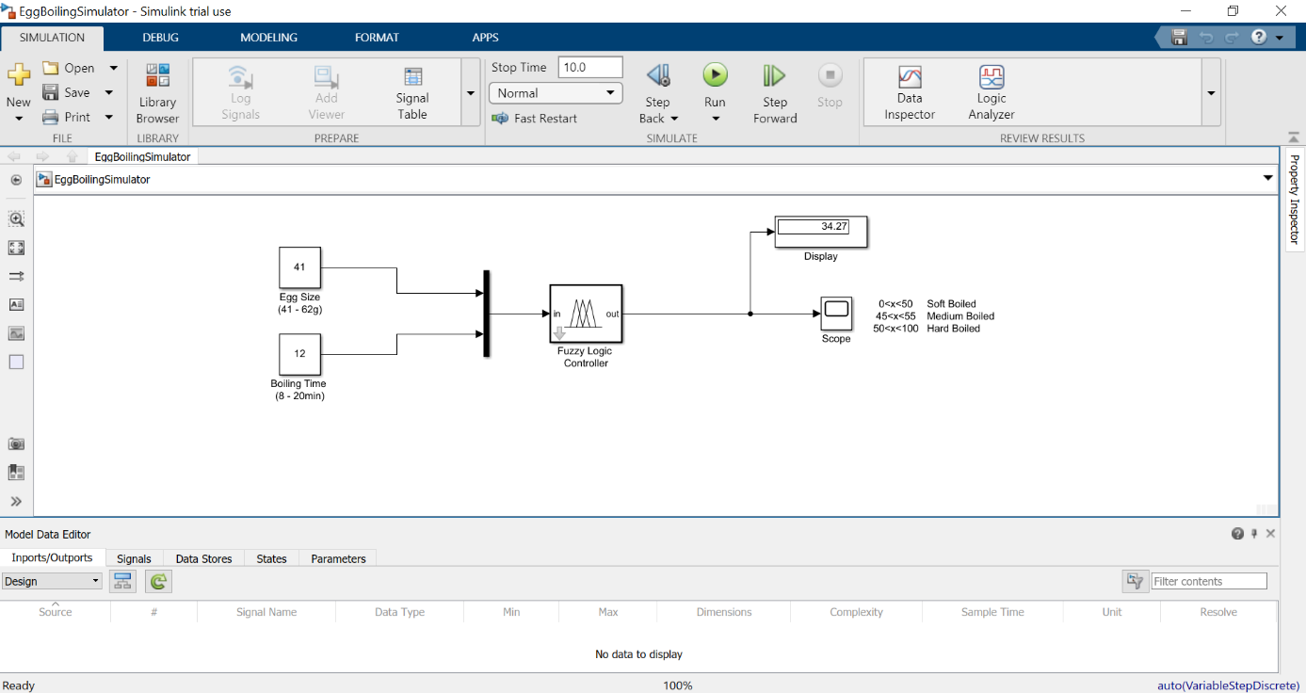For simulation, I used SimuLink. By connecting the Fuzzy Logic Controller to my own fuzzy logic .fis project, I took the inputs and printed the appropriate output on the screen. Thus, I visualized my work.

**5.Fuzzy Logic in Python**

This SciKit is a fuzzy logic toolbox for SciPy. Scikit-Fuzzy is a collection of fuzzy logic algorithms intended for use in the SciPy Stack, written in the Python computing language.

Taking the egg boiling example full circle, if we were to create a controller which estimates the type of egg, we might structure it as such:

**Antecedants(Inputs)**

**- egg size**

* Universe (ie, crisp value range): What is the size of egg ?

* Fuzzy set (ie, fuzzy value range): small, medium, big

**- boilingtime**

* Universe: What is the boiling time ?

* Fuzzy set: low, medium, high

**Consequents(Outputs)**

**- egg type**

* Universe: How the egg type will be ?

* Fuzzy set: softboiled, mediumboiled, hardboiled

• Rules

* IF (eggsize is small) AND (boilingtime is low) THEN (eggtype is softboiled)
* IF (eggsize is small) AND (boilingtime is medium) THEN (eggtype is mediumboiled)
* IF (eggsize is small) AND (boilingtime is high) THEN (eggtype is hardboiled)
* IF (eggsize is medium) AND (boilingtime is low) THEN (eggtype is softboiled)
* IF (eggsize is medium) AND (boilingtime is medium) THEN (eggtype is mediumboiled)
* IF (eggsize is medium) AND (boilingtime is high) THEN (eggtype is hardboiled) ….

• Usage

– If I tell this controller that I rated:

* the egg size as 41, and

* the boiling time as 11.8,

– the egg type will be:

* softboiled, mediumboiled, hardboiled

**Python Codes**

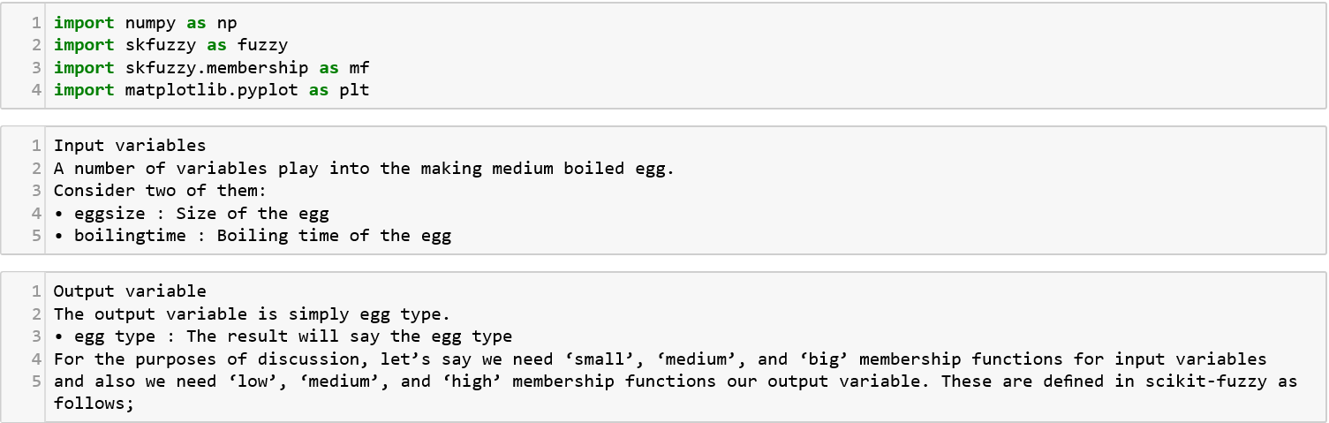

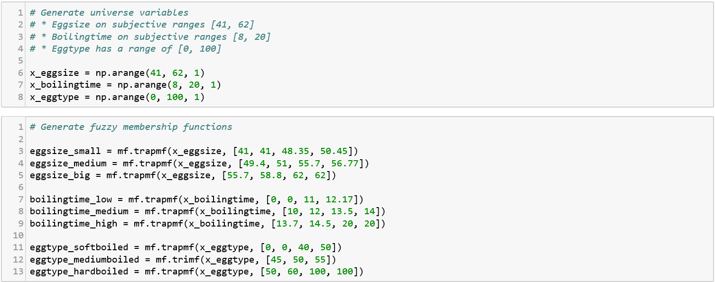

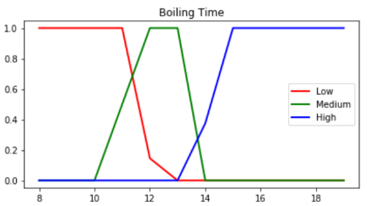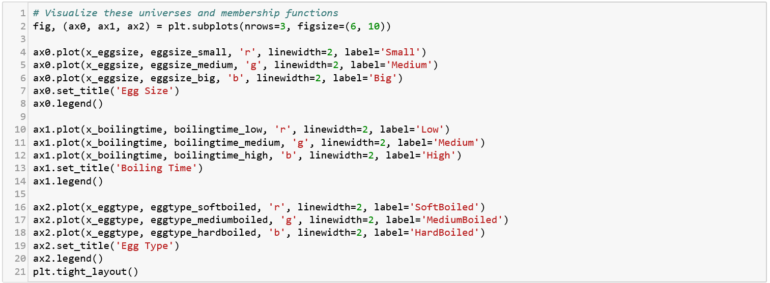

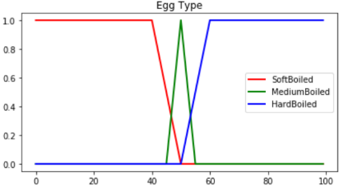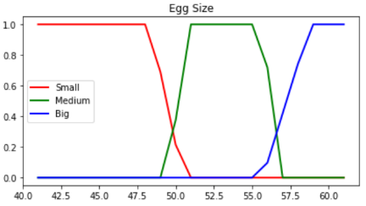

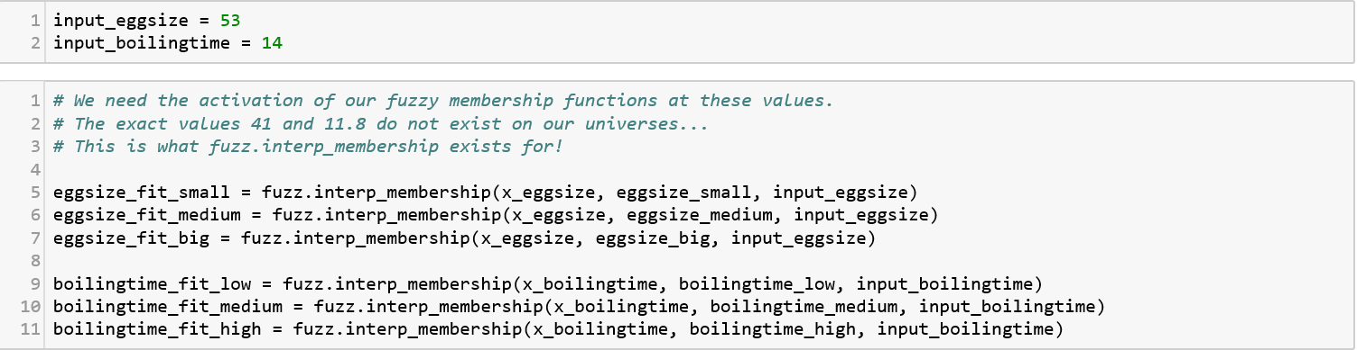

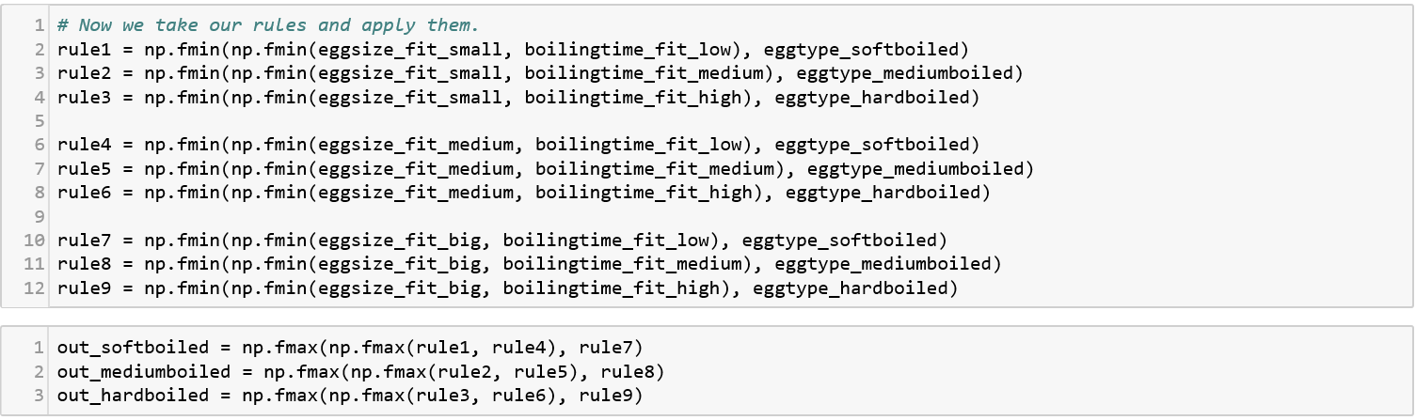

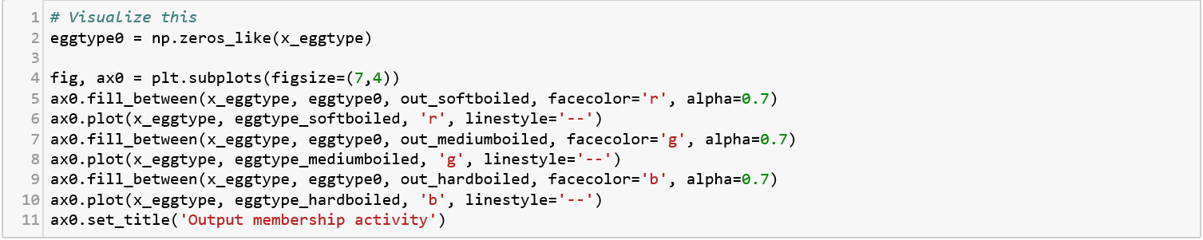

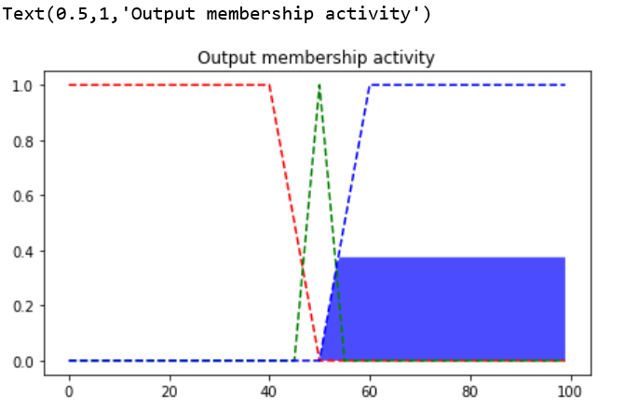

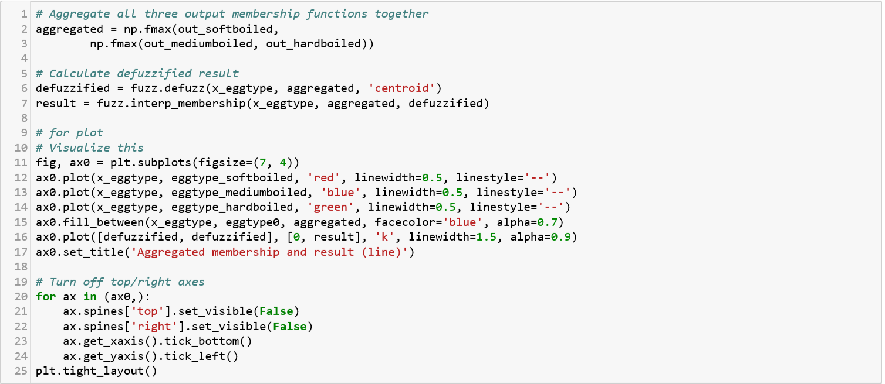

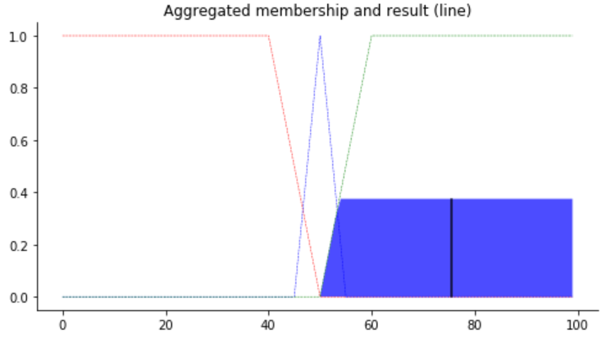

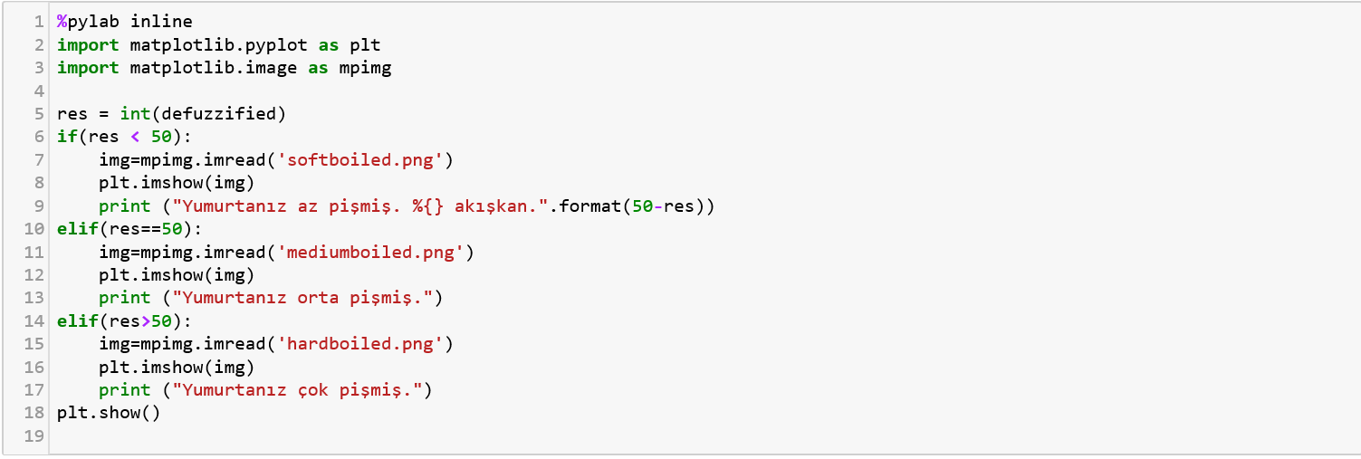

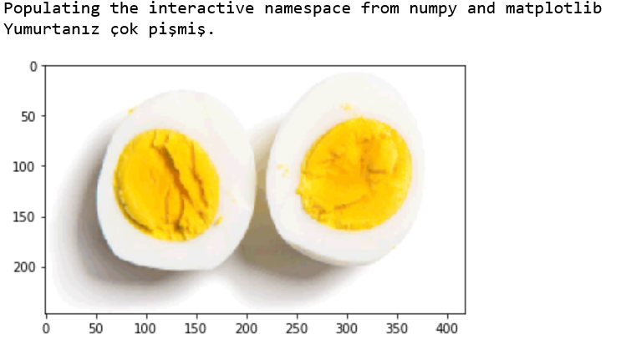

**6. Conclusion**

In this project, I aimed to find the best medium cooked egg. I used two inputs. One of them is the size of egg and the other is boiling time. I kept the amount of water and the amount of fire at the same level for each egg. I tried to create rules and membership functions according to the data I obtained. At the end, I did their checks and finally visualized them. For further projects by taking more than two inputs we can provide more precise results.

**References**

1. <https://www.youtube.com/watch?v=J_Q5X0nTmrA>

2. <https://www.youtube.com/watch?v=EXrBCZC0TTI&t=3s>

3. <https://www.tutorialspoint.com/fuzzy_logic/fuzzy_logic_inference_system.htm>