Beispielszenengraph

Beispiel 1

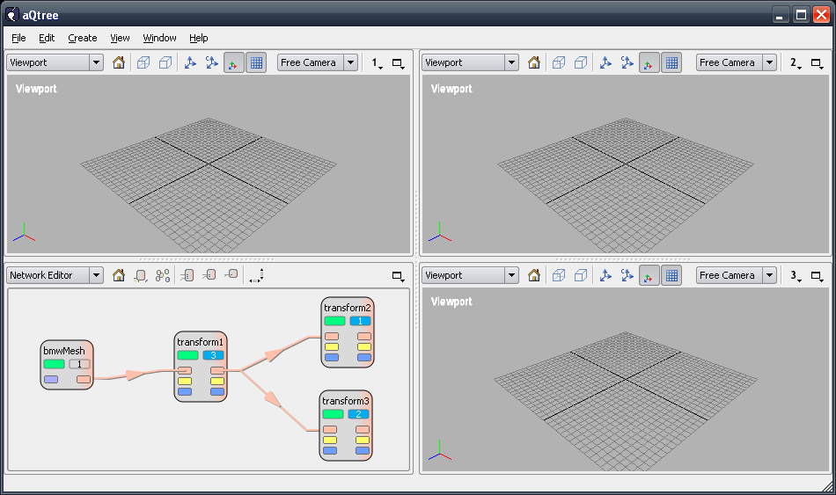

Root
viewport1
viewport2
viewport3
stage1
stage1_transform2
stage1_transform2_transform1
stage1_transform2_transform1_bmwMesh
stage1_transform2_transform1_bmwMesh_entity
stage2
stage2_transform3
stage2_transform3_transform1
stage2_transform3_transform1_bmwMesh
stage2_transform3_transform1_bmwMesh_entity
stage3
stage3_transform1
stage3_transform1_bmwMesh
stage3_transform1_bmwMesh_Entity

bmwMesh
bmwMesh_entity
transform1
transform2
transform3

Beispiel 2

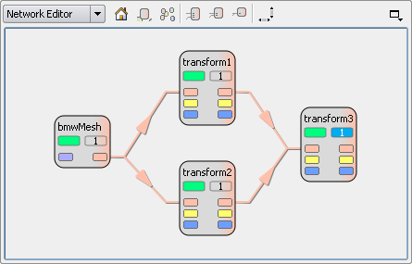

Root
viewport...
stage1
stage1_transform3
stage1_transform3_transform1
stage1_transform3_transform1_bmwMesh
stage1_transform3_transform1_bmwMeshEntity
stage1_transform3_transform2
stage1_transform3_transform2_bmwMesh
stage1_transform3_transform2_bmwMeshEntity

bmwMesh
bmwMesh_entity
transform1
transform2
transform3

//!
//! Sets the given view node as the node to be contained on the stage with the
//! given index.
//!
//! Is called from the scene model when a view node has been set to be viewed.
//!
//! \param stageIndex The index of the stage to which the view node belongs.
//! \param viewNode The node to be contained on the stage with the given index.
//!
void StageManager::setViewNode ( unsigned int stageIndex, ViewNode *viewNode)
{
Ogre::SceneNode *stageSceneNode = 0;
// check if the scene node for the stage already exists
if (m_stageSceneNodes.contains(stageIndex)) {
stageSceneNode = m_stageSceneNodes[stageIndex];
// clear the stage
destroySceneTree(stageSceneNode);
} else {
stageSceneNode = m_sceneManager->getRootSceneNode()->createChildSceneNode(QString("stage%1").arg(stageIndex).toStdString());
}

Ogre::SceneNode *viewNodeSceneNode = viewNode->getSceneNode();
duplicateSceneTree(stageSceneNode, viewNodeSceneNode);
}

//!
//! Duplicates the scene objects contained in the given scene node and
//! adds the duplicates to the given parent scene node.
//!
void StageManager::duplicateSceneTree ( Ogre::SceneNode *parentSceneNode, Ogre::SceneNode *sceneNode )
{
// iterate over all child scene nodes and recursively duplicate the
// subtrees

// iterate over all attached objects and duplicate them

}

//!
//! Destroys the scene objects contained in the given scene node.
//! The scene node itself is not destroyed.
//!
void StageManager::destroySceneTree ( Ogre::SceneNode *sceneNode )
{
// iterate over all child scene nodes and recursively destroy the subtrees

// iterate over all attached objects and destroy them

}

