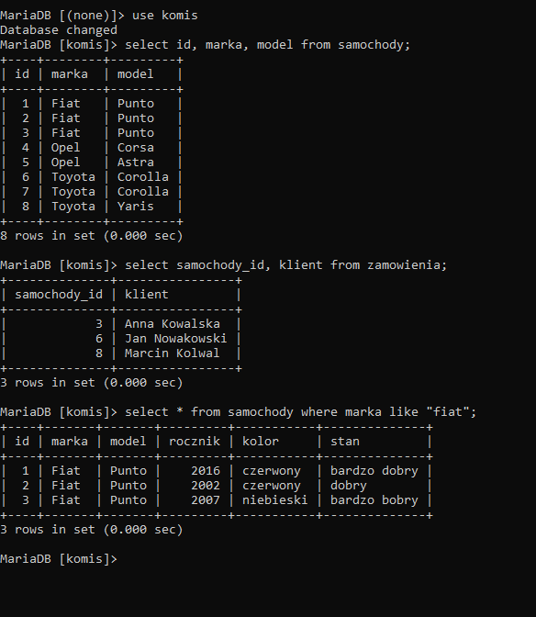

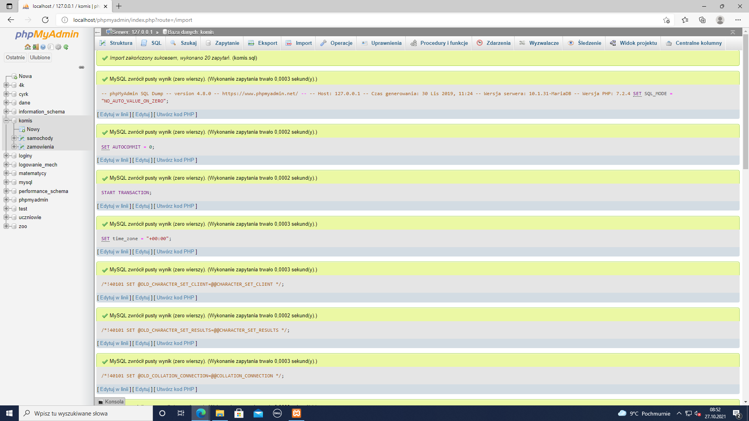

1 select id, marka, model from samochody;

2 select samochody_id, klient from zamowienia;

3 select * from samochody where marka like "fiat";