COM1025 Web and Database Systems

Coursework Assignment

Generic Club entity

# Business Rules and Assumptions

1. A university offers courses and has two categories of students: undergraduates and postgraduates.
   1. The university needs to store the following details about each student: name, date of birth, a phone number, and what course they are on.
   2. A student must be a postgraduate or an undergraduate, but they cannot be both at the same time.
   3. A student must be enrolled on one and only one course while a course can enrol no student or many students.
   4. A course has a course code, name and enrolment (total number of students on the course)
2. The university also wants to keep data on hobbies of students if they wish to provide that information so that appropriate clubs and societies can be suggested to them.
   1. A hobby has a name, a description and a category. Examples of categories and hobbies are shown below (these could be subjective and you can add/change items):

|  |  |
| --- | --- |
| Category | Hobby Name |
| Sports | Football, tennis, swimming, pingpong, badminton, basketball |
| Fitness | Yoga, Pilates, Taichi, hiking, climbing |
| Outdoor | Mountain climbing, fishing, kayaking, gardening |
| Intellectual | Reading, sudoku, puzzles, chess, coding, debating, poetry |
| Social | Sustainability campaigner, charity work, community work, animal rescue |
| Gaming | Multi-player games, Minecraft, FIFA |
| Construction | Modelling, 3D printing, Robots |

* 1. A student can have no hobby or can have many hobbies. A student does not have to provide any information on their hobbies if they choose not to.
  2. A hobby can be related to no student or to many students.

1. The university offers clubs to participate in.
   1. Each club must have: name, description , category, founding date, website address, phone number(s)
   2. A student can have no clubs or many clubs
   3. A club must be related to at least 1 student
2. The university wants to keep track of students accommodation
   1. A student must have accommodation.
   2. Accommodation does not need to have students in it but it can have many.
   3. University accommodation either has a parking space or a bus pass
   4. Each accommodation has varying rent
   5. In the case of external student accommodation a phone number for a landlord must be stored.

# Extended Entity Relationship Diagram (EERD)

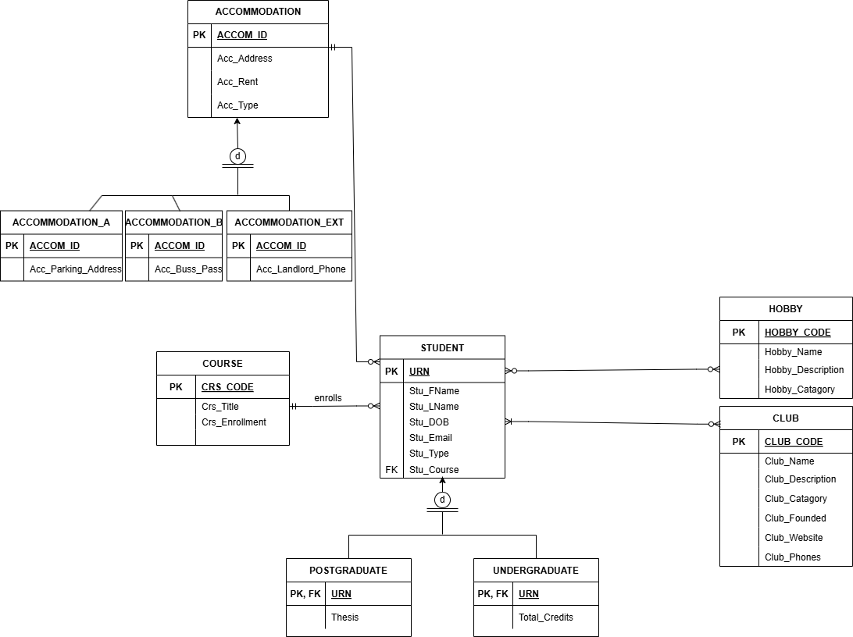

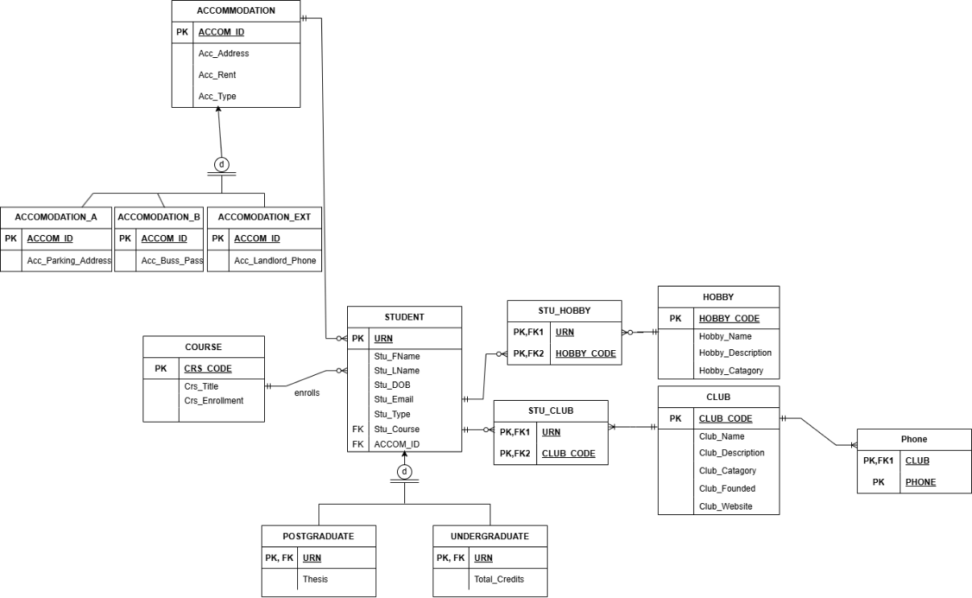

Both diagrams were made with diagrams.net

The first is before normalisation and the second is afterwards.

# Logical Relational Database Schema

**Course**(Crs_Code, Crs_Title, Crs_enrollment)

PRIMARY KEY: Crs_Code

**Student**(URN, Stu_FName, Stu_LName, Stu_DOB, Stu_Email, Stu_Course, Stu_Type, ACCOM_ID)

PRIMARY KEY: URN

FOREIGN KEY: Stu_Course REFERENCES **Course**(Crs_Code)  
 ACCOM_ID REFERENCES **Accomodation** (ACCOM_ID)

**Postgraduate**(URN, Thesis)

PRIMARY KEY: URN

FOREIGN KEY: URN REFERENCES **Student**(URN)

**Undergraduate**(URN, Total_credits)

PRIMARY KEY: URN

FOREIGN KEY: URN REFERENCES **Student**(URN)

**Hobby**(HOBBY_CODE, Hobby_name, Hobby_Description, Hobby_Catagory)

PRIMARY KEY: HOBBY_CODE

**Stu_Hobby**(URN, HOBBY_CODE)

PRIMARY KEY: URN, HOBBY_CODE

FOREIGN KEY: URN REFERENCES **Student**(URN)

HOBBY_CODE REFERENCES **Hobby** (HOBBY_CODE)

**Club** (CLUB_CODE, Club_Name, Club_Description, Club_Catagory, Club_Founded, Club_Website)

PRIMARY KEY: CLUB_CODE

**Phone** (CLUB, PHONE)

Primary KEY: CLUB, PHONE

FOREIGN KEY: CLUB REFERENCES **Club** (CLUB_CODE)

**Stu_Club** (URN, CLUB_CODE)

PRIMARY KEY: URN, CLUB_CODE

FOREIGN KEY: URN REFERENCES **Student**(URN)

CLUB_CODE REFERENCES **Club** (CLUB_CODE)

**Accommodation** (ACCOM_ID, Acc_Address, Acc_Rent, Acc_Type)

PRIMARY KEY: ACCOM_ID

**Accommodation_A** (ACCOM_ID, Acc_Parking_Address)

PRIMARY KEY: ACCOM_ID

FOREIGN KEY: ACCOM_ID REFERENCES **Accommodation** (ACCOM_ID)

**Accommodation_B** (ACCOM_ID, Acc_Buss_Pass)

PRIMARY KEY: ACCOM_ID

FOREIGN KEY: ACCOM_ID REFERENCES **Accommodation** (ACCOM_ID)

**Accommodation_A** (ACCOM_ID, Acc_Landlord_Phone)

PRIMARY KEY: ACCOM_ID

FOREIGN KEY: ACCOM_ID REFERENCES **Accommodation** (ACCOM_ID)

# Website Working with MySQL Database

*In this section, you should give a list of all files of your website with a description of what it does.*

# Advanced Tasks

*In this section, please list what extra challenge advanced tasks you have done. If you did some advanced tasks but forgot to include them in this section, you might bear the risk that such advanced tasks may not be noticed by the marker and thus additional marks may not be awarded.* ***If you did not attempt any advanced task, still include this section but just say you didn’t attempt any*.**

# References

*Put the links of the websites you used for eliciting the business rules and any other references. Make sure you cite every reference in the main body of your report. You are recommended to use Harvard or IEEE referencing.*

*If you used a CSS template or any external libraries in your website, make it clear in the main body of the report and add proper references (with URLs if relevant). Make sure you have the needed permission to use such templates and libraries as well (you should be aware of such legal issues and what are your responsibilities).*

# Appendix: Screenshots of Website

*Show the screenshots for your website.*