UNIVERSITY OF INFORMATION TECHNOLOGY

FACULTY OF COMPUTER NETWORK AND COMMUNICATION

**REPORT**

Subject: Cryptography

Semester I (2024 – 2025)

**Report Lab 3**

Student: Nguyễn Huỳnh Nhân

Student ID Number: 23520180

Class: NT219.P22.ANTT

University of Information Technology

Report Lab 3

**Student Information**

Full Name: Nguyễn Huỳnh Nhân

Student ID Number: 23520180

Class: ATTT2023.2

Full Name: Võ Hoài Nam

Student ID Number: 23520990

Class: ATTT2023.2

**Device Information**

CPU: 11th Gen Intel(R) Core(TM) i5-1135G7

Ram: 16 GB DDR4 3200MHz

SSD PCle: 512GB

**RSA**

key: AD12463E840DCE194EFB330E3C5D751C1D90A286A8DDFE3A4AB76D46B637ABDD

iv:018C53B1CA0FBBFCB571C82191F32265

**Plain1KB.txt**

|  |  |  |  |  |
| --- | --- | --- | --- | --- |
| Mode | Encrypt (Window) | Decrypt (Window) | Encrypt (Linux) | Decrypt (Linux) |
| 100 Bytes | 56 ms | 5076 ms |  |  |
| 200 Bytes | 56 ms | 4210 ms |  |  |
| 300 Bytes | 58 ms | 4408 ms |  |  |

100 bytes

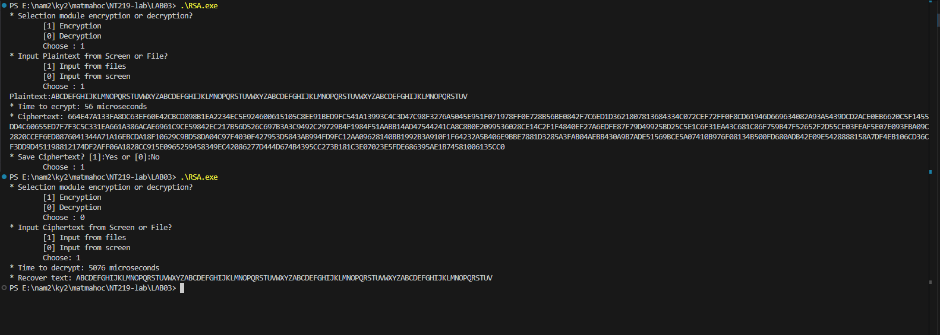

200 bytes

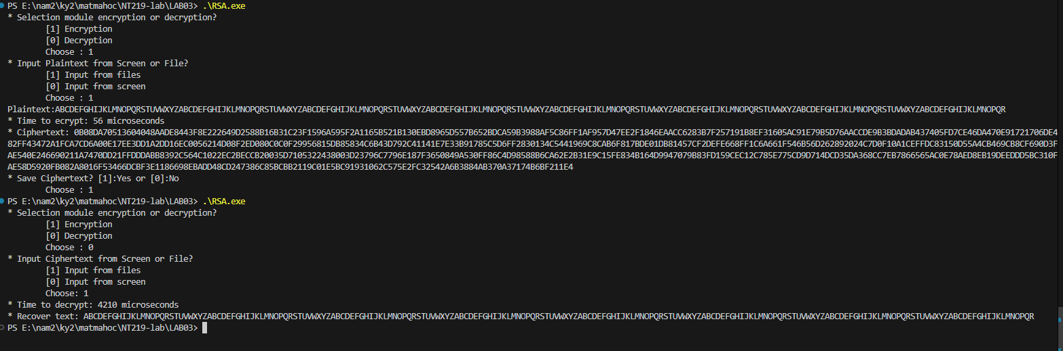

300 bytes

