UNIVERSITY OF INFORMATION TECHNOLOGY

FACULTY OF COMPUTER NETWORK AND COMMUNICATION

**REPORT**

Subject: Cryptography

Semester II (2024 – 2025)

**Report Lab 5**

Student: Võ Hoài Nam

Student ID Number: 20520990

Student: Nguyễn Huỳnh Nhân

Student ID Number: 20521080

Class: NT219.P22.ANTT.2

University of Information Technology

Lecturer: Đỗ Thị Phương Uyên

**Hồ Chí Minh City, May 2025**

Report Lab 5 – 6

**Student Information**

Full Name: Võ Hoài Nam

Student ID Number: 20520990

Class: ATTT2023.2

Full Name: Nguyễn Huỳnh Nhân

Student ID Number: 20521080

Class: ATTT2023.2

**Device Information**

Processor AMD Ryzen 7 6800H with Radeon Graphics, 3201 Mhz, 8 Core(s), 16 Logical Processor(s) Ram: 16 GB DDR3L

1. window
2. ECDSA

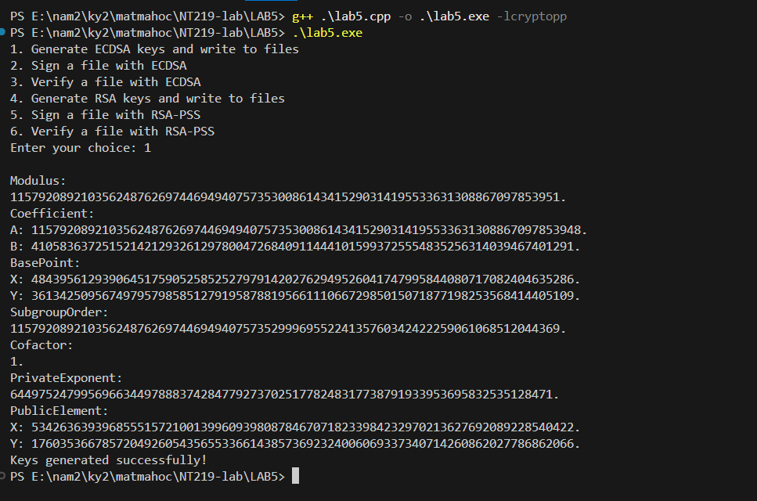

Key generation

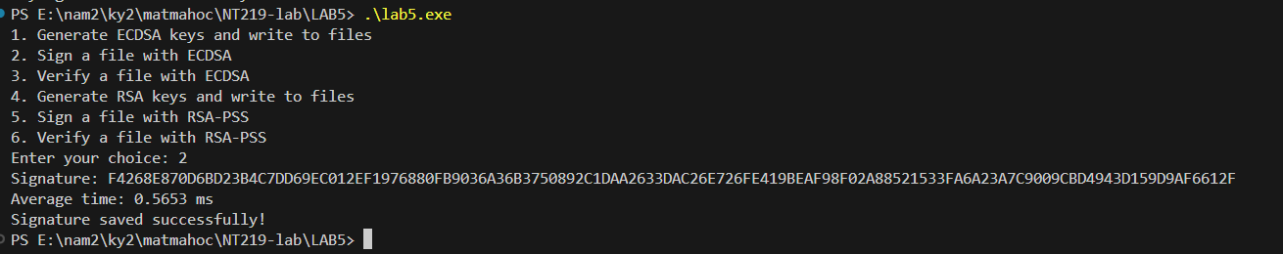

Sign

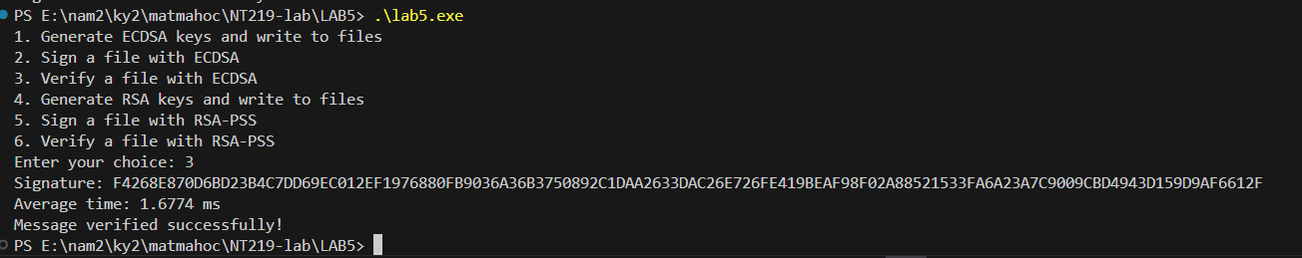

verify

1. RSAPSS

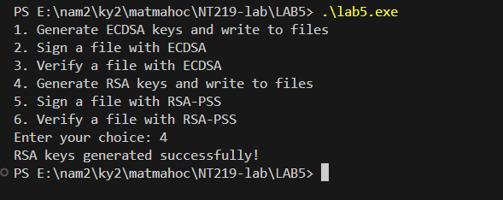

Key generation

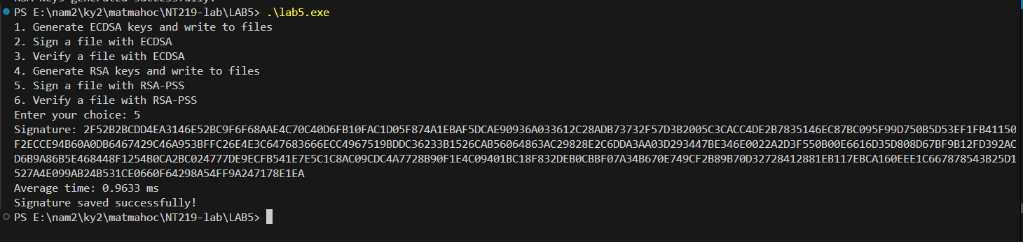

Sign

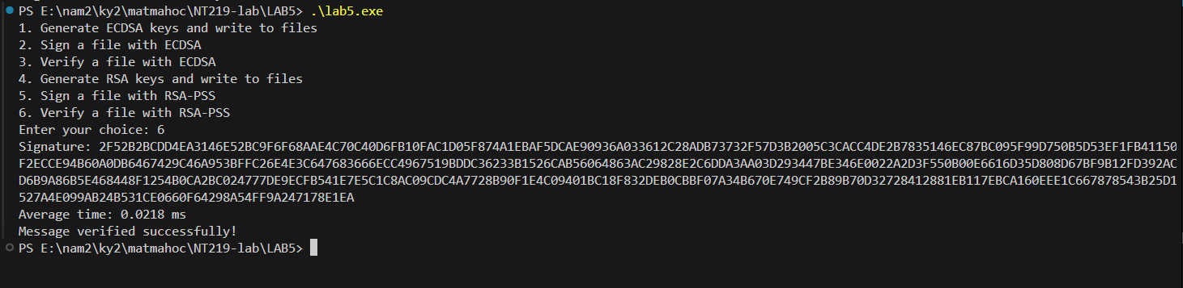verify

II.Linux

ECDSA

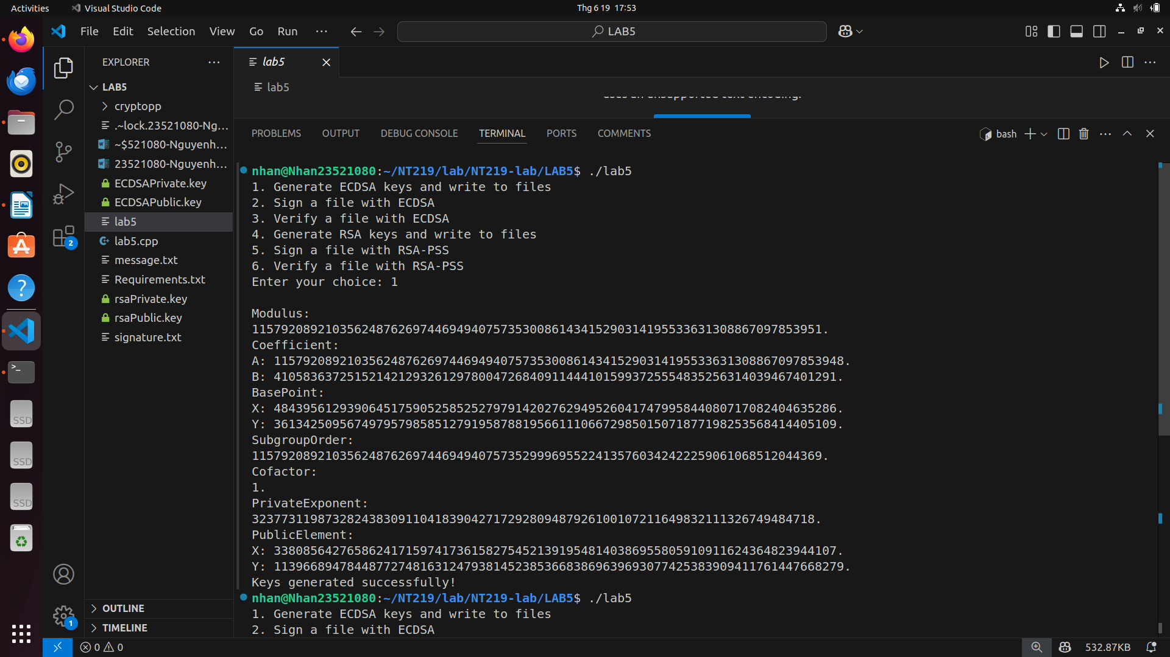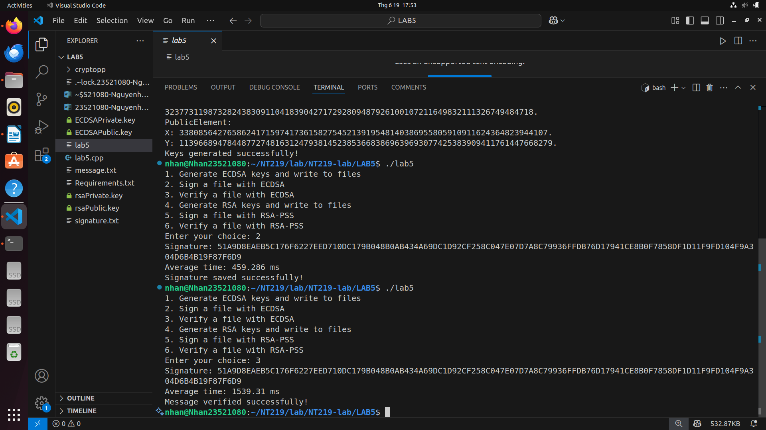RSAPSS

