Overarching structure:
The code for the multi-threaded card playing simulation is contained within the package cardplayingsimulation, the simulation can be activated via invoking the main method from the CardGame.java class or by executing the CardGame.jar file. All other methods and classes within the packages are designated as package-private or private in order to provide encapsulation of the game’s data: protecting it from direct access by unintended parties. This also provides abstraction from the user – as they can only access the intended means to play the simulation and do not need to understand its inner workings to get an output.
The main method takes and validates the in-putted number of players and the input pack location. It then deals hands to the players, and then fills out the decks – both in round-robin fashion, before doing an initial check to see if a player has won: updating the winner flag if it has. The threads are then started – if a player has already won then all threads are stopped and outputs are written to the command line interface and output text files. Otherwise the threads proceed with their draw/discard cycles as detailed below.
Win condition:
CardGame contains the AtomicInteger winner. This is used as a flag to signal to the threads when another player has won. A flag was chosen instead of an interrupt because of the requirement for a player to always have four cards in their hand at the end of the game, as such, the threads are allowed to complete their final draw/discard after a winner is declared, if they have already began that draw/discard cycle (as the winner flag is checked before a draw/discard cycle).
The use of an AtomicInteger also prevents simultaneous access race conditions, the use of the AtomicInteger.compareAndSet method, ensures that only one thread can win the game by atomically updating the flag’s value to the winning thread, and the AtomicInteger.get method provides an up-to-date value on every call.
Decks:
Decks must be ordered, thread-safe FIFO containers of cards. As such, each deck is a ConcurrentLinkedQueue containing instances of Card. Card is an immutable class (declared final) – making it thread-safe. The use of ConcurrentLinkedQueue means that changes to decks are immediately visible to threads. The FIFO structure of a deck means that a player discarding to a deck does not need to consider the state that a deck is in – it can simply enqueue the card. Conversely, when drawing from a deck, a player must check that the deck has at least one card within it, if not the player must wait until the deck does have a card before drawing.
When an instance of a Player is constructed it is passed both a deck to draw from and a deck to discard to. What is actually passed is the memory references for these decks, and so when multiple players access the same deck (one to discard and one to draw) there are no issues with duplication or lost changes as both players access the same memory reference.
Players:
Player is a thread-safe class which extends Thread. It performs moves in the simulation via an overridden run method, inherited from Thread (polymorphism). Within the run method the process of drawing and discarding is performed atomically by first choosing a random, non-favoured value of card to potentially discard. Then that card is passed to the atomicDrawDiscard method which enforces the atomicity of the draw/discard cycle by locking both the draw and discard deck of the player within synchronised blocks. This means that another player cannot edit the contents of either deck whilst the first player completes their draw/discard cycle.
The order in which the decks are locked matters in order to prevent a deadlock between the threads. For example: consider the situation where player 1 wants to draw from deck 1 and discard to deck 2, and player 2 wants to draw from deck 2 and discard to deck 1. Then if both players lock the deck that they draw from first, player 1 will then want to lock deck 2, which is not possible as player 2 has already locked it; the opposite is also true for player 2. This creates a deadlock. To avoid this the final player in the ring topology must always lock their discard deck before their draw deck. If we then go back to our previous scenario: player 1 and 2 will try to lock deck 1, whoever locks it first will then lock deck 2 and so will atomically draw and discard before the other player can.
Alternatives considered:
A semi-turn base approach was considered for players where each player would wait until all players had finished a single draw/discard cycle within a given turn. This was considered as a solution to prevent race conditions, however, it violates the requirement of the specification such that “By multi-threading, players should NOT play the game sequentially, i.e., NOT in a way that, when one player finishes actions another player starts”.
A priority queue was initially used for player’s hands such that cards with the player’s preferred value would be enqueued with lower priority than those without the preferred value. This means that the player could blindly dequeue the front of their deck when discarding, instead of having to randomly choose a non-preferred card. This method enforced that cards would always be passed around in the same relative order – unless stopped as the card had a player’s preferred value. This was not an issue if, at least, there were 4 cards which were the preferred denomination for a single given player. If this was not the case then it is possible for the simulation to loop indefinitely – effecting the liveness of the program – as it did not perform correctly in an acceptable amount of time. This was changed to random selection to prevent this issue; there exists the possibility of any random choice simulation looping indefinitely, although the probability is so small as to be negligible.
A cardContainer class was considered from which pack and deck would inherit from – however it was deemed as unnecessary bloat which would also overly abstract the workings of the FIFO structure of both pack and deck. Finally, as decks are of type ConcurrentLinkedQueue and a pack has no need to be thread-safe the classes actually do not share an underlying data type and so a superclass has little to no benefit.
Performance limitations:
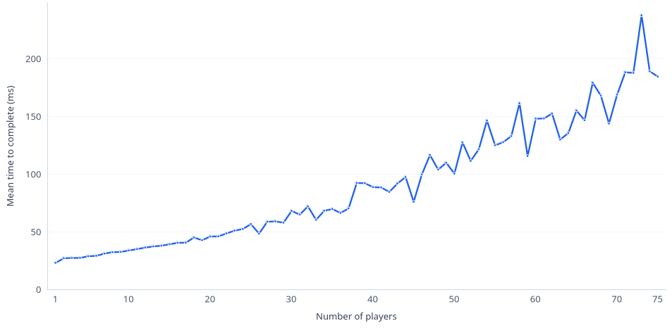
The graph shows the increase in execution time as more players are added. The y-axis is calculated as an average of the times taken for 10 runs of the simulation to execute for that many players (outliers are excluded and are treated as being outside of 1.5*(the interquartile range).

From the graph we can see that there is an overhead of about 25ms at 1 player, caused by initialisation costs. We can also see that performance trends greater than linearly as the number of players in the simulation increases, this trend would be exemplified with a greater number of players and so care should be taken when running the simulation with very large player counts. As the number of players increases we also see an increase in the variability of the mean time taken – this may be due to noise created by random chance and so to eliminate this more runs per number of players should be performed.

Testing:
Our test suite uses JUnit 6.1.3 and contains tests for the expected correct execution of the simulation for various numbers of players (two, four, ten, or fifty players). It also contains tests to check for boundary conditions such as only having one player, immediate wins, there being no possible win, and other similar events. It contains tests for erroneous inputs; there is no pack, there are a negative number of players submitted, there are incorrect values within a pack file, the pack file is the wrong length, and others. As well as miscellaneous tests for checking the conservation of cards before and after the game, checking that a player never discards a preferred denomination of card, and checking that deck behaviour is in a first-in-first-out fashion.
Testing input files were generated using a script which generated 100 of each file per number of players in a game tested. These tests are passed to a parametrised test with a method source which loops through each input file desired.
Limitations to the testing of our program are caused by access modifiers within the cardplayingsimulation package protecting methods and attributes from being accessed in the test package, this means that it is difficult to accurately trace private and package-private attributes within the execution of the simulation. To circumvent this copies of classes where added to the test package so that specific static methods could be called and tested, however, the cardplayingsimulation.CardGame.main method (and the full execution of the program) remain a black box.

