**GROUP 4: PROJECT 3 PROPOSAL**

**TEAM MEMBERS:**

Ambreen Simon,Sebastien Vezina, Stephen Chen, Wazarat Hussein, & Val De Franco

**BACKGROUND:**

Blockchain technologies have emerged as one of the leading tools in many industries. In particular, there is a vastly growing interest in adopting blockchain and cryptocurrency in the gambling industry for reasons such as protection of privacy, immutable data security, transparency and ease of virtual transactions. In addition, in countries where cryptocurrencies are not recognized as a valid form of currency, in combination with regulations forbidding gambling, using a digital currency allows players to participate without infringing on the local regulations. Finally, there is the issue around random number generators and the associated technical security challenges within Blockchain.

**PROJECT AIM:**

Our project aims to create a simple online gaming interface utilizing cryptocurrency such as Ether as the currency for betting. Via a web interface using underlying smart contracts, a user will bet any amount of wei and choose a number between one, two or three. If the user correctly guesses the number, s/he will win 2x the amount back in addition to being refunded their initial bet. Importantly, our app will use a Verifiable Random Function (VRF) from the decentralized Oracle (ChainLink) to instill confidence in game participants that the game results are truly random. Random number generators have been problematic on dapps due to security issues and potential conflict of interest issues with miners. Our project will discuss these challenges, potential solutions and explain our solution choice of VRF.

An example of the webpage interface is shown on the next page.

**EXTERNAL RESOURCES (APIs, Librairies…):**

* [Solidity](https://docs.soliditylang.org/)
* [ChainLink](https://chain.link/)
* [Web3.js - Ethereum JavaScript API](https://web3js.readthedocs.io)
* [Remix](https://remix.ethereum.org/)
* [MetaMask](https://metamask.io/)
* [Rinkeby Ethereum Testnet](https://www.rinkeby.io/#stats)
* HTML, JavaScript

**RESPONSIBILITIES:**

1. GITHUB Manager: Sebastien

2. Coding Tasks (Smart Contracts, Chainlink, JavaScript): Sebastien et al

3. Webpage generation: Stephen & Wazarat

4. Presentation Write-Up: Ambreen and Val.

**NEXT STEPS/DELIVERABLES**:

**March 9, 2021**: Sebastient will present preliminary smart contracts; Stephen and Wazarat will present preliminary html codes for sample webpage interface. Ambreen and Val will start working on putting together a presentation.

**March 9 & 13, 2021**: Test run smart contracts with connectivity to Chainlink; complete presentation

**March 16, 2021**: Finalize presentation and dry runs

**March 18, 2021/Presentation**: **Ambreen & Va**l

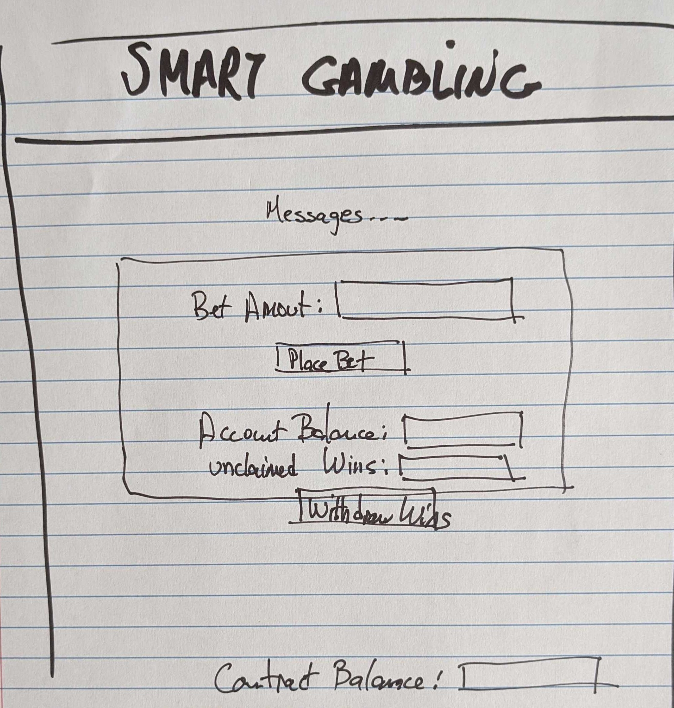

(Picture to be tokenized…)