Objective 2 (Uttarakhand)
AI-Driven Design Optimisation of the PCM Storage Unit
Current pipeline (port of Rajasthan v3, PCM fraction cap 30 %, Objective 1 K = 4 regimes): implementation, parameters and results
Project: Climate-Adaptive Intelligent Control and Optimization of PCM Thermal Storage for Solar Water Heating
Group 12, Amrita School of Engineering. Guide: Dr. T. Deepika. B.Tech CSE (Final Year)
Folder: Objective---2/objective2-uttarakhand (branch main, working tree after the cleanup that mirrors Rajasthan; not yet committed)
Maps to: Objective O2 and research gap RG2
Report date: 28 October 2026. Prepared from the saved files in docs/, configs/, results/, scripts/ and src/.
How to read this report. Every number comes from a file in results/ or configs/; the file name is printed under each table or figure. The structure follows the Rajasthan v3 report so the two states can be read side by side. Where the written docs and the saved files disagree, the saved files are used and the disagreement is listed in Section 12. Items that were not run are said so explicitly. Uttarakhand's delivery target is 50 C (Rajasthan 45 C): every column or metric named ...45 is computed at 50 C here, so kWh values of the two states are not directly comparable.

Contents
1. Overview 4
1.1 Headline results 4
2. Pipeline architecture (G1 to G18) 5
2.1 Entry points 7
3. Thermal model and metrics 7
3.1 Simulator and repairs 7
3.2 Time-step convergence (G2) 7
3.3 Multi-node (stratified) tank (G4) 8
3.4 Solver safeguards and the overheat shield 9
3.5 Metrics (src/metrics/tes_metrics.py) at the 50 C target 9
3.6 What is not modelled 9
4. Weather, design space and system sizing 10
4.1 Uttarakhand regimes (Objective 1, K = 4) 10
4.2 Weather inventory and year roles 10
4.3 PCM shortlist (from Objective 1) 11
4.4 System sizing and standards 11
4.5 Design space and geometry engine 11
5. All parameters 12
6. Optimisation method 13
6.1 Sensitivity study (G7) 13
6.2 Screening (S1) and DOE (S2) 14
6.3 Surrogate comparison (S3) 14
6.4 Search (S4/S5) with the box-vertex step 14
6.5 Search checks (G9) 15
6.6 Selection rule and the one-shot held-out lock 15
7. Results 15
7.1 Selection on the select years (2021-2023) 15
7.2 Held-out test (2024-2025, run once) 16
7.3 Optimiser checks 17
7.4 Ablations and controls (G11, explore years 2016-2020) 18
7.5 Shield hours, water side versus PCM side (G13) 19
7.6 Controls from an interior anchor (G14) 19
7.7 Evening (night-serve) decomposition (G16) 20
7.8 Stack position and widened bounds (G15, G17) 20
7.9 Box-vertex step, with and without (G18) 21
7.10 Surrogate and gain-by-year figures 21
8. Validation and checks run 22
9. Result registry and provenance 22
10. Limitations and open items 22
10.1 What the results do not support 22
10.2 Items for Dr. Deepika and the O1 owner 23
11. Handoff to Objective 3 23
12. Doc and code discrepancies 24
Appendix A. File-to-stage index 24
A.1 Files removed as legacy 25
Appendix B. How to reproduce 25

1. Overview
Objective 2 (O2) takes the PCM candidates recommended by Objective 1 (O1) for each Uttarakhand climate regime and finds the physical design of the PCM storage unit that stores and delivers the most useful heat. The work uses the same grey-box simulator as Rajasthan (a 50 L solar water-heating tank with spherical PCM capsules), driven by real hourly weather at the medoid point of each regime. It answers research gap RG2: no AI-driven optimisation of PCM thickness, capsule arrangement, capsule count and flow rate tailored to a location-specific climate.
Table 1. Design variables optimised in O2
Objective wording | Design variable | Range
PCM thickness | Capsule inner radius R_in (thickness = inner radius) | 10 to 40 mm, continuous
Number of capsules | PCM outer-volume fraction of the tank; capsule count N is derived | 2 to 30 % of tank volume
Flow rate | Collector-loop mass flow | 0.010 to 0.050 kg/s
Capsule arrangement | Packing pattern | single-layer, staggered, radial
Source: configs/design_space.yaml (version design_space_o2_v3_cap30_2026-10-27_uttarakhand)
What was done, in one paragraph. Objective 1 had reduced Uttarakhand from five to four climate regimes, so the frozen O1 inputs, the regime weather and the state configuration were rebuilt for K = 4. The Rajasthan v3 code (repaired simulator, stratified 10-node tank, same-flow paired baseline, safety shield) was ported unchanged except for the state name and four regimes; the delivery target stays at 50 C. For each of 12 (regime, PCM) pairs, a Taguchi screening, a 128-point Sobol design of experiments and surrogate models fed an NSGA-II multi-objective search with active learning and the declared box-vertex step. A 720-design dense grid cross-checked the search. Designs were selected on years 2021-2023 and tested once on untouched years 2024-2025 behind a single-use lock. Ablations, controls and five diagnostic studies were then run on these designs.

1.1 Headline results
Table 2. Chosen design and gain per regime
Regime | Chosen PCM | R_in mm | Fraction | Flow kg/s | Arrangement | Select-year gain kWh/yr (2021-23) | Held-out gain kWh/yr (2024-25) | Band kWh
0 | PureTemp 58 | 39.8 | 26.3 % | 0.0194 | staggered | 80.0 | 76.0 | 22.0
1 | PureTemp 58 | 39.3 | 29.7 % | 0.0314 | single-layer | 72.1 | 61.8 | 19.4
2 | savE OM55 | 39.7 | 30.0 % | 0.0199 | single-layer | 63.0 | 56.4 | 20.0
3 | n-Hexacosane (C26) * | 38.4 | 2.0 % | 0.0100 | single-layer | -5.8 | -6.1 | 6.1
Source: results/g10_selection_r{0,1,2,3}.json; results/g10_heldout_results.csv. * not better than water-only (meaningful_on_primary_metric = false)
- Gain = extra energy delivered at the 50 C target in the 18:00-09:00 window (g_window), compared with a water-only tank at the same flow, weather and demand. In regimes 0-2 it is well above the repeatability band (19-22 kWh) on the select years and in both test years (weakest test year 74.6 / 60.7 / 49.6 kWh).
- Regime 3 (cold, high altitude, mains about 7 C): PCM does not help. No design of any of its three O1 PCMs beats the water-only tank by more than the 6.1 kWh band, and the gain falls as PCM is added. The 'chosen' design is the least-PCM design that the written tie-break rule returns; the recommendation for regime 3 is a water-only tank.
- The regime 0-2 designs are still boundary-limited: inner radius 39.3-39.8 mm and PCM fraction 26-30 % sit at the edges of the box, and raising the fraction from 30 % to 40 % in a diagnostic run adds +23 to +30 kWh, beyond the band. The best PCM amount is therefore not yet known (Section 10).
- The choice of PCM inside a regime is not resolved: on the test years the runner-up PCM is within the band of the chosen one in every regime (regime 0: PlusICE A58 86.4 against PureTemp 58 76.0).
- The night-serve duration (tau_serve) is not improved against the same 50 L tank (gain -0.10 to -0.16 h in regimes 0-2), because the capsules displace water. This is reported as a finding.
- Quality gates: energy-balance residual at most 0.076 % (single node; multi-node about 1e-12 %); PCM peak at most 64.2 C on the held-out runs (limit 65); water peak at most 73.1 C (limit 75); 81 unit tests pass.

2. Pipeline architecture (G1 to G18)
The work follows the Rajasthan gate numbering. G1-G6 repair and verify the model, G7 fixes the design space, G8-G10 search and select, G11 tests the result, G12 packages it, and G13-G17 are diagnostic studies. G18 (with / without the box-vertex step) was not run for Uttarakhand, and G19 (fresh 2011-2015 test weather) is not needed because 2024-2025 had not been used as a test here.
Table 3. Stage-by-stage flow
Gate | Purpose | Method | Script / entry | Main outputs
G1 | Fix demand timing | Demand follows local hour (IST floor), not UTC hour; morning peak 07:30 | src/simulation/tank_model.py; tests/test_demand_timing.py | regime weather files carry local_hour / local_date
G2 | Model repairs and time step | Inner-volume PCM mass, inner-radius conduction, leap day dropped, dt convergence | scripts/g2_timestep_convergence.py | g2_timestep_convergence_150_75_37p5.csv
G3 | Thermal-storage metrics at 50 C | E_del, tau_hold, tau_serve, closure residual | scripts/g3_metrics_report.py | g3_metrics_report.csv, g3_night_daily_*.csv
G4 | Stratified tank | 1-D multi-node tank (N = 10), CFD draw-case check | scripts/g4_multinode_report.py | g4_multinode_report.csv, g4_cfd_draw_case.csv
G5 | Weather inventory and year roles | 4 medoid points x 2016-2025; explore / select / test; one-shot lock | src/weather/inventory.py, roles.py | data/weather/point_years/
G6 | O1 shortlist and Phase-4 gates | O1 MCDM top-3 per regime; verification battery (incl. cold-mains case) | pipeline.py --stage verify | phase4_verification_o1_pcms.txt
G7 | Sensitivity | 568 paired runs on explore years 2018-2019 | scripts/g7_sensitivity.py, g7_paired.py | g7_sensitivity_r*.csv, g7_sensitivity_paired.csv
G8 (S1) | Screening | Taguchi L9 + ANOVA, 12 pairs x 9 runs x 5 years | scripts/g8_s1_screening.py | g8_s1_*.csv, g8_s1_anova_*.csv
G8 (S2) | DOE | 128 scrambled-Sobol points, 5 years, 12 pairs | scripts/g8_s2_doe.py | g8_s2_r*_p*.csv
G8 (S3) | Surrogates | NN ensemble, XGBoost, quadratic RSM; within-pair validation | scripts/g8_s3_compare.py | g8_s3_comparison.csv, g8_s3_selection.csv
G8 base | Paired baseline | Water-only flow grid (17 flows), PCHIP interpolation | pipeline.py --stage baseline | plain_baseline_*_r*.csv
G9 (band) | Repeatability band | Year spread + dt + node-count + property effects | scripts/g9_band.py | wp6_band.csv, g9_band_r*.csv
G9 (S4/S5) | Search | NSGA-II on surrogate, committee active learning, box-vertex step | scripts/g9_s4_s5.py; src/optimize/nsga2.py | g9_al_log_*, g9_points_*, g9_seed_front_*
G9 (S6) | Dense grid | 720 simulator runs per regime (rank-1 PCM) | scripts/g9_s6_grid.py | g9_s6_grid_r*_p1.csv
G9 checks | Search validation | Seed stability, grid coverage, boundary detector | scripts/g9_assess.py | g9_seed_stability.csv, g9_grid_check.csv, g9_boundary_check.csv
G10 (S7) | Selection | Re-simulate front designs on 2021-2023, tie-break rule | scripts/g10_select.py | g10_selection_r*.json
G10 (S8) | One-shot test | Chosen + best of other PCMs on 2024-2025, once | scripts/g10_test.py --confirm-run-once | g10_heldout_results.csv, held_out_test.lock
G11 | Ablations and controls | One variable at a time, positive / negative controls | scripts/g11_ablation.py | g11_ablation_r*.csv
G12 | Packaging | Registry, results doc, doc check, O3 contract v2, plots | scripts/g12_*.py; src/handoff/; src/plots/ | results_registry.csv, obj3_environment_contract_uttarakhand_v2.json
G13-G17 | Five diagnostics (on these designs) | Shield split, interior controls, stack position, serve decomposition, widened bounds | scripts/g13 ... g17 | g13_* ... g17_*.csv
G18 | Vertex step with / without | Not run (12 extra active-learning runs); Rajasthan's comparison is the evidence | scripts/g18_issue1_compare.py | -
Source: docs/03_OPTIMISATION_PIPELINE.md; docs/PROGRESS.md; pipeline.py; scripts/ and results/ file names

2.1 Entry points
Table 4. Pipeline stages in pipeline.py
Stage | Gate | Note
verify | G6 | Phase-4 battery on the O1 PCMs
sensitivity | G7
baseline | G8 | water-only flow grid
screening / doe / surrogate | G8
band | G9
optimize | G9 | 193 min for the 12 pairs on 20 logical CPUs
select | G10
heldout | G10 | refuses: the lock exists (run once on 2026-10-28)
ablation | G11
report / handoff / plots | G12
simulate / status | utility | quick check, no files written
Source: pipeline.py; docs/README.md
Stages that decide the frozen designs (baseline, screening, doe, surrogate, band, optimize, select) refuse to run while results/held_out_test.lock exists unless --allow-invalidate is given. The whole chain G2-G10 selection ran unattended on 2026-10-28 (about 6 h, --jobs 6); the reporting stages were re-run afterwards.

3. Thermal model and metrics

3.1 Simulator and repairs
Entry point: src/simulation/run_case.py: run_case(state, cluster_id, pcm_name, design, ...). Passing pcm_name=None gives the water-only tank with the same design vector, which is the paired baseline. The simulator code is the Rajasthan v3 code; only the state name and the regime loop changed.
Table 5. Repairs made to the simulator (Level 1, ported from Rajasthan)
Repair | Where | Uttarakhand note
Demand follows local time (local_hour, floor of IST), not UTC hour | tank_model.py: _demand_hour_of_day | the regime weather files carry local_hour / local_date; a frame with only a UTC timestamp is refused. Morning peak 07:30, evening peak 19:00
PCM mass from inner sphere (D - 2 t_wall); wall heat capacity carried in the PCM node | capsule_mass.py, capsule_enthalpy.py | unchanged
PCM conduction path uses inner radius and inner area | heat_transfer.py | unchanged
29 February dropped; every year 8760 h | io_utils.drop_leap_day | all 40 point-years 8760 h
Pump energy flagged pump_energy_meaningful=False | run_case.py | not an objective
Source: docs/01_MODEL_AND_METRICS.md section 2; docs/PROGRESS.md section 2

3.2 Time-step convergence (G2)
Rajasthan showed that 300 s fails the convergence check and 150 s passes; Uttarakhand re-ran the 150 / 75 / 37.5 s halvings only. The largest change on any halving is 0.029 % (criterion 0.05 %) and the largest closure residual 0.076 % (criterion 0.1 %). PASS; the production step is 150 s (solver.timestep_s in configs/system_config_shared.yaml).
Table 6. Plain-tank useful energy versus time step (kWh/yr, illustrative mid design year)
Regime | dt 150 s | dt 75 s | dt 37.5 s | Change 150->75 | Change 75->37.5 | Largest PCM-tank change
0 | 1263.42 | 1263.15 | 1263.00 | -0.021 % | -0.012 % | -0.029 % (PureTemp 58)
1 | 1297.23 | 1297.10 | 1297.01 | -0.010 % | -0.007 % | -0.022 % (PureTemp 58)
2 | 1325.87 | 1325.73 | 1325.66 | -0.011 % | -0.005 % | -0.013 % (PureTemp 58)
3 | 1327.89 | 1328.15 | 1328.28 | +0.020 % | +0.010 % | +0.010 % (PureTemp 53)
Source: results/g2_timestep_convergence_150_75_37p5.csv

3.3 Multi-node (stratified) tank (G4)
N equal nodes (default 10). Draw is plug flow from the mains at the bottom; the outlet is the top node. The collector loop takes water from the bottom node and returns it at the node of equal temperature, so flow sets the loop temperature rise and inlet level, not collector heat (collector F_R does not depend on flow). One year runs in 0.69-0.91 s at N = 10 and 1.5-2.4 s at N = 20. The single-node tank is kept as the regression reference.
Table 7. CFD draw-case reproduction (30 L at 55 C over 20 L at 25 C, 50 L tank; run with a 45 C override)
Model | Litres at or above 45 C
Fully mixed (43 C) | 0.0
N = 1 / 5 (stratified initial state) | 19.8
N = 10 | 22.5
N = 15 | 24.3
N = 20 | 25.2
N = 40 | 26.1
OpenFOAM CFD (existing project run) | 27
Source: results/g4_cfd_draw_case.csv
This is agreement with another model, not validation against measurements. The annual result is not converged in N: going from N = 10 to 20 adds 0.83-0.99 % to useful energy. This is included in the repeatability band, not removed.
Table 8. Single-node versus multi-node, plain tank (annual, illustrative design)
Regime | Model | Useful energy kWh | Solar fraction | Max water C | Residual %
0 | single, N=1 | 1263.42 | 0.322 | 72.63 | 0.0546
0 | multinode, N=10 | 1347.49 | 0.299 | 73.10 | 2.8e-12
0 | multinode, N=20 | 1358.98 | 0.295 | 73.60 | 1.4e-12
1 | single, N=1 | 1297.23 | 0.303 | 72.60 | 0.0407
1 | multinode, N=10 | 1381.62 | 0.285 | 73.03 | 2.2e-12
1 | multinode, N=20 | 1393.91 | 0.282 | 73.65 | 9.9e-13
2 | single, N=1 | 1325.87 | 0.297 | 72.59 | 0.0354
2 | multinode, N=10 | 1415.75 | 0.282 | 72.97 | 1.2e-12
2 | multinode, N=20 | 1428.16 | 0.279 | 73.61 | 3.7e-13
3 | single, N=1 | 1327.89 | 0.239 | 72.42 | 0.0675
3 | multinode, N=10 | 1414.90 | 0.239 | 72.54 | 2.5e-12
3 | multinode, N=20 | 1428.97 | 0.239 | 72.88 | 5.3e-14
Source: results/g4_multinode_report.csv

3.4 Solver safeguards and the overheat shield
Table 9. Mechanisms kept in both tank models (unchanged from Rajasthan)
Mechanism | What it does | Why
Differential-controller re-solve | If the solve implies reverse collector flow, re-solve with collector off | Energy closure
Adaptive sub-stepping | Sub-step below 0.5 x PCM time constant (max 60); T_pcm clipped to [-50, 500] C and counted | Stability at very high conductivity
Water-side bypass | Collector stops while top-node water is at or above 72 C | IS 12976:2023 section 8.2 overheat protection
PCM-side charge block | Capsule UA set to zero while PCM at or above 62 C and water hotter than PCM; discharge never blocked | Keeps PCM under its 65 C material limit
Source: docs/01_MODEL_AND_METRICS.md; configs/system_config_shared.yaml (safety_shield, safety)

3.5 Metrics (src/metrics/tes_metrics.py) at the 50 C target
Table 10. Metric definitions (target T_del = 50 C for Uttarakhand)
Metric | Definition
E_stored | Energy above mains temperature held by water and PCM
E_rec,45 (at 50 C) | Energy recoverable above the target; PCM latent heat counts only if melt temperature is above it
E_del,45 (at 50 C) | Sum of m_dot cp (min(T_out, 50 C) - T_mains) over draws. Annual, and in the 18:00-09:00 window
g_window (objective 1) | E_del in the window, PCM tank minus water-only tank at the same flow (kWh/yr). Primary metric
g_annual (objective 2) | Same, whole year (kWh/yr)
d_overheat (objective 3) | Shield hours (water + PCM side) of the PCM tank minus the water-only tank water-side hours; positive by construction; also reported split
tau_hold | Hours from 18:00 that the tank alone (no draw, no sun) keeps the outlet at or above 50 C, censored at 72 h
tau_serve / serve_frac_45 | With the project demand and no sun: hours from 18:00 until outlet first drops below 50 C (max 15); share of drawn volume at or above 50 C
Closure residual | Annual energy balance; criterion below 0.1 %
Solar fraction | 1 - E_unmet / E_demand_ideal with 300 L/day heated from mains to the target; no backup heater
Feasible | PCM peak at most 65 C in every simulated year and water peak at most 75 C
Source: docs/01_MODEL_AND_METRICS.md section 4
With the 50 C target, tau_hold and tau_serve are close to zero for both tanks in regimes 1-3 at the illustrative mid design (results/g3_metrics_report.csv): the outlet rarely holds 50 C through the night at that design. The PCM peak at the mid design is 65.4-66.3 C, above the 65 C limit; the limit is a feasibility constraint in the optimisation, so such designs are excluded there.

3.6 What is not modelled
- No supercooling, no volume change on melting, no backup heater, no pump energy, flow-independent collector F_R.
- Single lumped PCM resistance r/(5k) with a liquid-convection factor of 2.0 (assumed). No CFD-derived resistance correction is applied.
- Melting treated as a narrow band Tm +/- 1 K because the PCM database gives one Tm.
- Hourly weather held constant over each hour; hydraulics cover only the packed capsule bed (Ergun); all capsules in a node are identical.

4. Weather, design space and system sizing

4.1 Uttarakhand regimes (Objective 1, K = 4)
Objective 1 reduced Uttarakhand from 5 to 4 regimes (O1 commit 6be0dcd). The frozen O1 inputs in data/objective1/ were refreshed for K = 4 (manifest data/objective1/manifest.json) and configs/states/uttarakhand.yaml was regenerated. The medoid is the O1 recommendation-card medoid (the member closest to the cluster mean, src/weather/inventory.py: CURRENT_MEDOIDS), not the point with the highest membership probability that the old build script picked. The K = 5 files were later removed in the cleanup that mirrors Rajasthan.
Table 11. The four Objective 1 climate regimes
Regime | Medoid point | Description | Grid points | Population covered | T_mains est. C | Daily GHI kWh/m2 | Tm target C
0 | UKP_0014 | Warmest, lowest elevation (~320 m), highest clearness | 10 | 3,700,876 | 21.82 | 4.75 | 57.0
1 | UKP_0029 | Mid-hills (~1,090 m), largest population | 23 | 3,993,013 | 18.58 | 4.84 | 57.0
2 | UKP_0025 | Higher hills (~1,300 m), cloudiest of the three warm regimes | 9 | 2,451,044 | 17.01 | 4.90 | 56.5
3 | UKP_0041 | Cold high-altitude (~2,220 m), coldest mains water | 3 | 330,780 | 7.45 | 4.57 | 55.2
Source: configs/states/uttarakhand.yaml (from data/objective1/cluster_profiles_uttarakhand.csv); docs/02_WEATHER_AND_DESIGN_SPACE.md
Regime 3 has only 3 grid points, so its weather basis is narrow.

4.2 Weather inventory and year roles
Source: raw NASA POWER hourly JSON for the four medoid points (read-only, SHA-256 per file). 40 point-years (4 points x 2016-2025) were cleaned; the acceptance rule is at least 98 % valid hours, gaps up to 3 h interpolated and flagged. All 40 were accepted with 100 % valid hours and no gaps; each year is 8760 h after dropping 29 February. load_point_year(...) refuses a year whose role differs from the stated purpose.
Table 12. Year roles
Role | Years | Used for
explore | 2016-2020 | Screening, DOE, surrogates, active learning, dense grid, ablations
select | 2021-2023 | Choosing the final design
test | 2024-2025 | One-shot held-out evaluation, untouched until 2026-10-28 (chosen with the user)
Source: src/weather/roles.py; docs/02_WEATHER_AND_DESIGN_SPACE.md section 3
Table 13. Annual GHI (kWh/m2) from the inventory
Years | Regime 0 | Regime 1 | Regime 2 | Regime 3
2016-2020 mean (explore) | 1796 | 1767 | 1809 | 1697
2021-2023 mean (select) | 1785 | 1753 | 1787 | 1651
2024 (test) | 1763 | 1742 | 1789 | 1652
2025 (test) | 1729 | 1686 | 1691 | 1608
Source: data/weather/point_years/weather_inventory.csv; docs/02_WEATHER_AND_DESIGN_SPACE.md section 2
Rajasthan's statement that the test years are the two lowest-GHI years does not hold here: 2025 is the lowest in regimes 0-2, but 2023 is the lowest in regime 3 and is below 2024 in regime 0. What does hold, and is now the test: the mean of the two test years is below the mean of the other eight years in every regime (tests/test_weather_roles.py). The held-out test uses the single-use lock results/held_out_test.lock (run id heldout_c75ac0e6fb78, created 2026-10-28 13:18 UTC). It is a guard rail in code, not a security boundary, and must never be deleted to retry.

4.3 PCM shortlist (from Objective 1)
Table 14. O1 MCDM top-3 per regime used by O2 (Borda score)
Regime | Rank 1 | Rank 2 | Rank 3
0 | PureTemp 58 (107) | n-Octacosane C28 (102) | PlusICE A58 (99)
1 | PureTemp 58 (107) | n-Octacosane C28 (102) | PlusICE A58 (99)
2 | PureTemp 58 (105) | savE OM55 (96) | n-Hexacosane C26 (95)
3 | PureTemp 53 (108) | n-Hexacosane C26 (107) | Myristic acid C14 (103)
Source: data/objective1/mcdm_topk_by_cluster.csv via configs/states/uttarakhand.yaml (pcm_shortlist_detail)
There are no rank-1 ties (tests/test_o1_shortlist.py). The Uttarakhand O1 file names its PCM column name (Rajasthan: pcm_id); src/io_utils.py: o1_top3 accepts both.

4.4 System sizing and standards
Table 15. Fixed system (identical for all regimes; not optimised)
Item | Value | Basis
Tank | 50 L vertical cylinder, height = 2 x diameter, U = 0.8 W/m2K, 5 cm insulation | Same as Rajasthan; proportion is an assumption
Collector | Flat plate 1.5 m2, F_R(tau alpha) = 0.75, F_R U_L = 4.5 W/m2K, off below 10 W/m2 | Typical values
Delivery target | 50 C (Rajasthan 45 C) | configs/system_config_shared.yaml, Uttarakhand value kept
Demand | 300 L/day, local-time profile (peaks 07:30 and 19:00) | Avargani 2021 assumption; data/demand/demand_profile_uttarakhand.csv
Mains temperature | 7.45-21.82 C over the four regimes | cluster_profiles_uttarakhand.csv (Ta_mean - 2.0)
Safety limits | Water at most 75 C, PCM at most 65 C, pressure at most 3.5 bar | Scald prevention; datasheets
Shield | Bypass water at 72 C, PCM charge block at 62 C (3 C guard bands) | IS 12976:2023 section 8.2
Source: configs/system_config_shared.yaml; configs/states/uttarakhand.yaml
Sizing caveat. 50 L on 1.5 m2 is 33.3 L/m2, below the 40-100 L/m2 range of IS 12976:2023 section 4.2, as in Rajasthan. The compact tank is the fixed condition of this work; no resizing study was run for Uttarakhand.

4.5 Design space and geometry engine
Every design passes an exact geometry check (src/design/geometry.py, constraints.py) before it is simulated; feasibility is never learned by a surrogate. Capsule count is derived: N = clip(round(f V_tank / V_capsule(R)), ceil(0.02 V/v), floor(0.30 V/v)). Rejection codes are the same as Rajasthan's (bounds_violation, overlap, volume_exceeded, passage_blocked, below_min_pcm_fraction, pressure_drop_limit, flow_out_of_range).
Table 16. Maximum packing fraction per radius and arrangement (administrative cap is 30 %)
R_in mm | single-layer | staggered | radial
10 | 34.3 % | 39.6 % | 34.3 %
15 | 38.7 % | 45.2 % | 36.9 %
20 | 41.2 % | 47.5 % | 39.1 %
25 | 41.1 % | 47.5 % | 30.1 %
30 | 39.7 % | 46.3 % | 15.4 %
40 | 43.8 % | 47.8 % | 27.9 %
Source: results/g7_max_packing_fraction.csv (the tank geometry is the same as Rajasthan's, so the values are identical)
The 30 % cap is therefore administrative, not geometric; at R = 40 mm the packing accepts 28-48 %.

5. All parameters
Table 17. Simulator and system parameters
Name | Value / range | Unit | Why chosen
collector.area_m2 | 1.5 | m2 | Domestic baseline
collector.fr_tau_alpha / fr_ul | 0.75 / 4.5 | - / W/m2K | Typical flat-plate
collector.min_irradiance_cutoff | 10 | W/m2 | Pump off below this
tank.volume_L / H:D | 50 / 2.0 | L / - | Domestic standard; assumed proportion
tank.insulation_m / U_tank | 0.05 / 0.8 | m, W/m2K | Ambient loss stays active
pump.flow_min / flow_max | 0.010 / 0.050 | kg/s | Project range
safety.max_water / max_pcm / max_pressure | 75 / 65 / 3.5 | C, C, bar | Scald, material limit, hydraulic limit
safety_shield.bypass_water / bypass_pcm | 72 / 62 | C | Limit minus 3 C guard
delivery.target_temp_C | 50 | C | Uttarakhand value (Rajasthan 45)
solver.timestep_s | 300 in YAML; 150 in production | s | Code override after convergence (Rajasthan G2)
solver.initial_water_temp / initial_pcm_state | 30 / solid | C | Cold-start default
demand.daily_total_L | 300 | L/day | Avargani 2021 assumption
mains temperature | 21.82 / 18.58 / 17.01 / 7.45 | C | Per regime, O1 cluster profiles
model.tank_model / n_nodes / stack_anchor | multinode / 10 / center | - | configs/design_space.yaml; anchor ablated in G11 and G15
Source: configs/system_config_shared.yaml; configs/states/uttarakhand.yaml; configs/design_space.yaml
Table 18. Design-space and optimisation parameters (Rajasthan v3 recipe, unchanged)
Name | Value / range | Why chosen
inner_radius_m | 0.010-0.040 | Rajasthan G7; vendor availability below 15 mm not checked
pcm_volume_fraction | 0.02-0.30 | Rajasthan v3 cap; floor where the gain is at most 0
flow_rate_kg_s | 0.010-0.050 | Any optimum at 0.010 is a model artefact (flow-independent F_R)
arrangement | single-layer, staggered, radial | Project-defined categories
PCM peak constraint | 65 C in ANY simulated year; 1 C guard on surrogate prediction during search | User decision
Geometry limits | min spacing 3 mm, passage fraction >= 0.05, pressure <= 3.5 bar | Exact engine
S1 screening | Taguchi L9, fraction levels 2 / 16 / 30 %, 5 explore years | Screening aid
S2 DOE | 128 scrambled-Sobol points, seed 20261026, same points for every pair, 5 explore years | Space-filling
S3 surrogates | NN ensemble 5 x (32,32) tanh; XGBoost; quadratic ridge RSM; 5-fold and leave-one-year-out | Rank by Spearman and RMSE / year-sd
S4/S5 NSGA-II | SBX + polynomial mutation, constrained domination, exact hypervolume, 3 seeds | src/optimize/nsga2.py
Active learning | 10 designs per round; 5 rounds, then 24 box vertices, then 3 more rounds (stops early if hypervolume moves < 1 % for two rounds) | Vertex step declared in Rajasthan v3
S6 dense grid | 6 radii x 8 fractions x 5 flows x 3 arrangements = 720 runs per regime (rank-1 PCM) | Independent coverage check
Baseline grid | 17 flows per regime and year role, PCHIP | Paired same-flow baseline
Selection | Front designs re-simulated on 2021-2023; tie-break rule (Section 6.6)
Held-out | 2024-2025, chosen + best of every other O1 PCM, once | One-shot lock
Source: configs/design_space.yaml; docs/03_OPTIMISATION_PIPELINE.md
Table 19. Repeatability band (WP6) used to judge whether differences matter
Scope | Objective | Year term | dt effect | Node effect | Property effect | Band
all | g_window kWh | 1.81 | 3.30 | 15.81 | 7.73 | 17.99
all | g_annual kWh | 1.81 | 3.37 | 13.74 | 7.73 | 16.22
all | d_overheat h | 16.3 | 9.5 | 35.9 | 67.1 | 78.34
r0 | g_window kWh | 1.45 | 3.89 | 19.23 | 9.79 | 21.98
r1 | g_window kWh | 1.89 | 3.51 | 17.45 | 7.57 | 19.43
r2 | g_window kWh | 2.20 | 3.52 | 17.82 | 7.98 | 19.96
r3 | g_window kWh | 1.71 | 1.92 | 2.80 | 4.71 | 6.05
Source: results/wp6_band.csv (also g9_band_r*.csv)
Band = sqrt((year sd / sqrt 5)^2 + dt effect^2 + node-count effect^2 + property effect^2). The property effect perturbs latent heat by +/-10 % and conductivity by +/-20 %. Regime 3's band is small because almost nothing in it responds to the PCM.

6. Optimisation method

6.1 Sensitivity study (G7)
568 paired simulator rows on explore years 2018-2019, O1 top-3 PCMs per regime (results/g7_sensitivity_paired.csv, built by the new scripts/g7_paired.py: each row minus the reference row of the same regime, year and model). The design ranges were not re-derived: Uttarakhand uses Rajasthan's approved v3 box. G7 here confirms the direction of each variable.
Table 20. G7: change in window energy delivered at 50 C against the reference tank (kWh, mean over PCMs and years)
Variable | Setting | Regime 0 | Regime 1 | Regime 2 | Regime 3
Thickness at constant PCM mass | R 10 mm | -1.4 | -4.9 | -1.8 | -10.0
 | R 25 mm | 6.9 | 2.6 | 5.0 | -5.7
 | R 40 mm | 8.1 | 3.6 | 5.2 | -5.5
PCM fraction (R 20 mm) | 2 % | -1.0 | -2.4 | -1.3 | -4.4
 | 10 % | 12.6 | 4.6 | 10.6 | -10.1
 | 20 % | 28.1 | 12.5 | 24.4 | -17.6
Arrangement (R 20 mm) | radial / single / staggered | 10.2 / 10.2 / 10.1 | 5.6 / 5.6 / 5.4 | 4.0 / 3.9 / 3.8 | -2.4 / -2.4 / -2.5
Source: results/g7_sensitivity_paired.csv (column d_E_del45_window_kWh, computed at 50 C)
- Regimes 0-2: the gain rises with PCM fraction over the whole range and with radius up to about 25-30 mm, then flattens. Regime 3: the gain is negative and falls with more PCM - the first sign that PCM does not help there.
- Flow: the reference in the flow block is a fixed-flow water-only tank, so the flow rows mix the water-only flow effect with the PCM effect and are not quoted as gains; the same-flow gain is handled by the paired baseline from G8 on.
- Arrangement: a null at this single point (spread at most 0.2 kWh), as in Rajasthan.
- PCM peaks at the sensitivity designs were 62.0-67.1 C; 48 of 568 rows exceed 65 C (R 20-30 mm). G7 only maps responses; the 65 C limit is applied from G8 on.

6.2 Screening (S1) and DOE (S2)
Table 21. Mean ANOVA contribution of each variable (%, average over the 12 pairs)
Response | Inner radius | PCM fraction | Flow | Arrangement
g_window | 19.5 | 48.1 | 6.4 | 19.6
g_annual | 14.4 | 49.8 | 9.6 | 19.3
d_overheat | 87.5 | 3.8 | 1.9 | 0.6
t_pcm_max | 68.2 | 9.8 | 15.8 | 5.3
Source: results/g8_s1_anova_r*_p*.csv (mean of contribution_pct over the 12 pairs, computed for this report)
No variable could be fixed: each explains at least 5 % of one response. L9 aliases interactions with main effects, so this is a screening result only. The DOE produced 1,536 designs (128 points x 12 pairs): 1,452 simulated, 84 geometry-rejected, 0 errors.

6.3 Surrogate comparison (S3)
Table 22. Surrogate quality, mean over 12 pairs (5-fold over designs)
Target | Spearman NN / RSM / XGB | RMSE / year-sd NN / RSM / XGB | Global R2 NN / RSM / XGB
g_window | 0.969 / 0.978 / 0.978 | 1.03 / 0.91 / 0.98 | 0.935 / 0.952 / 0.951
g_annual | 0.971 / 0.977 / 0.977 | 1.11 / 0.99 / 1.10 | 0.937 / 0.952 / 0.948
d_overheat | 0.950 / 0.970 / 0.963 | 1.39 / 1.03 / 1.17 | 0.892 / 0.940 / 0.923
t_pcm_max | 0.741 / 0.836 / 0.891 | 6.65 / 5.48 / 4.47 | 0.501 / 0.673 / 0.792
Source: results/g8_s3_comparison.csv (mean over 12 pairs, computed for this report)
Per-pair winner (g8_s3_selection.csv): XGBoost in 11 pairs, quadratic RSM in r0_p2. The NN ensemble won nowhere and is kept only as a committee member for active learning. Surrogate error is about the size of the year-to-year scale (RMSE 0.9-1.4 x year sd for the energy targets), so surrogates only rank and propose designs; every reported number is a simulator run.

6.4 Search (S4/S5) with the box-vertex step
Per pair: NSGA-II on the winning surrogate (3 seeds; objectives -g_window, -g_annual, d_overheat; constraint PCM peak at most 65 C), then committee-disagreement active learning (10 new simulator designs per round). The box-vertex step from Rajasthan v3 is part of the recipe from the start: after 5 rounds all 24 box vertices (2^3 corners x 3 arrangements) are simulated, then 3 more rounds (files with suffix _ext2). The search for all 12 pairs took 193 min.
Table 23. Active-learning summary
Pair | Rounds | Training points | Hypervolume first | Hypervolume last | Gain %
r0_p1 | 8 | 223 | 12.59e6 | 15.72e6 | 24.9
r0_p2 | 7 | 213 | 4.52e6 | 5.63e6 | 24.5
r0_p3 | 8 | 222 | 10.19e6 | 13.05e6 | 28.0
r1_p1 | 8 | 223 | 5.88e6 | 7.42e6 | 26.1
r1_p2 | 8 | 223 | 2.50e6 | 3.20e6 | 28.0
r1_p3 | 8 | 222 | 4.65e6 | 6.04e6 | 29.8
r2_p1 | 8 | 223 | 4.51e6 | 5.63e6 | 24.7
r2_p2 | 8 | 223 | 5.19e6 | 6.53e6 | 25.9
r2_p3 | 7 | 212 | 2.99e6 | 3.79e6 | 27.0
r3_p1 | 8 | 223 | 0.147e6 | 0.198e6 | 34.7
r3_p2 | 7 | 213 | 0.428e6 | 0.520e6 | 21.5
r3_p3 | 6 | 203 | 0.151e6 | 0.188e6 | 24.6
Source: results/g9_al_summary.csv

6.5 Search checks (G9)
Table 24. Dense grid (720 designs per regime) versus final front, rank-1 PCM
Pair | Grid ok / rejected | Final front size | HV ratio final / grid | eps g_window kWh | Band g_window kWh | Within band
r0_p1 | 680 / 40 | 38 | 1.08 | 0.45 | 17.99 | True
r1_p1 | 680 / 40 | 74 | 1.07 | 2.56 | 17.99 | True
r2_p1 | 680 / 40 | 51 | 1.08 | 0.16 | 17.99 | True
r3_p1 | 680 / 40 | 37 | 1.05 | 2.77 | 17.99 | True
Source: results/g9_grid_check.csv; results/g9_s6_grid_r*_p1.csv
Seed stability: the hypervolume spread across the 3 seeds is inside the band for all 12 pairs (results/g9_seed_stability.csv; for example r0_p1 spread 78,665 against band 5,385,171). The grid contains the box vertices by construction, so the grid pass is not fully independent evidence. The bands in g9_grid_check.csv are the all-regime bands; the regime bands are in wp6_band.csv.

6.6 Selection rule and the one-shot held-out lock
- Hard constraints on select years 2021-2023: PCM peak at most 65 C, water peak at most 75 C.
- S0: candidates whose g_window is within the band of the best. S1: within S0, those within the d_overheat band of the lowest. S2: within S1, those within the measured tau_serve uncertainty of the best.
- Pick the lowest PCM mass, then fewest capsules, then the larger margin to 65 C. Candidates the band cannot tell apart are reported as indistinguishable, not as a win.
- "Better than water-only" is claimed only if the paired select-year g_window exceeds its band (meaningful_on_primary_metric in the selection log).
- The chosen design plus the best design of each other O1 PCM are then run once on both years 2024-2025 under the lock (run heldout_c75ac0e6fb78). Selection logs carry a SHA-256 fingerprint.
Consequence for regime 3: no candidate exceeds the band, so S0 holds the near-zero designs and the tie-break picks the smallest PCM mass (2 % fraction, 4 capsules, 0.73 kg). That is the rule working as written, not a recommendation to fit PCM.

7. Results
Version note. Unlike Rajasthan, every result in this section, including the diagnostics G13-G17, was run on the same (current) designs. Nothing is carried over from an older cap.

7.1 Selection on the select years (2021-2023)
Table 25. Chosen design per regime
Regime | PCM (O1 rank) | R_in mm | Fraction | Capsules | Flow kg/s | Arrangement | g_window kWh | g_annual kWh | d_overheat h | PCM peak C | PCM kg | Band g_window
0 | PureTemp 58 (1) | 39.8 | 0.263 | 47 | 0.0194 | staggered | 80.0 | 89.8 | 210 | 63.2 | 11.04 | 22.0
1 | PureTemp 58 (1) | 39.3 | 0.297 | 55 | 0.0314 | single-layer | 72.1 | 85.1 | 294 | 63.5 | 12.45 | 19.4
2 | savE OM55 (2) | 39.7 | 0.300 | 54 | 0.0199 | single-layer | 63.0 | 74.5 | 223 | 62.9 | 13.20 | 20.0
3 | n-Hexacosane C26 (2) | 38.4 | 0.020 | 4 | 0.0100 | single-layer | -5.8 | -4.3 | 114 | 63.5 | 0.73 | 6.1
Source: results/g10_selection_r{0,1,2,3}.json
Table 26. Selection funnel
Regime | Candidates | S0 (indistinguishable on g_window) | S1 | S2 | g_window sd across years kWh | tau_serve gain h | Beats water-only
0 | 85 | 30 | 6 | 6 | 2.40 | not in selection file (held-out: -0.11) | yes
1 | 90 | 25 | 16 | 6 | 2.83 | -0.107 | yes
2 | 90 | 27 | 20 | 7 | 5.87 | -0.160 | yes
3 | 90 | 49 | 12 | 12 | 0.24 | not in selection file | NO
Source: results/g10_selection_r*.json
Within each S0 set the pick follows the written tie-break order, so the exact flow and capsule count should not be over-interpreted. In regime 2 the chosen PCM is savE OM55, O1 rank 2, not the O1 rank-1 PureTemp 58. Share of the rank-1 final front at the 30 % cap / at the 40 mm radius end: regime 0 34 % / 88 %, regime 1 80 % / 100 %, regime 2 59 % / 65 %, regime 3 32 % / 68 %.

7.2 Held-out test (2024-2025, run once)
Table 27. Held-out means over the two untouched years, chosen design versus best design of each other O1 PCM
Regime | Role | PCM | g_window kWh | Min year kWh | g_annual kWh | d_overheat h | PCM peak C | Water peak C | tau_serve gain h
0 | chosen | PureTemp 58 | 76.0 | 74.6 | 85.9 | 200 | 63.1 | 72.2 | -0.11
0 | other | PlusICE A58 | 86.4 | 85.9 | 99.4 | 491 | 64.0 | 72.7 | -0.08
0 | other | n-Octacosane C28 | 38.7 | 37.7 | 52.5 | 471 | 62.0 | 72.1 | -0.05
1 | chosen | PureTemp 58 | 61.8 | 60.7 | 74.6 | 271 | 63.5 | 72.5 | -0.10
1 | other | PlusICE A58 | 52.9 | 52.3 | 67.0 | 375 | 64.0 | 73.1 | -0.09
1 | other | n-Octacosane C28 | 10.3 | 9.6 | 25.2 | 365 | 62.0 | 72.1 | -0.06
2 | chosen | savE OM55 | 56.4 | 49.6 | 67.8 | 191 | 62.9 | 72.3 | -0.16
2 | other | PureTemp 58 | 50.9 | 43.0 | 64.7 | 242 | 63.7 | 72.6 | -0.10
2 | other | n-Hexacosane C26 | 41.2 | 34.3 | 57.8 | 411 | 64.2 | 73.1 | -0.10
3 | chosen | n-Hexacosane C26 | -6.1 | -6.4 | -4.7 | 86 | 63.7 | 72.2 | -0.00
3 | other | Myristic acid C14 | -4.8 | -5.0 | -2.7 | 176 | 64.2 | 72.6 | -0.00
3 | other | PureTemp 53 | -10.1 | -14.0 | 8.9 | 121 | 63.4 | 72.8 | -0.04
Source: results/g10_heldout_results.csv (means over the 2 years; PCM peak and water peak are maxima)
Table 28. Chosen designs, g_window by held-out year (kWh/yr)
Regime | 2024 | 2025 | Mean | Select-year value
0 PureTemp 58 | 77.4 | 74.6 | 76.0 | 80.0
1 PureTemp 58 | 62.8 | 60.7 | 61.8 | 72.1
2 savE OM55 | 63.2 | 49.6 | 56.4 | 63.0
3 n-Hexacosane C26 | -5.9 | -6.4 | -6.1 | -5.8
Source: results/g10_heldout_results.csv; results/g10_selection_r*.json
- Regimes 0-2: every chosen design-year gain is positive and above the band (minimum 49.6 kWh, regime 2 in 2025, band 20.0). Peak PCM temperature over all designs and years is 64.2 C (limit 65) and peak water 73.1 C (limit 75). Energy-balance residual 0.0 % (multi-node tank).
- Regime 3: the chosen design stays below zero in both years (-5.9, -6.4); no PCM of the regime does better than the band of zero on g_window.
- PCM choice: regime 0 - PlusICE A58 is 10.4 kWh ahead of the chosen PureTemp 58, inside the band of 22.0, with more than twice the shield hours (491 vs 200 h/yr). Regime 1 - chosen ahead of PlusICE A58 by +8.9 kWh (band 19.4). Regime 2 - chosen ahead of PureTemp 58 by +5.5 kWh (band 20.0). The chosen PCM is not separated from the runner-up in any regime; n-Octacosane (C28) is clearly weaker.
- tau_hold gain of the chosen designs: +6.7 / +6.5 / +1.1 / -0.1 h (regimes 0-3); tau_serve gain about -0.10 to -0.16 h in regimes 0-2 (Section 7.7).
- The test years are below-average GHI years in every regime, so a lower level than on the select years is expected (Section 4.2).
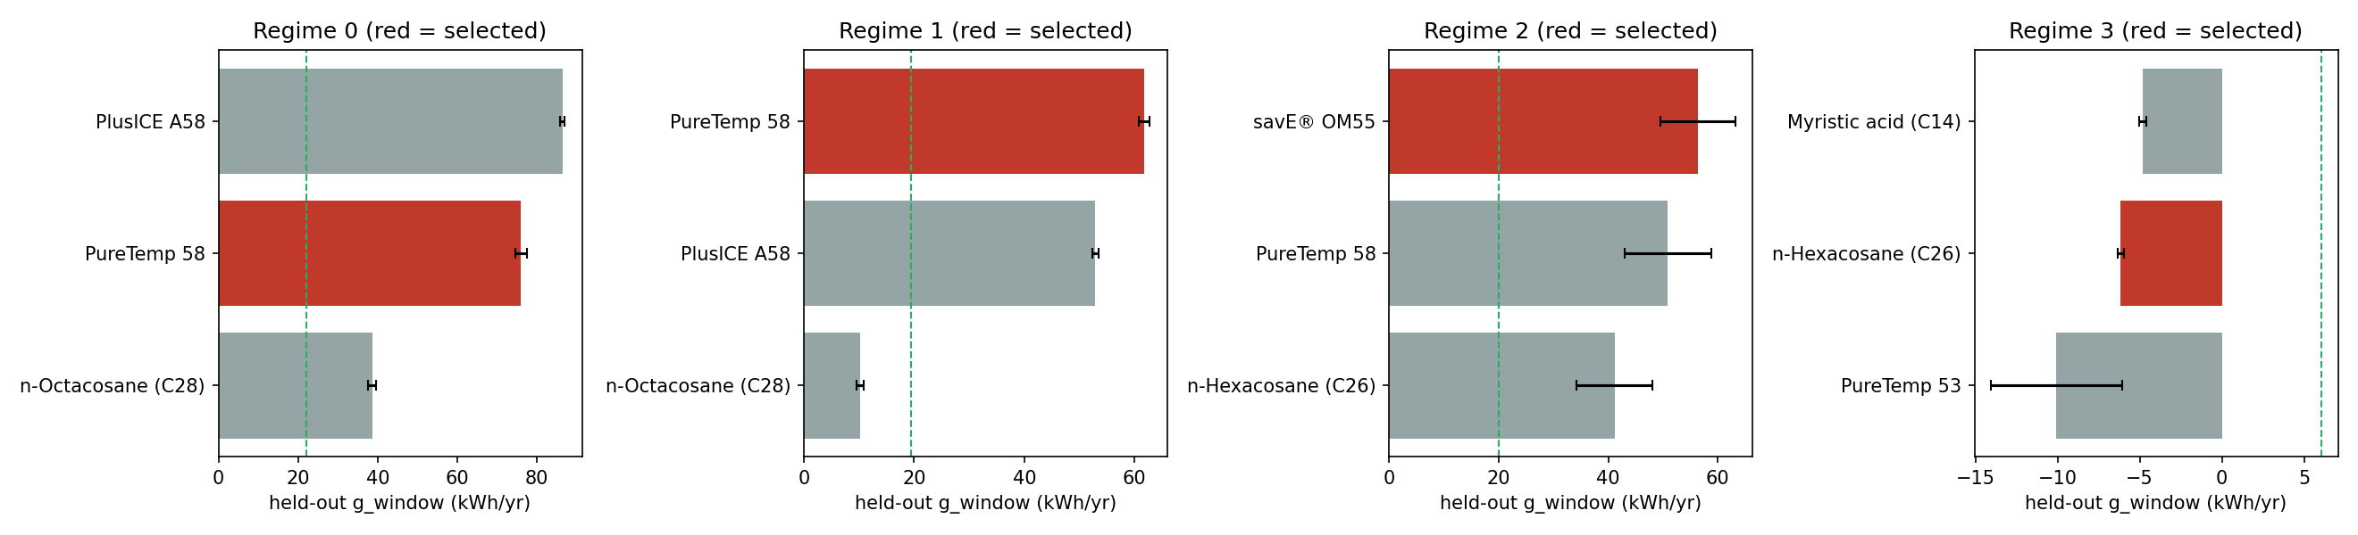
Figure 1. Held-out comparison of the chosen design with the best design of the other O1 PCMs. Source: results/plots/fig4_heldout_pcm_comparison.png (from results/g10_heldout_results.csv)

7.3 Optimiser checks
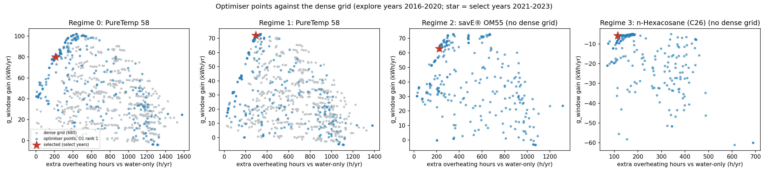
Figure 2. Final Pareto front versus the dense 720-design grid, rank-1 PCM of each regime. Source: results/plots/fig1_front_vs_grid.png (g9_s6_grid_r*_p1.csv, g9 fronts)
Table 29. Where the final Pareto fronts sit relative to the box edges (share of front)
Pair | Front size | R_in at 40 mm end | Fraction at 30 % cap | Fraction at 2 % floor | Flow at 0.010 floor (model artefact) | Flow at 0.050 cap
r0_p1 | 41 | 88 % | 34 % | 0 % | 20 % | 0 %
r0_p2 | 24 | 96 % | 8 % | 0 % | 17 % | 13 %
r0_p3 | 37 | 54 % | 38 % | 0 % | 16 % | 0 %
r1_p1 | 51 | 100 % | 80 % | 0 % | 4 % | 4 %
r1_p2 | 33 | 94 % | 6 % | 0 % | 27 % | 12 %
r1_p3 | 37 | 100 % | 11 % | 0 % | 43 % | 0 %
r2_p1 | 34 | 65 % | 59 % | 0 % | 12 % | 0 %
r2_p2 | 32 | 75 % | 84 % | 0 % | 25 % | 6 %
r2_p3 | 31 | 39 % | 0 % | 0 % | 61 % | 0 %
r3_p1 | 31 | 68 % | 32 % | 0 % | 29 % | 42 %
r3_p2 | 52 | 62 % | 0 % | 83 % | 37 % | 0 %
r3_p3 | 75 | 32 % | 0 % | 7 % | 15 % | 25 %
Source: results/g9_boundary_check.csv
No front sits at the 10 mm radius end. Fronts of regimes 0-2 crowd the 40 mm radius end and, in several pairs, the 30 % cap. In regime 3 the n-Hexacosane front (r3_p2) sits mostly at the 2 % fraction floor - the search itself is trying to remove the PCM.
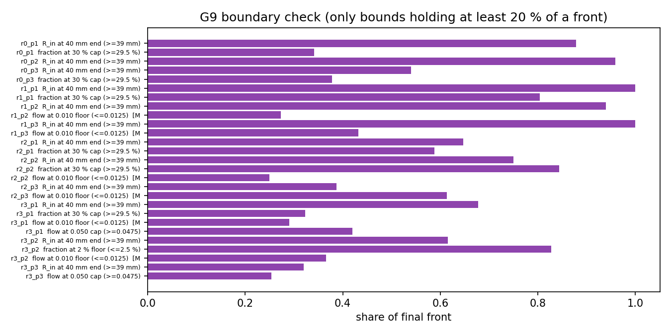
Figure 3. Share of each final front at the radius, fraction and flow bounds. Source: results/plots/fig9_boundary_share.png (from g9_boundary_check.csv)

7.4 Ablations and controls (G11, explore years 2016-2020)
Table 30. g_window (kWh) under one-at-a-time changes around the chosen design
Regime | Band | Chosen | Fraction 2 % | Fraction 10 % | Fraction 20 % | Fraction 30 % | Flow 0.010 | Flow 0.050 | Latent heat = 0 | Synthetic Tm 45 C
0 | 22.0 | 80.4 | 2.6 | 28.3 | 63.0 | 90.5 | 27.4 | 89.1 | -68.8 | 134.6
1 | 19.4 | 71.5 | 0.8 | 19.8 | 44.9 | 71.5 | 18.5 | 73.0 | -83.5 | 134.0
2 | 20.0 | 66.1 | 0.4 | 16.9 | 38.9 | 66.1 | 30.2 | 71.9 | -72.9 | 104.8
3 | 6.1 | -5.5 | -5.5 | -20.1 | -38.6 | -56.3 | -5.5 | -4.7 | -8.6 | -1.1
Source: results/g11_ablation_r{0,1,2,3}.csv
- Negative controls (water-only invariance to design variables, determinism, wall conductivity x10) all returned zero difference. Latent heat = 0 changes the gain by -149.1 / -155.0 / -138.9 kWh in regimes 0-2, so the metric responds to the PCM; in regime 3 only by -3.1 kWh.
- Fraction sweep from 25 % to 30 %: +13.8 / +14.8 / +15.5 kWh in regimes 0-2 (inside the band: the curve flattens but has not stopped rising, see Section 7.8), -9.9 kWh in regime 3. From 20 % to 30 %: +27.5 / +26.7 / +27.2 / -17.8 kWh.
- A synthetic PCM melting at 45 C gives a larger gain than the O1 PCM in every regime (regime 3: -1.1 kWh, still not above zero). This is a control showing that the metric responds to the melting temperature, not a candidate: 45 C is below the 50 C target.
- Moving the capsule stack bottom / centre / top changes the chosen arrangement's gain by 55.8 / 35.3 / 35.2 / 5.3 kWh (regimes 0-3).
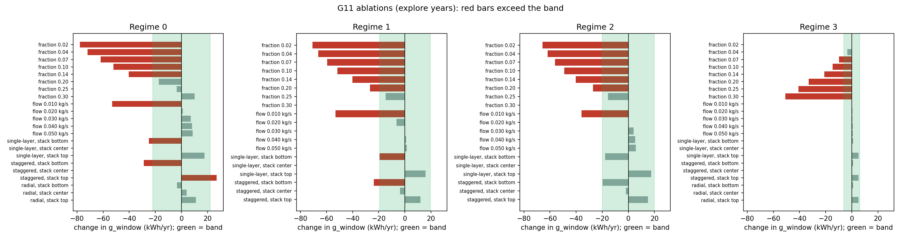
Figure 4. Ablation and control results around the chosen designs. Source: results/plots/fig6_ablations.png (from g11_ablation_r*.csv)
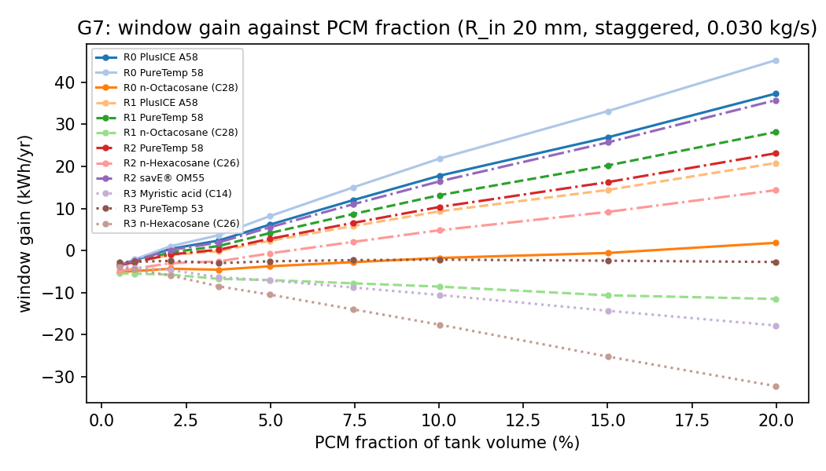
Figure 5. G7 window gain against PCM fraction (R_in 20 mm, staggered, 0.030 kg/s): rising in regimes 0-2, falling in regime 3. Source: results/plots/fig8_fraction_response.png (from g7_sensitivity_paired.csv)

7.5 Shield hours, water side versus PCM side (G13)
Table 31. Like-for-like shield hours, held-out chosen designs (mean per year)
Regime | Water-side h, PCM tank | Water-side h, water-only tank | PCM-side throttle h
0 | 284 | 430 | 346
1 | 142 | 279 | 408
2 | 140 | 233 | 284
3 | 37 | 39 | 88
Source: results/g10_heldout_results.csv (shield_water_h, plain_shield_water_h, shield_pcm_h)
Table 32. Shield split on the select years, chosen designs
Regime | Water-side h, PCM | Water-side h, water-only | d_shield_water h | PCM-side throttle h | d_overheat stored h | Peak water C: PCM / water-only
0 | 310.9 | 465.8 | -154.9 | 365.4 | 210.5 | 72.2 / 73.0
1 | 159.1 | 313.2 | -154.1 | 448.2 | 294.2 | 72.4 / 72.9
2 | 166.4 | 275.4 | -109.0 | 332.4 | 223.4 | 72.3 / 72.9
3 | 47.7 | 50.5 | -2.7 | 116.8 | 114.1 | 72.1 / 72.6
Source: results/g13_shield_split_r{0,1,2,3}.csv
d_overheat is positive by construction because the PCM-side throttle (62 C, blocks charging when the capsules are full) does not exist in a water-only tank. Like for like, the PCM tank has fewer water-side shield hours in 128 of 128 design-years (chosen designs and the best design of every other O1 PCM, explore and select years). The PCM-side hours (91-820 h/yr over these design-years) mean charging is held back, not that a limit was exceeded (highest PCM peak 64.4 C).

7.6 Controls from an interior anchor (G14)
Table 33. Change in g_window (kWh) relative to the anchor (R 25 mm, 10 %, 0.030 kg/s, staggered, centre)
Regime | Band | Anchor g_window | R 10 mm | R 15 mm | R 20 mm | R 30 mm | R 40 mm | Fraction x0.5 | Fraction x2
0 | 22.0 | 27.0 | -18.8 | -10.9 | -5.7 | +2.5 | +1.8 | -16.9 | +29.9
1 | 19.4 | 18.7 | -16.8 | -9.7 | -5.1 | +2.0 | +0.2 | -12.4 | +21.1
2 | 20.0 | 20.7 | -13.8 | -6.8 | -3.3 | +0.7 | -3.3 | -13.3 | +24.3
3 | 6.1 | -14.6 | -8.9 | -4.6 | -2.8 | +0.6 | +0.0 | +5.5 | -11.8
Source: results/g14_controls_r{0,1,2,3}.csv
The metric responds to PCM amount in every regime (x2 adds 21-30 kWh in regimes 0-2; in regime 3 halving the PCM improves the gain and doubling it worsens it). Thickness matters below about 25 mm and is flat above it: R 30 and 40 mm are within the band of R 25 mm, so the 40 mm edge is a plateau, not a distinct peak. The fraction cap for x2 is read from the design space (30 %), not the old hard-coded 20 %.

7.7 Evening (night-serve) decomposition (G16)
Table 34. Evening scenario, select years, every 15th day (18:00 start, no sun, project demand to 09:00)
Regime | tau_serve h: plain / displaced / L=0 / PCM | E_del kWh (to 50 C): plain / displaced / L=0 / PCM | PCM minus plain: tau_serve h, E_del kWh | PCM minus displaced: tau_serve h
0 | 0.364 / 0.195 / 0.233 / 0.253 | 1.080 / 0.617 / 0.866 / 1.288 | -0.111, +0.209 | +0.058
1 | 0.290 / 0.100 / 0.148 / 0.182 | 1.125 / 0.559 / 0.861 / 1.287 | -0.107, +0.161 | +0.083
2 | 0.265 / 0.081 / 0.126 / 0.105 | 1.147 / 0.566 / 0.915 / 1.293 | -0.160, +0.146 | +0.024
3 | 0.091 / 0.089 / 0.090 / 0.087 | 1.151 / 1.114 / 1.127 / 1.135 | -0.004, -0.016 | -0.002
Source: results/g16_serve_r{0,1,2,3}.csv ('displaced' = case plain_40L: a water-only tank of 50 L x (1 - PCM fraction), about 35 L here)
As in Rajasthan, the negative tau_serve gain is the net of two opposite effects: capsules displace water (the displaced-volume water tank serves less) and the PCM wins back part of that (+0.02 to +0.08 h). Energy delivered to 50 C in the same scenario is higher with PCM in regimes 0-2 (+0.15 to +0.21 kWh per night), and the L = 0 case is below the water-only tank, so that gain comes from the latent heat. In regime 3 all four cases are almost equal. The displaced tank is a diagnostic, not a baseline.

7.8 Stack position and widened bounds (G15, G17)
Table 35. Stack-anchor dependence of g_window (kWh), select years, chosen designs
Regime | Band | Bottom | Centre | Top | Range | Best PCM at every position
0 | 22.0 | 51.8 | 80.0 | 106.0 | 54.2 | PureTemp 58
1 | 19.4 | 52.5 | 72.1 | 87.8 | 35.3 | PureTemp 58
2 | 20.0 | 45.0 | 63.0 | 80.8 | 35.8 | savE OM55
3 | 6.1 | -4.6 | -5.8 | -1.0 | 4.8 | Myristic acid (bottom), PureTemp 53 (centre, top), all within 3 kWh
Source: results/g15_anchor_r{0,1,2,3}.csv
For regimes 0-2 the sign of the gain survives every position (smallest mean gain of any kept design at any position 5.0 kWh; chosen designs at their worst position 51.8 / 52.5 / 45.0 kWh), but the level depends on the position by about 1.8 to 2.5 times the band. Quote absolute kWh only as "stack centred (model default)" with the range beside it. No source read settles the mounting position.
Table 36. Widened-bound diagnostic: change in g_window (kWh) versus the chosen design, explore years
Regime | Band | R 30 mm | R 45 mm | R 50 mm | Fraction 25 % | Fraction 30 % | Fraction 40 % | Flow 0.080 | Valid rows | All feasible
0 | 22.0 | -1.5 | -20.7 | -36.3 | -3.7 | +12.3 | +42.5 | +8.2 | 22 / 22 | True
1 | 19.4 | -4.2 | -8.0 | -25.9 | -14.7 | +0.0 | +23.4 | +0.9 | 22 / 22 | True
2 | 20.0 | +5.8 | -18.2 | -40.6 | -15.5 | -0.0 | +22.6 | +6.2 | 22 / 22 | True
3 | 6.1 | +0.4 | -1.1 | -1.2 | -40.9 | -50.8 | n/a (geometry-invalid) | +0.8 | 21 / 22 | True
Source: results/g17_widen_r{0,1,2,3}.csv
The radius edge is not limiting (R 45 and 50 mm are worse at the same fraction) and neither is the upper flow bound (within the band). The 30 % fraction cap is: from 30 % to 40 % the gain rises by +30.2 / +23.4 / +22.6 kWh in regimes 0-2 (regime 0's chosen fraction is 26.3 %, so its 30 % row is already +12.3), beyond the band. In regime 3 more PCM makes the window delivery worse. The wider bounds exist only inside the script; the approved box was not changed.

7.9 Box-vertex step, with and without (G18)
Not run for Uttarakhand. scripts/g18_issue1_compare.py needs 12 extra active-learning runs (about 3 h). The step is a declared part of the recipe since Rajasthan v3, where the comparison showed that without it regime 0 PCM 1 failed the grid check (23.5 kWh vs band 13.8) and with it passed (3.1). In Uttarakhand all four grid checks pass with the step (Section 6.5); whether they would also pass without it is not known.

7.10 Surrogate and gain-by-year figures
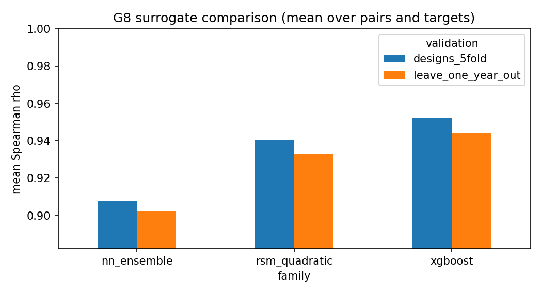
Figure 6. Surrogate comparison on ranking and error. Source: results/plots/fig7_surrogate_comparison.png (from g8_s3_comparison.csv)
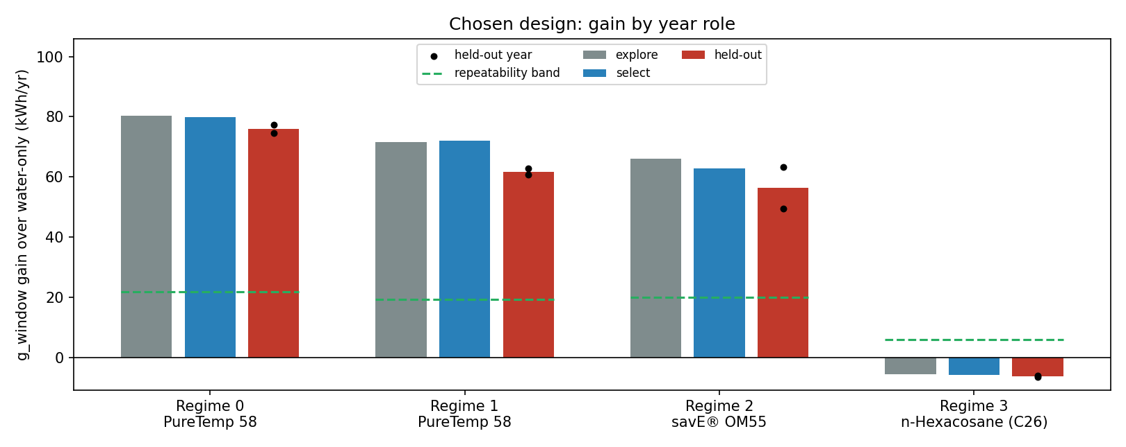
Figure 7. Gain of the chosen designs by year role (explore, select, test); regime 3 below zero. Source: results/plots/fig3_gain_by_year_role.png
All nine result figures are in results/plots/ and are listed in docs/plots/10_PLOTS.md. As in Rajasthan, the 17 older phase figures were removed in the cleanup.

8. Validation and checks run
Table 37. Checks and their outcome
Check | Result
Unit tests | 81 passed (python -m pytest tests -q, 45 s, 2026-10-28, after the cleanup): demand timing (morning peak 07:30), multinode N=1 equals single node, energy closure, CFD draw case (45 C override), weather roles and lock, O1 shortlist, design space, ANOVA, metrics hand-calculations at the 50 C target
Time-step convergence | 150 s passes on halving to 75 and 37.5 s (largest change 0.029 %, criterion 0.05 %)
Energy closure | Largest annual residual 0.076 % (criterion below 0.1 %); multi-node about 1e-12 %
Phase-4 gates (G6) | Gate 1 PASS (8 cases incl. a regime-3 cold-mains case, max 0.073 %); Gate 2 PASS (12/12); Gate 3 PASS; Gate 4 PASS-WITH-CAVEAT (33.1 % solar fraction vs the 54-84 % band: 50 L tank for 300 L/day, no backup heater; reported, not tuned); Gate 5 PASS (3/3). All 12 O1 PCMs verified (worst residual 0.072 %). GO
CFD draw-case agreement | N = 10 gives 22.5 L, N = 40 gives 26.1 L against 27 L from CFD (model-to-model only)
Weather QC | 40/40 point-years accepted, 100 % valid hours, no gaps
Surrogate validation | Within-pair 5-fold and leave-one-year-out; used only for ranking
Dense-grid check | Within band in all four regimes (eps 0.45 / 2.56 / 0.16 / 2.77 vs band 17.99 kWh); partly dependent on the vertex step
Seed stability | 3 seeds, spread inside band for 12/12 pairs
Negative / positive controls (G11, G14) | Zero differences for invariance, determinism, inert wall; latent heat = 0 removes the gain; fraction x2 responds in every regime
Held-out lock | Test run once (heldout_c75ac0e6fb78); a second run refuses
Doc check | scripts/g12_verify_docs.py: 161 file references in docs/, 0 missing
Source: tests/; docs/PROGRESS.md; results/phase4_verification_o1_pcms.txt; results/

9. Result registry and provenance
results/results_registry.csv holds 535 quantities (id, value, unit, source file, filter) generated by scripts/g12_registry.py. docs/04_RESULTS.md is generated from the saved files by scripts/g12_results_doc.py (rewritten for Uttarakhand so that the numbers inside the reading sentences are also computed from the files, not typed by hand) and checked by scripts/g12_verify_docs.py. The selection logs are fingerprinted (regime 0: 9466c3c2...), and the Objective 3 contract stores SHA-256 hashes of the selection logs, the band file, the held-out results and the config files.

10. Limitations and open items

10.1 What the results do not support
- PCM does not help in regime 3. In the cold, high-altitude regime (UKP_0041, mains 7.4 C, lowest sun, 3 grid points) no design of any of the three O1 PCMs beats the water-only tank by more than the band; the more PCM, the worse (-20 kWh at 10 %, -56 kWh at 30 %), and latent heat barely matters (L = 0 changes the gain by -3 kWh). The honest output is "no PCM" for regime 3.
- Still boundary-limited at the 30 % cap in regimes 0-2. Chosen radius 39.3-39.8 mm, fraction 26-30 %; 30 % to 40 % adds +23 to +30 kWh, beyond the band. The best PCM amount is unknown and is not claimed.
- Level of the gain depends on the unvalidated stack position. Range over bottom / centre / top is 35-54 kWh against bands of about 19-22 kWh; the sign survives.
- PCM choice inside a regime is not resolved. The runner-up PCM is within the band of the chosen one on the test years in every regime.
- Flow optima are not physical. Collector F_R does not depend on flow; flow at the 0.010 floor appears on up to 61 % of a final front (r2_p3). Regime 3's 0.010 pick is the same artefact.
- Night-serve duration is not improved against the fixed 50 L tank (water displacement). Energy delivered in the evening does rise in regimes 0-2.
- Shield hours: d_overheat mixes water-side and PCM-side terms; the PCM-side throttle (91-820 h/yr) is real.
- Delivery target 50 C (Rajasthan 45 C): the kWh of the two states are not directly comparable.
- Tank-model convergence: N = 10 vs 20 changes useful energy by 0.8-1.0 %; part of the band.
- Weather: one medoid point per regime, 10 years (2016-2025); the test years are below average in every regime but not the two lowest in every regime.
- No measurements. Nothing is validated against hardware or field data; CFD agreement is model-to-model.
- G18 not run (Section 7.9).

10.2 Items for Dr. Deepika and the O1 owner
- Regime 3: confirm that a water-only recommendation is acceptable for the cold regime, or whether a different PCM (melting between the 50 C target and about 55 C) or a larger collector should be studied. O1's top-3 for regime 3 (PureTemp 53, n-Hexacosane, Myristic acid) do not help in this model.
- Fraction cap: 30 % is still limiting in regimes 0-2. Raising it would need a new untouched test period, because 2024-2025 is now used.
- Sizing: 33.3 L/m2 is below the IS 12976:2023 range of 40-100 L/m2.
- Collector F_R(flow): a cited flow-dependent correction would remove the flow artefact.
- Delivery temperature: Uttarakhand 50 C vs Rajasthan 45 C; decide whether the states should report at a common target (a shared-config change for all states).
- No feedback from O2 to O1: O1 does not use O2 achievable temperatures and loading; for regime 3, O2 suggests the O1 ranking does not reflect usefulness in this tank.
- O1 conductivity: unlike Rajasthan, the O1 ranking table and the PCM database agree for all 7 Uttarakhand PCMs; nothing to resolve.
- Safety: at the illustrative mid design the O1 PCMs reach 62.0-66.3 C (single node; PureTemp 58 and PureTemp 53 exceed 65 C); the 65 C rule is a feasibility constraint and O3 shield design should cover it.
- Gate 4 solar fraction is below the 54-84 % band; reported, not tuned.

11. Handoff to Objective 3
File: results/obj3_environment_contract_uttarakhand_v2.json, written by python -m src.handoff.build_obj3_contract_v2. It supersedes the legacy K = 5 contract in results/uttarakhand/ (UTC demand, single-node tank), which must not be used for training.
Table 38. Environment contract v2 (Uttarakhand)
Item | v2 content
Simulator | Multi-node N = 10, dt 150 s, local-time demand, inner-volume PCM mass with wall mass, O1 top-3 PCMs
State vector | Rajasthan v2's, incl. T_water_top_C, T_water_bottom_C, recoverable_energy_above_45C_kWh (computed above 50 C here; cross-state field name kept), minutes_since_last_draw
Actions | Charge / discharge / bypass plus continuous flow in 0.010-0.050 kg/s
Limits and shield | Delivery 50 C, water 75 C, PCM 65 C; bypass at top node 72 C and PCM 62 C
Weather sequences | Training 2016-2020, validation 2021-2023; 2024-2025 held out (used once by O2; O3 must not tune on it); points UKP_0014 / 0029 / 0025 / 0041
Regimes | 4: chosen design, best design of each other O1 PCM, select-year and held-out results, WP6 bands; regime 3 flagged meaningful_on_primary_metric = false
Reward | Suggestion from the WP1 metrics; weights not chosen; pump term removed
Provenance | SHA-256 of the four selection logs, band file, held-out results and config files
Source: docs/06_OBJECTIVE3_HANDOFF.md; results/obj3_environment_contract_uttarakhand_v2.json
- The case for a controller is hour-by-hour operation (the PCM-side throttle, the evening serve time the passive design does not extend), not that the best PCM changes with weather.
- Regime 3 should be treated as a water-only tank, or as a case where a controller has no passive PCM benefit to build on.
- Compare any controller against the same-flow water-only twin and the passive PCM design, on the explore and select years only.

12. Doc and code discrepancies
Table 39. Disagreements found while preparing this report
Item | What the files say | Resolution
Time step | Before the cleanup the YAML said 300 s and a code override set 150 s | Resolved in the cleanup: the YAML now says 150 s (as in Rajasthan)
Column names ...45 | E_del45, serve_frac_45, recoverable_energy_above_45C_kWh | Computed at the Uttarakhand 50 C target; names kept so the files match Rajasthan's
G7 PCM peaks | docs/02 said peaks stayed at 63-65 C; g7_sensitivity_paired.csv has 62.0-67.1 C (48 of 568 rows above 65 C) | docs/02 corrected while preparing this report
Front size | g9_grid_check.csv n_final_front (e.g. r0_p1 38) differs from g9_boundary_check.csv n_front (41) | Different front definitions in the two checks (grid comparison vs boundary detector); both kept as written
Bands in the grid check | g9_grid_check.csv uses the all-regime band 17.99 kWh | Regime bands (wp6_band.csv) are used everywhere else
Gate 4 solar fraction | phase4 report: 33.1 % (single-node 'optimized-looking' design); docs/05: 0.24-0.30 at the illustrative designs (multi-node) | Both are below the 54-84 % band; the difference is the tank model and the design
Phase-4 report footer | Mentions a legacy tag sim_v2_uttarakhand (2026-09-17) | Legacy text in a saved output; not used
Regime 3 'chosen' design | g10_selection_r3.json has a chosen block like the other regimes | meaningful_on_primary_metric = false; read as 'no PCM', not as a design to build
Legacy chain | docs_objective2/, results/uttarakhand/, the K = 5 configs and build scripts described the old chain | Removed in the cleanup that mirrors Rajasthan (git history only); README rewritten
O1 conductivity | Rajasthan found ranking-table vs database conductivity differences | Checked for Uttarakhand: all 7 shortlisted PCMs agree; the discrepancy does not apply
Source: files named in each row

Appendix A. File-to-stage index
Table 40. Main files per stage
Stage | Inputs | Outputs
Inputs (K = 4) | ../era5-uttarakhand outputs | data/objective1/*, manifest.json, configs/states/uttarakhand.yaml, data/weather/weather_regime_uttarakhand_cluster{0-3}_*.csv
G2-G4 | data/legacy/g2_g4_illustrative_designs.csv | g2_timestep_convergence_150_75_37p5.csv, g3_metrics_report.csv, g4_*.csv
G5 | raw NASA POWER JSON (O1 folder) | data/weather/point_years/weather_inventory.csv and 40 point-year files
G6 | O1 top-3 | phase4_verification_o1_pcms.txt
G7 | explore 2018-2019 | g7_sensitivity_r*.csv, g7_sensitivity_paired.csv, g7_max_packing_fraction.csv, g7_plain_flow_baseline.csv
G8 | design space | g8_s1_*, g8_s2_*, g8_s3_*, plain_baseline_*
G9 | surrogates | wp6_band.csv, g9_band_*, g9_al_*, g9_points_*, g9_seed_front_*, g9_ref_*, g9_s6_grid_*, g9_seed_stability.csv, g9_grid_check.csv, g9_boundary_check.csv
G10 | fronts | g10_selection_r*.json, g10_selection_candidates_r*.csv, g10_heldout_results.csv, held_out_test.lock
G11, G13-G17 | chosen designs | g11_ablation_r*, g13_shield_split_r*, g14_controls_r*, g15_anchor_r*, g16_serve_r*, g17_widen_r*
G12 | all results | results_registry.csv, docs/04_RESULTS.md, obj3_environment_contract_uttarakhand_v2.json, results/plots/
Source: results/ listing; docs/03_OPTIMISATION_PIPELINE.md

A.1 Files removed as legacy
Removed in the cleanup of 2026-10-28 to match Rajasthan (git history only): the legacy K = 5 chain (results/uttarakhand/, docs_objective2/, configs/design_bounds_shared.yaml, configs/cfd_closure_v1.yaml), the build scripts and old root notes, unused O1 copies and raw weather, data/legacy/k5_weather/, unused legacy modules, scripts/g19_fetch_test2_weather.py and the 17 phase figures. Results were re-checked after the cleanup and are unchanged.

Appendix B. How to reproduce
Python 3.12, from objective2-uttarakhand/:
python -m pytest tests
python scripts/g2_timestep_convergence.py 150,75,37.5 results/g2_timestep_convergence_150_75_37p5.csv
python scripts/g3_metrics_report.py ; python scripts/g4_multinode_report.py
python -c "from src.weather.inventory import build_inventory; build_inventory()"
python pipeline.py --state uttarakhand --stage verify (then sensitivity baseline screening doe surrogate band optimize select)
python scripts/g7_paired.py
python scripts/g10_test.py --confirm-run-once (ONLY ONCE - already done; refuses now)
python scripts/g11_ablation.py <regime> (and scripts/g13 ... g17, regime = 0 1 2 3)
python scripts/g12_registry.py ; python scripts/g12_results_doc.py ; python scripts/g12_verify_docs.py
python run_all_uttarakhand.py (tests + report + handoff + plots from saved results)

