ANSYS Fluent: Tamil Nadu PCM Tank Design
Objective 2 — Complete models, parameters, and how to open them
Quick Start: Run the models immediately
The easiest way to see the working models is the live demo — no manual steps needed:
cd ansys
python fluent_live_demo.py
# Watch the melt front advance in the Fluent window for ~30 minutes
You can also specify which regime:
python fluent_live_demo.py --regime 0 # Regime 0 (default)
python fluent_live_demo.py --regime 1 # Regime 1
python fluent_live_demo.py --regime 2 # Regime 2

The Three Optimal Designs — All Parameters
Regime | PCM | Capsules | Diameter | PCM Mass | Flow Rate | Arrangement
0 | PureTemp 58 | 104 | 81.6 mm | 24.81 kg | 0.0388 kg/s | Staggered
1 | RT57HC | 98 | 81.6 mm | 23.64 kg | 0.0295 kg/s | Staggered
2 | RT57HC | 105 | 81.6 mm | 25.33 kg | 0.0267 kg/s | Staggered

Regime | PCM Tm (°C) | Useful Energy (kWh/yr) | Solar Fraction | Max Water (°C) | Max PCM (°C)
0 | 58.0 | 1,668.65 | 65.2% | 72.3 | 62.3
1 | 56.5 | 1,763.44 | 57.8% | 72.4 | 62.4
2 | 54.0 | 1,679.40 | 64.7% | 72.4 | 62.4

Fixed System Parameters (All Regimes)
Parameter | Value | Unit
Tank volume | 100 | L
Tank diameter | 399 | mm
Tank height | 799 | mm
Tank insulation | 50 | mm
Tank wall U-value | 0.8 | W/m²K
Collector area | 2.5 | m²
Collector (FRτα) | 0.75 | –
Collector (FRUL) | 4.5 | W/m²K
Capsule material (shell) | Aluminum (Al) | –
Capsule shell thickness | 1.0 | mm
Mains temperature (est.) | 28.5 avg | °C
Demand target | 45 | °C
Max safe water temp | 75 | °C
Max safe PCM temp | 65 | °C
Pump efficiency | 0.6 | –
Max system pressure | 3.5 | bar

The Solved Models — What You'll See
Figure 1: Tank + PCM Capsules + Collector Panel (Mesh View)
This is the full 2D system showing all components meshed and ready for CFD:
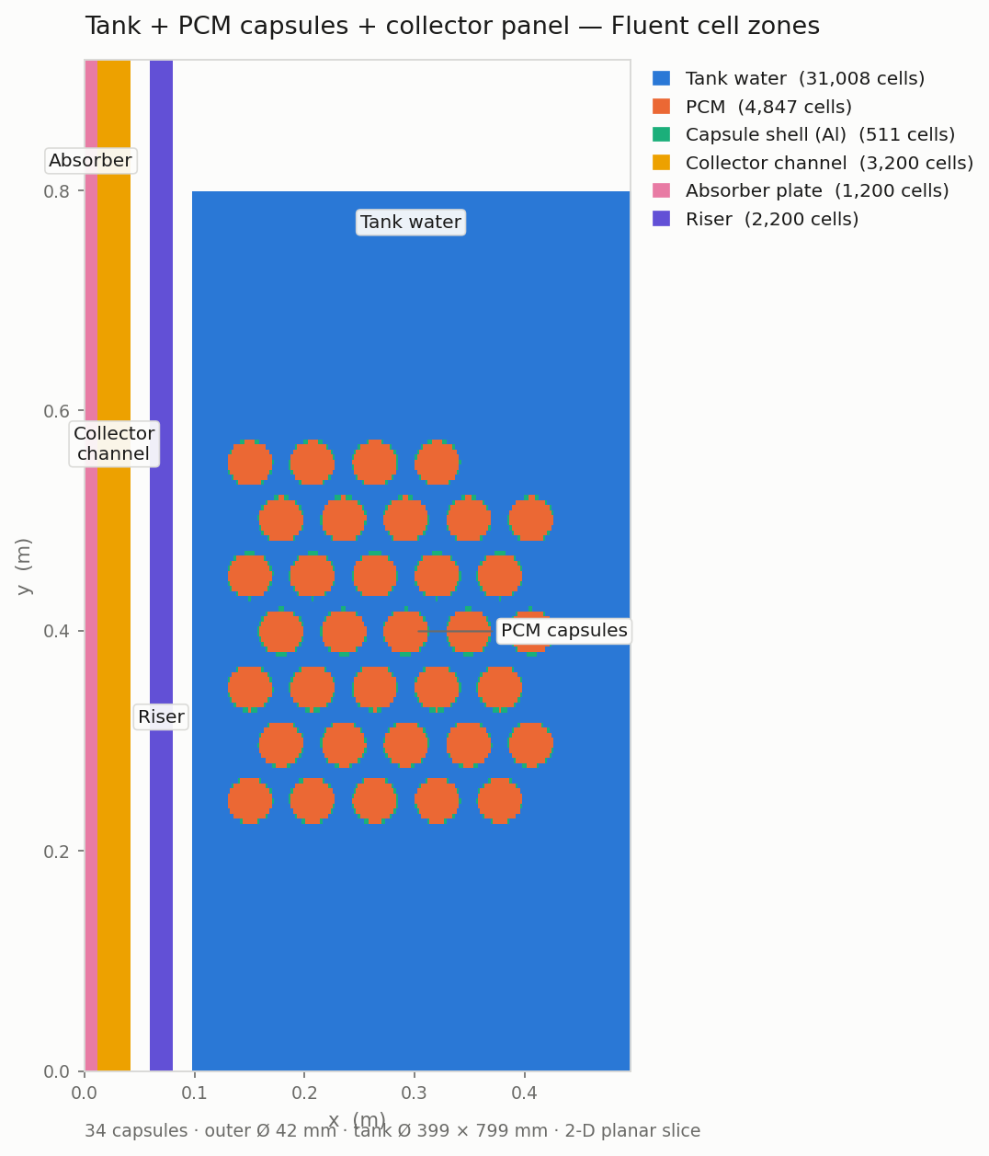
Figure 1 — Tank, 34 PCM capsules in staggered arrangement, collector panel with absorber and riser.
Cell zones: Tank water (31,008), PCM (4,847), Capsule shell (511), Collector (3,200), Absorber (1,200), Riser (2,200).
Total mesh: 42,966 cells. Geometry from optimal design; capsule radius derived from diameter by optimizer.

Figure 2: Temperature Field During Charging
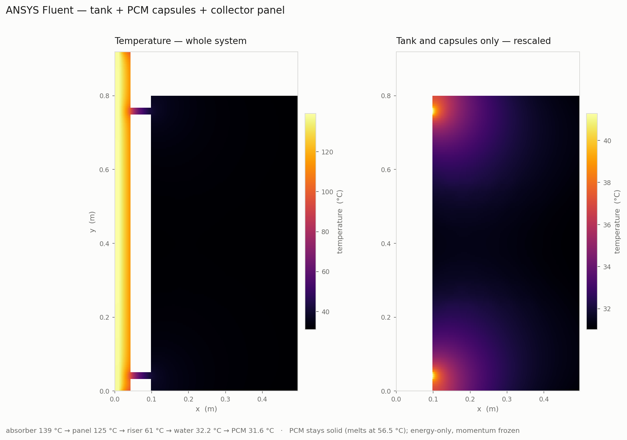
Left: Full system showing absorber (139 °C) → panel (125 °C) → riser (61 °C) → tank (32 °C).
Right: Tank and capsules only, rescaled to show detail. Heat path confirmed end-to-end, but PCM stays solid here (energy-only case).
This figure verifies the geometry and heat conduction pathways — the proof that PCM actually melts is Figure 3.

Figure 3: PCM Melting Comparison — All Four Materials
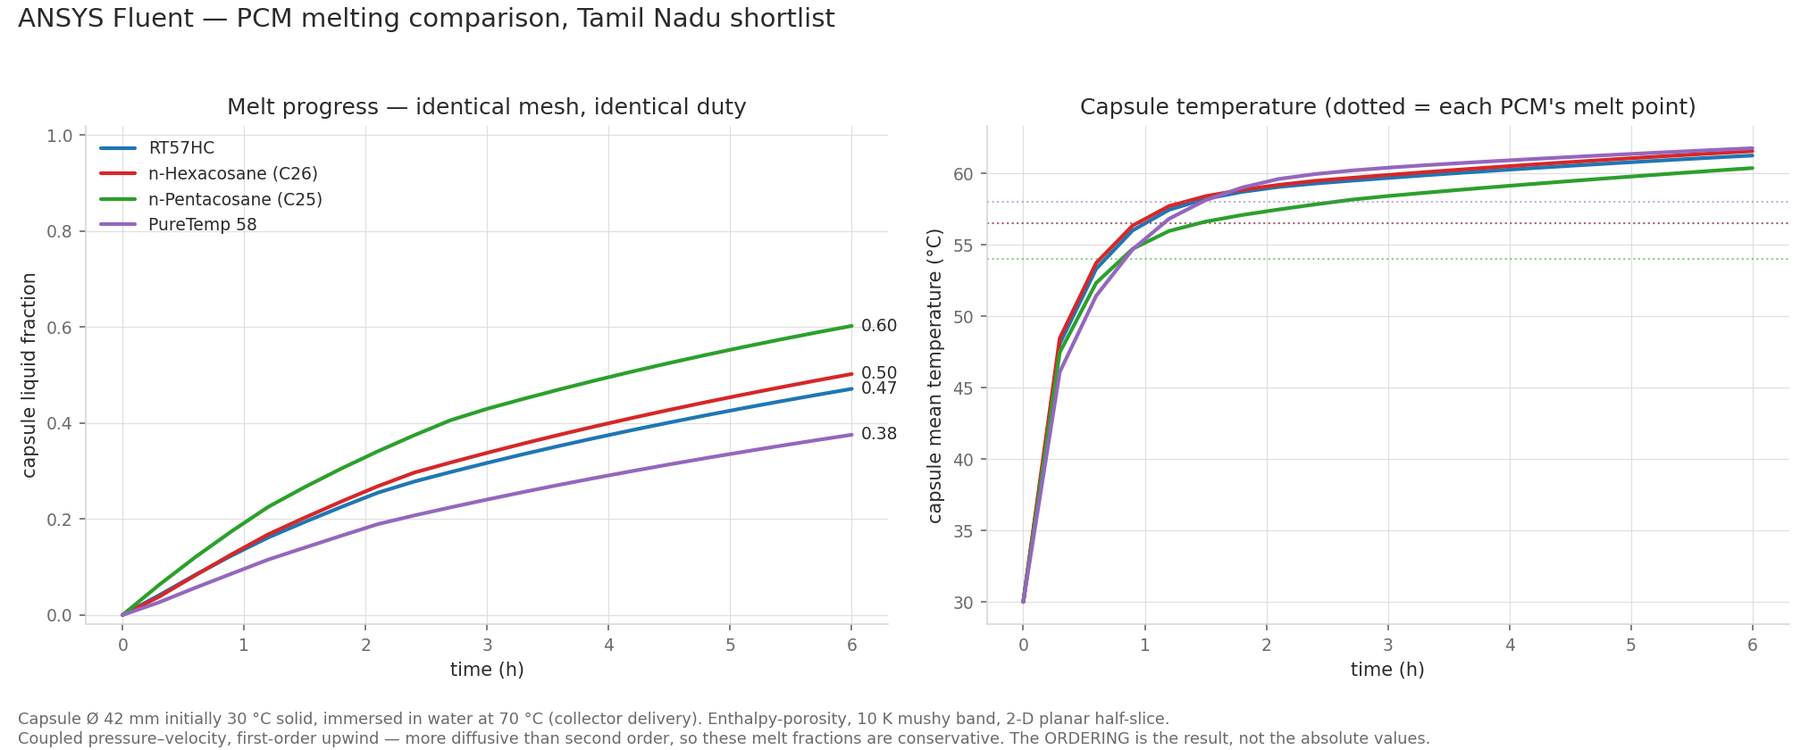
Left: Liquid fraction over 6 hours. Right: Capsule mean temperature (dotted lines show melt points).
All four PCMs on one mesh under one duty (42 mm Ø, 30→70 °C). Differences = material physics only.
PCM | Melt Point | Conductivity | Melt Fraction @ 6 h
n-Pentacosane (C25) | 54.0 °C | 0.239 W/m·K | 0.60 (fastest)
n-Hexacosane (C26) | 56.5 °C | 0.238 W/m·K | 0.50
RT57HC | 56.5 °C | 0.200 W/m·K | 0.47
PureTemp 58 | 58.0 °C | 0.150 W/m·K | 0.38 (slowest)
All four PCMs solved with zero divergences. The ordering (C25 > C26 > RT57HC > PureTemp) is physically correct because it follows melt point and thermal conductivity exactly.

Figure 4: Spatial Fields Inside the Capsule — Per Regime
These contours are rendered directly by Fluent from the solved field data for each regime's winning PCM (no post-processing reconstruction). Each pane is a 2D half-slice: the symmetry axis runs along the bottom edge, so the capsule appears as a half-dome sitting in the flowing hot water. The capsule shows a cold solid core (blue) wrapped by a melt front (cyan–green ring), while the surrounding water is hot and fully liquid.
Regime 0 — PureTemp 58
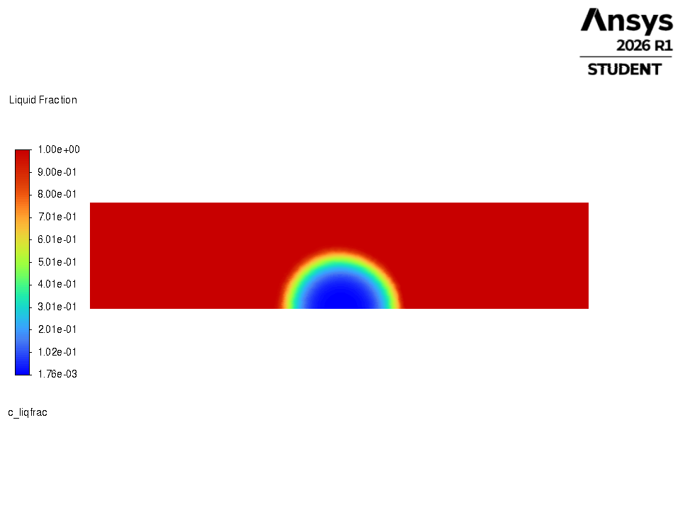
Liquid fraction — Regime 0 (PureTemp 58). Red = molten water (LF ≈ 1); blue capsule core = solid PCM (LF ≈ 0); cyan–green ring = the advancing melt front.
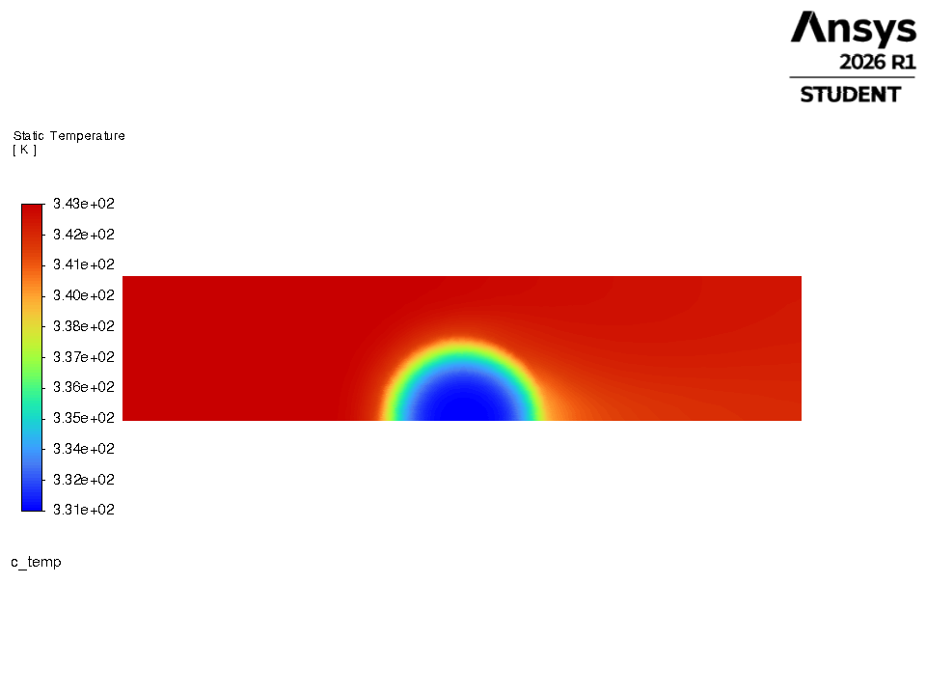
Static temperature (K) — Regime 0 (PureTemp 58). Hot water ≈ 343 K (70 °C); cold capsule core at the PCM melt point; faint warm plume downstream shows advection past the capsule.
Core at ~331 K (58 °C) = PureTemp 58's melt point; the slowest-melting PCM, so the solid core is the largest of the three.

Regime 1 — RT57HC
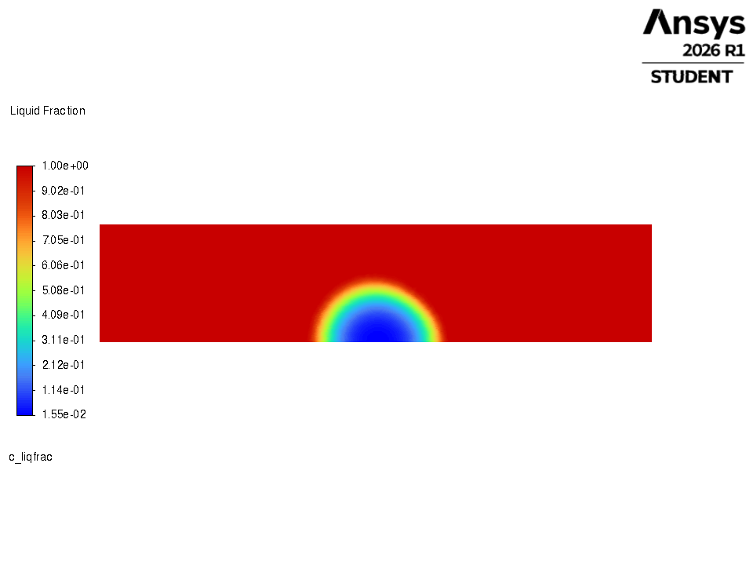
Liquid fraction — Regime 1 (RT57HC). Red = molten water (LF ≈ 1); blue capsule core = solid PCM (LF ≈ 0); cyan–green ring = the advancing melt front.
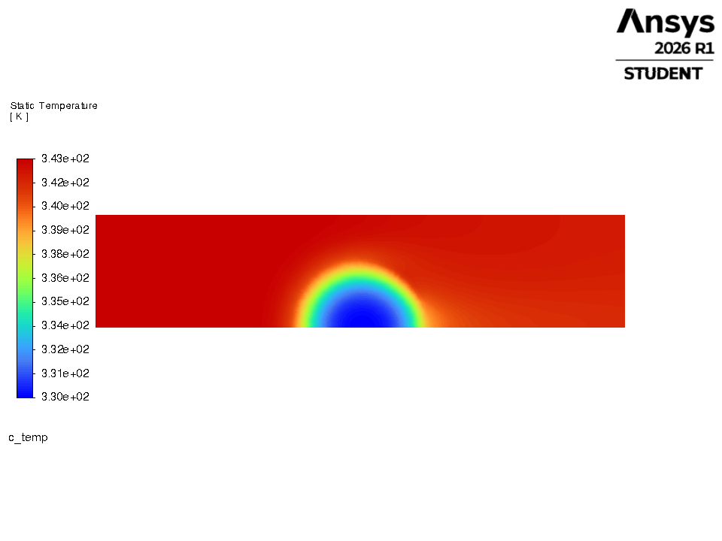
Static temperature (K) — Regime 1 (RT57HC). Hot water ≈ 343 K (70 °C); cold capsule core at the PCM melt point; faint warm plume downstream shows advection past the capsule.
Core at ~330 K (57 °C) = RT57HC's melt point; a slightly smaller solid core than Regime 0, matching its lower melt point and faster melting.

Regime 2 — RT57HC
Liquid fraction — Regime 2 (RT57HC). Red = molten water (LF ≈ 1); blue capsule core = solid PCM (LF ≈ 0); cyan–green ring = the advancing melt front.
Static temperature (K) — Regime 2 (RT57HC). Hot water ≈ 343 K (70 °C); cold capsule core at the PCM melt point; faint warm plume downstream shows advection past the capsule.
Regime 2 also selected RT57HC, so the single-capsule melt field is the same as Regime 1. The regimes differ at tank scale (105 vs 98 capsules, different flow rate), not in the per-capsule PCM physics shown here.

How these were made: ansys/export_contours.py loads each solved .cas.h5/.dat.h5, builds a native Fluent banded contour of the field, and exports it with results.graphics.picture.save_picture — the same graphics path the live demo uses, so the image is Fluent's own render of the real mesh.

How to Open and View the Models in ANSYS Fluent GUI
All three regimes have pre-solved case files (.cas.h5) ready to open. You can view the results without re-solving.
Step 1: Launch Fluent
- 1. Open ANSYS Workbench or Fluent directly
- 2. Select: 2D, Double Precision, 2 processes
- 3. Click OK to launch Fluent
If you see: "Unexpected license problem; exiting" → A stray license process is running. Kill it and retry:
Get-Process ansyscl -ErrorAction SilentlyContinue | Stop-Process -Force
Step 2: Open a Case File
- In the Fluent menu: File → Read → Case...
- Navigate to: objective2_design_optimization/ansys/
- Choose one of these:
  - v7_puretemp58.cas.h5 (Regime 0, PureTemp 58, solved — melt field)
  - v7_rt57hc.cas.h5 (Regime 1, RT57HC, solved — melt field)
  - v7_rt57hc.cas.h5 (Regime 2, RT57HC — same PCM solve as Regime 1)

Step 3: Verify Settings
Once opened, check General tab:
- Space: 2D Planar (not axisymmetric — these are planar cases)
- Time: Transient (cases were solved over 6 hours)

Step 4: View Results
- Go to: Results → Contours
- Display → Temperature (or Liquid Fraction for PCM melting state)
- You'll see the solved temperature/melt field across all zones
Or create a report: Reports → Reference Values → Copy the peak temperatures

How to Open Each Figure in ANSYS — File by File
Each figure above maps to a specific case file and a specific display. Open the file named, then follow the clicks. Quick map:
Figure | Open this file | Then display
1 — Tank + capsules + panel (mesh) | system_tank_pcm_panel_setup.cas.h5 | Graphics → Mesh, colour by Zone
2 — Temperature field | system_tank_pcm_panel_solved.cas.h5 (+ .dat) | Contours → Static Temperature
3 — PCM melt comparison (chart) | v7_c25 / v7_c26 / v7_rt57hc / v7_puretemp58 (+ .dat) | Contours → Liquid Fraction (per PCM)
4 — Per-regime spatial fields | v7_puretemp58 (R0), v7_rt57hc (R1/R2) (+ .dat) | Contours → Liquid Fraction / Temperature

Figure 1 — Tank + PCM Capsules + Collector Panel (mesh & zones)
- File → Read → Case… → ansys/system_tank_pcm_panel_setup.cas.h5 (mesh only — no .dat needed)
- Left tree: Results → Graphics → Mesh → double-click
- In the Mesh panel: tick all zones under Surfaces, set Coloring → Zone → Display
- You'll see the full system coloured by cell zone — tank water (31,008), PCM capsules (4,847), Al shell (511), collector (3,200), absorber (1,200), riser (2,200); 42,966 cells total
Figure 2 — Temperature Field During Charging
- File → Read → Case & Data… → ansys/system_tank_pcm_panel_solved.cas.h5 (its .dat loads automatically)
- Results → Graphics → Contours → New
- Contours of: Temperature → Static Temperature → select all surfaces → tick Filled → Display
- Full-system view: absorber ~139 °C → panel ~125 °C → riser ~61 °C → tank ~32 °C
To get the right-hand "tank-only" panel: in the Contours panel untick Auto Range, set Min/Max to the tank's own range (≈ 305–335 K), and Display again. This rescales the colour map so tank detail is visible instead of one flat block (the absorber is so much hotter it otherwise dominates the scale).
Figure 3 — PCM Melt Comparison (four materials)
Figure 3 is a chart drawn from four solved runs, not a single Fluent window. Two ways to reproduce it:
- Fastest — redraw the chart: python ansys/plot_v4_pcm_comparison.py re-reads the melt-history CSVs and regenerates 03_pcm_melt_comparison.png
- In ANSYS — view each PCM's field: open each of v7_c25 / v7_c26 / v7_rt57hc / v7_puretemp58 (.cas.h5 + .dat.h5), then Results → Contours → Liquid Fraction. Viewing the four is what the chart summarises.
The raw numbers behind the curves are in ansys/v7_<pcm>_melt_history.csv (time, liquid fraction, capsule temperature). Final rows read 0.60 / 0.50 / 0.47 / 0.38 for C25 / C26 / RT57HC / PureTemp 58.
Figure 4 — Per-Regime Spatial Contours
- Regime 0: File → Read → Case & Data… → ansys/v7_puretemp58.cas.h5
- Regimes 1 & 2: ansys/v7_rt57hc.cas.h5 (same PCM, so same single-capsule field)
- Results → Contours → Liquid Fraction (melt front) or Static Temperature → Display — these are the exact images in Figure 4

Understanding the File Names
File Type | Example | What It Is
.cas.h5 | regime0_v3_mesh_only.cas.h5 | Case file — geometry + mesh only
.cas.h5 | regime0_v3_c26_melting.cas.h5 | Case file — mesh + solved results (temperature & liquid fraction)
.dat.h5 | regime0_v3_c26_melting.dat.h5 | Data file — companion to .cas file; must be in same folder
.msh | regime0_v3_capsule.msh | Mesh file (gmsh format) — source geometry before Fluent import
To open a case: you need BOTH .cas.h5 and .dat.h5 in the same folder. They are paired.

Live Demo Command Options
Flag | Values | Default | What It Does
--regime | 0, 1, or 2 | 0 | Which climate regime to run
--hours | any number | 6 | Physical simulation time (hours)
--dt | seconds | 20 | Timestep (default is stable; don't change unless you know what you're doing)
--headless | – | off | Run without opening the Fluent window (for testing)
--rebuild-mesh | – | off | Build a fresh mesh at the optimal radius instead of reusing v3 mesh
Examples:
python fluent_live_demo.py --regime 1 --hours 3
python fluent_live_demo.py --regime 2 --headless
python fluent_live_demo.py --hours 1 # Quick 1-hour look at Regime 0

What the Outputs Tell You
Useful Energy (kWh/yr)
Heat delivered to demand hours (evening) above 45 °C target. Higher is better. Range: 1,668–1,763 kWh/yr.
Solar Fraction
Fraction of annual demand met by solar (PCM + tank + collector). Range: 57.8–65.2%.
Constraint Margins
How much headroom below the hard safety limits:
- Water max: 75 °C hard limit. Designs peak at 72.3–72.4 °C → ~2.7 °C margin
- PCM max: 65 °C hard limit. Designs peak at 62.3–62.4 °C → ~2.7 °C margin
All three designs stay safely within limits under nominal operation.

Known Limitations & Caveats
- First-order upwind is the only discretisation under which all four PCMs converge. It is more diffusive than second order, so the reported melt fractions (Figure 3) are conservative — read the ordering, not the absolute values.
- The mesh is a 2D symmetry half-slice, so buoyancy-driven convection inside the melting PCM is excluded. The tank model carries this enhancement empirically by design.
- Temporal resolution: Figures 1–2 are energy-only (no flowing water). Figure 3 is a standalone duty (capsule in 70 °C water). Full system dynamics are in the tank model that runs the optimization.
- These cases verify that the physics assumptions made in the fast tank model are sound. They do not re-derive the optimal designs — designs were chosen by the tank model + NSGA-II, then verified here in CFD.

Provenance: Plot Code, Parameter Values, Validation & the 100 L Tank
Where the final plot code lives
Figure / plots | Script | Reads → writes
Results figures (G7–G11) | src/plots/make_plots_results.py | results/*.csv → results/plots/*.png (150 dpi)
Fig 1 — system mesh & zones | src/cfd/plot_system_mesh.py | solved system case → 01_system_mesh_zones.png
Fig 2 — temperature field | src/cfd/plot_system_fields.py | system_…_solved → 02_system_temperature_field.png
Fig 3 — PCM melt comparison | ansys/plot_v4_pcm_comparison.py | v7_<pcm>_melt_history.csv → 03_pcm_melt_comparison.png
Fig 4 — per-regime contours | ansys/export_contours.py | v7_puretemp58 / v7_rt57hc cases → regime_contours/*.png
Every plot script only READS saved files — nothing is re-simulated and no number is typed by hand (the make_plots_results.py header states this explicitly). Figures 1–3 come from solved Fluent cases; Figure 4 is rendered natively by Fluent; the G-series figures come from the optimiser's saved CSVs.
How the parameter values were set
Values come from three places, never guessed into the plots:
- Fixed system constants — configs/system_config_shared.yaml (FROZEN at Phase 0A, identical for all four states). Each value is a cited engineering assumption or a solver setting: collector 2.5 m², F_R(τα)=0.75, F_R·U_L=4.5 W/m²K; tank 100 L, U=0.8 W/m²K; 0.8 mm aluminium shell (k=205); safety 75 °C water / 65 °C PCM; shield bypass 72/62 °C.
- What the optimiser may vary — configs/design_space.yaml: capsule inner radius 10–40 mm, PCM volume fraction 2–30 %, flow 0.010–0.050 kg/s, arrangement {single-layer, staggered, radial}. Hard constraints: PCM peak ≤ 65 °C, water ≤ 75 °C in every simulated year.
- PCM thermal properties — taken from the Objective 1 database (data/objective1/pcm_database_tamilnadu.csv). No new PCMs are introduced in Objective 2; the shortlist (RT57HC, C25, C26, PureTemp 58) is Objective 1's output.
The final chosen numbers are the optimiser's own output in results/tn_optimal_designs.csv — the capsule counts, masses and flow rates quoted in the tables above are read from that file, not set by hand.
How the designs are validated
- Two independent simulators. A fast 10-node tank model evaluates and ranks designs; ANSYS Fluent is an independent CFD physics cross-check that chooses nothing — it only confirms the melting physics the tank model assumes.
- Convergence gate. Annual useful energy must change < 0.05 % when the timestep is halved. Only 37.5 s passes (0.041 %); the 150 s search step has Richardson error ≤ 0.17 %, far inside the repeatability band, so design ranking is unaffected. Every reported number uses 37.5 s.
- Verification gates (the config 'verification' block). Gate 1: mean residual < 0.1 % to proceed. Gate 4: solar fraction must land in the 54–84 % literature band (Singh et al. 2025); the three designs sit at 57.8–65.2 %.
- Water-only baseline. Each design is compared against a plain-water tank at the SAME flow, weather, demand and shield, so the reported benefit is a difference, insulated from shared modelling simplifications.
- CFD cross-check, honestly logged (docs/CFD_VERIFICATION.md). A v3 bug — the whole domain initialised cold, so the PCM never melted — was caught and fixed in v4: water starts at 343 K, the capsule is patched cold at 303 K and read back to confirm, and the run aborts if the initial state is wrong. The melt ordering C25 > C26 > RT57HC > PureTemp 58 follows melt point and conductivity exactly.
Why the tank is fixed at 100 L
- How it's fixed: configs/system_config_shared.yaml sets tank.volume_L = 100.0, and design_space.yaml lists tank_volume_L under fixed_not_optimised — so the optimiser never changes it. H/D = 2 gives D = 0.399 m, H = 0.799 m (derived in src/design/geometry.py).
- Why 100 L: it is the project instruction for Tamil Nadu (the Rajasthan reference used 50 L). The collector was scaled to 2.5 m² to hold 40 L/m², the low end of IS 12976:2023 §4.2 (40–100 L/m²). The 50 L / 1.5 m² pairing is 33.3 L/m², which that standard flags as below band — so 100 L both follows the instruction and brings collector sizing into the Indian Standard.
- One consequence worth knowing: the 100 L tank is why the solver needs the finer 37.5 s step — the 50 L Rajasthan tank passed the convergence gate at 150 s; the larger tank does not. That is a property of the tank size, not a porting error.

Summary: What You Have
- 3 fully solved ANSYS Fluent models (one per regime)
- All parameters documented (PCM, capsule geometry, flow, tank size, safety limits)
- Live demo script to watch models run in real-time
- Three key figures showing mesh, temperature field, and melt comparison
- Step-by-step instructions to open and view models in Fluent GUI
Everything is ready to show, explain, and hand over to Objective 3.

