Objective 2 (Rajasthan)
AI-Driven Design Optimisation of the PCM Storage Unit
Redesigned pipeline (v3, PCM fraction cap 30 %): implementation, parameters and results
Project: Climate-Adaptive Intelligent Control and Optimization of PCM Thermal Storage for Solar Water Heating
Group 12, Amrita School of Engineering. Guide: Dr. T. Deepika. B.Tech CSE (Final Year)
Folder: OBJECTIVE2/Objective---2/objective2-rajasthan (branch o2-redesign-rajasthan)
Maps to: Objective O2 and research gap RG2
Report date: 28 October 2026. Prepared from the saved files in docs/, configs/, results/, scripts/ and src/.
How to read this report. Every number comes from a file in results/ or configs/; the file name is printed under each table or figure. Where the written docs and the saved files disagree, the saved files are used and the disagreement is listed in Section 12. Items that were not run or not available are said so explicitly.

Contents
1. Overview
1.1 Headline results
2. Pipeline architecture (G1 to G19)
2.1 Entry points
3. Thermal model and metrics
3.1 Simulator and repairs
3.2 Time-step convergence (G2)
3.3 Multi-node (stratified) tank (G4)
3.4 Solver safeguards and the overheat shield
3.5 Metrics (`src/metrics/tes_metrics.py`)
3.6 What is not modelled
4. Weather, design space and system sizing
4.1 Rajasthan regimes
4.2 Weather inventory and year roles
4.3 PCM shortlist (from Objective 1)
4.4 System sizing and standards
4.5 Design space and geometry engine
5. All parameters
6. Optimisation method
6.1 Sensitivity study (G7)
6.2 Screening (S1) and DOE (S2)
6.3 Surrogate comparison (S3)
6.4 Search (S4/S5) with the box-vertex step
6.5 Search checks (G9)
6.6 Selection rule and the one-shot held-out lock
7. Results
7.1 Selection on the select years (2021-2023)
7.2 Held-out test (2011-2015, run once)
7.3 Optimiser checks
7.4 Ablations and controls (G11, explore years 2016-2020)
7.5 Shield hours, water side versus PCM side
7.6 Controls from an interior anchor (G14, v1)
7.7 Evening (night-serve) decomposition (G16, v1)
7.8 Stack position and widened bounds (G15, G17, v1)
7.9 Box-vertex step, with and without (G18, v1)
7.10 Surrogate and fraction-response figures
8. Validation and checks run
9. Result registry and provenance
10. Limitations and open items
10.1 What the results do not support
10.2 Items for Dr. Deepika and the O1 owner
11. Handoff to Objective 3
12. Doc and code discrepancies
Appendix A. File-to-stage index
A.1 Files left out as legacy or unclear
Appendix B. How to reproduce

1. Overview
Objective 2 (O2) takes the PCM candidates recommended by Objective 1 (O1) for each Rajasthan climate regime and finds the physical design of the PCM storage unit that stores and delivers the most useful heat. The work is done on a grey-box simulator of a 50 L solar water-heating tank with spherical PCM capsules, using real hourly weather for the medoid point of each regime. It answers research gap RG2: no AI-driven optimisation of PCM thickness, capsule arrangement, capsule count and flow rate tailored to a location-specific climate.
Table 1. Design variables optimised in O2
Objective wording | Design variable | Range
PCM thickness | Capsule inner radius R_in (thickness = inner radius) | 10 to 40 mm, continuous
Number of capsules | PCM outer-volume fraction of the tank; capsule count N is derived | 2 to 30 % of tank volume
Flow rate | Collector-loop mass flow | 0.010 to 0.050 kg/s
Capsule arrangement | Packing pattern | single-layer, staggered, radial
Source: configs/design_space.yaml (version design_space_o2_v3_cap30_2026-10-27)
What was done, in one paragraph. The simulator was repaired and given a stratified (10-node) tank. A sensitivity study fixed the search ranges. For each of 9 (regime, PCM) pairs, a Taguchi screening, a 128-point Sobol design of experiments and surrogate models fed an NSGA-II multi-objective search with active learning. A 720-design dense grid cross-checked the search. Designs were selected on years 2021-2023 and tested once on untouched years 2011-2015 behind a single-use lock. Ablations, controls and six diagnostic studies were then run to test what the result does and does not support.

1.1 Headline results
Table 2. Chosen design and gain per regime (v3)
Regime | Chosen PCM | R_in mm | Fraction | Flow kg/s | Arrangement | Select-year gain kWh/yr (2021-23) | Held-out gain kWh/yr (2011-15)
0 | savE OM55 | 39.5 | 28.4 % | 0.0155 | staggered | 130.4 | 137.5
1 | PureTemp 60 | 40.0 | 29.6 % | 0.0493 | single-layer | 137.4 | 145.7
2 | PureTemp 58 | 40.0 | 29.6 % | 0.0236 | single-layer | 140.6 | 149.3
Source: results/g10_selection_r{0,1,2}.json; results/g10_heldout_results.csv
- Gain = extra energy delivered at the 45 C target in the 18:00-09:00 window (g_window), compared with a water-only tank at the same flow, weather and demand. It is far above the repeatability band (14-22 kWh) in every regime and every test year.
- The designs are still boundary-limited: inner radius 39.5-40 mm and PCM fraction 28-30 % sit at the edges of the box. The best PCM amount is therefore not yet known (Section 10).
- The night-serve duration (tau_serve) is not improved against the same 50 L tank (gain about -0.12 to +0.03 h), because the capsules displace water. This is reported as a finding.
- Quality gates: energy-balance residual at most 0.0698 %; PCM peak at most 64.1 C (limit 65); water peak at most 73.3 C (limit 75); 83 unit tests pass.

2. Pipeline architecture (G1 to G19)
The work is organised in numbered gates. G1-G6 repair and verify the model, G7 fixes the design space, G8-G10 search and select, G11 tests the result, G12 packages it, G13-G18 are six diagnostic studies, and G19 fetches fresh test weather for the v3 run.
Table 3. Stage-by-stage flow
Gate | Purpose | Method | Script / entry | Main outputs
G1 | Fix demand timing | Demand follows local hour (IST floor), not UTC hour | src/simulation/tank_model.py; tests/test_demand_timing.py | plain-tank energy -30.7 / -34.9 / -32.4 %
G2 | Model repairs and time step | Inner-volume PCM mass, inner-radius conduction, leap day dropped, dt convergence | scripts/g2_timestep_convergence.py | g2_timestep_convergence_*.csv
G3 | Thermal-storage metrics | E_del,45, tau_hold, tau_serve, closure residual | scripts/g3_metrics_report.py; src/metrics/tes_metrics.py | g3_metrics_report.csv, g3_night_daily_*.csv
G4 | Stratified tank | 1-D multi-node tank (N = 10), CFD draw-case check | scripts/g4_multinode_report.py | g4_multinode_report.csv, g4_cfd_draw_case.csv
G5 | Weather inventory and year roles | 3 medoid points x 2011-2025, explore/select/test roles, one-shot lock | src/weather/inventory.py, roles.py | data/weather/point_years/
G6 | O1 shortlist and Phase-4 gates | O1 MCDM top-3 per regime as shortlist; verification battery | scripts/g6_phase4_o1.py | phase4_verification_o1_pcms.txt
G7 | Sensitivity and design ranges | 438 runs on explore years 2018-2019; ranges approved 2026-10-26 | scripts/g7_sensitivity.py, g7_flow_baseline_and_packing.py | g7_*.csv
G8 (S1) | Screening | Taguchi L9 + ANOVA, 9 pairs x 9 runs x 5 years | scripts/g8_s1_screening.py | g8_s1_*.csv, g8_s1_anova_*.csv
G8 (S2) | DOE | 128 scrambled-Sobol points, 5 years, 9 pairs | scripts/g8_s2_doe.py (+ g8_s2_repair.py) | g8_s2_r*_p*.csv
G8 (S3) | Surrogates | NN ensemble, XGBoost, quadratic RSM; within-pair validation | scripts/g8_s3_compare.py | g8_s3_comparison.csv, g8_s3_selection.csv
G8 base | Paired baseline | Water-only flow grid (17 flows), PCHIP interpolation | scripts/g8_build_plain_baseline.py | plain_baseline_*_r*.csv
G9 (band) | Repeatability band | Year spread + dt + node-count + property effects | scripts/g9_band.py | wp6_band.csv, g9_band_r*.csv
G9 (S4/S5) | Search | NSGA-II on surrogate, committee active learning, box-vertex step | scripts/g9_s4_s5.py; src/optimize/nsga2.py | g9_al_log_*, g9_points_*, g9_seed_front_*
G9 (S6) | Dense grid | 720 simulator runs per regime (rank-1 PCM) | scripts/g9_s6_grid.py | g9_s6_grid_r*_p1.csv
G9 checks | Search validation | Seed stability, grid coverage, boundary detector | scripts/g9_assess.py | g9_seed_stability.csv, g9_grid_check.csv, g9_boundary_check.csv
G10 (S7) | Selection | Re-simulate up to 30 front designs on 2021-2023, tie-break rule | scripts/g10_select.py | g10_selection_r*.json
G10 (S8) | One-shot test | Chosen + best of other PCMs on 2011-2015, once | scripts/g10_test.py --confirm-run-once | g10_heldout_results.csv, held_out_test.lock
G11 | Ablations and controls | One variable at a time, with positive/negative controls | scripts/g11_ablation.py | g11_ablation_r*.csv
G12 | Packaging | Results registry, results doc, doc check, O3 contract v2, plots | scripts/g12_*.py; src/handoff/; src/plots/ | results_registry.csv, obj3_environment_contract_rajasthan_v2.json
G13-G18 | Six diagnostics (run on v1 designs) | Shield split, controls, stack position, serve decomposition, widened bounds, vertex step | scripts/g13 ... g18 | g13_* ... g18_*.csv
G19 | Fresh test weather | NASA POWER 2011-2015, same request as 2016-2025 | scripts/g19_fetch_test2_weather.py | data/weather/raw_test_2011_2015/
Source: docs/03_OPTIMISATION_PIPELINE.md; docs/PROGRESS.md; pipeline.py docstring; scripts/ and results/ file names

2.1 Entry points
Table 4. Pipeline stages in pipeline.py
Stage | Gate | Run time (as stated in pipeline.py)
verify | G6 | minutes
sensitivity | G7 | about 1 h
baseline | G8 | about 30 min
screening | G8 | about 1 h
doe | G8 | hours
surrogate | G8 | not stated
band | G9 | not stated
optimize | G9 | many hours
select | G10 | not stated
heldout | G10 | refuses if the lock exists
ablation | G11 | not stated
report / handoff / plots | G12 | not stated
simulate / status | utility | quick check, no files written
Source: pipeline.py (docstring)
Stages that decide the frozen designs (baseline, screening, doe, surrogate, band, optimize, select) refuse to run while results/held_out_test.lock exists unless --allow-invalidate is given, so the one-shot test cannot be silently invalidated. --stage all has not been executed end to end (hours of computing); each stage ran on its own and the reporting stages were re-run.

3. Thermal model and metrics

3.1 Simulator and repairs
Entry point: src/simulation/run_case.py: run_case(state, cluster_id, pcm_name, design, ...). Passing pcm_name=None gives the water-only tank with the same design vector, which is the paired baseline.
Table 5. Repairs made to the simulator (Level 1)
Repair | Where | Effect
Demand follows local time (local_hour, floor of IST), not UTC hour | tank_model.py: _demand_hour_of_day | Plain-tank annual useful energy fell 30.7 / 34.9 / 32.4 % (regimes 0/1/2). A frame with only a UTC timestamp is refused.
PCM mass from inner sphere (D - 2 t_wall); wall heat capacity carried in the PCM node | capsule_mass.py, capsule_enthalpy.py | Older outer-volume mass overstated PCM by 11.5 / 5.9 %. Aluminium rho 2700 kg/m3, cp 900 J/kg K are handbook values, not in the frozen config.
PCM conduction path uses inner radius and inner area (thickness = inner radius) | heat_transfer.py | Decision D3
29 February dropped; every year 8760 h | io_utils.drop_leap_day | Equal-length years
Pump energy flagged pump_energy_meaningful=False | run_case.py | Ergun pressure drop only; not used as an objective
Source: docs/01_MODEL_AND_METRICS.md section 2; docs/PROGRESS.md section 3

3.2 Time-step convergence (G2)
The frozen config says 300 s. The 300 s step failed the convergence check (plain tank changed 0.073-0.091 % when the step was halved); 150 s passed (largest change 0.0453 % on any halving). The production step is therefore 150 s, applied by a code-level override (PRODUCTION_SOLVER_OVERRIDE in run_case.py) and the YAML was left unedited. The numeric pass threshold is not stated in the files read.
Table 6. Plain-tank useful energy versus time step, regime 0 and regime 1 (kWh/yr)
Regime | dt 300 s | dt 150 s | dt 75 s | dt 37.5 s | Change 300->150 | Change 150->75 | Change 75->37.5
0 | 1098.94 | 1098.13 | 1097.76 | 1097.57 | -0.0734 % | -0.0335 % | -0.0180 %
1 | 1196.13 | 1195.03 | 1194.49 | 1194.22 | -0.0912 % | -0.0453 % | -0.0226 %
2 | 1205.54 | 1204.53 | 1203.99 | 1203.70 | -0.0835 % | -0.0446 % | -0.0245 %
Source: results/g2_timestep_convergence_300_150_75.csv; g2_timestep_convergence_150_75_37p5.csv

3.3 Multi-node (stratified) tank (G4)
N equal nodes (default 10). Draw is plug flow from the mains at the bottom; the outlet is the top node. The collector loop takes water from the bottom node and returns it at the node of equal temperature, so flow sets the loop temperature rise and inlet level, not collector heat (collector F_R does not depend on flow). Upwind advection, axial conduction, per-node ambient loss, energy-conserving inversion removal (pool-adjacent-violators), and capsules assigned to nodes by layer height around the stack anchor. The kernel is numba-compiled; one year runs in 1.4-3.1 s at N = 10. The single-node tank (tank_model.py) is kept as the regression reference.
Table 7. CFD draw-case reproduction (30 L at 55 C over 20 L at 25 C, 50 L tank)
Model | Litres at or above 45 C
Fully mixed single node | 0.0
N = 1 / 5 (stratified initial state) | 19.8
N = 10 | 22.5
N = 15 | 24.3
N = 20 | 25.2
N = 40 | 26.1
OpenFOAM CFD (existing run) | 27
Source: results/g4_cfd_draw_case.csv; configs/cfd_closure_v1.yaml
This is agreement with another model, not validation against measurements. The annual result is not converged in N: going from N = 10 to 20 adds 0.7-1.0 % to useful energy and 0.15-0.25 percentage points to the paired gain. This is included in the repeatability band, not removed.
Table 8. Single-node versus multi-node, plain tank (annual)
Regime | Model | Useful energy kWh | Solar fraction | Max water C | Residual %
0 | single, N=1 | 1098.13 | 0.357 | 72.65 | 0.0453
0 | multinode, N=10 | 1165.59 | 0.302 | 73.26 | 2.7e-12
0 | multinode, N=20 | 1174.48 | 0.294 | 73.88 | 1.0e-12
1 | single, N=1 | 1195.03 | 0.393 | 72.69 | 0.0602
1 | multinode, N=10 | 1267.51 | 0.331 | 73.32 | 2.5e-12
1 | multinode, N=20 | 1275.88 | 0.322 | 74.03 | 3.5e-12
2 | single, N=1 | 1204.53 | 0.382 | 72.69 | 0.0339
2 | multinode, N=10 | 1285.96 | 0.327 | 73.20 | 3.4e-12
2 | multinode, N=20 | 1296.37 | 0.320 | 73.89 | 2.0e-14
Source: results/g4_multinode_report.csv

3.4 Solver safeguards and the overheat shield
Table 9. Mechanisms kept in both tank models
Mechanism | What it does | Why
Differential-controller re-solve | If the solve implies reverse collector flow, re-solve with collector off | First Gate-1 run had a 1.6 % residual; re-solve brought it to about 2e-5 %
Adaptive sub-stepping | Sub-step below 0.5 x PCM time constant (max 60); T_pcm clipped to [-50, 500] C and counted | Very high conductivity (k x 200) diverged to about 1e300 C
Water-side bypass | Collector stops while top-node water is at or above 72 C | IS 12976:2023 section 8.2 overheat protection
PCM-side charge block | Capsule UA set to zero while PCM at or above 62 C and water hotter than PCM; discharge never blocked | Keeps PCM under its 65 C material limit
Source: docs/01_MODEL_AND_METRICS.md section 3b; configs/system_config_shared.yaml (safety_shield, safety)

3.5 Metrics (`src/metrics/tes_metrics.py`)
Table 10. Metric definitions
Metric | Definition
E_stored | Energy above mains temperature held by water and PCM
E_rec,45 | Energy recoverable above 45 C; PCM latent heat counts only if melt temperature is above 45 C
E_del,45 | Sum of m_dot cp (min(T_out, 45 C) - T_mains) over draws. Annual, and in the 18:00-09:00 window
g_window (objective 1) | E_del,45 in the window, PCM tank minus water-only tank at the same flow (kWh/yr). Primary metric
g_annual (objective 2) | Same, whole year (kWh/yr)
d_overheat (objective 3) | Shield hours (water + PCM side) of the PCM tank minus the water-only tank water-side hours. Positive by construction because the water-only tank has no PCM-side throttle. Also reported split as d_shield_water_h and shield_pcm_h
tau_hold,45 | Hours from 18:00 that the tank alone (no draw, no sun) keeps the outlet at or above 45 C, censored at 72 h
tau_serve / serve_frac_45 | With the project demand profile and no sun: hours from 18:00 until end-of-hour outlet first drops below 45 C (max 15); share of drawn volume at or above 45 C
Closure residual | Annual energy balance; criterion below 0.1 % (largest observed 0.0698 %)
Solar fraction | 1 - E_unmet / E_demand_ideal, with the full 300 L/day heated from mains to 45 C. No backup heater, so stricter than an installed system figure
Feasible | PCM peak at most 65 C in every simulated year and water peak at most 75 C
Source: docs/01_MODEL_AND_METRICS.md sections 4 and 5

3.6 What is not modelled
- No supercooling, no volume change on melting, no backup heater, no pump energy, flow-independent collector F_R.
- Single lumped PCM resistance r/(5k) with a liquid-convection factor of 2.0 (assumed, not measured). The CFD-derived correction in configs/cfd_closure_v1.yaml is provisional and not applied (applied_in_simulator: false).
- Melting treated as a narrow band Tm +/- 1 K because the PCM database gives one Tm.
- Hourly weather held constant over each hour; hydraulics cover only the packed capsule bed (Ergun 1952); all capsules in a node are identical.

4. Weather, design space and system sizing

4.1 Rajasthan regimes
Table 11. The three Objective 1 climate regimes
Regime | Medoid point | Description | Grid points | Population covered | T_mains est. C | Daily GHI
0 | RJP_0132 | Cooler, arid/low-monsoon, erratic solar (Udaipur) | 109 | 21,755,737 | 25.13 | 5.00-5.35 kWh/m2/day (all three regimes)
1 | RJP_0192 | Hot, monsoon-influenced, steady solar, long low-clearness runs (Nagaur) | 83 | 14,033,429 | 25.98 | same band
2 | RJP_0083 | Cooler, arid/low-monsoon, erratic solar, largest population (Jaipur) | 128 | 34,514,036 | 24.70 | same band
Source: configs/states/rajasthan.yaml; docs/02_WEATHER_AND_DESIGN_SPACE.md

4.2 Weather inventory and year roles
Source: raw NASA POWER hourly JSON for the three current medoid points. 45 point-years (3 points x 2011-2025) were cleaned; the acceptance rule is at least 98 % valid hours, gaps up to 3 h interpolated and flagged. All 45 were accepted with 100 % valid hours and no gaps; each year is 8760 h after dropping 29 February. load_point_year(...) refuses a year whose role differs from the stated purpose.
Table 12. Year roles
Role | Years | Used for
explore | 2016-2020 | Screening, DOE, surrogates, active learning, dense grid, ablations
select | 2021-2023 | Choosing the final design
test (v3) | 2011-2015 | One-shot held-out evaluation, untouched until 2026-10-27
used_test_v1 | 2024-2025 | The v1 (20 % cap) test, already used; accepted for no purpose
Source: src/weather/roles.py; docs/02_WEATHER_AND_DESIGN_SPACE.md section 2
The held-out test uses an atomic single-use lock file (results/held_out_test.lock, run id heldout_3242a7f4fd8a, created 2026-10-27 22:08 UTC). A second run raises HeldOutLockError. This is a guard rail in code, not a security boundary, and the lock must never be deleted to retry. The 2024 and 2025 years are the two lowest-GHI years in all three clusters.

4.3 PCM shortlist (from Objective 1)
Table 13. O1 MCDM top-3 per cluster used by O2
Cluster | Rank 1 | Rank 2 | Rank 3
0 | savE OM55 (tie with rank 1 below, Borda 10) | Palmitic-stearic acid / Expanded graphite (Borda 10) | Myristic acid / NBR-0.5 (Borda 4)
1 | PureTemp 60 (Borda 27) | CrodaTherm 60 (23) | n-Heptacosane C27 (17)
2 | n-Heptacosane C27 (36) | PureTemp 58 (33) | PlusICE A58 (30)
Source: data/objective1/mcdm_topk_by_cluster.csv via configs/states/rajasthan.yaml (pcm_shortlist_detail)

4.4 System sizing and standards
Table 14. Fixed system (identical for all regimes; not optimised)
Item | Value | Basis
Tank | 50 L vertical cylinder, height = 2 x diameter (about 0.317 m x 0.634 m), U = 0.8 W/m2K, 5 cm insulation | Chen 2025 Table 1; proportion is an assumption
Collector | Flat plate 1.5 m2, F_R(tau alpha) = 0.75, F_R U_L = 4.5 W/m2K, off below 10 W/m2 | Singh 2025 section 3; typical values
Delivery target | 45 C | Frozen shared config
Demand | 300 L/day, local-time profile (peaks 07:00 and 19:00) | Avargani 2021 assumption; data/demand/demand_profile_rajasthan.csv
Safety limits | Water at most 75 C, PCM at most 65 C, pressure at most 3.5 bar | Scald prevention; Rubitherm datasheets
Shield | Bypass water at 72 C, PCM charge block at 62 C (3 C guard bands) | IS 12976:2023 section 8.2
Source: configs/system_config_shared.yaml; configs/states/rajasthan.yaml
Sizing caveat. 50 L on 1.5 m2 is 33.3 L/m2, below the 40-100 L/m2 range of IS 12976:2023 section 4.2 (decision D8). The compact tank is the fixed condition of this work. On the legacy model (run 2026-09-13), a 112.5 L (75 L/m2) tank made all 9 PCM cases pass 65 C without a shield; only the direction of that result applies here. The resizing study was not repeated on the new model.

4.5 Design space and geometry engine
Every design passes an exact geometry check (src/design/geometry.py, constraints.py) before it is simulated; feasibility is never learned by a surrogate. Packing: staggered uses a hexagonal lattice, single-layer a square grid, radial a centre capsule plus rings; layers stack up the tank height. Capsule count is derived: N = clip(round(f V_tank / V_capsule(R)), ceil(0.02 V/v), floor(0.30 V/v)).
Table 15. Geometry rejection codes
Code | Meaning
bounds_violation | A variable or derived thickness is outside the bounds
overlap | Not even one capsule fits per layer at the 3 mm minimum spacing
volume_exceeded | PCM volume fraction above the cap (30 %)
passage_blocked | Stack taller than the tank, or void fraction below the minimum free-flow fraction (0.05)
below_min_pcm_fraction | Fraction below the loading floor (2 %)
pressure_drop_limit | Pressure drop above 3.5 bar
flow_out_of_range | Flow outside 0.010-0.050 kg/s
Source: docs/02_WEATHER_AND_DESIGN_SPACE.md section 4b
Table 16. Maximum packing fraction per radius and arrangement (administrative cap is 30 %)
R_in mm | single-layer | staggered | radial
10 | 34.3 % | 39.6 % | 34.3 %
15 | 38.7 % | 45.2 % | 36.9 %
20 | 41.2 % | 47.5 % | 39.1 %
25 | 41.1 % | 47.5 % | 30.1 %
30 | 39.7 % | 46.3 % | 15.4 %
40 | 43.8 % | 47.8 % | 27.9 %
Source: results/g7_max_packing_fraction.csv
The 30 % cap is therefore administrative, not geometric; at R = 40 mm the packing accepts 28-48 %.

5. All parameters
Table 17. Simulator and system parameters
Name | Value / range | Unit | Why chosen
collector.area_m2 | 1.5 | m2 | Domestic baseline (Singh 2025)
collector.fr_tau_alpha | 0.75 | - | Typical flat-plate
collector.fr_ul_W_m2K | 4.5 | W/m2K | Typical 3.5-6 range
collector.min_irradiance_cutoff | 10 | W/m2 | Pump off below this
tank.volume_L | 50 | L | Domestic standard (Chen 2025)
tank.height_to_diameter_ratio | 2.0 | - | Assumed proportion
tank.insulation_m / U_tank | 0.05 / 0.8 | m, W/m2K | Framework doc; ambient loss must stay active
capsule wall | Aluminium, 0.8 mm, k = 205 | m, W/mK | Direct encapsulation
liquid_convection_enhancement | 2.0 once melt fraction >= 0.5 | - | Assumed simplification for unresolved natural convection
melting_half_width_K | 1.0 | K | Database holds one Tm only
pump.flow_min / flow_max | 0.010 / 0.050 | kg/s | Existing project range
pump.efficiency | 0.60 | - | Not used as objective
safety.max_water / max_pcm / max_pressure | 75 / 65 / 3.5 | C, C, bar | Scald, material limit, hydraulic limit
safety_shield.bypass_water / bypass_pcm | 72 / 62 | C | Limit minus 3 C guard
delivery.target_temp_C | 45 | C | Usable hot water; all metrics use it
water cp / rho / k / Pr | 4186 / 1000 / 0.63 / 4.3 | SI | Near 40-50 C
solver.timestep_s | 300 in YAML; 150 in production | s | Code override after convergence failure at 300 s
solver.substeps_in_melt_band / margin | 6 / 2.0 | - / K | Extra sub-stepping near melting
solver.initial_water_temp / initial_pcm_state | 30 / solid | C | Cold-start default
selection.pareto_tolerance_pct | 5.0 | % | Pre-declared
verification.gate1 pass / warn | 0.1 / 0.5 | % | Energy residual gates
verification.gate4 benchmark band | 54-84 | % solar fraction | Singh 2025 benchmark
demand.daily_total_L | 300 | L/day | Avargani 2021 assumption
mains temperature range | 18-30 (state); 25.13 / 25.98 / 24.70 per regime | C | Framework doc; configs/states/rajasthan.yaml
model.tank_model / n_nodes / stack_anchor | multinode / 10 / center | - | User decision; anchor ablated in G11 (configs/design_space.yaml)
Source: configs/system_config_shared.yaml unless stated
Table 18. Design-space and optimisation parameters
Name | Value / range | Why chosen
inner_radius_m | 0.010-0.040 | G7 sensitivity: effect above the band; vendor availability below 15 mm not checked
pcm_volume_fraction | 0.02-0.30 (v1 was 0.02-0.20) | Floor: gain at most 0 below about 2 %. Cap raised 2026-10-27 because the 20 % cap was the only limiting bound (issue 2)
flow_rate_kg_s | 0.010-0.050 | Kept; any optimum at 0.010 is a model artefact (flow-independent F_R)
arrangement | single-layer, staggered, radial | Project-defined categories
PCM peak constraint | 65 C in ANY simulated year, else infeasible; 1 C guard on surrogate prediction during search | User decision
Geometry limits | min spacing 3 mm, passage fraction >= 0.05, pressure <= 3.5 bar | Exact engine
S1 screening | Taguchi L9, fraction levels 2 / 16 / 30 %, 5 explore years per run | Screening aid
S2 DOE | 128 scrambled-Sobol points, seed 20261026, same points for every pair, 5 explore years | Space-filling
S3 surrogates | NN ensemble 5 x (32,32) tanh; XGBoost; quadratic ridge RSM; 5-fold and leave-one-year-out | Rank by Spearman and RMSE/year-sd, not global R2
S4/S5 NSGA-II | SBX + polynomial mutation, constrained domination, exact hypervolume, 3 seeds | Hand-written (src/optimize/nsga2.py)
Active learning | 10 designs per round; stop when hypervolume moves under 1 % for two rounds; 5 rounds, then 24 box vertices (2^3 corners x 3 arrangements), then 3 more rounds | Vertex step declared after regime 0 failed the grid check
S6 dense grid | 6 radii x 8 fractions (2-30 %) x 5 flows x 3 arrangements = 720 runs per regime (rank-1 PCM) | Independent coverage check
Baseline grid | 17 flows per regime and year role, PCHIP; error vs exact plain runs below 0.01 % | Paired same-flow baseline
Selection | Up to 30 front designs re-simulated on 2021-2023; tie-break D9/D10 | Section 7.4
Held-out | 2011-2015, chosen + best of every other O1 PCM, once | One-shot lock
Source: configs/design_space.yaml; docs/03_OPTIMISATION_PIPELINE.md; scripts/g8_*.py, g9_*.py, g10_*.py
Table 19. Repeatability band (WP6) used to judge whether differences matter
Scope | Objective | Year term | dt effect | Node effect | Property effect | Band
all | g_window kWh | 1.85 | 4.36 | 14.38 | 12.14 | 19.41
all | g_annual kWh | 1.86 | 4.44 | 13.37 | 12.14 | 18.69
all | d_overheat h | 30.4 | 24.1 | 74.7 | 102.0 | 132.25
r0 | g_window kWh | 1.62 | 4.38 | 16.33 | 12.48 | 21.07
r1 | g_window kWh | 1.93 | 3.74 | 7.58 | 11.47 | 14.37
r2 | g_window kWh | 2.00 | 4.89 | 17.22 | 12.46 | 21.90
Source: results/wp6_band.csv (also g9_band_r*.csv)
Band = sqrt((year sd / sqrt 5)^2 + dt effect^2 + node-count effect^2 + property effect^2). The property effect perturbs latent heat by +/-10 % and conductivity by +/-20 %.

6. Optimisation method

6.1 Sensitivity study (G7)
438 simulator runs, explore years 2018-2019 only, O1 top-3 PCMs per regime, all geometrically valid. Measured repeatability: useful-energy sd 0.10 pp, E_del,45 sd 0.16 pp, tau_hold sd 0.52 h. Findings that set the ranges:
Table 20. G7 findings (mean over 3 regimes x 3 PCMs x 2 years)
Variable | Setting | Finding
Thickness at constant PCM mass (5 % inner volume) | R = 10, 15, 20, 25, 30, 40 mm | E_del,45 gain -0.25 to 2.31 %, tau_hold gain 1.83 to 0.68-1.12 h: metrics pull in opposite directions (small radius longer hold, large radius more energy). Confound: outer volume falls from 6.3 % to 5.1 % with radius.
Count as volume fraction (R = 20 mm) | 0.5 to 20 % | Every metric rises monotonically (useful gain 0.31 to 3.31 %, E_del,45 gain -0.53 to 5.64 %). Optimum sits at the cap. Gain at or below 0 below about 2 %
Flow (R = 20 mm, 5 %) | 0.010 to 0.050 kg/s | Water-only tank depends strongly on flow (+7.4 % useful at 0.01 vs 0.05 in regime 0); PCM gain at same flow nearly flat (useful 0.85-1.31 %); PCM peak rises with flow 63.7 to 65.5 C
Arrangement (R = 20 mm, 5 %) | 3 levels | Spread at most 0.002 pp useful, 0.03 pp E_del,45: a null at this single point
Source: docs/PROGRESS.md section 9; results/g7_sensitivity_*.csv, g7_flow_same_flow_gain.csv

6.2 Screening (S1) and DOE (S2)
Table 21. Mean ANOVA contribution of each variable (%, average over the 9 pairs)
Response | Inner radius | PCM fraction | Flow | Arrangement
g_window | 29.1 | 45.1 | 7.2 | 17.9
g_annual | 26.7 | 48.0 | 7.0 | 17.6
d_overheat | 88.9 | 0.9 | 6.6 | 1.1
t_pcm_max | 78.1 | 4.7 | 14.9 | 1.8
Source: results/g8_s1_anova_r*_p*.csv (v3 files; mean of contribution_pct over the 9 pairs, computed for this report)
No variable could be fixed: each explains at least 5 % of one response. Arrangement is not a null over the whole space (about 18 % of gain variance). L9 aliases interactions with main effects, so this is a screening result only. The v3 DOE produced 1,152 designs (128 points x 9 pairs): 1,089 valid and 63 geometry-rejected, counted from the valid column of g8_s2_r*_p*.csv. (The v1 log recorded 1,143 simulated and 9 rejected; see Section 12.)

6.3 Surrogate comparison (S3)
Table 22. Surrogate quality, mean over 9 pairs (5-fold over designs)
Target | Spearman NN / RSM / XGB | RMSE / year-sd NN / RSM / XGB | Global R2 NN / RSM / XGB
g_window | 0.984 / 0.992 / 0.986 | 1.75 / 1.40 / 1.86 | 0.974 / 0.979 / 0.973
g_annual | 0.984 / 0.992 / 0.986 | 1.83 / 1.43 / 1.94 | 0.974 / 0.980 / 0.973
d_overheat | 0.955 / 0.971 / 0.966 | 1.59 / 1.21 / 1.37 | 0.903 / 0.945 / 0.930
t_pcm_max | 0.824 / 0.874 / 0.924 | 7.56 / 7.32 / 5.62 | 0.640 / 0.701 / 0.843
Source: results/g8_s3_comparison.csv (v3; mean over 9 pairs, computed for this report)
Per-pair winner (g8_s3_selection.csv): XGBoost for r0_p1, r0_p3, r1_p1, r1_p2, r2_p2, r2_p3 and quadratic RSM for r0_p2, r1_p3, r2_p1. The NN ensemble won nowhere and is kept only as a committee member for active learning. Absolute surrogate error is larger than the year-to-year scale (RMSE 1.4-1.9 x year sd), so surrogates only rank and propose designs; every reported number is a simulator run.

6.4 Search (S4/S5) with the box-vertex step
Per pair: NSGA-II on the winning surrogate (3 seeds, objectives -g_window, -g_annual, d_overheat, constraint PCM peak at most 65 C), then committee-disagreement active learning (10 new simulator designs per round). The v1 run of regime 0 PCM 1 failed the dense-grid check twice because a box-corner design (40 mm, about 20 %, flow 0.010, staggered) was a cliff in overheating that the surrogate smoothed. The fix is a declared step: simulate all 24 box vertices before three more rounds. It is now part of the recipe for every pair, regime and seed (defined by the box only, before any refit).
Table 23. Active-learning summary (v3)
Pair | Rounds | Training points | Hypervolume first | Hypervolume last | Gain %
r0_p1 | 8 | 223 | 34.6e6 | 44.6e6 | 29.2
r0_p2 | 8 | 223 | 21.8e6 | 27.6e6 | 26.6
r0_p3 | 8 | 223 | 10.6e6 | 13.4e6 | 27.3
r1_p1 | 8 | 223 | 31.2e6 | 42.8e6 | 37.3
r1_p2 | 7 | 213 | 22.0e6 | 28.5e6 | 29.8
r1_p3 | 8 | 223 | 19.4e6 | 24.6e6 | 26.7
r2_p1 | 8 | 223 | 15.6e6 | 20.5e6 | 31.2
r2_p2 | 8 | 223 | 33.9e6 | 42.3e6 | 24.8
r2_p3 | 8 | 223 | 27.2e6 | 34.9e6 | 28.5
Source: results/g9_al_summary.csv

6.5 Search checks (G9)
Table 24. Dense grid (720 designs per regime) versus final front, rank-1 PCM
Pair | Grid ok / rejected | Final front size | HV ratio final/grid | eps g_window kWh | Band g_window kWh | Within band
r0_p1 | 680 / 40 | 57 | 1.12 | 0.71 | 19.41 | True
r1_p1 | 680 / 40 | 42 | 1.03 | 11.27 | 19.41 | True
r2_p1 | 680 / 40 | 49 | 1.09 | 0.23 | 19.41 | True
Source: results/g9_grid_check.csv
Seed stability: the hypervolume spread across the 3 seeds is inside the band for all 9 pairs (results/g9_seed_stability.csv; for example r0_p1 spread 2.78e6 against band 12.88e6). The grid contains the box vertices by construction, so the grid pass is not fully independent evidence.

6.6 Selection rule and the one-shot held-out lock
- Hard constraints on select years 2021-2023: PCM peak at most 65 C, water peak at most 75 C.
- S0: candidates whose g_window is within the band of the best. S1: within S0, those within the d_overheat band of the lowest. S2: within S1, those within the measured tau_serve uncertainty of the best.
- Pick the lowest PCM mass, then fewest capsules, then the larger margin to 65 C. Candidates the band cannot tell apart are reported as indistinguishable, not as a win.
- "Better than water-only" is claimed only if the paired select-year g_window exceeds its band.
- The chosen design plus the best design of each other O1 PCM are then run once on all five years 2011-2015 under the lock (run heldout_3242a7f4fd8a). Selection logs carry a SHA-256 fingerprint.

7. Results
Version note. Sections 7.1-7.4, the first table of 7.5 and the figures in 7.10 are v3 (cap 30 %, tested once on 2011-2015). The second table of 7.5 and Sections 7.6-7.9 are diagnostic studies (G13-G18). They were run on the v1 designs (cap 20 %) and have not been re-run on v3; their source files are unchanged in results/ and the v1 archive is in results/v1_cap20/.

7.1 Selection on the select years (2021-2023)
Table 25. Chosen design per regime
Regime | PCM (O1 rank) | R_in mm | Fraction | Capsules | Flow kg/s | Arrangement | g_window kWh | g_annual kWh | d_overheat h | PCM peak C | PCM kg | Band g_window
0 | savE OM55 (1, tied) | 39.5 | 0.284 | 52 | 0.0155 | staggered | 130.4 | 136.1 | 191 | 62.8 | 12.51 | 21.1
1 | PureTemp 60 (1) | 40.0 | 0.296 | 52 | 0.0493 | single-layer | 137.4 | 144.9 | 245 | 62.3 | 13.38 | 14.4
2 | PureTemp 58 (2) | 40.0 | 0.296 | 52 | 0.0236 | single-layer | 140.6 | 147.2 | 449 | 63.4 | 12.41 | 21.9
Source: results/g10_selection_r{0,1,2}.json
Table 26. Selection funnel
Regime | Candidates | S0 (indistinguishable on g_window) | S1 | S2 | g_window sd across years kWh | tau_serve gain h
0 | 79 | 30 | 7 | 7 | 7.24 | not available in selection file (held-out: -0.12)
1 | 90 | 3 | 3 | 3 | 4.01 | +0.024
2 | 90 | 21 | 11 | 1 | 3.45 | -0.012
Source: results/g10_selection_r*.json
Within each S0 set the pick follows the written tie-break order, so the exact flow and capsule count should not be over-interpreted. In regime 2 the chosen PCM is PureTemp 58, O1 rank 2, not the O1 rank-1 n-Heptacosane.

7.2 Held-out test (2011-2015, run once)
Table 27. Held-out means over the five untouched years, chosen design versus best design of each other O1 PCM
Regime | Role | PCM | g_window kWh | Min year kWh | g_annual kWh | d_overheat h | PCM peak C | Water peak C | tau_serve gain h
0 | chosen | savE OM55 | 137.5 | 129.9 | 143.0 | 203 | 62.9 | 72.3 | -0.12
0 | other | Palmitic-stearic / EG | 138.0 | 132.1 | 144.7 | 986 | 63.4 | 73.3 | -0.06
0 | other | Myristic / NBR-0.5 | 99.7 | 95.7 | 106.6 | 1226 | 63.4 | 73.2 | -0.08
1 | chosen | PureTemp 60 | 145.7 | 142.9 | 153.1 | 264 | 62.3 | 72.3 | +0.03
1 | other | CrodaTherm 60 | 118.9 | 116.1 | 127.6 | 734 | 62.4 | 72.3 | +0.06
1 | other | n-Heptacosane | 116.8 | 114.3 | 124.6 | 991 | 62.4 | 73.0 | +0.04
2 | chosen | PureTemp 58 | 149.3 | 146.9 | 155.6 | 479 | 63.4 | 72.5 | -0.01
2 | other | PlusICE A58 | 137.8 | 135.3 | 145.3 | 800 | 64.1 | 73.1 | +0.01
2 | other | n-Heptacosane | 105.3 | 102.6 | 113.4 | 884 | 62.4 | 73.2 | +0.02
Source: results/g10_heldout_results.csv (means computed over 5 years; PCM peak and water peak are maxima)
Table 28. Chosen designs, g_window by held-out year (kWh/yr)
Regime | 2011 | 2012 | 2013 | 2014 | 2015 | Mean
0 savE OM55 | 142.1 | 139.2 | 129.9 | 135.1 | 141.1 | 137.5
1 PureTemp 60 | 151.7 | 143.3 | 147.5 | 142.9 | 143.2 | 145.7
2 PureTemp 58 | 154.3 | 148.6 | 148.3 | 146.9 | 148.6 | 149.3
Source: results/g10_heldout_results.csv
- Every design-year gain is positive (minimum 95.7 kWh) and far above the band for the chosen designs. Peak PCM temperature over all designs and years is 64.1 C (limit 65) and peak water 73.3 C (limit 75). Energy-balance residual was 0.0 % (multi-node tank).
- Regime 0: the chosen design (137.5) ties with Palmitic-stearic acid / Expanded graphite (138.0, difference -0.5 against a band of 21.1), so the PCM choice is indistinguishable in regime 0; the chosen design has far fewer shield hours (203 vs 986 h/yr). Regime 1: chosen is ahead by +26.8 kWh over CrodaTherm 60 (band 14.4). Regime 2: ahead by +11.5 kWh over PlusICE A58, inside the band of 21.9.
- tau_hold gain is +8.3 to +10.1 h for the chosen designs; tau_serve gain is about zero (Section 7.7).
- The 2011-2015 years differ from 2021-2023 (the two lowest-GHI years are 2024-2025), so the held-out level is not a like-for-like comparison with the select value. v1 held-out levels on 2024-2025 were 96.4 / 89.5 / 91.0 kWh/yr and are not like for like either.
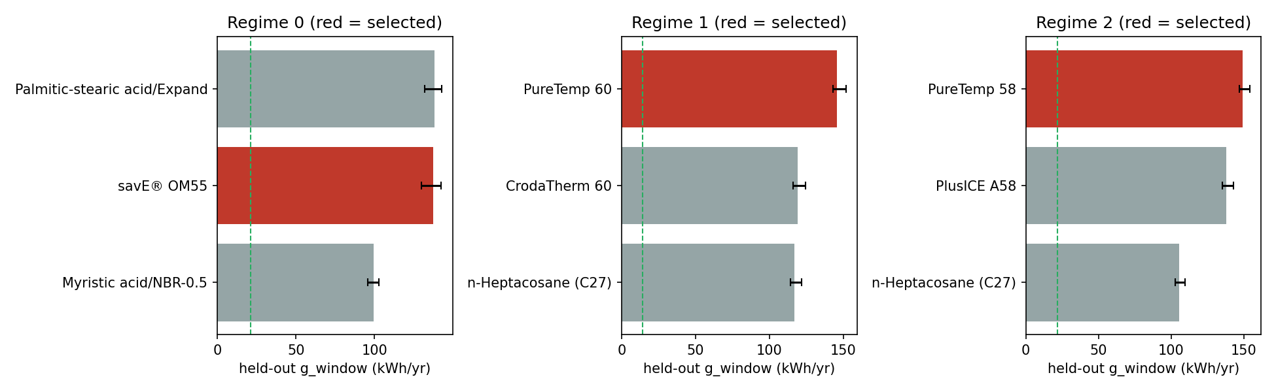
Figure 1. Held-out comparison of the chosen design with the best design of the other O1 PCMs. Source: results/plots/fig4_heldout_pcm_comparison.png (from results/g10_heldout_results.csv)

7.3 Optimiser checks
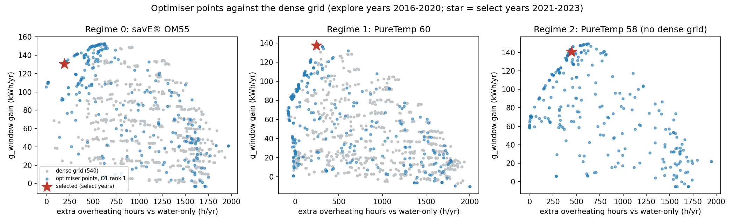
Figure 2. Final Pareto front versus the dense 720-design grid, rank-1 PCM of each regime. Source: results/plots/fig1_front_vs_grid.png (g9_s6_grid_r*_p1.csv, g9 fronts)
Table 29. Where the final Pareto fronts sit relative to the box edges (share of front)
Pair | Front size | R_in at 40 mm end | Fraction at 30 % cap | Flow at 0.010 floor (model artefact) | Flow at 0.050 cap
r0_p1 | 36 | 100 % | 56 % | 31 % | 0 %
r0_p2 | 19 | 100 % | 74 % | 32 % | 5 %
r0_p3 | 34 | 100 % | 68 % | 26 % | 0 %
r1_p1 | 31 | 0 % | 0 % | 0 % | 6 %
r1_p2 | 29 | 59 % | 24 % | 14 % | 0 %
r1_p3 | 30 | 97 % | 80 % | 17 % | 3 %
r2_p1 | 29 | 97 % | 83 % | 17 % | 0 %
r2_p2 | 30 | 70 % | 10 % | 40 % | 0 %
r2_p3 | 22 | 100 % | 9 % | 23 % | 0 %
Source: results/g9_boundary_check.csv
No front sits at the 10 mm radius end or the 2 % fraction floor. Fronts of regimes 0 and 2 still crowd the 40 mm radius and 30 % cap edges; regime 1 rank 1 is interior.
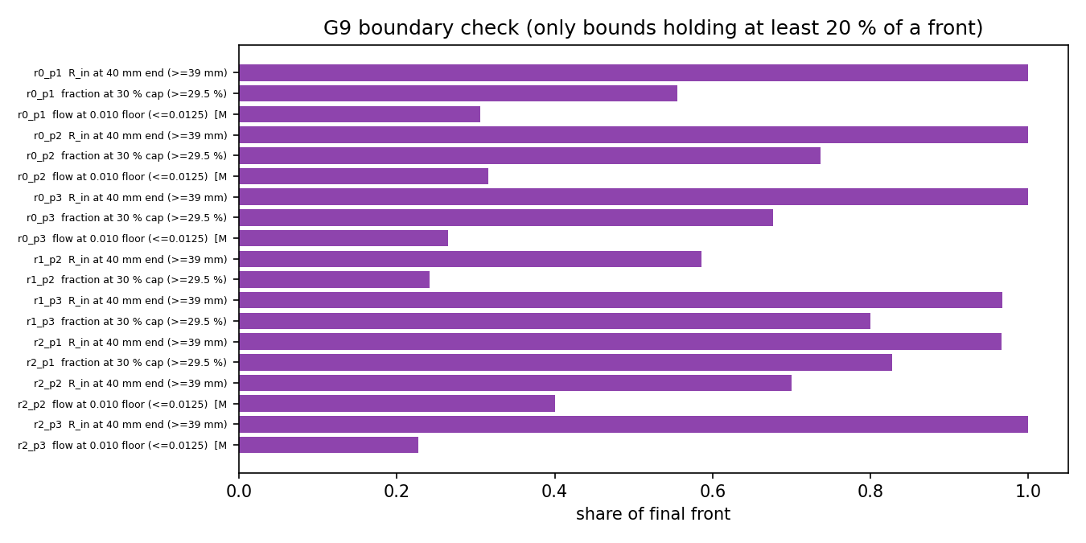
Figure 3. Share of each final front at the radius, fraction and flow bounds. Source: results/plots/fig9_boundary_share.png (from g9_boundary_check.csv)

7.4 Ablations and controls (G11, explore years 2016-2020)
Table 30. g_window (kWh) under one-at-a-time changes around the chosen design
Regime | Chosen | Fraction 2 % | Fraction 10 % | Flow 0.010 | Flow 0.050 | Anchor bottom | Anchor top | Latent heat = 0 | Synthetic Tm 45 C
0 | 132.8 | 5.3 | 43.3 | 88.7 | 146.1 | 95.1 | 164.3 | -39.9 | 161.9
1 | 139.0 | 6.0 | 47.0 | 19.6 | 139.3 | 109.1 | 151.7 | -57.4 | 212.4
2 | 146.3 | 5.9 | 48.8 | 69.7 | 149.4 | 117.1 | 159.2 | -55.1 | 195.7
Source: results/g11_ablation_r{0,1,2}.csv
- Negative controls (water-only invariance to design variables, determinism, inert wall conductivity) all returned zero difference. The latent-heat = 0 control drops the gain below zero in every regime, so the metric responds to the PCM.
- The fraction sweep still rises at the cap: from 25 % to 30 % it adds +16.5 / +19.6 / +21.1 kWh, and from 20 % to 30 % +36.6 / +50.0 / +52.2 kWh (regimes 0/1/2), all above the band.
- Moving the capsule stack bottom / centre / top changes the chosen arrangement gain by 69.2 / 40.9 / 41.1 kWh across the three positions. Thickness at constant mass is valid only at 40 mm in regimes 1 and 2 (smaller radii are geometry-infeasible at that mass). The PCM-fraction x2 control is clipped by the 30 % cap and adds nothing from these designs.
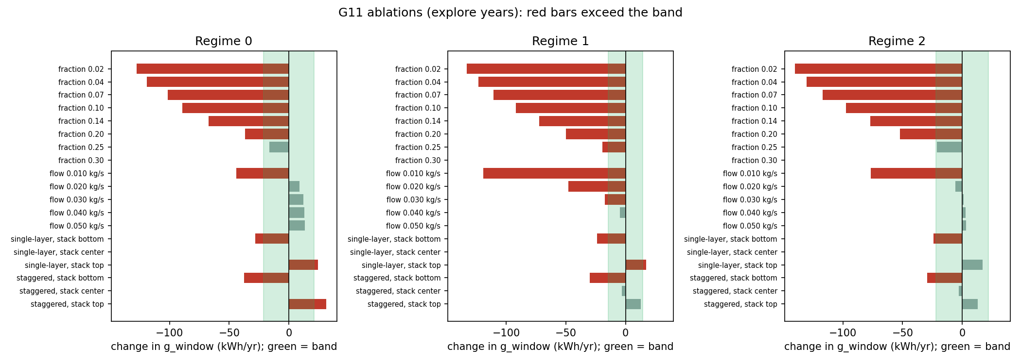
Figure 4. Ablation and control results around the chosen designs. Source: results/plots/fig6_ablations.png (from g11_ablation_r*.csv)
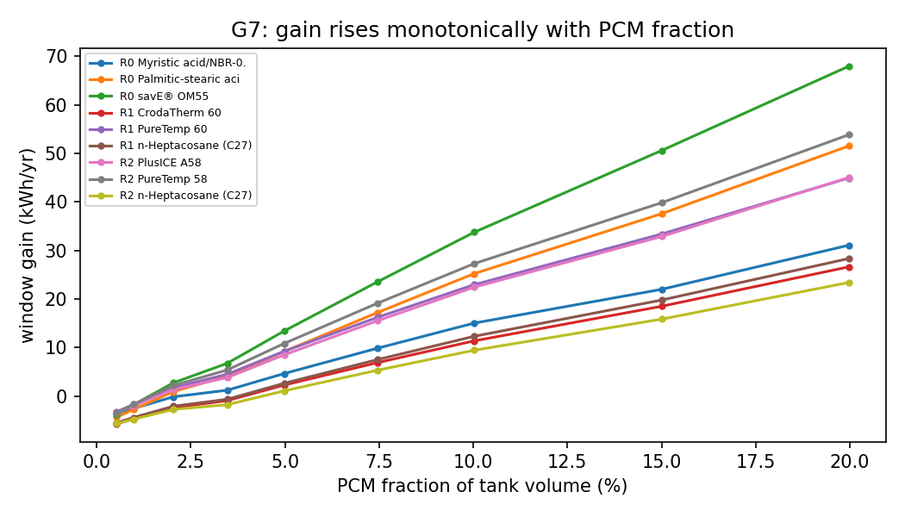
Figure 5. Gain versus PCM fraction: still rising at the 30 % cap. Source: results/plots/fig8_fraction_response.png

7.5 Shield hours, water side versus PCM side
Table 31. Like-for-like shield hours, held-out chosen designs (mean per year, v3)
Regime | Water-side h, PCM tank | Water-side h, water-only tank | PCM-side throttle h
0 | 543 | 715 | 376
1 | 541 | 858 | 581
2 | 473 | 733 | 740
Source: results/g10_heldout_results.csv (shield_water_h, plain_shield_water_h, shield_pcm_h)
d_overheat is positive by construction because the PCM-side throttle (62 C, blocks charging when capsules are full) does not exist in a water-only tank. Like for like, the PCM tank has fewer water-side shield hours in all three regimes, and the PCM-side hours are reported separately. The optimisation objective f3 remains the combined d_overheat (option B, decided 2026-10-27).
Table 32. v1 shield split on the select years (diagnostic G13)
Regime | Water-side h, PCM | Water-side h, water-only | d_shield_water h | PCM-side throttle h | d_overheat stored h | Peak water C: PCM / water-only
0 | 482.9 | 648.1 | -165.3 | 590.0 | 424.7 | 72.4 / 73.1
1 | 571.7 | 796.2 | -224.5 | 417.7 | 193.2 | 72.2 / 73.4
2 | 482.2 | 662.0 | -179.8 | 540.5 | 360.7 | 72.2 / 73.0
Source: results/g13_shield_split_r{0,1,2}.csv
In 96 of 96 v1 design-years the PCM tank had fewer water-side shield hours than the water-only tank.

7.6 Controls from an interior anchor (G14, v1)
Table 33. Change in g_window (kWh) relative to the anchor (R 25 mm, 10 %, 0.030 kg/s, staggered, centre)
Regime | Band | Anchor g_window | R 10 mm | R 15 mm | R 20 mm | R 30 mm | R 40 mm | Fraction x0.5 | Fraction x2
0 | 21.1 | 41.5 | -28.1 | -16.2 | -8.5 | +4.0 | +3.8 | -24.8 | +43.8
1 | 14.4 | 33.1 | -31.0 | -21.3 | -11.4 | +6.4 | +8.1 | -19.7 | +30.8
2 | 21.9 | 36.6 | -29.6 | -19.4 | -10.6 | +5.8 | +9.1 | -22.2 | +36.3
Source: results/g14_controls_r{0,1,2}.csv
The metric responds to PCM amount (x2 adds 31-44 kWh, x0.5 removes 20-25 kWh). Thickness matters below about 25 mm and is flat above it: R 30 and 40 mm are within the band of R 25 mm, so the 40 mm edge is a plateau, not a distinct peak.

7.7 Evening (night-serve) decomposition (G16, v1)
Table 34. Evening scenario, select years, every 15th day (18:00 start, no sun, project demand to 09:00)
Regime | tau_serve h: plain / 40 L water / L=0 / PCM | E_del45 kWh: plain / 40 L / L=0 / PCM | PCM minus plain: tau_serve h, E_del45 kWh | PCM minus 40 L water: tau_serve h, E_del45 kWh
0 | 0.719 / 0.558 / 0.602 / 0.638 | 0.986 / 0.708 / 0.894 / 1.247 | -0.081, +0.261 | +0.080, +0.539
1 | 0.777 / 0.598 / 0.655 / 0.765 | 0.995 / 0.721 / 0.871 / 1.249 | -0.012, +0.254 | +0.167, +0.527
2 | 0.692 / 0.537 / 0.584 / 0.658 | 0.998 / 0.717 / 0.884 / 1.246 | -0.034, +0.248 | +0.121, +0.529
Source: results/g16_serve_r{0,1,2}.csv; g16_serve_plain_40L_r{0,1,2}.csv
The zero or negative tau_serve gain is the net of two opposite effects: capsules displace water (a 40 L water-only tank serves 0.16-0.18 h less) and PCM adds back +0.08 to +0.17 h relative to that. Energy delivered to 45 C in the same scenario is higher with PCM in every regime, and the L = 0 case is lower than water-only, so that gain comes from latent heat. The 40 L tank is a diagnostic, not a baseline. Volume at 45 C and time to first dip are not improved against the same fixed 50 L tank.

7.8 Stack position and widened bounds (G15, G17, v1)
Table 35. Stack-anchor dependence of g_window (kWh), select years
Regime | Band | Bottom | Centre | Top | Range | Regret of chosen at bottom | Regret at centre | Regret at top
0 | 21.1 | 72.6 | 99.4 | 118.3 | 45.7 | 4.1 | 2.6 | 0.2
1 | 14.4 | 58.0 | 94.3 | 114.1 | 56.1 | 22.2 | 2.7 | 0.0
2 | 21.9 | 60.9 | 94.9 | 116.0 | 55.0 | 22.0 | 4.5 | 0.0
Source: results/g15_anchor_r{0,1,2}.csv
The sign of the gain survives every position (smallest mean gain 41.6 kWh), but the level depends on the position by 3 to 6 times the band. Quote absolute kWh only as "stack centred (model default), range over bottom / centre / top given beside it". No source read settles the mounting position.
Table 36. Widened-bound diagnostic: change in g_window (kWh) versus the chosen v1 design, explore years
Regime | Band | R 30 mm | R 45 mm | R 50 mm | Fraction 25 % | Fraction 30 % | Fraction 40 % | Flow 0.080 | All feasible
0 | 21.1 | -38.0 | -39.0 | -59.3 | -7.7 | +17.8 | +68.9 | -28.3 | True
1 | 14.4 | -59.7 | -54.9 | -79.9 | -22.4 | -0.2 | +40.7 | -39.8 | True
2 | 21.9 | -61.0 | -54.2 | -74.2 | -25.8 | -2.6 | +40.5 | -43.2 | True
Source: results/g17_widen_r{0,1,2}.csv
The radius edge was not limiting (larger radii worse at the same fraction) and neither was the upper flow bound; the 20 % fraction cap was. This led to the v3 decision to raise the cap to 30 %. The wider bounds exist only inside the script; the approved box was not changed.

7.9 Box-vertex step, with and without (G18, v1)
Table 37. G9 variants for all nine pairs: hypervolume ratio to the best and epsilon test
Pair | base eps g_window (band 13.8) | novert eps | vert eps | base hv/best | novert hv/best | vert hv/best
r0_p1 | 24.9 FAIL | 23.5 FAIL | 3.1 pass | 0.966 | 0.966 | 1.000
r1_p1 | 5.9 pass | 5.0 pass | 1.8 pass | 0.932 | 0.953 | 1.000
r2_p1 | 0.4 pass | 0.2 pass | 0.2 pass | 1.000 | 1.000 | 0.999
r0_p2 | - | - | - | 0.988 | 0.991 | 1.000
r0_p3 | - | - | - | 0.961 | 0.995 | 1.000
r1_p2 | - | - | - | 0.999 | 1.000 | 0.998
r1_p3 | - | - | - | 0.999 | 1.000 | 0.998
r2_p2 | - | - | - | 0.961 | 0.986 | 1.000
r2_p3 | - | - | - | 0.958 | 0.959 | 1.000
Source: results/g18_issue1_with_without.csv
At equal rounds, without the vertex step regime 0 PCM 1 still fails the grid check (23.5 kWh vs 13.8); with it, it passes (3.1). Regimes 1 and 2 rank-1 pairs pass either way. Caveat: r0_p1 used 11 rounds with the step and 8 without.

7.10 Surrogate and fraction-response figures
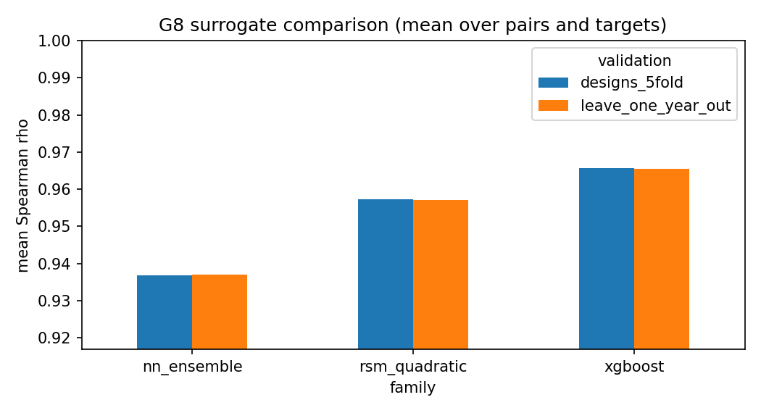
Figure 6. Surrogate comparison on ranking and error. Source: results/plots/fig7_surrogate_comparison.png (from g8_s3_comparison.csv)
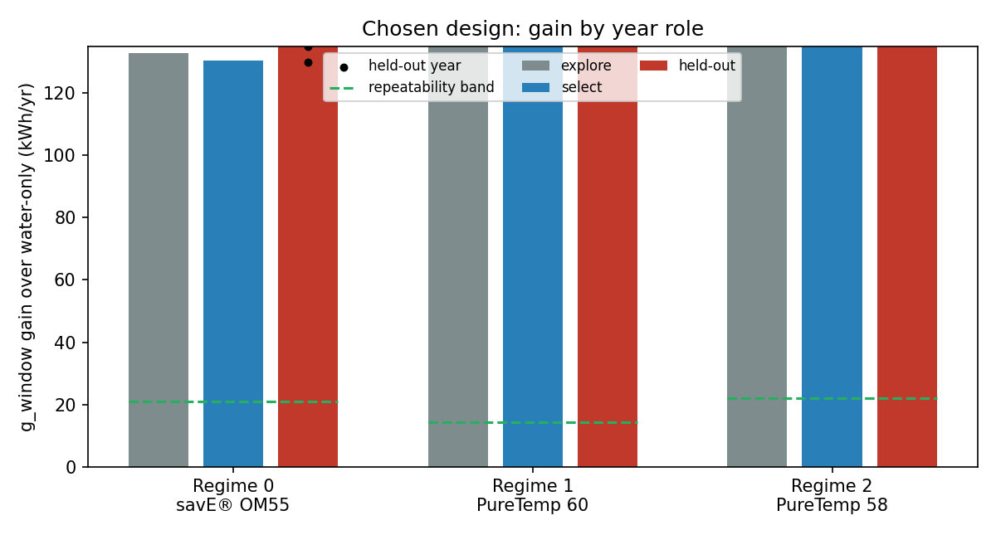
Figure 7. Gain of the chosen designs by year role (explore, select, test). Source: results/plots/fig3_gain_by_year_role.png

8. Validation and checks run
Table 38. Checks and their outcome
Check | Result
Unit tests | 83 passed (demand timing, multinode N=1 equals single node, energy closure below 1e-6 %, CFD draw case, weather roles and lock, O1 shortlist, design space, ANOVA, metrics hand-calculations)
Time-step convergence | 300 s failed (0.073-0.091 % on halving); 150 s passed (largest change 0.0453 %)
Energy closure | Largest annual residual 0.0698 % (criterion below 0.1 %); multi-node about 1e-12 %
Phase-4 gates (G6, phase4_verification_o1_pcms.txt) | Gate 1 PASS; Gate 2 PASS (12/12); Gate 3 PASS; Gate 4 PASS-WITH-CAVEAT (36.9 % solar fraction vs the 54-84 % band: 50 L tank for 300 L/day, no backup heater; reported, not tuned); Gate 5 PASS (3/3). All nine O1 PCMs verified (worst residual 0.067 %)
CFD draw-case agreement | N = 10 gives 22.5 L, N = 40 gives 26.1 L against 27 L from CFD (model-to-model only)
Weather QC | 45/45 point-years accepted, 100 % valid hours, no gaps
Surrogate validation | Within-pair 5-fold and leave-one-year-out; used only for ranking
Dense-grid check | Within band in all three regimes (eps 0.71 / 11.27 / 0.23 vs band 19.41 kWh); partly dependent on the vertex step
Seed stability | 3 seeds, spread inside band for 9/9 pairs
Negative / positive controls (G11, G14) | Zero differences for invariance, determinism, inert wall; latent heat = 0 gives negative gain; fraction x2 responds
Baseline comparison | Same-flow water-only twin; PCHIP error against exact plain runs below 0.01 %
Held-out lock | Test run once; tests/test_weather_roles.py checks the lock names the run that wrote g10_heldout_results.csv
Source: tests/ (83 tests, `python -m pytest tests -q`, 83 passed in 132 s on 2026-10-28); docs/PROGRESS.md; results/

9. Result registry and provenance
results/results_registry.csv holds 604 quantities (id, value, unit, source file, filter) generated by scripts/g12_registry.py; docs/04_RESULTS.md is generated from the saved files by scripts/g12_results_doc.py and checked by scripts/g12_verify_docs.py. The selection logs are fingerprinted (regime 0: ec24f653...), and the Objective 3 contract stores SHA-256 hashes of the selection logs, the band file and the held-out results.

10. Limitations and open items

10.1 What the results do not support
- Still boundary-limited after raising the cap to 30 %. Chosen radius 39.5-40 mm, fraction 28.4-29.6 %. The ablation sweep still rises +16.5 / +19.6 / +21.1 kWh from 25 % to 30 %. The best PCM amount is unknown. Planned, not started: a 40 % cap with a new untouched test (about 11-12 h of computing; proposed new test years 2006-2010; docs/PROGRESS.md section 27).
- Level of the gain depends on the unvalidated stack position. Range over bottom / centre / top is 46-56 kWh against bands of about 10-16 kWh (v1).
- Flow optima are not physical. Collector F_R does not depend on flow, so low flow always helps the stratified water tank. Flow at the 0.010 floor appears on up to 40 % of the final fronts (r2_p2). Chosen flows (0.0155 / 0.0493 / 0.0236 kg/s) lie inside the indistinguishable sets and should not be over-interpreted.
- Night-serve duration is not improved against the fixed 50 L tank (water displacement). Energy delivered in the evening does rise.
- Shield hours: d_overheat mixes water-side and PCM-side terms; the PCM-side throttle (376-740 h/yr) is real.
- Arrangement is a null on g_window at the centre anchor in the v1 check (largest gap 4.4 / 8.9 / 8.1 kWh vs bands 15.1 / 10.0 / 15.7) but matters for overheating hours.
- Tank-model convergence: N = 10 vs 20 changes the paired gain by 0.15-0.25 pp; part of the band.
- Weather: one medoid point per cluster, 15 years in the inventory.
- No measurements. Nothing is validated against hardware or field data; CFD agreement is model-to-model.
- Six diagnostics (G13-G18) were run on the v1 designs and not re-run on v3.

10.2 Items for Dr. Deepika and the O1 owner
- Conductivity discrepancy: O1 ranking table vs PCM database (savE OM55 0.429 vs 0.13 W/mK; Palmitic-stearic/EG 0.452 vs 0.16; PureTemp 60 0.208 vs 0.20; n-Heptacosane 0.210 vs 0.2415). The simulator reads the database.
- Sizing: 33.3 L/m2 is below IS 12976:2023 range 40-100 L/m2.
- Collector F_R(flow): a cited flow-dependent correction would remove the flow artefact.
- Delivery temperature: O1 sizes for 60 C delivery, O2 uses 45 C. On the legacy model re-scoring at 60 C cut solar fraction by about 19-20 points. Aligning means changing the shared config for all states; not done.
- No feedback from O2 to O1: O1 does not use O2 achievable temperatures and loading.
- Safety: several O1 PCMs exceed 65 C at some designs (for example Palmitic-stearic/EG and PureTemp 58 at the mid design); the 65 C rule is a feasibility constraint and O3 shield design should cover it.
- Gate 4 solar fraction (about 0.30-0.33 multi-node at old designs) is below the 54-84 % band; reported, not tuned.

11. Handoff to Objective 3
File: results/obj3_environment_contract_rajasthan_v2.json, written by python -m src.handoff.build_obj3_contract_v2. It supersedes the v1 contract (UTC demand, single-node tank, retargeted PCMs), which must not be used for training.
Table 39. Environment contract v2
Item | v2 content
Simulator | Multi-node N = 10, dt 150 s, local-time demand, inner-volume PCM mass with wall mass, O1 top-3 PCMs
State vector | Adds T_water_top_C, T_water_bottom_C, recoverable_energy_above_45C_kWh (estimator), minutes_since_last_draw
Actions | Charge / discharge / bypass plus continuous flow in 0.010-0.050 kg/s
Safety shield | Force bypass at top node 72 C and PCM 62 C; flow clamped; design infeasible if PCM peak exceeds 65 C in any simulated year
Weather sequences | Training 2016-2020, validation 2021-2023; 2011-2015 held out (used by O2, O3 must not tune on it); 2024-2025 used by v1 test
Reward | Suggestion from delivered energy at 45 C, overheating hours, safety violation, bypass switching. Weights not chosen. Pump term removed
Provenance | SHA-256 of selection logs, band file, held-out results, and five config files
Source: docs/06_OBJECTIVE3_HANDOFF.md; results/obj3_environment_contract_rajasthan_v2.json
- The case for a controller is not that the best PCM changes with weather (O1 selection is stable per region). It is hour-by-hour operation: the PCM-side throttle of about 420-1,140 h/yr and the evening volume and time at 45 C.
- Passive-design gain is 130-141 kWh/yr on select years and 138-149 kWh/yr on 2011-2015 test years. A controller must be compared with the same-flow water-only twin and the passive PCM design, on explore and select years only.
- Pump energy is not a meaningful quantity in the O2 simulator.

12. Doc and code discrepancies
Where a written document disagrees with a saved file, the saved file is trusted. Found while preparing this report:
Table 40. Discrepancies
# | Where | Document says | Files show
1 | docs/05, limitation 3 | Chosen flows 0.021-0.048 kg/s | v3 selection JSONs: 0.0155 / 0.0493 / 0.0236 kg/s (the text is from v1)
2 | docs/05, items 1, 2, 4, 6, 7 | Numbers from v1 (cap 20 %, bands 15.1 / 10.0 / 15.7, tau_serve gain -0.08 / -0.01 / -0.03 h) | v3 bands 21.1 / 14.4 / 21.9 kWh; v3 held-out tau_serve gain -0.12 / +0.03 / -0.01 h
3 | configs/system_config_shared.yaml | timestep_s: 300 | Production step is 150 s via code override (PRODUCTION_SOLVER_OVERRIDE)
4 | configs/states/rajasthan.yaml | pcm_shortlist: savE OM42, RT44HC, RT47 / n-Tricosane, savE OM49, RT45HC / RT45HC, Lauric acid, n-Docosane; Tm_target 43.5 / 47.9 / 45.7 | Pipeline uses the O1 top-3 from mcdm_topk_by_cluster.csv via get_regime(); the YAML list is the retired retargeted list (pcm_shortlist_detail has the O1 list)
5 | configs/design_bounds_shared.yaml | Legacy bounds (8-37 capsules, 40-80 mm) | Used only through space.geometry_bounds(); design_space.yaml is authoritative
6 | docs/04 section 1 | Regime 0 tau_serve gain shown as "+nan" | The regime 0 chosen entry in g10_selection_r0.json has no tau_serve fields; reported here as "not available"; held-out value is -0.12 h
7 | docs/03 (S2 row) and docs/PROGRESS.md section 10 (DOE counts, ANOVA means, surrogate means and winners) | DOE 1,143 simulated + 9 rejected; ANOVA radius 34.1 / fraction 45.4 %; surrogate winners listed for v1 | v3 files: 1,089 valid + 63 rejected; ANOVA g_window radius 29.1 / fraction 45.1 / flow 7.2 / arrangement 17.9 %; winners differ (r0_p2, r1_p2, r1_p3, r2_p1). This report uses the v3 files
8 | docs/04 sections 1b, 5b-5f | Titled v1 diagnostics | Not re-run on v3 designs; their numbers describe the v1 designs
Source: as named in each row

Appendix A. File-to-stage index
Table 41. Result files by stage
Stage | Files
G2 | g2_timestep_convergence_300_150_75.csv, g2_timestep_convergence_150_75_37p5.csv
G3 | g3_metrics_report.csv, g3_night_daily_r{0,1,2}_{pcm,plain}.csv
G4 | g4_cfd_draw_case.csv, g4_multinode_report.csv
G6 | phase4_verification_o1_pcms.txt, phase0_climate_signature_check.txt, phase2_geometry_boundary_selftest.txt
G7 | g7_sensitivity_r{0,1,2}.csv, g7_sensitivity_paired.csv, g7_plain_flow_baseline.csv, g7_flow_same_flow_gain.csv, g7_max_packing_fraction.csv
G8 | plain_baseline_{explore,select}_r*.csv, g8_s1_r*_p*.csv, g8_s1_anova_r*_p*.csv, g8_s2_r*_p*.csv, g8_s3_comparison.csv, g8_s3_selection.csv
G9 | wp6_band.csv, g9_band_r*.csv, g9_al_log_*, g9_points_*, g9_ref_*, g9_seed_front_* (with _ext / _ext2 variants), g9_s6_grid_r*_p1.csv, g9_al_summary.csv, g9_seed_stability.csv, g9_grid_check.csv, g9_boundary_check.csv
G10 | g10_selection_r*.json, g10_selection_candidates_r*.csv, g10_heldout_results.csv, held_out_test.lock
G11 | g11_ablation_r*.csv
G12 | results_registry.csv, obj3_environment_contract_rajasthan_v2.json, plots/fig1-fig9
G13-G18 | g13_shield_split_r*.csv, g14_controls_r*.csv, g15_anchor_r*.csv, g16_serve_r*.csv, g16_serve_plain_40L_r*.csv, g17_widen_r*.csv, g18_issue1_with_without.csv, issue1_novert/
Archive | results/v1_cap20/ (v1 cap 20 % results, v1 lock and held-out file)
Source: results/ directory listing

A.1 Files left out as legacy or unclear
Table 42. Not part of this report
Item | Status | Basis
src/doe, src/surrogate, src/optimize/search.py, src/robustness, src/plots/make_plots.py | Legacy | docs/05: "still the old chain; nothing in the entry points calls them"
src/design/retarget_tm.py, src/handoff/build_obj3_contract.py (v1 contract) | Legacy / retired | docs/02, docs/06
configs/design_bounds_shared.yaml | Legacy bounds | docs/02 section 4
results/phase*, fix*, old plots, legacy_result_hashes.sha256 | Legacy | docs/README; archive deleted 2026-10-28
Root check_*.py (climate signature, delivery temp, overheat track, shielded phase 7, standards-compliant sizing, widened bounds loading), sweep_pcm_loading.py, build_regime_weather.py | Unclear | Names suggest legacy checks from the old chain; not described in docs/01-06 except check_delivery_temp_reconciliation.py and check_overheat_track_pcm.py (cited as legacy-model results). Not read for this report
docs/CLEANUP_PROPOSAL.md | Unclear | Housekeeping proposal; not read
results/plots/static and interactive phase*.png/html | Rebuilt legacy figures | PROGRESS section 22: rebuilt for the current chain; fig1-fig9 are the ones used here
Source: docs/05 (legacy list); docs/PROGRESS.md sections 16, 28, 29; folder listing

Appendix B. How to reproduce
Run from OBJECTIVE2/Objective---2/objective2-rajasthan . The reporting stages are safe to run at any time; the search stages refuse while the held-out lock exists.
python -m pytest tests -q
python pipeline.py --state rajasthan --stage status
python pipeline.py --state rajasthan --stage report
python pipeline.py --state rajasthan --stage handoff
python pipeline.py --state rajasthan --stage plots
python pipeline.py --state rajasthan --stage simulate --cluster 0 --pcm-rank 1 --radius-mm 40 --fraction 0.2 --flow 0.025 --arrangement staggered
python pipeline.py --state rajasthan --stage optimize --dry-run
python pipeline.py --state rajasthan --stage all --allow-invalidate --jobs 3 # hours; invalidates the frozen designs
python run_all_rajasthan.py # tests + report + handoff + plots from saved results
python run_all_rajasthan.py --full # whole chain (hours)

The one-shot held-out test (python scripts/g10_test.py --confirm-run-once) has already been run for v3 and will refuse a second run. Do not delete results/held_out_test.lock.

