What we simulate with, and why
Objective 2 — PCM capsule tank, Tamil Nadu · 31 October 2026
The objective
For each of Tamil Nadu's three climate regimes, find the capsule size, number of capsules, PCM and flow rate that make a 100 L solar water tank deliver the most useful hot water in the evening, and establish whether that beats an identical tank with no PCM at all. Three sub-goals follow: search the design space over full years of real weather against a paired plain tank; prove the benefit exceeds the measured repeatability band, since a smaller gain is noise; and confirm the physics independently in CFD.
Two simulators, two jobs
 | Tank model | ANSYS Fluent
scope | whole tank, whole year | one capsule, six hours
runtime | seconds per simulated year | about 30 minutes per PCM
role | the optimiser's evaluator — it chooses the design | independent physics check — it chooses nothing
melt front | not resolved; carried as an empirical factor | resolved by enthalpy-porosity
Not alternatives. The search ran over 1,100 design evaluations before anything was chosen: at CFD speed that is years of compute. CFD is how we test the assumptions that buy the speed.
Why ANSYS Fluent here, where Rajasthan used OpenFOAM
A capability difference, not a preference: OpenFOAM's standard solvers have no native solidification/melting model. Its chtMultiRegionFoam resolves conjugate heat transfer well, but with sensible heating only — no latent heat, no phase change. For a study whose premise is that a PCM stores heat in its phase change, a solver that cannot melt the material shows only half the physics.
 | Rajasthan (source study) | Tamil Nadu (this study)
CFD solver | OpenFOAM chtMultiRegionFoam | ANSYS Fluent 2026 R1 Student
phase change in CFD | not modelled — sensible heating only | enthalpy-porosity, melt front resolved
tank volume | 50 L | 100 L, collector scaled to keep 40 L/m²
surrogate model | XGBoost | stacked ensemble, chosen over 5 families in all 9 pairs
tank model | hers | hers, adopted unchanged
The last row matters: the tank model is the source study's own code, so a difference in results is a difference in inputs, not method. Absolute energy is not comparable across a 50 L and a 100 L tank; the algorithms and pass/fail criteria are.
What we run in Fluent
A half-disk capsule in a water annulus, meshed in gmsh, solved 2-D planar: solid at 30 °C in water held at the 70 °C collector delivery temperature for a six-hour charging window. Geometry, PCM identity and flow rate are read from the optimiser's own output. It yields melt curves for all four PCMs, a flow-rate sweep showing the benefit saturating where the optimiser settled, and the whole-system heat path.
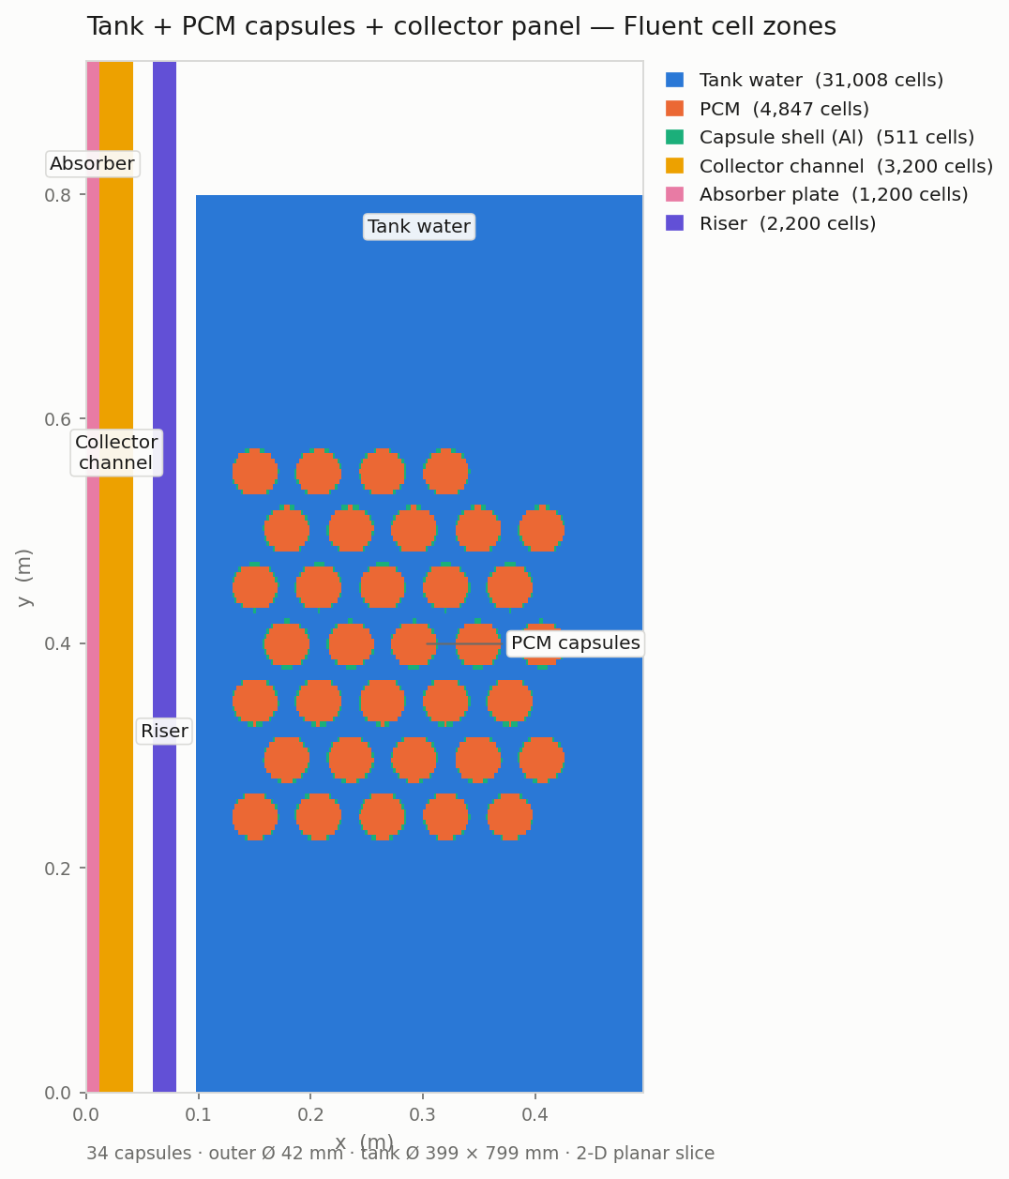  Figure 1 — the modelled system: 100 L tank, 34 PCM capsules, collector channel, absorber plate and riser, as six separate Fluent cell zones over 42,966 cells.  It is the geometry check: confirming the thing meshed is the thing meant, before any physics is solved on it. | 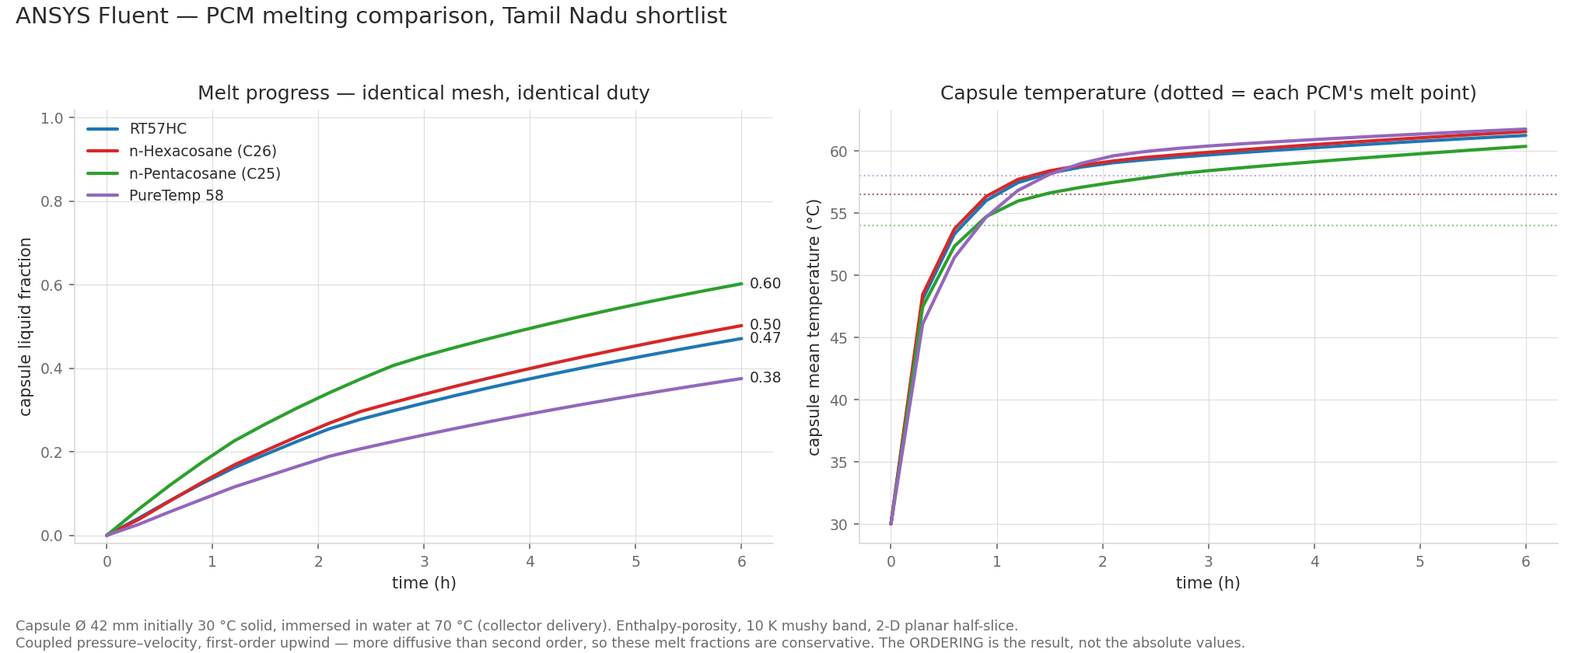  Figure 2 — all four shortlisted PCMs melted on one mesh under one duty, so the only difference between the curves is the material itself.  The ordering follows melt point and conductivity exactly as predicted, which is the independent confirmation the fast tank model needed.
Stated limits
First-order upwind is the only discretisation under which all four PCMs solve and is more diffusive than second order, so melt fractions are conservative — read the ordering, not the absolute values. The mesh is a symmetry half-slice, so buoyancy in the melt is excluded: that is the enhancement the tank model carries empirically, by design. The whole-system case runs energy-only, so it shows the heat path, not melting.
Full CFD history: docs/SIMULATOR_AND_CFD.md and docs/CFD_VERIFICATION.md.

