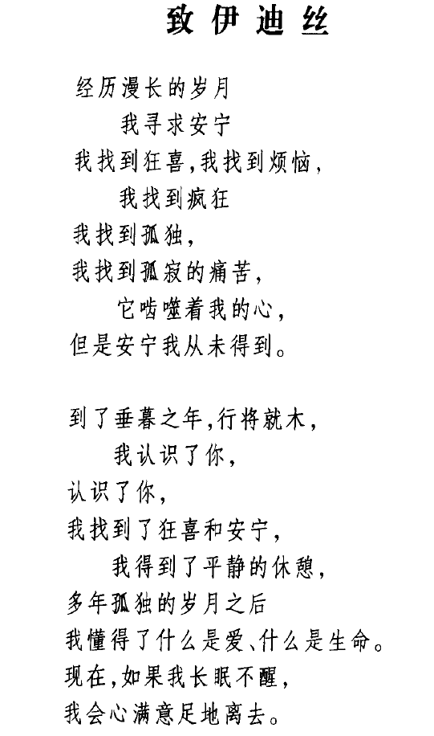

Through the long years

I sought peace.

I found ecstasy, I found anguish,

I found madness,

I found loneliness.

I found the solitary pain

that gnaws the heart,

But peace I did not find.

Now, old and near my end,

I have known you,

And, knowing you,

I have found both ecstasy and peace

I know rest.

After so many lonely years

I know what life and love may be.

Now, if I sleep,

I shall sleep fulfilled.

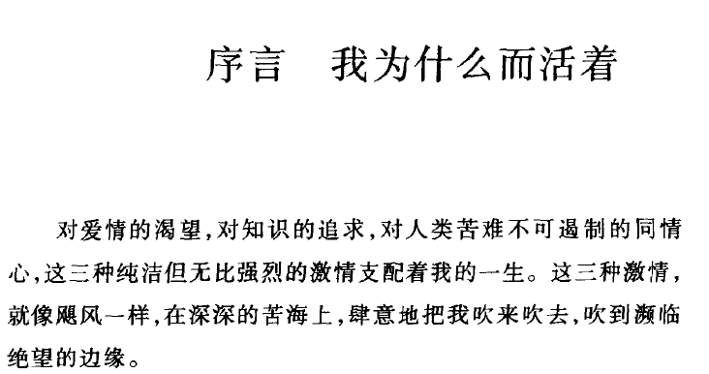

The Prologue to Bertrand Russell's Autobiography

What I Have Lived For

Three passions, simple but overwhelmingly strong, have governed my life: the longing for love, the search for knowledge, and unbearable pity for the suffering of mankind. These passions, like great winds, have blown me hither and thither, in a wayward course, over a great ocean of anguish, reaching to the very verge of despair.

I have sought love, first, because it brings ecstasy - ecstasy so great that I would often have sacrificed all the rest of life for a few hours of this joy. I have sought it, next, because it relieves loneliness--that terrible loneliness in which one shivering consciousness looks over the rim of the world into the cold unfathomable lifeless abyss. I have sought it finally, because in the union of love I have seen, in a mystic miniature, the prefiguring vision of the heaven that saints and poets have imagined. This is what I sought, and though it might seem too good for human life, this is what--at last--I have found.

With equal passion I have sought knowledge. I have wished to understand the hearts of men. I have wished to know why the stars shine. And I have tried to apprehend the Pythagorean power by which number holds sway above the flux. A little of this, but not much, I have achieved.

Love and knowledge, so far as they were possible, led upward toward the heavens. But always pity brought me back to earth. Echoes of cries of pain reverberate in my heart. Children in famine, victims tortured by oppressors, helpless old people a burden to their sons, and the whole world of loneliness, poverty, and pain make a mockery of what human life should be. I long to alleviate this evil, but I cannot, and I too suffer.

This has been my life. I have found it worth living, and would gladly live it again if the chance were offered me.

罗素的祖父是英国前相、第一代罗素伯爵约翰·罗素曾去厄尔巴岛拜谒拿破仑（p10）；屠格涅夫曾送给罗素的祖母他写的书（12）；罗伯特·布朗宁常来罗素家的庄园做客（42）；他曾和爱尔兰自治运动领袖帕内尔握手（47）；自由党领袖格拉德斯通是ta们家的好友；他小时候常去看望约翰·丁达尔（48）；罗杰·弗莱、特里威廉是他在剑桥的朋友（72）；与他交往的人有凯恩斯（概率的逻辑阐释；经济学；官员）（83）、利顿·斯特雷奇（85）等布卢姆茨伯里派成员、费边社（如萧伯纳和西德尼·韦伯夫妇）（90）、德国社会主义者（倍倍尔和老李卜克内西）（p172）、H.G.威尔斯（p212）、威廉詹姆斯（p287，他与柏格森交往）、康拉德（302~，罗素的儿子的名字“约翰·康拉德”正是为了对康拉德表示敬意）、康托（318-）、泰戈尔（323）、维特（324）、维纳（327-8）；他从父亲那继承来了2万英镑财产（99）；与庞加莱长期论战（pp176, 183）；为妇女普选权活动（213）；F.H.布拉德雷，尽管是他在哲学上的敌手，也对他怀着极大的尊敬（pp290-2）；数学家哈代曾写过《罗素与三一学院》一书

What is mind? No matter; what is matter? never mind (44)

麦克塔格特的人格：

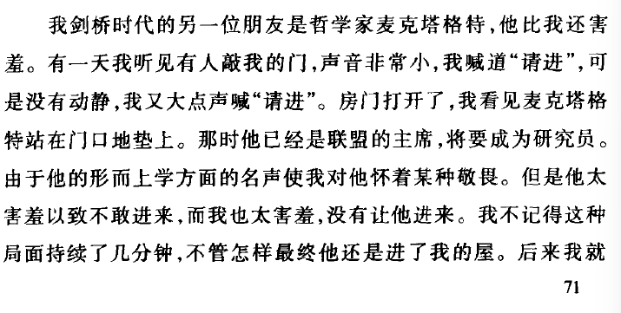

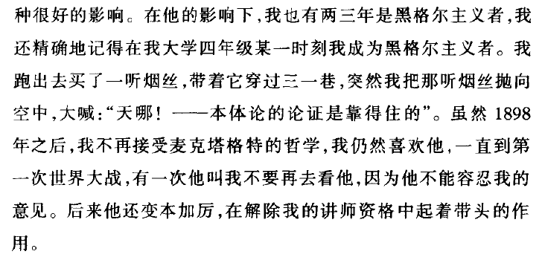

G.E.摩尔

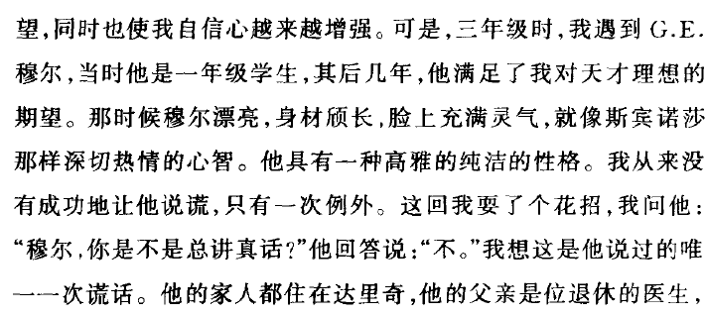

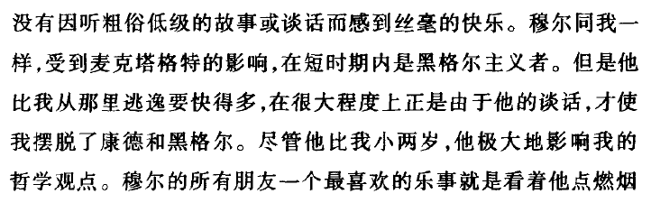

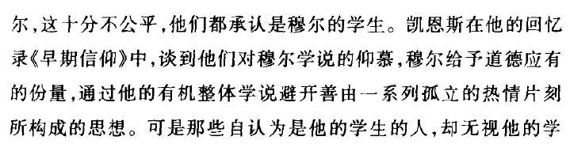

P83

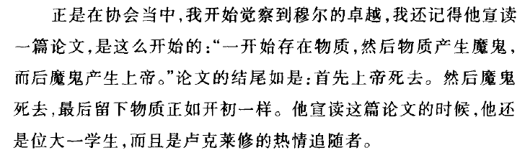

P87

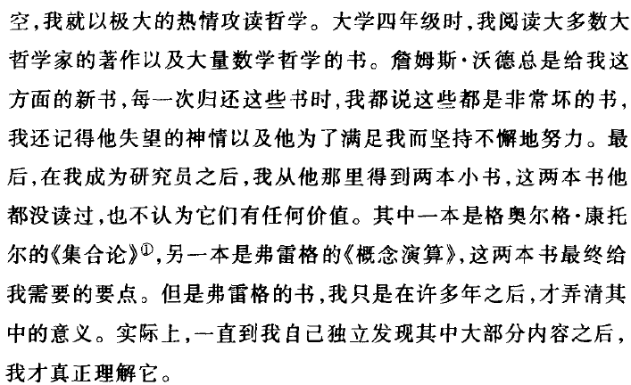

P79

剑桥的“协会“：

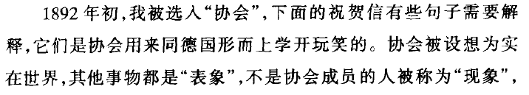

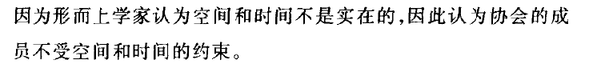

80-81

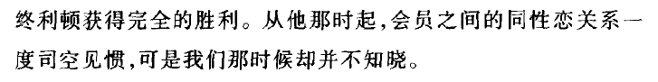

P87

凯恩斯：

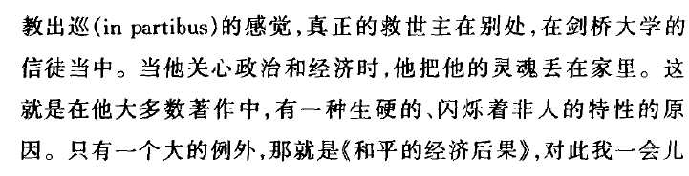

P83

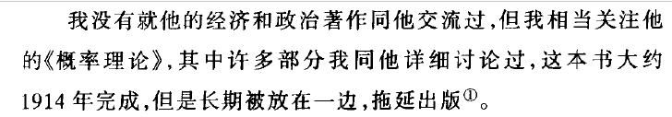

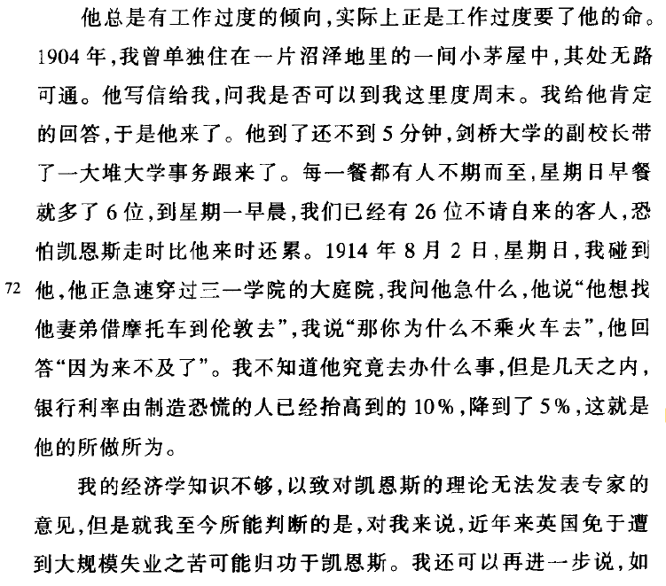

P84

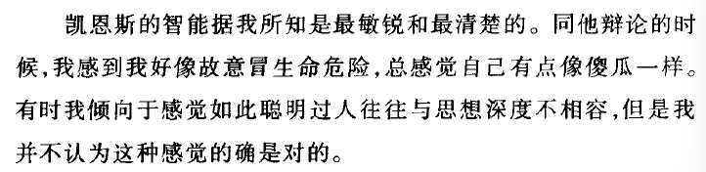

P85

费边社

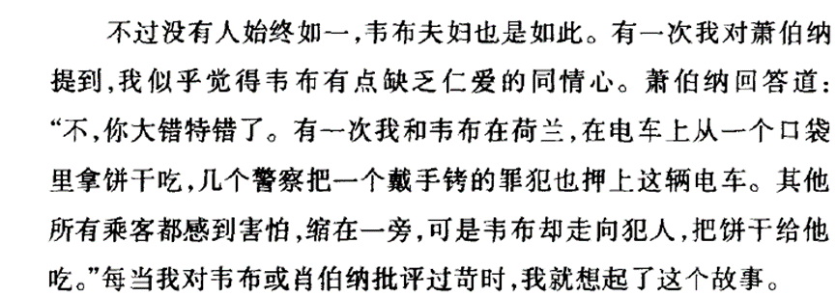

P93

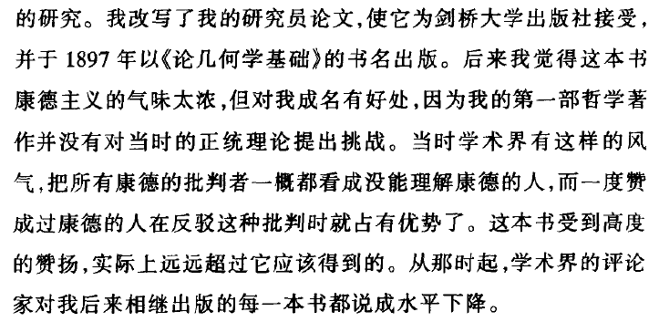

P177

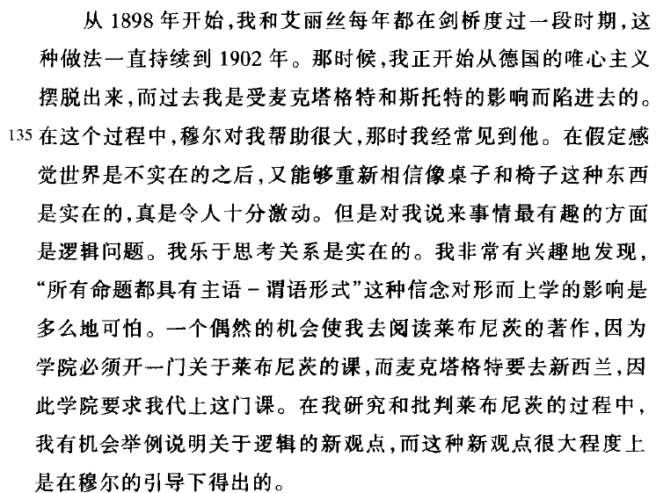

184

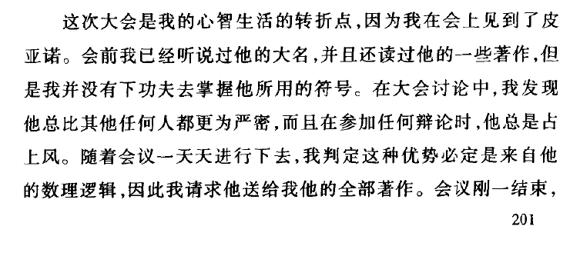

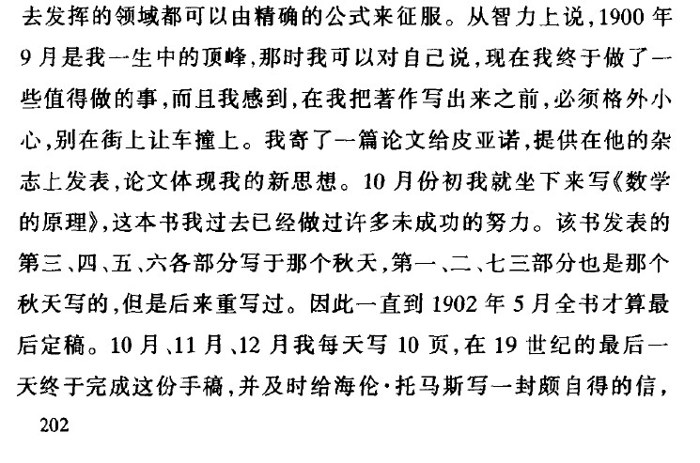

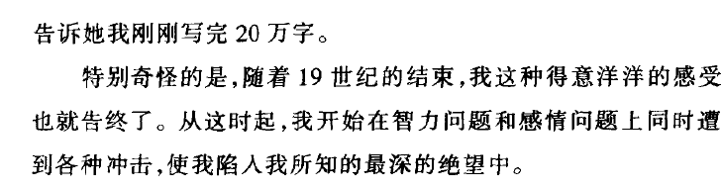

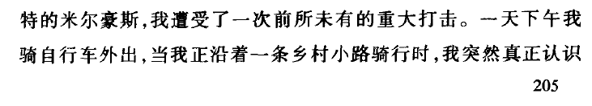



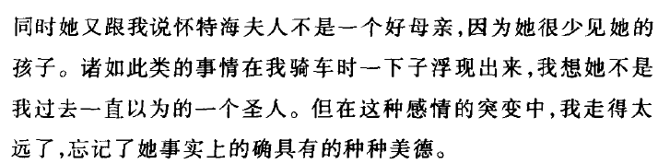

P207

怀特海：

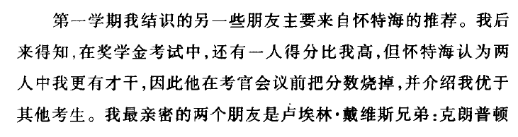

P64

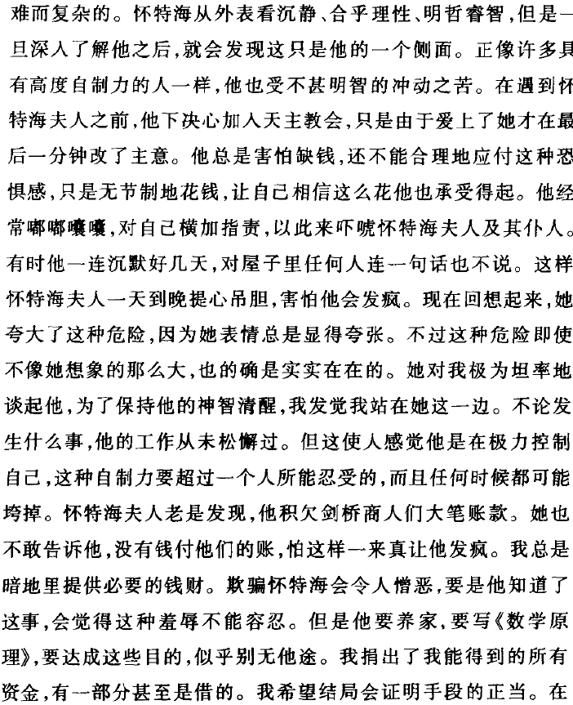

209

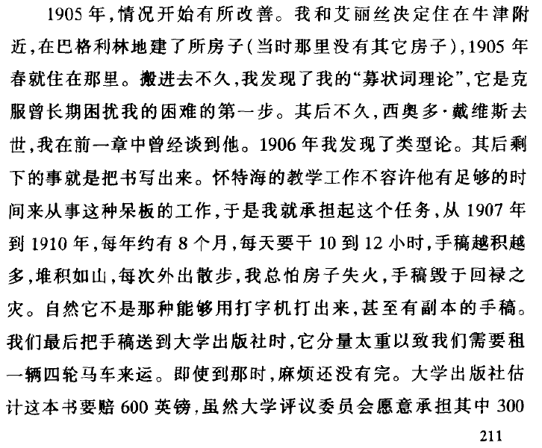

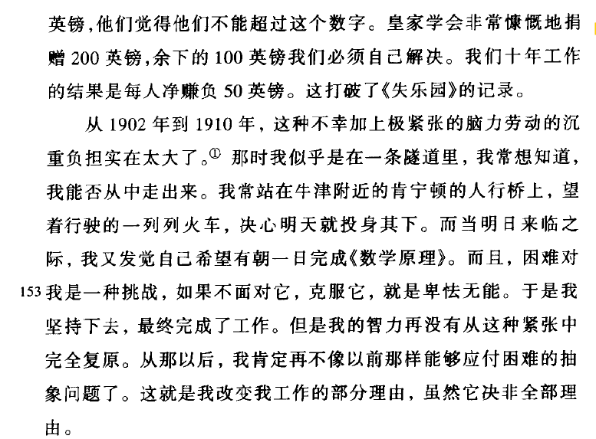

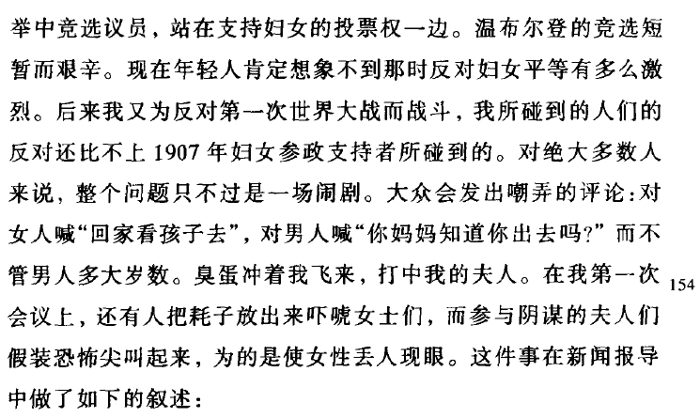

P213

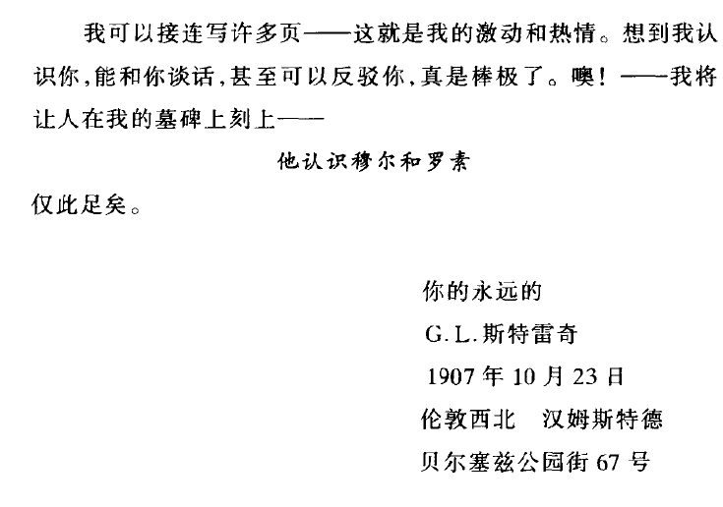

286

F.H.布拉德雷

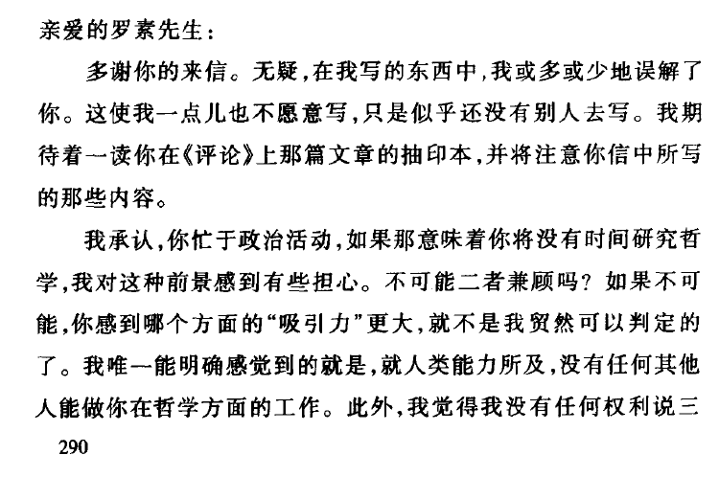

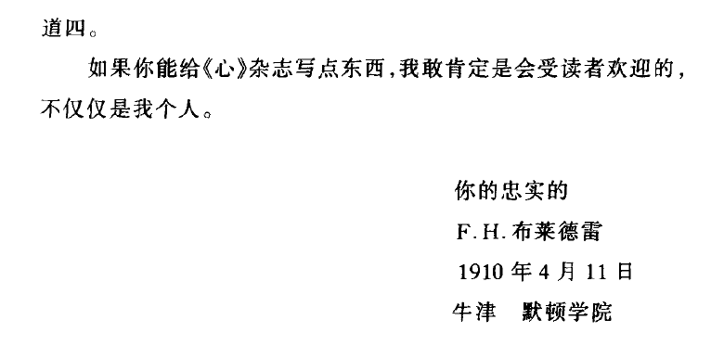

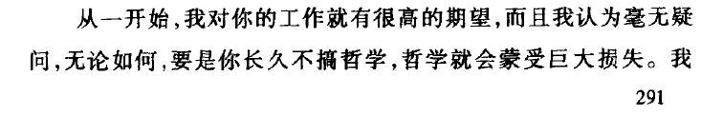

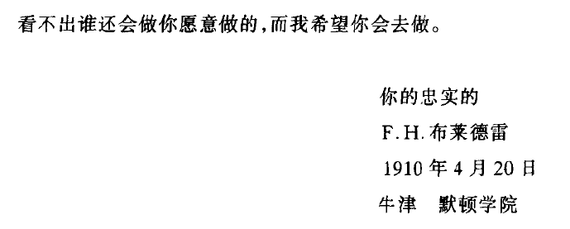

康托：

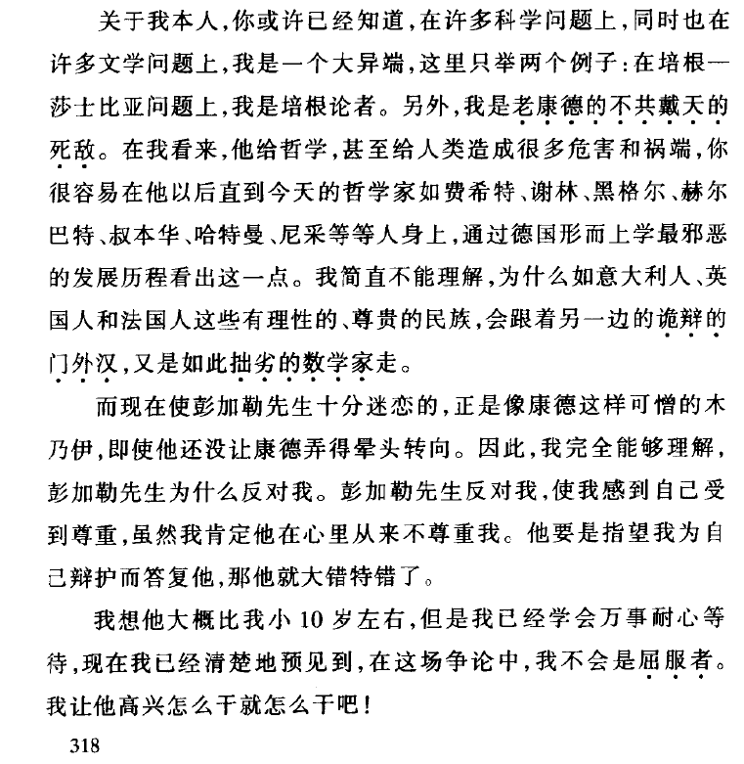

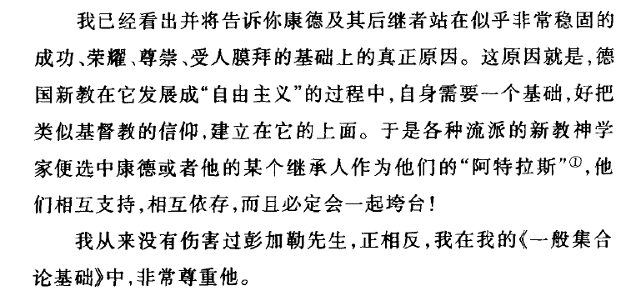

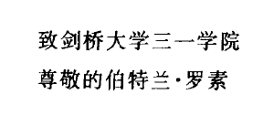

318-20

维特

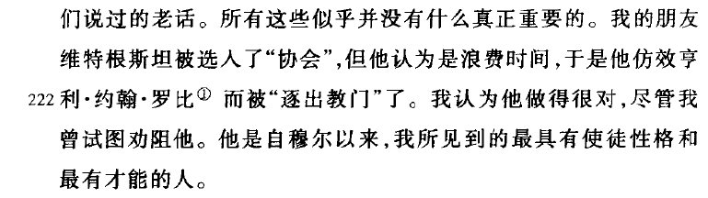

324

维纳：

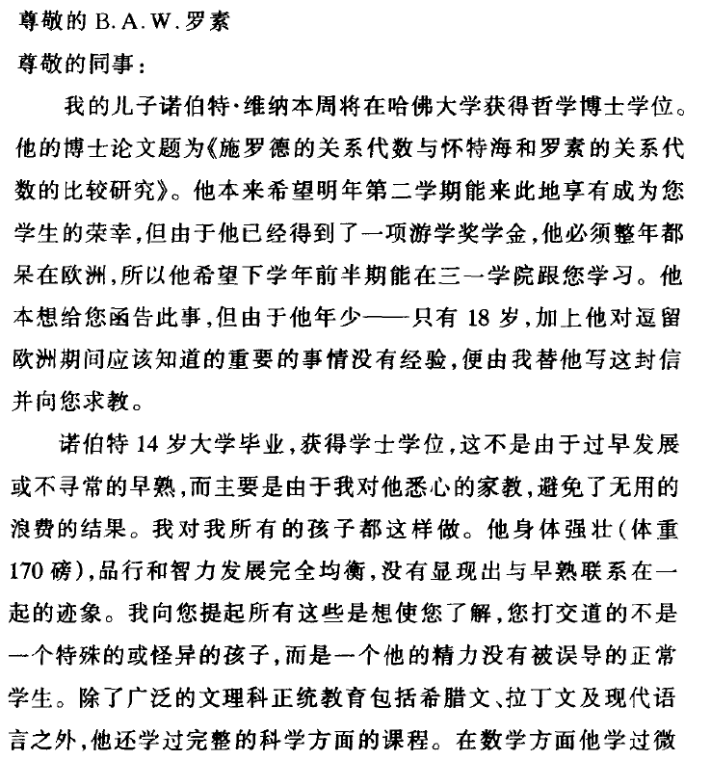

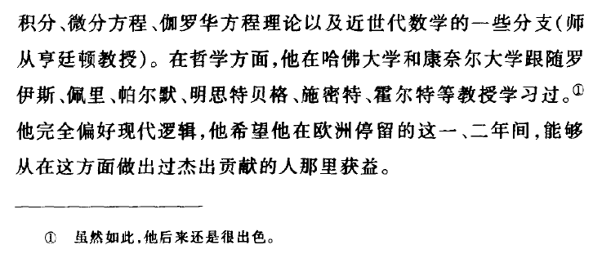

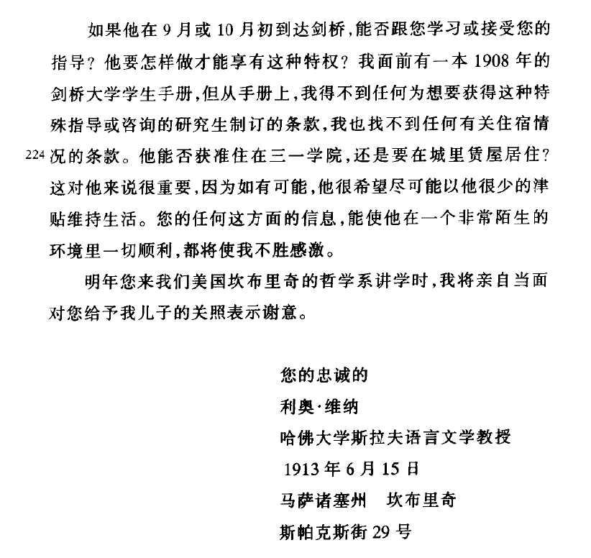

康拉德：

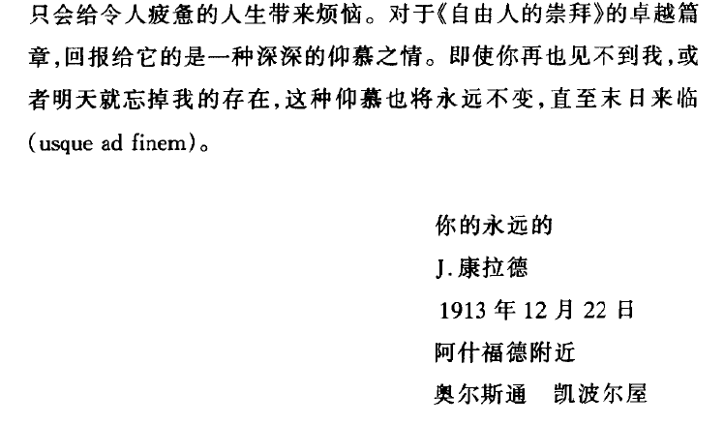

330

翻译不佳，如p64“因此他在考官会议前把分数烧掉，并介绍我优于其他考生。”

译名不统一，“波尔战争“（184），其它地方又作“布尔战争”等