Final Project

Kyle Duplessis, Dean Gladish & Kavie Yu

5/30/2018

Natality <- read.csv("C:/Users/gladi/Documents/GitHub/Final-Project/Natality, 2007-2016.csv")  
library(dplyr)

##   
## Attaching package: 'dplyr'

## The following objects are masked from 'package:stats':  
##   
## filter, lag

## The following objects are masked from 'package:base':  
##   
## intersect, setdiff, setequal, union

library(ggformula)

## Warning: package 'ggformula' was built under R version 3.4.4

## Loading required package: ggplot2

## Warning: package 'ggplot2' was built under R version 3.4.4

##   
## New to ggformula? Try the tutorials:   
## learnr::run_tutorial("introduction", package = "ggformula")  
## learnr::run_tutorial("refining", package = "ggformula")

library(broom)

## Warning: package 'broom' was built under R version 3.4.4

library(gridExtra)

## Warning: package 'gridExtra' was built under R version 3.4.4

##   
## Attaching package: 'gridExtra'

## The following object is masked from 'package:dplyr':  
##   
## combine

library(Sleuth3)

## Warning: package 'Sleuth3' was built under R version 3.4.4

library(car)

## Warning: package 'car' was built under R version 3.4.4

## Loading required package: carData

## Warning: package 'carData' was built under R version 3.4.4

##   
## Attaching package: 'car'

## The following object is masked from 'package:dplyr':  
##   
## recode

library(ggplot2)

View(Natality)

# Turns Tobacco Use into 1s and 0s - yes and no  
Natality <- mutate(Natality, TobaccoUseCodeBinary = TobaccoUseCode - 1)

## Warning: package 'bindrcpp' was built under R version 3.4.4

# Removes all table entries where TobaccoUse is Not Stated  
Natality <- Natality[!(Natality$TobaccoUse == "Not Stated"),]  
  
# Removes all table entries where Education is not stated  
Natality <- Natality[!(Natality$Education == "Unknown/Not on certificate"),]  
  
Natality$EducationCode <- factor(Natality$EducationCode, labels = c("8thGrade", "12thGrade", "HS/GED", "SomeCollege", "AssociateDegree", "BachelorsDegree", "Masters", "Doctorate"))  
  
Natality$Region <- factor(Natality$Region, labels = c("NorthEast", "MidWest", "South", "SouthWest", "West"))  
  
# Turns the Average Birth Weight column into a numeric.   
  
Natality <- mutate(Natality, AverageBirthWeight = as.numeric(AverageBirthWeight))  
  
library(MASS)

##   
## Attaching package: 'MASS'

## The following object is masked from 'package:dplyr':  
##   
## select

mod.base <- lm(AverageBirthWeight ~ Region + DeliveryMethod + TobaccoUse + AverageAgeofMother, data = Natality)  
mod.plus <- lm(log(as.numeric(AverageBirthWeight)) ~ Region + DeliveryMethod + TobaccoUse + AverageAgeofMother, data = Natality)  
summary(mod.base)

##   
## Call:  
## lm(formula = AverageBirthWeight ~ Region + DeliveryMethod + TobaccoUse +   
## AverageAgeofMother, data = Natality)  
##   
## Residuals:  
## Min 1Q Median 3Q Max   
## -1148.70 -178.46 -3.58 175.51 1278.28   
##   
## Coefficients:  
## Estimate Std. Error t value Pr(>|t|)   
## (Intercept) -432.083 88.630 -4.875 1.20e-06 ***  
## RegionMidWest 104.540 24.017 4.353 1.44e-05 ***  
## RegionSouth -123.317 22.607 -5.455 5.73e-08 ***  
## RegionSouthWest -172.240 27.301 -6.309 3.70e-10 ***  
## RegionWest 184.200 30.992 5.944 3.47e-09 ***  
## DeliveryMethodNot Stated 120.196 46.603 2.579 0.01 *   
## DeliveryMethodVaginal 391.160 16.549 23.637 < 2e-16 ***  
## TobaccoUseYes -699.047 16.478 -42.424 < 2e-16 ***  
## AverageAgeofMother 54.699 2.808 19.479 < 2e-16 ***  
## ---  
## Signif. codes: 0 '***' 0.001 '**' 0.01 '*' 0.05 '.' 0.1 ' ' 1  
##   
## Residual standard error: 307.8 on 1487 degrees of freedom  
## Multiple R-squared: 0.6769, Adjusted R-squared: 0.6752   
## F-statistic: 389.4 on 8 and 1487 DF, p-value: < 2.2e-16

## (A)

Since we are trying to predict an age range for mothers that are interested in having a baby in a “healthy weight,” we will set aside 25% of our data to test the efficacy of our model once we have it.

index <- sample(nrow(Natality), size = nrow(Natality)*0.75)  
train_Natality <- Natality[index,]  
test_Natality <- Natality[-index,]

View(train_Natality)

View(test_Natality)

## (B) EDA

### (i) barplots

barplot1 <- gf_bar(~Region, data = train_Natality)  
barplot1

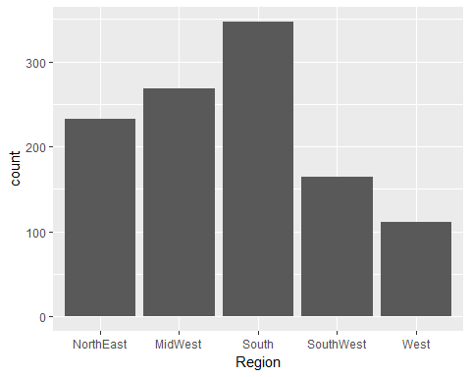

barplot2 <- gf_bar(~TobaccoUse, data = train_Natality)  
barplot2

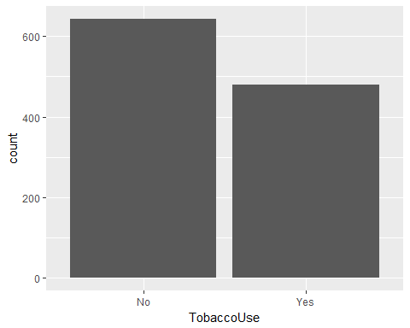

gf_bar(~EducationCode, data = train_Natality)

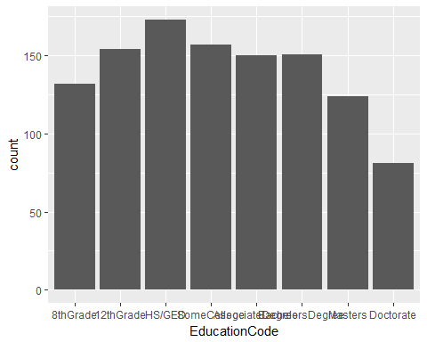

gf_histogram(~AverageAgeofMother, data = train_Natality)

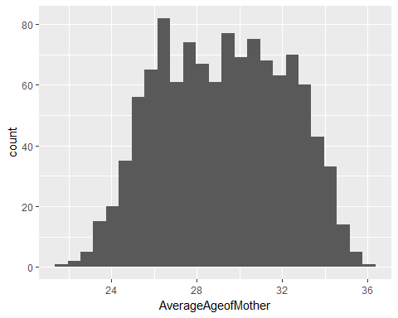

### (ii) Scatterplot

plot(AverageBirthWeight ~ AverageAgeofMother , data = train_Natality)

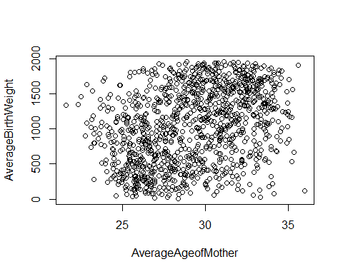

### (iii) Boxplots

boxplot(AverageBirthWeight ~ Region, data = train_Natality)

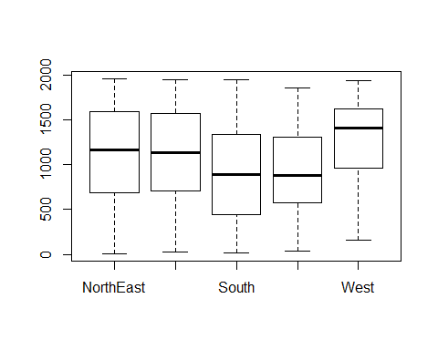

### (iv) Barplots

library(viridisLite)

## Warning: package 'viridisLite' was built under R version 3.4.4

gf_bar( ~ TobaccoUse, data = train_Natality, fill = ~Region)

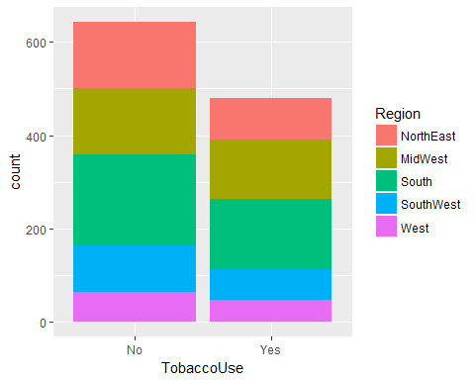

library(broom)  
resid_mod_base <- augment(mod.base)  
head(resid_mod_base)

## AverageBirthWeight Region DeliveryMethod TobaccoUse  
## 1 1607 NorthEast Vaginal No  
## 2 1187 NorthEast Cesarean No  
## 3 511 NorthEast Vaginal Yes  
## 4 1097 NorthEast Vaginal No  
## 5 461 NorthEast Cesarean Yes  
## 6 1017 NorthEast Cesarean No  
## AverageAgeofMother .fitted .se.fit .resid .hat .sigma  
## 1 29.52 1573.7851 20.45240 33.21487 0.004414004 307.9443  
## 2 31.25 1277.2535 20.48133 -90.25351 0.004426501 307.9366  
## 3 26.33 700.2492 22.39051 -189.24917 0.005290201 307.9062  
## 4 25.26 1340.7684 23.65519 -243.76844 0.005904693 307.8802  
## 5 27.19 356.1296 22.88321 104.87036 0.005525582 307.9335  
## 6 28.01 1100.0295 21.79031 -83.02954 0.005010384 307.9380  
## .cooksd .std.resid  
## 1 5.760260e-06 0.1081348  
## 2 4.265244e-05 -0.2938323  
## 3 2.245170e-04 -0.6163934  
## 4 4.162919e-04 -0.7942105  
## 5 7.204406e-05 0.3416081  
## 6 4.090732e-05 -0.2703931

## (C) Model Assumptions Check

### (i) QQ-plot for checking constant variance

gf_qq(~.std.resid, data = resid_mod_base) %>%  
 gf_qqline() %>%  
 gf_labs(x = "N(0,1) quantiles", y = "Standardized residuals" )

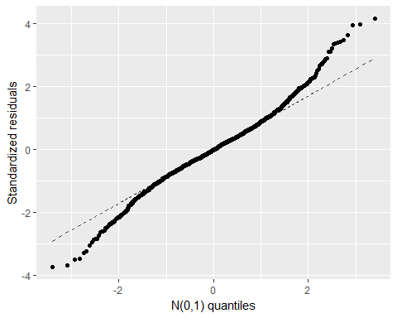

library(broom)  
resid_mod_plus <- augment(mod.plus)  
head(resid_mod_plus)

## log.as.numeric.AverageBirthWeight.. Region DeliveryMethod TobaccoUse  
## 1 7.382124 NorthEast Vaginal No  
## 2 7.079184 NorthEast Cesarean No  
## 3 6.236370 NorthEast Vaginal Yes  
## 4 7.000334 NorthEast Vaginal No  
## 5 6.133398 NorthEast Cesarean Yes  
## 6 6.924612 NorthEast Cesarean No  
## AverageAgeofMother .fitted .se.fit .resid .hat  
## 1 29.52 7.425865 0.03539966 -0.043740149 0.004414004  
## 2 31.25 7.015687 0.03544974 0.063497341 0.004426501  
## 3 26.33 6.240197 0.03875420 -0.003827497 0.005290201  
## 4 25.26 7.139493 0.04094316 -0.139158681 0.005904693  
## 5 27.19 5.771535 0.03960698 0.361862712 0.005525582  
## 6 28.01 6.797883 0.03771536 0.126728922 0.005010384  
## .sigma .cooksd .std.resid  
## 1 0.5330008 3.334476e-06 -0.08227315  
## 2 0.5329994 7.047207e-06 0.11943625  
## 3 0.5330020 3.065498e-08 -0.00720251  
## 4 0.5329897 4.528495e-05 -0.26194708  
## 5 0.5329188 2.863324e-04 0.68102694  
## 6 0.5329918 3.181101e-05 0.23844254

gf_qq(~.std.resid, data = resid_mod_plus) %>%  
 gf_qqline() %>%  
 gf_labs(x = "N(0,1) quantiles", y = "Standardized residuals" )

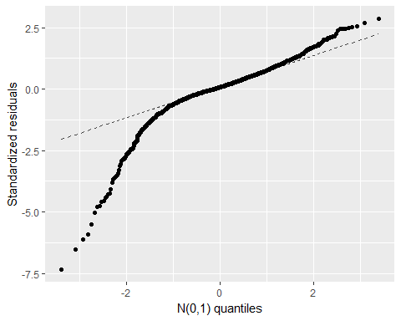 Transformation does not seem to be necessary. The QQ-plot also indicates heavy tails, particularly on the left side of the distribution of residuals; this means that our assumption of a normal distribution of residuals is not violated but that the distribution has a little more variance than usual. We could assume that the residuals follow a t-distribution.

### (ii) Residual plot for checking linearity

It appears that the linearity is satisfied by this model, as the points are randomly dispersed around the horizontal line.

gf_point(.resid ~ .fitted, data = resid_mod_base) %>%  
 gf_hline(yintercept = 0, col = "blue", lty = 2) %>%  
 gf_labs(x = "Fitted values", y = "Residuals", title = "Residuals vs. Fitted Values")

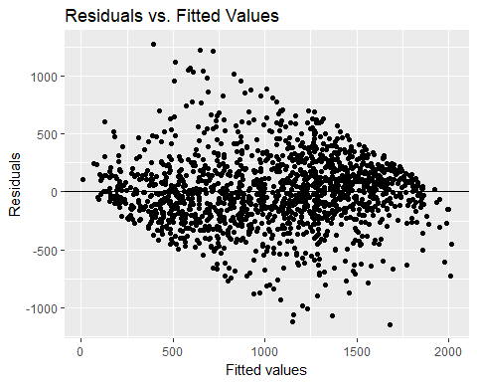

### (iii) Independence

The location of any response variable in relation to its mean cannot be predicted from the knowledge of the explanatory variable.

## (D) Model Diagnostics

### (i) Check for influential points and high-leverages

library(car)  
 influenceIndexPlot(mod.base, id.n = 3) # row numbers of high 3 cases

## Warning in plot.window(...): "id.n" is not a graphical parameter

## Warning in plot.xy(xy, type, ...): "id.n" is not a graphical parameter

## Warning in axis(side = side, at = at, labels = labels, ...): "id.n" is not  
## a graphical parameter  
  
## Warning in axis(side = side, at = at, labels = labels, ...): "id.n" is not  
## a graphical parameter

## Warning in box(...): "id.n" is not a graphical parameter

## Warning in title(...): "id.n" is not a graphical parameter

## Warning in plot.xy(xy.coords(x, y), type = type, ...): "id.n" is not a  
## graphical parameter  
  
## Warning in plot.xy(xy.coords(x, y), type = type, ...): "id.n" is not a  
## graphical parameter

## Warning in plot.window(...): "id.n" is not a graphical parameter

## Warning in plot.xy(xy, type, ...): "id.n" is not a graphical parameter

## Warning in axis(side = side, at = at, labels = labels, ...): "id.n" is not  
## a graphical parameter  
  
## Warning in axis(side = side, at = at, labels = labels, ...): "id.n" is not  
## a graphical parameter

## Warning in box(...): "id.n" is not a graphical parameter

## Warning in title(...): "id.n" is not a graphical parameter

## Warning in plot.xy(xy.coords(x, y), type = type, ...): "id.n" is not a  
## graphical parameter  
  
## Warning in plot.xy(xy.coords(x, y), type = type, ...): "id.n" is not a  
## graphical parameter

## Warning in plot.window(...): "id.n" is not a graphical parameter

## Warning in plot.xy(xy, type, ...): "id.n" is not a graphical parameter

## Warning in axis(side = side, at = at, labels = labels, ...): "id.n" is not  
## a graphical parameter  
  
## Warning in axis(side = side, at = at, labels = labels, ...): "id.n" is not  
## a graphical parameter

## Warning in box(...): "id.n" is not a graphical parameter

## Warning in title(...): "id.n" is not a graphical parameter

## Warning in plot.xy(xy.coords(x, y), type = type, ...): "id.n" is not a  
## graphical parameter  
  
## Warning in plot.xy(xy.coords(x, y), type = type, ...): "id.n" is not a  
## graphical parameter  
  
## Warning in plot.xy(xy.coords(x, y), type = type, ...): "id.n" is not a  
## graphical parameter  
  
## Warning in plot.xy(xy.coords(x, y), type = type, ...): "id.n" is not a  
## graphical parameter  
  
## Warning in plot.xy(xy.coords(x, y), type = type, ...): "id.n" is not a  
## graphical parameter  
  
## Warning in plot.xy(xy.coords(x, y), type = type, ...): "id.n" is not a  
## graphical parameter  
  
## Warning in plot.xy(xy.coords(x, y), type = type, ...): "id.n" is not a  
## graphical parameter  
  
## Warning in plot.xy(xy.coords(x, y), type = type, ...): "id.n" is not a  
## graphical parameter  
  
## Warning in plot.xy(xy.coords(x, y), type = type, ...): "id.n" is not a  
## graphical parameter  
  
## Warning in plot.xy(xy.coords(x, y), type = type, ...): "id.n" is not a  
## graphical parameter  
  
## Warning in plot.xy(xy.coords(x, y), type = type, ...): "id.n" is not a  
## graphical parameter  
  
## Warning in plot.xy(xy.coords(x, y), type = type, ...): "id.n" is not a  
## graphical parameter

## Warning in plot.window(...): "id.n" is not a graphical parameter

## Warning in plot.xy(xy, type, ...): "id.n" is not a graphical parameter

## Warning in axis(side = side, at = at, labels = labels, ...): "id.n" is not  
## a graphical parameter  
  
## Warning in axis(side = side, at = at, labels = labels, ...): "id.n" is not  
## a graphical parameter

## Warning in box(...): "id.n" is not a graphical parameter

## Warning in title(...): "id.n" is not a graphical parameter

## Warning in plot.xy(xy.coords(x, y), type = type, ...): "id.n" is not a  
## graphical parameter  
  
## Warning in plot.xy(xy.coords(x, y), type = type, ...): "id.n" is not a  
## graphical parameter

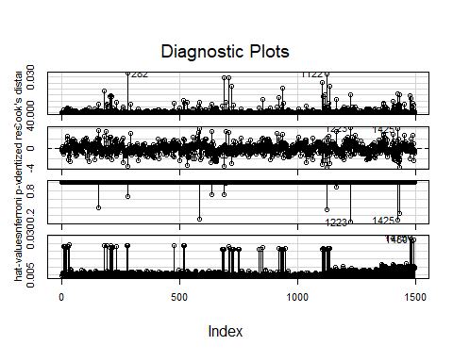

The studentized residuals are too high for data points 63 (with an average birthweight of 2446.04 grams), 657(with an average birthweight of 2515.94 grams) and 1122 (with an average birthweight of 2683.07 grams). Our reference number 4, since this is a large dataset.

Data point 1486 (with an average birthweight of 3191.61 grams)has a large hat value.

There appears to be no influential point, as there is no Cook’s Distance that is close to 1.

The reference hat-value we use is 3((p+1)/n) = 0.018.

After examining the aberrant data points, we still decided to keep the original model, as the Cook’s Distance plot did not show any influential points.

### (ii) Check for multicollinearity

Now we must check for multicollinearity:

vif(mod.base)

## GVIF Df GVIF^(1/(2*Df))  
## Region 1.035228 4 1.004337  
## DeliveryMethod 1.093301 2 1.022551  
## TobaccoUse 1.045763 1 1.022625  
## AverageAgeofMother 1.087144 1 1.042662

Multicollinearity is not suspected. All the VIF values are much smaller than 5.

## (D) Investigate whether our model is sufficient.

### (i) We included all the interaction terms and created mod.one.

We also look at the ANOVA test as well as a modified model according to the AIC criterion.

mod.one <- lm(AverageBirthWeight ~ Region * DeliveryMethod * TobaccoUse * AverageAgeofMother, data = Natality)  
anova(mod.one, mod.base, test = "Chisq")

## Analysis of Variance Table  
##   
## Model 1: AverageBirthWeight ~ Region * DeliveryMethod * TobaccoUse * AverageAgeofMother  
## Model 2: AverageBirthWeight ~ Region + DeliveryMethod + TobaccoUse + AverageAgeofMother  
## Res.Df RSS Df Sum of Sq Pr(>Chi)   
## 1 1448 126204382   
## 2 1487 140918061 -39 -14713678 < 2.2e-16 ***  
## ---  
## Signif. codes: 0 '***' 0.001 '**' 0.01 '*' 0.05 '.' 0.1 ' ' 1

Our low p-value indicates that we most likely need interaction terms to be included in our model.

The following code gives numeric coefficients for our new model:

### (ii) We used StepAIC to determine an interaction-based model with the lowest AIC criterion using stepwise elimination.

mod.forwardstep <- stepAIC(mod.base, scope = list(lower = ~1, upper = ~Region + DeliveryMethod + TobaccoUse + AverageAgeofMother + Region * DeliveryMethod + Region * TobaccoUse + Region * AverageAgeofMother + DeliveryMethod * TobaccoUse + DeliveryMethod * AverageAgeofMother + TobaccoUse * AverageAgeofMother), direction = "both", k = log(nrow(Natality)))

## Start: AIC=17199.69  
## AverageBirthWeight ~ Region + DeliveryMethod + TobaccoUse + AverageAgeofMother  
##   
## Df Sum of Sq RSS AIC  
## + DeliveryMethod:TobaccoUse 1 2130649 138787411 17184  
## + TobaccoUse:AverageAgeofMother 1 1416140 139501921 17192  
## + Region:TobaccoUse 4 3049122 137868938 17196  
## + Region:AverageAgeofMother 4 3004545 137913516 17197  
## <none> 140918061 17200  
## + DeliveryMethod:AverageAgeofMother 2 393118 140524942 17210  
## + Region:DeliveryMethod 7 1399669 139518391 17236  
## - Region 4 21493434 162411494 17383  
## - AverageAgeofMother 1 35958010 176876071 17532  
## - DeliveryMethod 2 53325844 194243905 17665  
## - TobaccoUse 1 170560606 311478667 18379  
##   
## Step: AIC=17184.21  
## AverageBirthWeight ~ Region + DeliveryMethod + TobaccoUse + AverageAgeofMother +   
## DeliveryMethod:TobaccoUse  
##   
## Df Sum of Sq RSS AIC  
## + Region:TobaccoUse 4 3093781 135693630 17180  
## + Region:AverageAgeofMother 4 2961020 135826391 17181  
## + TobaccoUse:AverageAgeofMother 1 853067 137934344 17182  
## <none> 138787411 17184  
## + DeliveryMethod:AverageAgeofMother 2 246163 138541248 17196  
## - DeliveryMethod:TobaccoUse 1 2130649 140918061 17200  
## + Region:DeliveryMethod 7 1374903 137412508 17221  
## - Region 4 21502545 160289956 17371  
## - AverageAgeofMother 1 36623182 175410593 17527  
##   
## Step: AIC=17179.73  
## AverageBirthWeight ~ Region + DeliveryMethod + TobaccoUse + AverageAgeofMother +   
## DeliveryMethod:TobaccoUse + Region:TobaccoUse  
##   
## Df Sum of Sq RSS AIC  
## + TobaccoUse:AverageAgeofMother 1 674295 135019335 17180  
## <none> 135693630 17180  
## + Region:AverageAgeofMother 4 2453117 133240513 17182  
## - Region:TobaccoUse 4 3093781 138787411 17184  
## + DeliveryMethod:AverageAgeofMother 2 256279 135437351 17192  
## - DeliveryMethod:TobaccoUse 1 2175308 137868938 17196  
## + Region:DeliveryMethod 7 1531516 134162114 17214  
## - AverageAgeofMother 1 36927081 172620711 17533  
##   
## Step: AIC=17179.58  
## AverageBirthWeight ~ Region + DeliveryMethod + TobaccoUse + AverageAgeofMother +   
## DeliveryMethod:TobaccoUse + Region:TobaccoUse + TobaccoUse:AverageAgeofMother  
##   
## Df Sum of Sq RSS AIC  
## <none> 135019335 17180  
## - TobaccoUse:AverageAgeofMother 1 674295 135693630 17180  
## + Region:AverageAgeofMother 4 2407555 132611780 17182  
## - Region:TobaccoUse 4 2915010 137934344 17182  
## - DeliveryMethod:TobaccoUse 1 1650640 136669975 17191  
## + DeliveryMethod:AverageAgeofMother 2 170018 134849316 17192  
## + Region:DeliveryMethod 7 1512997 133506338 17214

summary(mod.forwardstep)

##   
## Call:  
## lm(formula = AverageBirthWeight ~ Region + DeliveryMethod + TobaccoUse +   
## AverageAgeofMother + DeliveryMethod:TobaccoUse + Region:TobaccoUse +   
## TobaccoUse:AverageAgeofMother, data = Natality)  
##   
## Residuals:  
## Min 1Q Median 3Q Max   
## -1128.64 -172.62 -4.48 171.29 1318.09   
##   
## Coefficients: (1 not defined because of singularities)  
## Estimate Std. Error t value  
## (Intercept) -286.035 112.394 -2.545  
## RegionMidWest 99.355 30.992 3.206  
## RegionSouth -122.954 29.038 -4.234  
## RegionSouthWest -223.055 34.792 -6.411  
## RegionWest 63.473 39.639 1.601  
## DeliveryMethodNot Stated 132.924 46.693 2.847  
## DeliveryMethodVaginal 451.116 21.754 20.737  
## TobaccoUseYes -1125.439 174.472 -6.451  
## AverageAgeofMother 49.455 3.550 13.931  
## DeliveryMethodNot Stated:TobaccoUseYes NA NA NA  
## DeliveryMethodVaginal:TobaccoUseYes -139.081 32.686 -4.255  
## RegionMidWest:TobaccoUseYes 16.474 47.731 0.345  
## RegionSouth:TobaccoUseYes 1.930 45.011 0.043  
## RegionSouthWest:TobaccoUseYes 129.909 54.509 2.383  
## RegionWest:TobaccoUseYes 291.698 61.771 4.722  
## TobaccoUseYes:AverageAgeofMother 15.344 5.642 2.720  
## Pr(>|t|)   
## (Intercept) 0.01103 *   
## RegionMidWest 0.00138 **   
## RegionSouth 2.43e-05 ***  
## RegionSouthWest 1.94e-10 ***  
## RegionWest 0.10953   
## DeliveryMethodNot Stated 0.00448 **   
## DeliveryMethodVaginal < 2e-16 ***  
## TobaccoUseYes 1.51e-10 ***  
## AverageAgeofMother < 2e-16 ***  
## DeliveryMethodNot Stated:TobaccoUseYes NA   
## DeliveryMethodVaginal:TobaccoUseYes 2.22e-05 ***  
## RegionMidWest:TobaccoUseYes 0.73004   
## RegionSouth:TobaccoUseYes 0.96581   
## RegionSouthWest:TobaccoUseYes 0.01729 *   
## RegionWest:TobaccoUseYes 2.55e-06 ***  
## TobaccoUseYes:AverageAgeofMother 0.00661 **   
## ---  
## Signif. codes: 0 '***' 0.001 '**' 0.01 '*' 0.05 '.' 0.1 ' ' 1  
##   
## Residual standard error: 301.9 on 1481 degrees of freedom  
## Multiple R-squared: 0.6904, Adjusted R-squared: 0.6875   
## F-statistic: 235.9 on 14 and 1481 DF, p-value: < 2.2e-16

### (iii) This is our refined model: mod.two.

mod.two <- lm(AverageBirthWeight ~ Region + DeliveryMethod + TobaccoUse + AverageAgeofMother + TobaccoUse*AverageAgeofMother + Region*TobaccoUse, data = Natality)  
summary(mod.two)

##   
## Call:  
## lm(formula = AverageBirthWeight ~ Region + DeliveryMethod + TobaccoUse +   
## AverageAgeofMother + TobaccoUse * AverageAgeofMother + Region *   
## TobaccoUse, data = Natality)  
##   
## Residuals:  
## Min 1Q Median 3Q Max   
## -1126.16 -172.56 4.91 179.58 1292.31   
##   
## Coefficients:  
## Estimate Std. Error t value Pr(>|t|)   
## (Intercept) -184.283 110.453 -1.668 0.095440 .   
## RegionMidWest 97.224 31.167 3.119 0.001847 **   
## RegionSouth -125.646 29.198 -4.303 1.79e-05 ***  
## RegionSouthWest -224.468 34.990 -6.415 1.89e-10 ***  
## RegionWest 63.488 39.867 1.592 0.111493   
## DeliveryMethodNot Stated 99.349 46.286 2.146 0.032001 *   
## DeliveryMethodVaginal 389.512 16.330 23.853 < 2e-16 ***  
## TobaccoUseYes -1335.780 168.286 -7.938 4.04e-15 ***  
## AverageAgeofMother 47.109 3.527 13.356 < 2e-16 ***  
## TobaccoUseYes:AverageAgeofMother 20.061 5.564 3.606 0.000322 ***  
## RegionMidWest:TobaccoUseYes 18.818 48.003 0.392 0.695101   
## RegionSouth:TobaccoUseYes 5.990 45.259 0.132 0.894723   
## RegionSouthWest:TobaccoUseYes 131.727 54.821 2.403 0.016390 *   
## RegionWest:TobaccoUseYes 289.226 62.124 4.656 3.52e-06 ***  
## ---  
## Signif. codes: 0 '***' 0.001 '**' 0.01 '*' 0.05 '.' 0.1 ' ' 1  
##   
## Residual standard error: 303.7 on 1482 degrees of freedom  
## Multiple R-squared: 0.6867, Adjusted R-squared: 0.6839   
## F-statistic: 249.8 on 13 and 1482 DF, p-value: < 2.2e-16

## (E) Model Assumptions + Diagnostics for the Refined Model: mod.two.:

library(broom)  
resid_mod_two <- augment(mod.two)  
head(resid_mod_two)

## AverageBirthWeight Region DeliveryMethod TobaccoUse  
## 1 1607 NorthEast Vaginal No  
## 2 1187 NorthEast Cesarean No  
## 3 511 NorthEast Vaginal Yes  
## 4 1097 NorthEast Vaginal No  
## 5 461 NorthEast Cesarean Yes  
## 6 1017 NorthEast Cesarean No  
## AverageAgeofMother .fitted .se.fit .resid .hat .sigma  
## 1 29.52 1595.8789 23.76885 11.12105 0.006126206 303.7798  
## 2 31.25 1287.8652 23.89935 -100.86518 0.006193657 303.7685  
## 3 26.33 638.0293 30.50686 -127.02932 0.010091832 303.7618  
## 4 25.26 1395.1956 28.57746 -298.19564 0.008855688 303.6802  
## 5 27.19 306.2834 29.90600 154.71657 0.009698216 303.7530  
## 6 28.01 1135.2328 25.45303 -118.23280 0.007025122 303.7642  
## .cooksd .std.resid  
## 1 5.941117e-07 0.03673397  
## 2 4.941663e-05 -0.33317922  
## 3 1.287168e-04 -0.42043035  
## 4 6.208664e-04 -0.98632579  
## 5 1.833485e-04 0.51196539  
## 6 7.714369e-05 -0.39071168

gf_qq(~.std.resid, data = resid_mod_two) %>%  
 gf_qqline() %>%  
 gf_labs(x = "N(0,1) quantiles", y = "Standardized residuals" )

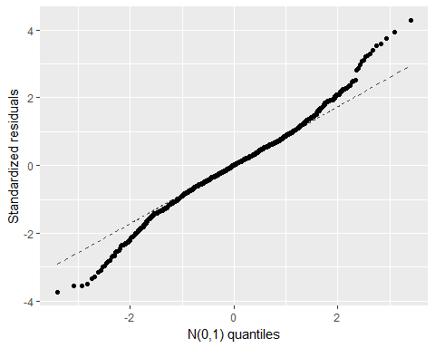

gf_point(.resid ~ .fitted, data = resid_mod_two) %>%  
 gf_hline(yintercept = 0, col = "blue", lty = 2) %>%  
 gf_labs(x = "Fitted values", y = "Residuals", title = "Residuals vs. Fitted Values")

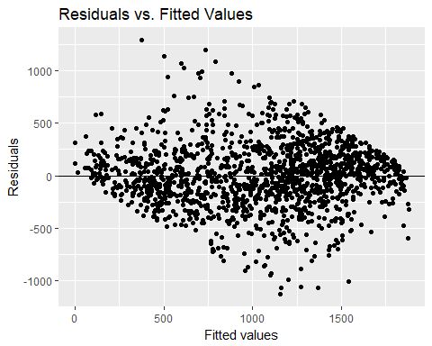

library(car)  
 influenceIndexPlot(mod.two, id.n = 3) # row numbers of high 3 cases

## Warning in plot.window(...): "id.n" is not a graphical parameter

## Warning in plot.xy(xy, type, ...): "id.n" is not a graphical parameter

## Warning in axis(side = side, at = at, labels = labels, ...): "id.n" is not  
## a graphical parameter  
  
## Warning in axis(side = side, at = at, labels = labels, ...): "id.n" is not  
## a graphical parameter

## Warning in box(...): "id.n" is not a graphical parameter

## Warning in title(...): "id.n" is not a graphical parameter

## Warning in plot.xy(xy.coords(x, y), type = type, ...): "id.n" is not a  
## graphical parameter  
  
## Warning in plot.xy(xy.coords(x, y), type = type, ...): "id.n" is not a  
## graphical parameter

## Warning in plot.window(...): "id.n" is not a graphical parameter

## Warning in plot.xy(xy, type, ...): "id.n" is not a graphical parameter

## Warning in axis(side = side, at = at, labels = labels, ...): "id.n" is not  
## a graphical parameter  
  
## Warning in axis(side = side, at = at, labels = labels, ...): "id.n" is not  
## a graphical parameter

## Warning in box(...): "id.n" is not a graphical parameter

## Warning in title(...): "id.n" is not a graphical parameter

## Warning in plot.xy(xy.coords(x, y), type = type, ...): "id.n" is not a  
## graphical parameter  
  
## Warning in plot.xy(xy.coords(x, y), type = type, ...): "id.n" is not a  
## graphical parameter

## Warning in plot.window(...): "id.n" is not a graphical parameter

## Warning in plot.xy(xy, type, ...): "id.n" is not a graphical parameter

## Warning in axis(side = side, at = at, labels = labels, ...): "id.n" is not  
## a graphical parameter  
  
## Warning in axis(side = side, at = at, labels = labels, ...): "id.n" is not  
## a graphical parameter

## Warning in box(...): "id.n" is not a graphical parameter

## Warning in title(...): "id.n" is not a graphical parameter

## Warning in plot.xy(xy.coords(x, y), type = type, ...): "id.n" is not a  
## graphical parameter  
  
## Warning in plot.xy(xy.coords(x, y), type = type, ...): "id.n" is not a  
## graphical parameter  
  
## Warning in plot.xy(xy.coords(x, y), type = type, ...): "id.n" is not a  
## graphical parameter  
  
## Warning in plot.xy(xy.coords(x, y), type = type, ...): "id.n" is not a  
## graphical parameter  
  
## Warning in plot.xy(xy.coords(x, y), type = type, ...): "id.n" is not a  
## graphical parameter  
  
## Warning in plot.xy(xy.coords(x, y), type = type, ...): "id.n" is not a  
## graphical parameter  
  
## Warning in plot.xy(xy.coords(x, y), type = type, ...): "id.n" is not a  
## graphical parameter  
  
## Warning in plot.xy(xy.coords(x, y), type = type, ...): "id.n" is not a  
## graphical parameter  
  
## Warning in plot.xy(xy.coords(x, y), type = type, ...): "id.n" is not a  
## graphical parameter  
  
## Warning in plot.xy(xy.coords(x, y), type = type, ...): "id.n" is not a  
## graphical parameter

## Warning in plot.window(...): "id.n" is not a graphical parameter

## Warning in plot.xy(xy, type, ...): "id.n" is not a graphical parameter

## Warning in axis(side = side, at = at, labels = labels, ...): "id.n" is not  
## a graphical parameter  
  
## Warning in axis(side = side, at = at, labels = labels, ...): "id.n" is not  
## a graphical parameter

## Warning in box(...): "id.n" is not a graphical parameter

## Warning in title(...): "id.n" is not a graphical parameter

## Warning in plot.xy(xy.coords(x, y), type = type, ...): "id.n" is not a  
## graphical parameter  
  
## Warning in plot.xy(xy.coords(x, y), type = type, ...): "id.n" is not a  
## graphical parameter

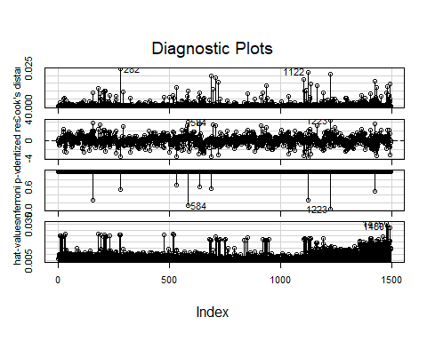

vif(mod.two)

## GVIF Df GVIF^(1/(2*Df))  
## Region 9.244888 4 1.320498  
## DeliveryMethod 1.108856 2 1.026169  
## TobaccoUse 112.090525 1 10.587281  
## AverageAgeofMother 1.762498 1 1.327591  
## TobaccoUse:AverageAgeofMother 102.966378 1 10.147235  
## Region:TobaccoUse 30.055122 4 1.530170