Doc2Patient: A Proof-of-Concept Web Platform for Low-Bandwidth Teleconsultation and Vital-Sign Sharing in Underserved Ghanaian Communities
Srinivasan Shankar Balapangu  Biomedical Engineering Department  University of Ghana  Accra, Ghana  ssbalapangu@ug.edu.gh |  |  | Wisdom Osborn Abuyah  Dept. of Biomedical Engineering  University of Ghana, Legon  Accra, Ghana  abuyahwisdom@gmail.com |  |  | Efua Kusiwa Aboagye  Dept. of Biomedical Engineering  University of Ghana, Legon  Accra, Ghana  ekaboagye010@st.ug.edu.gh |  |  | Dugbatey Emmanuel Kofi  Dept. of Biomedical Engineering  University of Ghana, Legon  Accra, Ghana  dugbateykofiemmanuel@gmail.com
Delores Nkrumah  Dept. of Biomedical Engineering  University of Ghana, Legon  Accra, Ghana  dnkrumah016@st.ug.edu.gh |  |  |  | Baffoe Boadu Paa Kwesi  Biomedical Engineering Department  University of Ghana  Accra, Ghana  boadupaakwesi4@gmail.com |  |  |  | John Jeff Abbu-Bonsra Kyei  Biomedical Engineering Department  University of Ghana  Accra, Ghana  kyei.johnjeff@gmail.com

Abstract—Access to timely healthcare consultation remains a critical challenge in rural and underserved communities across Ghana. This paper presents Doc2Patient, a proof-of-concept web-based teleconsultation platform combining browser WebRTC consultation, persistent chat, appointment management, and patient-recorded vital-sign sharing. Version 1 provides role-separated patient, doctor, and administrator accounts, optional two-factor authentication, and an interface in English, French, and Twi. A local HTTP load evaluation completed 962 requests across 10–100 simulated users without recorded request failures, but latency increased to a 5.3-second median and 18.0-second 95th percentile at 100 users. Lighthouse performance scores were 95–100 and accessibility scores were 100 on the tested landing, login, and FAQ pages. An unauthenticated OWASP ZAP baseline found 0 High, 3 Medium, 0 Low, and 6 Informational alerts after security-header hardening. These results are local proof-of-concept evidence, not production scalability, Ghanaian 3G/4G performance, clinical utility, or complete security assurance.
Index Terms—telemedicine, teleconsultation, WebRTC, digital health, healthcare access, Ghana, multilingual systems, proof of concept

I. Introduction
Telemedicine is the use of digital communication technologies to deliver healthcare services remotely, including diagnosis, treatment, and patient monitoring [1], [2]. Teleconsultation—direct virtual interaction between a clinician and a patient using real-time video and, increasingly, artificial intelligence (AI) and Internet of Things (IoT) instrumentation—is its most immediate expression [1]. Trust and usability studies of remote consultation continue to show that, when properly engineered, video and telephone consultations can match in-person care for a growing range of conditions [3].
Ghana’s healthcare system illustrates why this matters. The national physician-to-patient ratio is approximately 1:7,058, and in the Northern and Upper East regions this deteriorates to 1:9,385 and 1:21,465 respectively [4], [5]. This uneven distribution carries a measurable economic and clinical cost [6]. Health workforce and infrastructure shortages are compounded by government health spending that remains below the 15% Abuja Declaration target [7]–[10], leaving rural facilities without reliable equipment, water, or sanitation [7], [11]. Poor road networks and infrequent public transport further restrict patients’ ability to reach the clinics that do exist [12]–[15].
Prior teleconsultation efforts in Ghana and the wider region have generally been urban-centric, specialist-focused, and dependent on infrastructure that rural facilities do not have [16]–[18]. Sustained deployment has been further limited by inadequate provider training and underinvestment in digital infrastructure [16]. At the same time, the COVID-19 pandemic demonstrated that telehealth adoption can scale rapidly when platforms are designed around the connectivity constraints of their users [2], [19], and broader reviews of AI- and IoT-enabled teleconsultation point toward integrated, sensor-aware platforms as the next step for the field [1].
This paper reports the design, implementation, and descriptive evaluation of Doc2Patient version 1 (v1), a proof-of-concept teleconsultation platform built around Ghana’s connectivity and workforce constraints. Rather than treating video calling as the entire product, Doc2Patient combines consultation, scheduling, messaging, and patient-recorded vital signs in one application whose logical layers (presentation, application logic, real-time signaling, persistence, and notifications) are organized as separate modules. v1 is a research prototype: it has not been clinically validated, it uses patient-entered rather than sensor-acquired vital signs, and it has known limitations that we document and that define the roadmap for version 2 (Section VIII). The contributions of this paper are:
- A working proof of concept that integrates browser-based WebRTC consultation, appointment workflow, persistent chat, and patient-recorded vital-sign sharing in a single open-source Flask application deployed on a commodity platform-as-a-service.
- A role-separated account model (patient, doctor, administrator) with administrator vetting of doctor accounts and optional TOTP two-factor authentication.
- The v1 interface is available in English, French, and Twi. Translation coverage was not independently audited in the present evaluation.
- A descriptive evaluation of v1 (functional, load, network, vulnerability-scan, and pilot results) together with an explicit account of its limitations and the improvements planned for v2.

II. Related Work
Teleconsultation is increasingly recognized across Sub-Saharan Africa for its potential to mitigate chronic healthcare access challenges. Existing platforms employ diverse technological approaches, including mobile health applications, SMS-based services, web portals, and real-time video conferencing. Table I summarizes representative initiatives in the region by delivery channel and by the features most relevant to this work. Entries marked “not reported” were not stated in the cited source, which does not imply that the feature is absent.

TABLE I
Selected Teleconsultation Initiatives in Sub-Saharan Africa
Platform | Country | Delivery channel | Live video | Vitals / telemetry | Local-language UI | Source
Mobihealth | Nigeria | Mobile app–based telemedicine with integrated electronic medical records | Yes | Not reported | Not reported | [20], [21]
SomDoctor | Somalia | Remote medical consultation platform | Not reported | Not reported | Not reported | [22]
WelTel Kenya1 | Kenya | SMS: weekly two-way nurse check-in | No (SMS only) | Not reported | Not reported | [23]
EQUI-ResHuS telehealth | Mali | Tele-expertise (obstetric ultrasound, cardiology) and distance education in district hospitals | Not reported | Not reported | Not reported | [24]
Ghana Teleoncology | Ghana | Web-based | Not reported | Not reported | Not reported | [18]
Doc2Patient v1 | Ghana | Web application (WebRTC, chat, SMS and e-mail notifications) | Yes | Patient-recorded; shared during a session | English, French, Twi | This work
Adoption ratings used in the previous version were removed because the cited sources do not support a comparable rating. Security controls, accessibility, and low-bandwidth adaptation could not be compared because they are not reported in the cited publications.

Within Ghana specifically, platforms such as Ghana Teleoncology, mClinic, and the COVID Connect initiative demonstrate growing interest in telemedicine, but remain narrowly scoped, urban-centric, and reliant on complex infrastructure [18]. Even hub-and-spoke models designed explicitly for a rural district have reported implementation barriers around staffing, connectivity, and sustained institutional buy-in [25]. This urban-centric, specialist-focused approach restricts access for the rural populations who would benefit most from scalable, user-friendly teleconsultation platforms that integrate vital-sign monitoring with remote health support. Doc2Patient v1 targets a low-cost, self-hostable web deployment with patient-recorded vital signs and a local-language interface; as a proof of concept it has not been clinically validated.

III. Problem Definition and Motivation
Patients in underserved and rural Ghanaian communities face significant delays in accessing timely healthcare consultations because of a critical shortage of qualified healthcare professionals, inadequate infrastructure, and geographical barriers [18]. Beyond workforce deficiencies, rural facilities suffer from infrastructural inadequacies, including limited medical equipment and sanitation, that undermine care quality and patient safety [11]. Poor road networks and unreliable public transport further limit patient mobility, exacerbating delays or missed consultations [12], [14]. These factors motivate the need for an accessible, low-cost, and user-centric web-based teleconsultation platform that connects underserved patients with qualified healthcare professionals, facilitating timely consultations while reducing dependence on physical visits.

IV. Aim and Objectives
This project developed a simple, low-cost web-based teleconsultation prototype enabling real-time remote interaction between doctors and patients, supporting text and video consultations. The specific objectives were to: (1) design a user-centric web interface, available in English, French, and Twi, that accommodates varying digital literacy levels; (2) implement teleconsultation features supporting real-time video and persistent chat; (3) implement authenticated, role-separated access with administrator vetting of clinicians; (4) allow patients to record vital signs and share their latest readings with the consulting clinician during a session; and (5) organize the codebase in modular layers suitable for later extension across Ghana and Sub-Saharan Africa.

V. System Architecture and Methodology

A. Architectural Overview
Doc2Patient v1 is a Flask monolith organized into five logical layers: (i) a server-rendered presentation layer with separate patient, doctor, and administrator interfaces styled with Tailwind CSS; (ii) application logic for authentication, appointments, vitals, and administration; (iii) a PostgreSQL persistence layer (SQLite in development) accessed through SQLAlchemy with Alembic migrations; (iv) a real-time layer in which Flask-SocketIO provides signaling and chat while WebRTC carries audio and video directly between browsers; and (v) auxiliary services for localization (Flask-Babel), e-mail, and SMS notification (Hubtel). The layers are modules of one application, deployed as a single web service on the Render platform with a Render-managed PostgreSQL database. Because media flows peer-to-peer, the server carries page, signaling, and chat traffic rather than video. Fig. 1 shows the architecture.

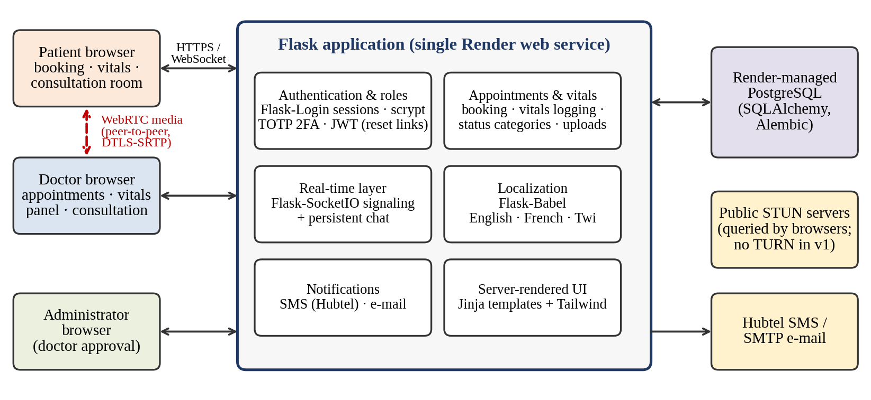
Fig. 1. Architecture of Doc2Patient v1: a single Flask application on Render, a Render-managed PostgreSQL database, peer-to-peer WebRTC media between browsers, and external STUN, SMS, and e-mail services.

B. Frontend and Interface Design
The frontend uses server-rendered HTML with Tailwind CSS for responsive styling. Key interfaces include a patient dashboard for appointment booking, appointment history, and vital-sign logging (Fig. 2); a doctor portal for confirming or declining appointments, viewing patient records and vitals, and uploading a post-consultation document; and a consultation room integrating video, text chat, voice-to-text transcription, and a panel showing the patient’s latest shared vitals (Fig. 3).
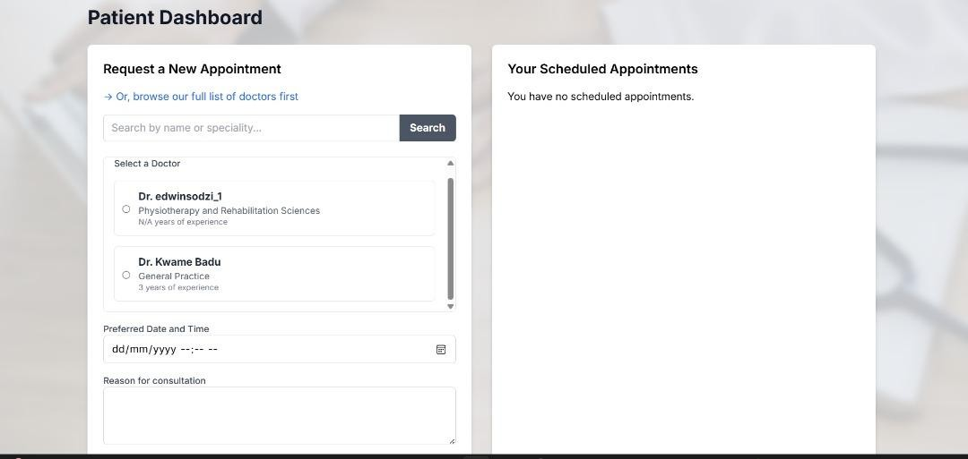
Fig. 2. Patient dashboard: appointment request form (left) and scheduled appointments (right).
Consultation-room screenshot: not captured in the automated HTTP evaluation. A browser-based two-user WebRTC test is required before adding this figure.
Fig. 3. Consultation room with the shared-vitals panel.

C. Real-Time Communication Layer
Audio/video consultation uses WebRTC, which provides peer-to-peer media exchange in the browser without plugins. Signaling (offers, answers, and ICE candidates) is relayed by Flask-SocketIO. Connection establishment uses public STUN servers to discover peers’ public addresses; v1 does not deploy a TURN relay, so connections between peers that cannot establish a direct path (for example, behind symmetric or carrier-grade NAT) may fail. Once a call is established, adaptation of bitrate and resolution to changing network conditions is performed by the browser’s built-in congestion control [26] rather than by application logic; users can additionally turn their camera off to continue the consultation by audio only. A persistent text chat over WebSocket, stored with the appointment, and optional voice-to-text transcription through the browser’s Web Speech API (English; Chromium-based browsers) supplement the video channel. Automatic audio-only fallback and a TURN relay are planned for v2 (Section VIII).

D. Authentication and Security
Users authenticate with a username and password. Sessions are managed with signed cookies (Flask-Login), and passwords are stored as salted hashes (Werkzeug). Time-limited JSON Web Tokens are used only for password-reset links. Three roles (patient, doctor, administrator) determine which interfaces and actions are available; doctor registrations remain inactive until approved by an administrator. Users can optionally enable time-based one-time-password (TOTP) two-factor authentication. Traffic between browsers and the server is protected by TLS provided by the hosting platform, and WebRTC media is protected by DTLS-SRTP. v1 does not implement application-layer encryption of stored data, a session inactivity timeout, or rate limiting, and its access-control checks are role-based rather than uniformly object-level. A vulnerability scan and manual review of v1 (Section VI) identified authorization and input-handling gaps in the real-time channel and in file handling that are scheduled for v2; v1 should therefore be regarded as a research prototype and not be used with real patient data.

E. Data Management and Vital Signs
Consultation records, user profiles, chat messages, and vitals are stored in PostgreSQL. In v1 vital signs are recorded manually by the patient: temperature, systolic and diastolic blood pressure, heart rate, oxygen saturation, blood glucose, and height and weight (from which body-mass index is computed). Entries are range-checked on input; the accepted ranges exclude some extreme readings (for example, oxygen saturation below 80%). For each reading the patient’s page shows an informational status category obtained by comparing the value x with fixed bounds [L_{v}, U_{v}]:
status(v) = low if x < L_{v}; high if x > U_{v}; else normal (1)
using the bounds in Table II. These categories are informational and are not clinical alarms. During a consultation the patient can send their most recent recorded reading to the doctor’s panel, which updates over the WebSocket channel. SMS notifications are used for appointment requests, confirmations, and doctor-joined events (Fig. 4); v1 does not generate automated alerts from vital signs. Streaming of simulated and sensor-acquired vitals with threshold-based alerting is planned for v2.
TABLE II
Informational Status Bounds Used by the v1 Vitals Page
Measure | Low | High
Blood pressure (mmHg) | systolic < 90 or diastolic < 60 | systolic > 130 or diastolic > 80
Heart rate (bpm) | < 60 | > 100
SpO₂ (%) | < 95 | —
Temperature (°C) | < 36.1 | > 37.5
BMI (kg/m²) | < 18.5 (underweight) | 25–29.9 overweight; ≥ 30 obese
Bounds were selected by the developers from commonly used adult resting reference ranges and are not clinically validated. Blood glucose is recorded but not categorized.
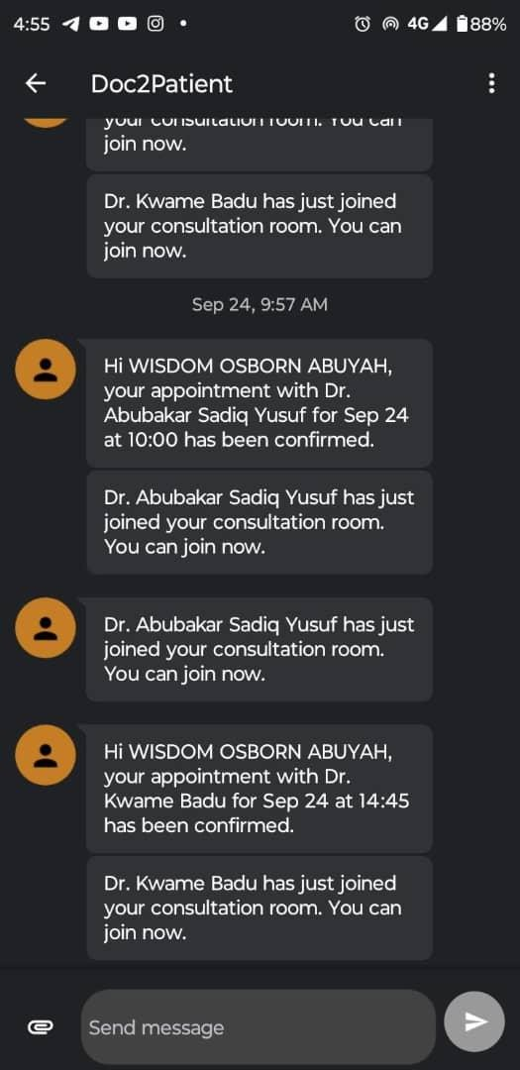
Fig. 4. SMS notifications sent to users for appointment confirmation and when the doctor joins the consultation room.
Patients register, book appointments, and choose a video or text consultation through a trilingual interface. Doctors confirm appointments, review shared vitals, and may upload a post-consultation document that the patient can download; each appointment’s chat is stored.

F. Localization and Accessibility
Flask-Babel provides the interface in English, French, and Twi (Akan); Ga and Ewe are planned. The responsive interface uses a locally built and minified Tailwind CSS bundle. Automated Lighthouse accessibility scores were 100 on the landing, login, and FAQ pages, while axe found ten moderate region-landmark findings on the landing page and no violations on the login page. These automated results do not replace manual screen-reader, keyboard, and usability testing.

G. Backend and Deployment
For the local evaluation, the backend ran as one Flask-SocketIO development process with SQLite. The production deployment description should identify the actual Render service and database plans used for any hosted measurements. Multi-instance signaling and a shared message queue remain v2 work.
Separate dashboards serve patients and doctors: the patient portal supports registration, login, booking, vitals logging, and consultation history, while the doctor portal enables appointment management, patient record and vitals access, and upload of a post-consultation document. An administrator dashboard supports doctor approval and user management. Fig. 5 shows the platform’s landing page, which provides access to login, registration, language selection, and health information resources.
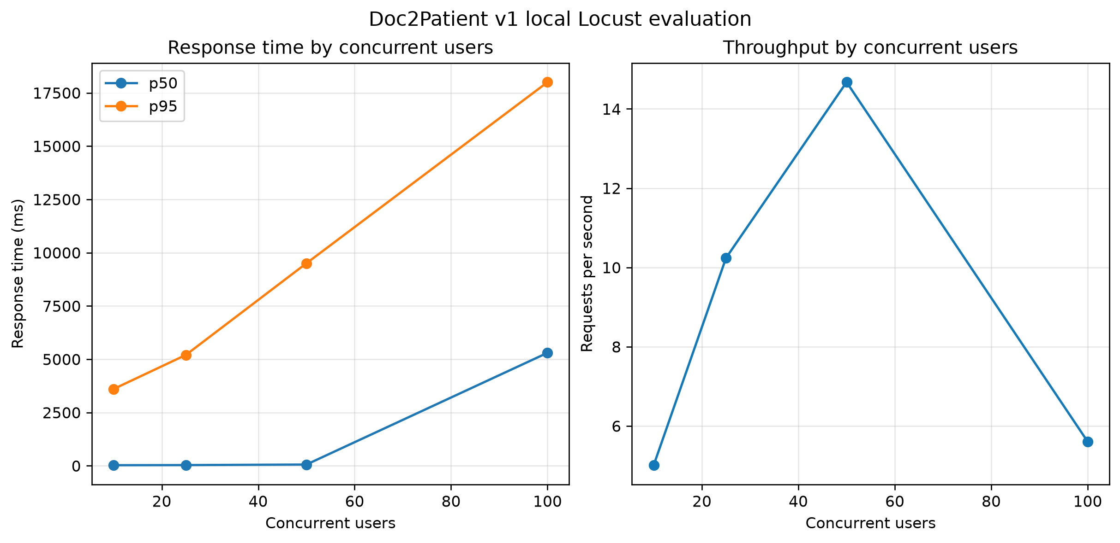
Fig. 5. Homepage of the Doc2Patient platform.

VI. Testing and Evaluation

A. Protocol
The evaluation used a local Windows 11/Python 3.14 environment with one Flask-SocketIO development process and SQLite. Locust stages ran for 30 seconds at 10, 25, 50, and 100 simulated users with a spawn rate of 10 users per second. The test exercised the public landing page, login, and authenticated role-dispatch route. Lighthouse 13.5 and axe-core 4.13 tested the current optimized frontend; OWASP ZAP 2.17.0 performed an unauthenticated quick baseline scan against the local application.
Functional smoke testing verified the public landing page, login form, CSRF token presence, protected-route redirects, role-dispatch routing, and rejection of the obsolete /dashboard path. The load test measured HTTP page and authentication traffic only; it did not measure WebRTC media, STUN/TURN connectivity, vitals-sharing latency, or pilot usability.
The current unauthenticated ZAP baseline reported 0 High, 3 Medium, 0 Low, and 6 Informational alerts. The remaining Medium alerts concern CSP policy quality: wildcard WebSocket schemes and use of unsafe-inline for scripts and styles. Security headers, cookie SameSite settings, and Socket.IO SRI protection are present. This scan does not establish complete platform security; authenticated authorization, CSRF, XSS, and real-time-channel testing remain required.

B. Results
Functional. Route smoke checks passed for the public and protected-route behaviours described above. Load. Across the four clean 30-second Locust stages, the test completed 962 requests with 0 recorded failures. At 100 users, the median response time was 5.3 seconds, the 95th percentile was 18.0 seconds, and the maximum was 22.9 seconds. Latency increased substantially as concurrency rose.
TABLE III
Load Test Results (HTTP and Signaling)
Users | Req/s | p50 (ms) | p95 (ms) | Errors (%)
10 | 5.0 | 26 | 3600 | 0.0
25 | 10.2 | 32 | 5200 | 0.0
50 | 14.7 | 57 | 9500 | 0.0
100 | 5.6 | 5300 | 18000 | 0.0
Local test instance: Windows 11, Python 3.14, one Flask-SocketIO development process, SQLite, and 30-second stages. CPU and memory were not sampled with a dedicated monitoring tool.
Ghanaian 3G/4G profiles, packet loss, STUN/TURN connectivity, WebRTC media statistics, and vitals-sharing latency were not measured. Lighthouse results used local Chrome defaults and must not be interpreted as Ghanaian network measurements.
TABLE IV
Emulated Network Conditions and Observed Behaviour
Profile | Bitrate (kb/s) | Resolution | fps | Call survived
Not measured in this evaluation | Not measured | Not measured | Not measured | Not measured
Not measured in this evaluation | Not measured | Not measured | Not measured | Not measured
Not measured in this evaluation | Not measured | Not measured | Not measured | Not measured
No constrained-network profiles were applied in this evaluation.
Page weight and accessibility. Lighthouse results were Landing: performance 95, accessibility 100; Login: performance 99, accessibility 100; FAQ: performance 100, accessibility 100. Landing transferred approximately 77 KiB in 5 requests with LCP 1.56 seconds; login transferred 72 KiB in 5 requests with LCP 1.46 seconds; FAQ transferred 72 KiB in 5 requests with LCP 1.38 seconds. These are local Chrome results, not Slow 3G/4G measurements. Security. The current unauthenticated ZAP baseline reported 0 High, 3 Medium, 0 Low, and 6 Informational alerts.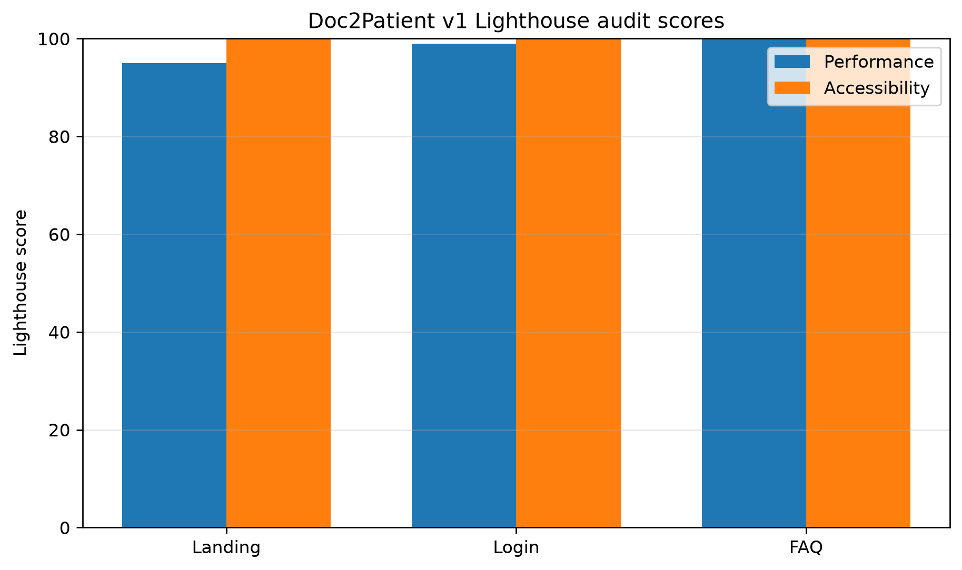
TABLE V
Vulnerability Scan Findings by Risk Level
Risk | Count | Examples (alert types)
High | 0 | None
Medium | 3 | CSP wildcard / unsafe-inline policy warnings
Low | 0 | None
Informational | 6 | ZAP informational observations
Tool: OWASP ZAP 2.17.0; mode: unauthenticated quick baseline scan; target: local http://127.0.0.1:5000/; report: docs/audits/zap-baseline.html.
Pilot: no participant study was conducted for this revision; usability and SUS results are not reported.

VII. Discussion
Doc2Patient v1 shows that a single open-source Flask application on commodity hosting can support the core teleconsultation workflow (booking, video and audio, chat, and patient-recorded vitals) at pilot scale, and that peer-to-peer media keeps server load low. The evaluation also shows where a proof of concept falls short: connectivity depends on STUN alone, adaptation to poor links relies on the browser, vital signs are entered manually, and security and accessibility controls are incomplete. Each limitation maps to a planned change in v2 (Section VIII). The modular layering and the choice of open-source components (Flask, WebRTC, PostgreSQL) make iterative improvement feasible without replacing the platform.
The main limitations are the small, non-clinical pilot; the absence of sensor-acquired vitals and of any clinical validation; reliance on internet connectivity and a free-tier demonstration instance; the security gaps described in Section V-D; and the absence of a formal regulatory assessment under Ghana’s Data Protection Act. Claims of clinical utility are therefore not made.

VIII. Limitations and Version 2 Roadmap
Version 2, under development as an upgrade of the same codebase, will address the limitations identified in v1: (i) connectivity—a TURN relay for peers behind restrictive NATs; (ii) adaptation—an application-level bitrate controller with automatic audio-only fallback; (iii) telemetry—streamed simulated vitals and then IoT sensors, with persistence-filtered, two-tier alerts pushed to clinicians; (iv) security—session inactivity timeouts and revocation, object-level authorization on all resources and real-time channels, application-level encryption of sensitive stored data, request-forgery protection, rate limiting, hardened file uploads, and an automated test suite; (v) accessibility and localization—dedicated accessibility features, self-hosted assets for low-bandwidth use, and Ga and Ewe support; and (vi) clinical workflow—digital prescriptions and referrals, in-chat file sharing, and appointment prioritization queues.
Further opportunities include an interactive tutorial bot, pharmacy integration so that patients can route prescriptions to a pharmacy of their choice, and a billing and payment system using trusted local solutions such as Paystack or Hubtel. Finally, regulatory and ethical compliance with Ghana’s Data Protection Act and, for cross-border use, international frameworks such as HIPAA and GDPR, together with collaboration with national policymakers and a larger field evaluation with real medical devices, will be necessary before wider deployment.

IX. Conclusion
Doc2Patient v1 demonstrates that a proof-of-concept teleconsultation platform combining WebRTC video and audio, persistent chat, appointment management, patient-recorded vital signs, and a multilingual interface can be built with open-source components. The local load baseline completed all recorded requests without failures, but latency increased substantially at 100 users. Lighthouse scores were high on the tested pages, while the ZAP baseline retains three CSP-quality findings. The results support iterative development, not production scalability, Ghanaian network performance, clinical readiness, or complete security assurance.

Acknowledgment
The authors thank the Department of Biomedical Engineering, School of Engineering Sciences, University of Ghana, for guidance and support throughout the development of this project.

Ethics Statement
No pilot participant study was conducted as part of this evaluation; ethics approval and consent details are therefore not applicable to the automated tests. Test accounts used simulated data only.

Availability
The source code for Doc2Patient v1 is publicly available at https://github.com/FinalYear4/Doc2Patient. These results were generated from the local code using SQLite and a single development process. It is a research prototype: do not enter real patient data.

References
[1] T. Shaik, X. Tao, N. Higgins, L. Li, R. Gururajan, X. Zhou, and U. R. Acharya, “Remote patient monitoring using artificial intelligence: Current state, applications, and challenges,” WIREs Data Min. Knowl. Discov., vol. 13, no. 2, p. e1485, Jan. 2023, doi: 10.1002/widm.1485.
[2] F. Khoshrounejad, M. Hamednia, A. Mehrjerd, S. Pichaghsaz, H. Jamalirad, M. Sargolzaei, B. Hoseini, and S. Aalaei, “Telehealth-based services during the COVID-19 pandemic: A systematic review of features and challenges,” Front. Public Health, vol. 9, p. 711762, Aug. 2021, doi: 10.3389/fpubh.2021.711762.
[3] S. de Camargo Catapan et al., “Development and validation of novel scales to measure trust and confidence in using telephone and video consultation scales in people with chronic kidney disease,” J. Telemed. Telecare, vol. 32, no. 3, pp. 275–288, 2026, doi: 10.1177/1357633X251338950.
[4] J. Amoah-Nuamah, W. Agyemang-Duah, G. Prosper Ninorb, and B. Gladstone Ekeme, “Analysis of spatial distribution of health care facilities and its effects on access to primary healthcare in rural communities in Kpandai District, Ghana,” Cogent Public Health, vol. 10, no. 1, art. 2183566, Mar. 2023, doi: 10.1080/27707571.2023.2183566.
[5] B. O. Boye, S. Pokhrel, K. L. Cheung, and N. Anokye, “Drivers and barriers to rural and urban healthcare placement in Ghana: A Delphi study,” Front. Public Health, vol. 13, p. 1436098, May 2025, doi: 10.3389/fpubh.2025.1436098.
[6] J. A. Asamani, H. Ismaila, A. Plange, V. F. Ekey, A.-M. Ahmed, M. Chebere, J. K. Awoonor-Williams, and J. Nabyonga-Orem, “The cost of health workforce gaps and inequitable distribution in the Ghana Health Service: an analysis towards evidence-based health workforce planning and management,” Hum. Resour. Health, vol. 19, no. 1, p. 43, Mar. 2021, doi: 10.1186/s12960-021-00590-3.
[7] A. Kumah, “The future of patient safety in Ghana: challenges and opportunities,” Front. Health Serv., vol. 5, art. 1581468, Jul. 2025, doi: 10.3389/frhs.2025.1581468.
[8] Human Rights Watch, “African governments falling short on healthcare funding,” Apr. 26, 2024. [Online]. Available: https://www.hrw.org/news/2024/04/26/african-governments-falling-short-healthcare-funding
[9] Exemplars in Global Health, “Improving Primary Health Care Efficiency in Ghana: Challenges.” [Online]. Available: https://www.exemplars.health/topics/primary-health-care/ghana/challenges. [Accessed: Jul. 24, 2026].
[10] R. V. Kodom and R. T. Netangaheni, “Challenges in accessing patient-centered care and patient empowerment in selected Ghanaian hospitals,” Health SA Gesondheid, vol. 29, a2623, Nov. 2024, doi: 10.4102/hsag.v29i0.2623.
[11] P. A. Dalinjong, A. Y. Wang, and C. S. Homer, “Are health facilities well equipped to provide basic quality childbirth services under the free maternal health policy? Findings from rural Northern Ghana,” BMC Health Serv. Res., vol. 18, no. 1, p. 959, Dec. 2018, doi: 10.1186/s12913-018-3787-1.
[12] K. N. Atuoye, J. Dixon, A. Rishworth, S. Z. Galaa, S. A. Boamah, and I. Luginaah, “Can she make it? Transportation barriers to accessing maternal and child health care services in rural Ghana,” BMC Health Serv. Res., vol. 15, no. 1, p. 333, Aug. 2015, doi: 10.1186/s12913-015-1005-y.
[13] G. Ashiagbor, R. Ofori-Asenso, E. K. Forkuo, and S. Agyei-Frimpong, “Measures of geographic accessibility to health care in the Ashanti Region of Ghana,” Sci. Afr., vol. 9, p. e00453, Sep. 2020, doi: 10.1016/j.sciaf.2020.e00453.
[14] F. Agbenyo, A. Marshall Nunbogu, and A. Dongzagla, “Accessibility mapping of health facilities in rural Ghana,” J. Transp. Health, vol. 6, pp. 73–83, 2017, doi: 10.1016/j.jth.2017.04.010.
[15] P. A. Boakye, D. Buor, and F. Tei-Nartey, “Geospatial analysis of primary healthcare accessibility and qualitative assessment of affordability in rural communities of Twifo Ati-Morkwaa District, Ghana,” BMC Prim. Care, 2026, doi: 10.1186/s12875-026-03260-2.
[16] G. Dzando, H. Akpeke, A. Kumah, E. Agada, A. A. Lartey, J. Nortu, H. S. Nutakor, A. B. Donyi, and R. Dordunu, “Telemedicine in Ghana: Insight into the past and present, a narrative review of literature amidst the Coronavirus pandemic,” J. Public Health Afr., vol. 13, no. 1, art. 2024, May 2022, doi: 10.4081/jphia.2022.2024.
[17] N. K. Mensah, G. Adzakpah, J. Kissi, R. O. Boadu, O. U. Lasim, M. K. Oyenike, A. Bart-Plange, M. A. Dalaba, and F. Sukums, “Health professional’s readiness and factors associated with telemedicine implementation and use in selected health facilities in Ghana,” Heliyon, vol. 9, no. 3, p. e14501, Mar. 2023, doi: 10.1016/j.heliyon.2023.e14501.
[18] E. T. Tchao, I. Acquah, S. D. Kotey, C. S. Aggor, and J. J. Kponyo, “On telemedicine implementations in Ghana,” Int. J. Adv. Comput. Sci. Appl., vol. 10, no. 3, 2019, doi: 10.14569/IJACSA.2019.0100325.
[19] J. Thomason, “Big tech, big data and the new world of digital health,” Glob. Health J., vol. 5, no. 4, pp. 165–168, Dec. 2021, doi: 10.1016/j.glohj.2021.11.003.
[20] U.S. Trade and Development Agency, “Mobihealth Multi-Country Telehealth Expansion Feasibility Study.” [Online]. Available: https://ustda.gov/?p=22489. [Accessed: Oct. 1, 2026].
[21] “Nigeria’s Mobihealth wins Sanofi’s AfricaTech Healthcare Challenge,” Technext, Jun. 15, 2020. [Online]. Available: https://technext.ng/2020/06/15/nigerias-mobihealth-wins-sanofis-africatech-healthcare-challenge/. [Accessed: Oct. 1, 2026].
[22] M. M. Ahmed, “Revolutionizing healthcare in Somalia: the role of digital innovations in enhancing access and quality,” Explor. Digit. Health Technol., vol. 2, pp. 360–368, Nov. 2024, doi: 10.37349/edht.2024.00034.
[23] R. T. Lester et al., “Effects of a mobile phone short message service on antiretroviral treatment adherence in Kenya (WelTel Kenya1): a randomised trial,” Lancet, vol. 376, no. 9755, pp. 1838–1845, Nov. 2010, doi: 10.1016/S0140-6736(10)61997-6.
[24] C. O. Bagayoko et al., “Medical and economic benefits of telehealth in low- and middle-income countries: results of a study in four district hospitals in Mali,” BMC Health Serv. Res., vol. 14, suppl. 1, p. S9, 2014, doi: 10.1186/1472-6963-14-S1-S9.
[25] J. Oppong, B. S. Letsa, G. Botwey, F. Mbiba, S. Amu, and H. Amu, “Implementation of telemedicine in the Hohoe Municipality, Ghana: A qualitative study using the Hub and Spokes approach,” DIGITAL HEALTH, vol. 11, 2025, doi: 10.1177/20552076251390927.
[26] G. Carlucci, L. De Cicco, S. Holmer, and S. Mascolo, “Analysis and design of the Google congestion control for web real-time communication (WebRTC),” in Proc. 7th ACM Multimedia Syst. Conf. (MMSys), 2016, pp. 1–12.
[27] J. Brooke, “SUS: A ‘quick and dirty’ usability scale,” in Usability Evaluation in Industry, P. W. Jordan et al., Eds. London, U.K.: Taylor & Francis, 1996, pp. 189–194.

