VoiceGuard: AI-Cloned Voice Detection System

(Project Proposal)

Project Code
[To be assigned by the Project Office]

Project Advisor
Mr. Muhammad Fahad (Internal)

Project Manager
Mr. Muhammad Ilyas

Project Team
Ummamah Aiman – BSCS51F23S011 – Team Lead
Bisma Rizwan – BSCS51F23S037 – Team Member
Warda Zaheer – BSCS51F23S039 – Team Member

Submission Date
13 October 2026
Table of Contents
1. Abstract 3
2. Background and Justification 3
3. Project Methodology 4
4. Project Scope 5
5. High level Project Plan 5
6. References 5

Abstract
Problem and background. Modern text-to-speech (TTS) and voice-conversion systems can clone a person’s voice from only a few seconds of recorded speech [1]. Criminals exploit this for fraud, such as fake emergency calls to relatives and impersonation of managers or officials to obtain money or sensitive information [2]. Speaker-verification systems are known to be vulnerable to spoofing [3], and human listeners cannot reliably tell a high-quality clone from genuine speech. Existing detectors often lose accuracy on audio from unseen cloning tools or real-world recording conditions [4], and non-English languages such as Urdu receive almost no attention.
Objective and approach. The objective is to design, build and evaluate VoiceGuard, an open and reproducible dual-stream detector that classifies speech as genuine or AI-cloned. We will (i) assemble a labelled real/fake speech corpus, (ii) train a ResNet18 classifier [5] on log-mel spectrograms as a visual baseline, (iii) fine-tune Wav2Vec2 [6] on raw audio, (iv) fuse the two fake-probability scores by weighted averaging, (v) evaluate each model and the fused system on held-out data, and (vi) deliver a Streamlit application that accepts file uploads and microphone input and returns a verdict with a confidence score. Public benchmarks, namely Fake-or-Real (FoR) [7] and ASVspoof [8], will be the primary data sources.
Expected benefits. Academically, the project provides controlled evidence on whether spectrogram and raw-waveform views are complementary, using a fully open pipeline that can be extended to cross-generator and cross-lingual settings. Practically, it offers banks, call centres, telecom providers and forensic teams a transparent, low-cost tool for screening suspicious audio before acting on it.

Background and Justification
Voice-cloning fraud is growing because the tools are cheap, widely available and easy to use. The U.S. Federal Trade Commission warns that a scammer needs only a short clip of a person’s voice, often taken from online content, to impersonate a relative in distress [2]. Commercial detectors such as Resemble AI Detect and Pindrop exist, but they are largely closed-source and offer limited insight into their decisions. Regulatory frameworks such as the EU AI Act are beginning to require transparency and detection of AI-generated content, increasing institutional demand for reliable detectors.
Existing approaches.
End-to-end architectures such as RawNet2 [9] and AASIST [10] operate on raw waveforms or spectro-temporal graphs and remain strong open baselines. Self-supervised front-ends, particularly wav2vec 2.0 [6], have been fine-tuned successfully for spoof detection [11] because pre-training captures rich acoustic representations. Spectrogram-based convolutional networks, including ResNet variants [5], treat the time-frequency representation as an image and reuse mature computer-vision backbones. Surveys [12]–[14] agree that deep-learning methods generally outperform classical pipelines across fake-generation techniques, yet they also report persistent generalisation failures.
Evidence of gaps.
Recent studies point to two unresolved problems:
- Yi et al. [15] showed that more training data does not guarantee better results; a smaller but more diverse subset often outperformed a larger homogeneous one.
- Müller et al. [4] found that systems with under 2% error on the ASVspoof benchmark suffered error increases of 200–1000% on real-world audio, and Yi et al. [12] reported in-domain to out-of-domain EER degradations of 2% to 52%.
- Khan et al. [13] and Almutairi and Elgibreen [14] found no single feature/classifier pair consistently superior across corpora, and little research on non-English languages.
Our contribution.
VoiceGuard fuses two complementary streams—ResNet18 on spectrogram images and Wav2Vec2 on raw waveforms—under the hypothesis that their different inductive biases reduce complementary error modes and improve robustness to domain shift. The pipeline is open and reproducible, enabling later cross-tool and English–Urdu experiments that commercial systems do not address.

Project Methodology
Development follows a staged build order: ResNet18 baseline, Wav2Vec2 fine-tuning, score-level fusion, then the Streamlit application. As advised by the project supervisor, the first complete version will rely on public datasets and established architectures to obtain a measurable baseline; extensions follow if the schedule permits. The system pipeline is: audio input (upload, microphone or short stream chunks) → preprocessing (16 kHz, 4-second trim/pad) → two parallel paths (log-mel + ResNet18 giving p_R; raw waveform + Wav2Vec2 giving p_W) → fusion → REAL/FAKE verdict with confidence.
Step 1 – Data collection. Labelled real (0) and fake (1) audio will be drawn mainly from FoR [7], with ASVspoof [8], Common Voice and LibriSpeech as supplementary real-speech sources where more diversity is needed.
Step 2 – Preprocessing. Files are resampled to 16 kHz mono, truncated or zero-padded to 4 seconds, and split into stratified training, validation and held-out test sets, keeping speakers separate across sets. Log-mel spectrograms are computed with librosa [16].
Step 3 – Model A (ResNet18). Each spectrogram is treated as a single-channel image and a ResNet18 network initialised from ImageNet weights is trained for binary classification, giving a fast and interpretable baseline.
Step 4 – Model B (Wav2Vec2). Raw 16 kHz waveforms are passed to a pretrained Wav2Vec2 encoder with a lightweight classification head, and the whole model is fine-tuned on the same training split. This path captures temporal and phase cues that spectrograms discard.
Step 5 – Score-level fusion. The fused score is 0.4·p_R + 0.6·p_W with a decision threshold of 0.5 (initial weights, to be tuned on validation data). For example, 0.4 × 0.70 + 0.6 × 0.90 = 0.82, which is labelled FAKE.
Step 6 – Evaluation. Accuracy, Equal Error Rate (EER), precision, recall, F1-score, confusion matrix and ROC-AUC will be reported for the three configurations in Table I on the same held-out test set.
TABLE I
Evaluation configurations and metrics
Model Configuration | Accuracy | EER
ResNet18 alone | To be reported | To be reported
Wav2Vec2 alone | To be reported | To be reported
Fused system (0.4 / 0.6) | To be reported | To be reported

Step 7 – Application layer. A Streamlit interface accepts uploaded files or live microphone input. Audio is segmented into 3–4 second chunks, each chunk is classified, and the user sees a verdict with a confidence percentage.
Step 8 – Extensions (time permitting). (a) A consent-only cloning module (Coqui XTTS-v2 / RVC) to generate controlled cross-tool test samples; (b) Urdu speech for English-to-Urdu generalisation tests; (c) a lightweight view highlighting the time regions that most influenced a decision.
Tools and division of labour. Python, PyTorch, librosa, torchaudio, Streamlit, Kaggle (GPU) and Git/GitHub. Ummamah Aiman (Team Lead) owns the ResNet18 path, Bisma Rizwan the Wav2Vec2 path, and Warda Zaheer fusion, evaluation metrics and the Streamlit application. The proposal was prepared jointly under the guidance of the Project Advisor.

Project Scope
The system will provide:
- Classification of speech (uploaded files, microphone recordings or short streamed chunks) as genuine or AI-generated/cloned, with a confidence score.
- An independent ResNet18 model, a Wav2Vec2 model and their score-level fusion, evaluated with accuracy, EER, precision, recall and F1-score.
- A functional Streamlit application with upload, microphone input and near-real-time chunk-based checking.
Extensions (if schedule permits):
Consent-based generation of controlled test samples with cloning tools; cross-generator and English–Urdu generalisation experiments; temporal attribution visualisation.
The system will not provide:
- A production-ready commercial product or public cloud deployment.
- Integration with live telephone or telecom switching infrastructure.
- Coverage of every language or every voice-cloning tool, or a guarantee of detecting generators released in future.
- Speaker identification or verification, detection of non-speech audio, or legal/forensic-grade evidence.

High level Project Plan
The project runs for about 21 weeks; exact calendar dates will be aligned with the Project Office schedule. The Project Manager will maintain the detailed schedule (Gantt chart) in MS Project. The main activities, durations, resources and milestones are listed in Table II.

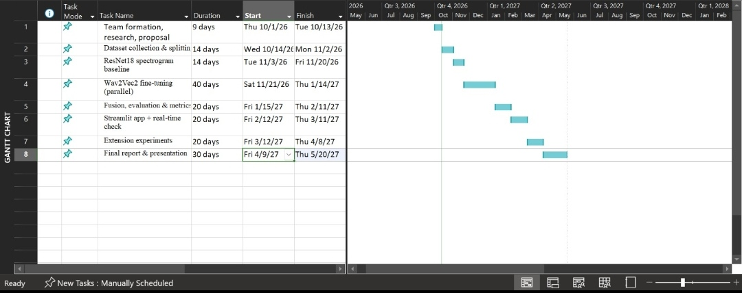

TABLE II
High-level project plan

References
[1] Y. Jia et al., “Transfer learning from speaker verification to multispeaker text-to-speech synthesis,” in Proc. Adv. Neural Inf. Process. Syst. (NeurIPS), vol. 31, 2018, pp. 4485–4495.
[2] A. Puig, “Scammers use AI to enhance their family emergency schemes,” Federal Trade Commission, Mar. 2023. [Online]. Available: https://consumer.ftc.gov/consumer-alerts/2023/03/scammers-use-ai-enhance-their-family-emergency-schemes
[3] Z. Wu, N. Evans, T. Kinnunen, J. Yamagishi, F. Alegre, and H. Li, “Spoofing and countermeasures for speaker verification: A survey,” Speech Commun., vol. 66, pp. 130–153, Feb. 2015.
[4] N. M. Müller, P. Czempin, F. Dieckmann, A. Froghyar, and K. Böttinger, “Does audio deepfake detection generalize?,” in Proc. Interspeech, 2022, pp. 2783–2787.
[5] K. He, X. Zhang, S. Ren, and J. Sun, “Deep residual learning for image recognition,” in Proc. IEEE Conf. Comput. Vis. Pattern Recognit. (CVPR), 2016, pp. 770–778.
[6] A. Baevski, H. Zhou, A. Mohamed, and M. Auli, “wav2vec 2.0: A framework for self-supervised learning of speech representations,” in Proc. Adv. Neural Inf. Process. Syst. (NeurIPS), vol. 33, 2020, pp. 12449–12460.
[7] R. Reimao and V. Tzerpos, “FoR: A dataset for synthetic speech detection,” in Proc. Int. Conf. Speech Technol. Human-Comput. Dialogue (SpeD), 2019.
[8] X. Wang et al., “ASVspoof 2019: A large-scale public database of synthesized, converted and replayed speech,” Comput. Speech Lang., vol. 64, Art. no. 101114, Nov. 2020.
[9] H. Tak, J. Patino, M. Todisco, A. Nautsch, N. Evans, and A. Larcher, “End-to-end anti-spoofing with RawNet2,” in Proc. IEEE Int. Conf. Acoust., Speech Signal Process. (ICASSP), 2021, pp. 6369–6373.
[10] J.-w. Jung et al., “AASIST: Audio anti-spoofing using integrated spectro-temporal graph attention networks,” in Proc. IEEE ICASSP, 2022, pp. 6367–6371.
[11] H. Tak, M. Todisco, X. Wang, J.-w. Jung, J. Yamagishi, and N. Evans, “Automatic speaker verification spoofing and deepfake detection using wav2vec 2.0 and data augmentation,” in Proc. Odyssey: Speaker Lang. Recognit. Workshop, 2022, pp. 112–119.
[12] J. Yi, C. Wang, J. Tao et al., “Audio deepfake detection: A survey,” arXiv:2308.14970, 2023.
[13] A. Khan et al., “Voice spoofing countermeasures: Taxonomy, state-of-the-art, experimental analysis of generalizability, open challenges, and the way forward,” ACM Comput. Surv., 2023.
[14] A. Almutairi and H. Elgibreen, “A review of modern audio deepfake detection methods: Challenges and future directions,” Algorithms, vol. 15, no. 5, 2022.
[15] J. Yi et al., “Exploring the scale and diversity of speech anti-spoofing datasets,” in Proc. Interspeech, 2023.
[16] B. McFee et al., “librosa: Audio and music signal analysis in Python,” in Proc. 14th Python Sci. Conf. (SciPy), 2015, pp. 18–25.

People Consulted:
Mr. Muhammad Fahad (Project Advisor)
Mr. Muhammad Ilyas (Project Manager),
University of Sargodha, Muhammad.ilyas@uos.edu.pk.

