q05
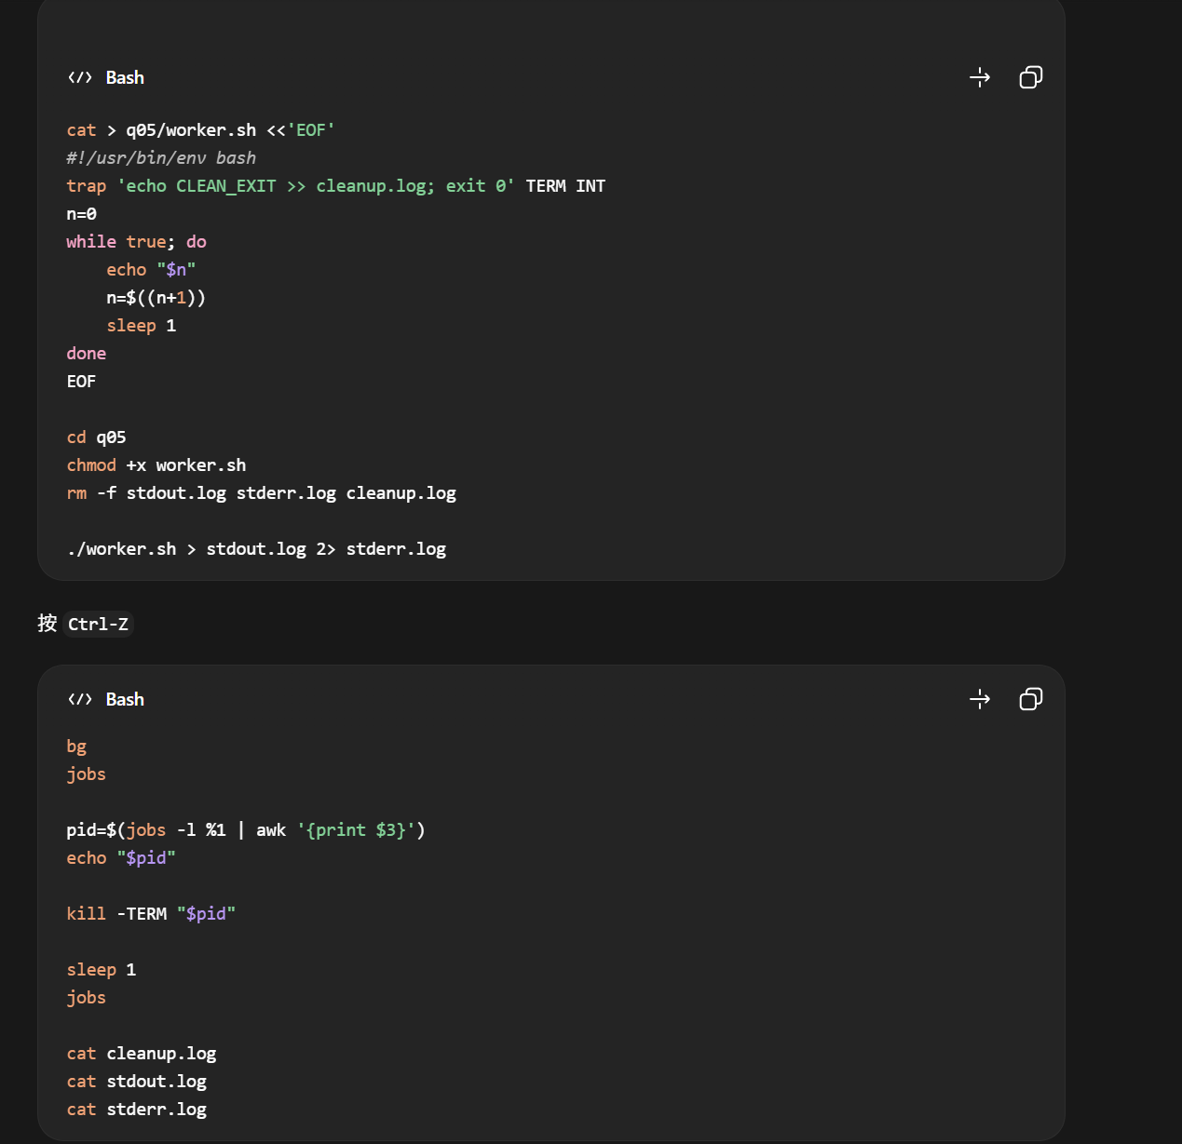

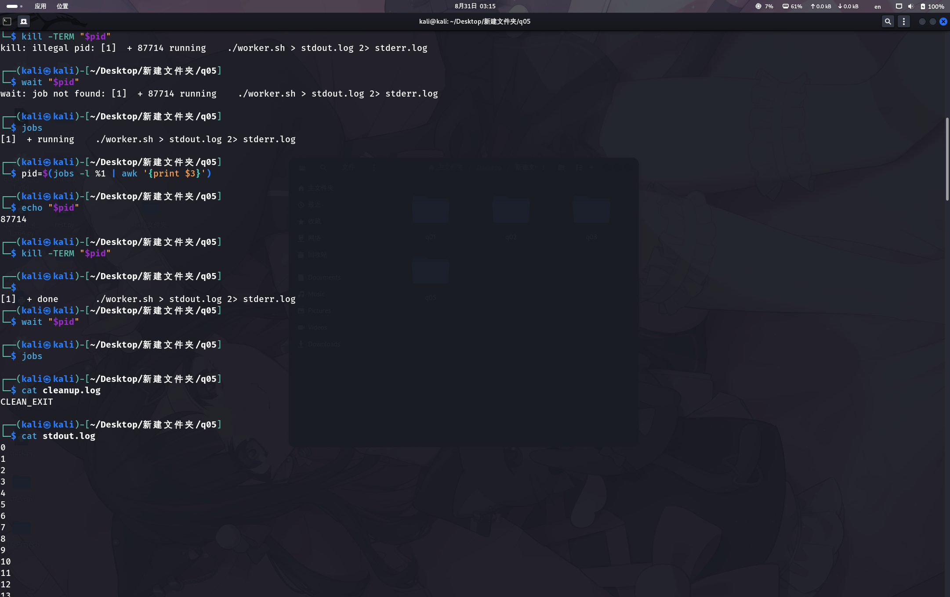

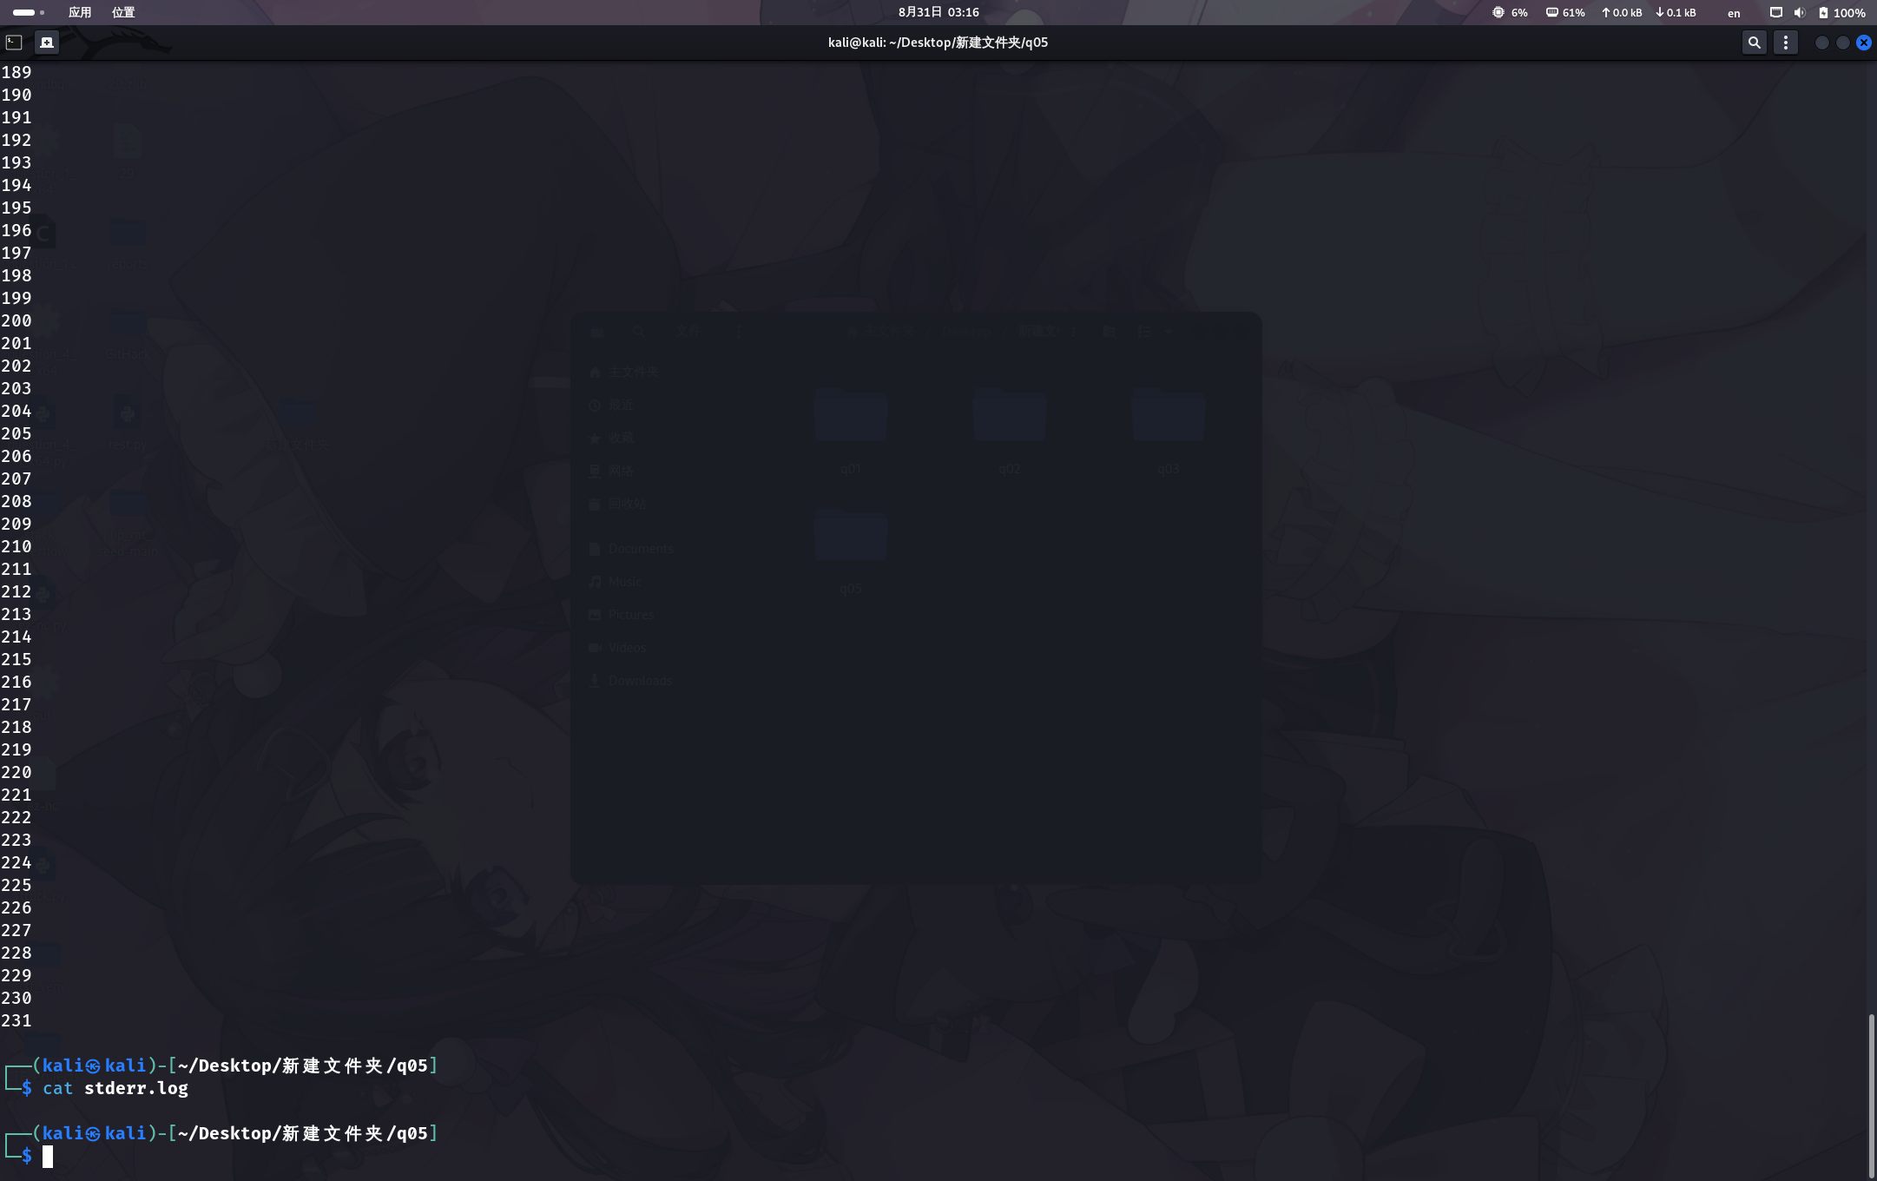

Q06

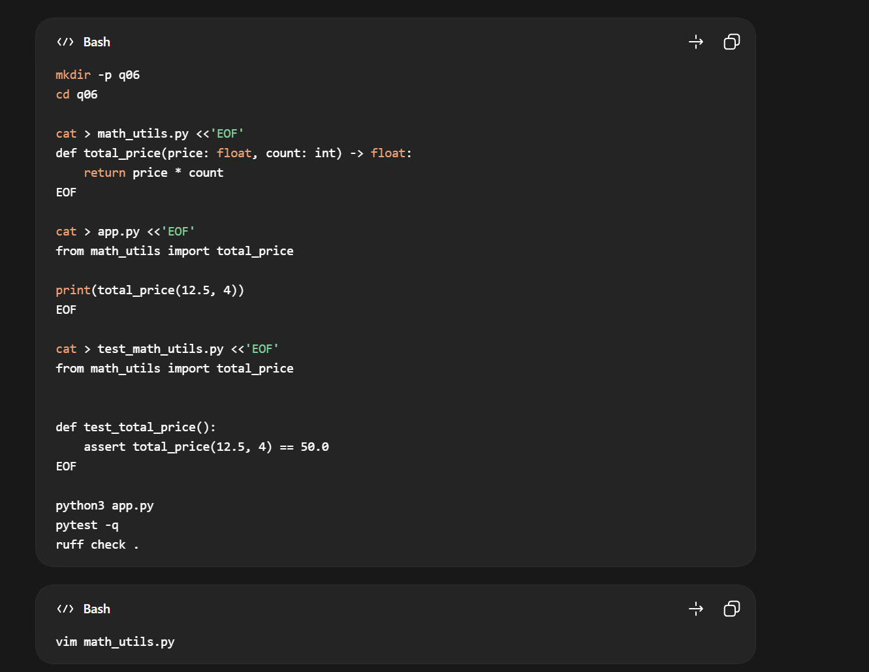
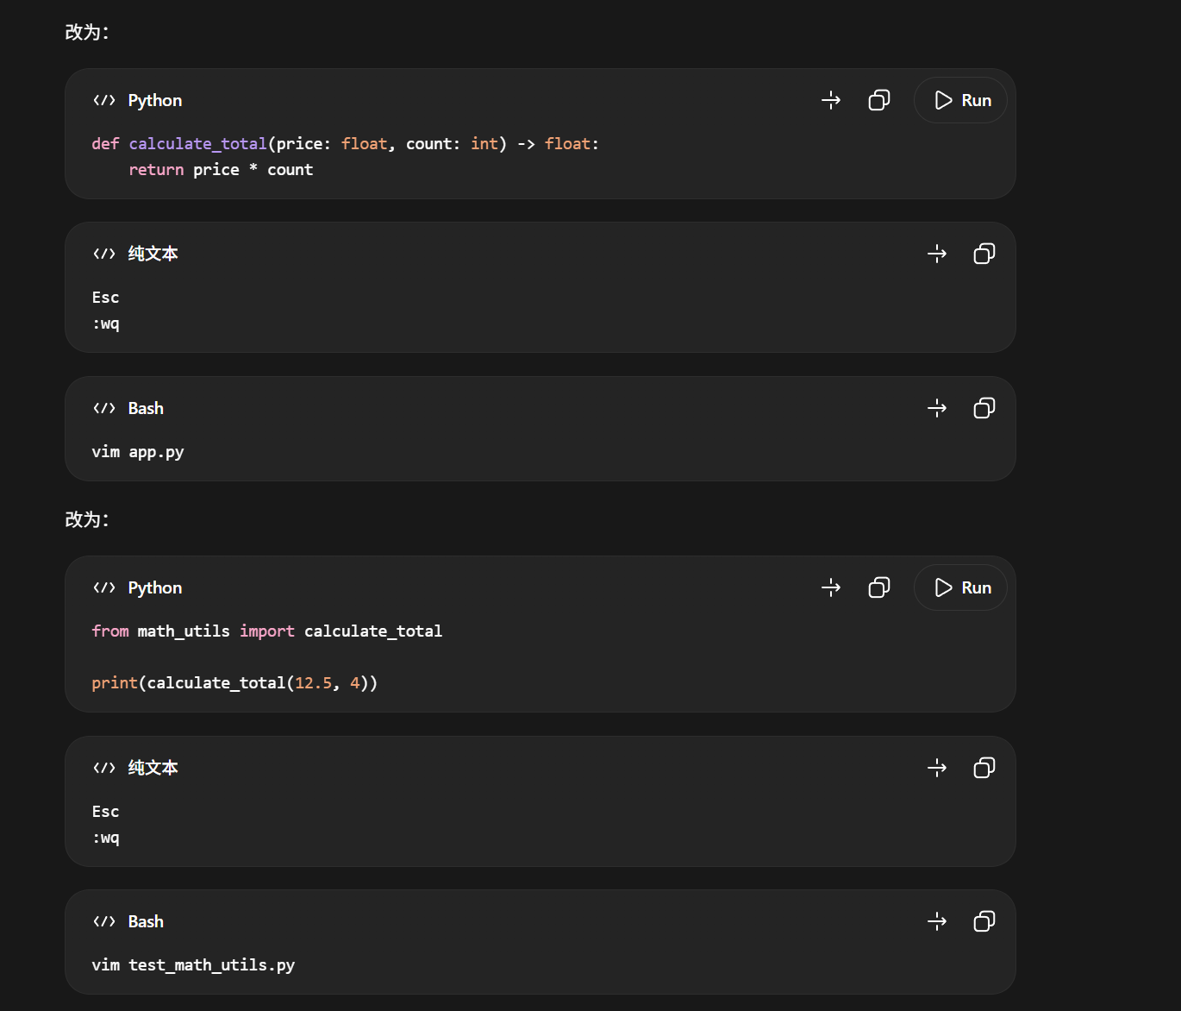

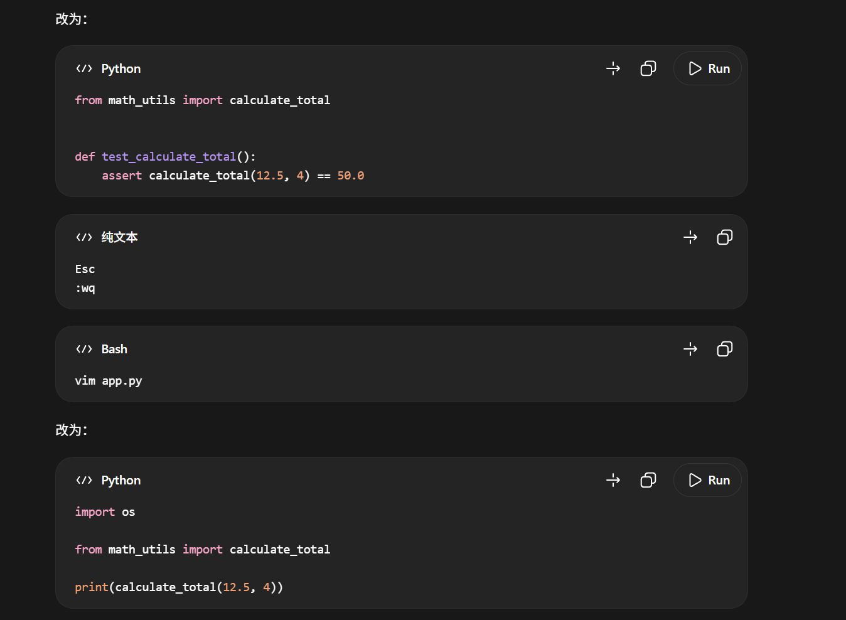

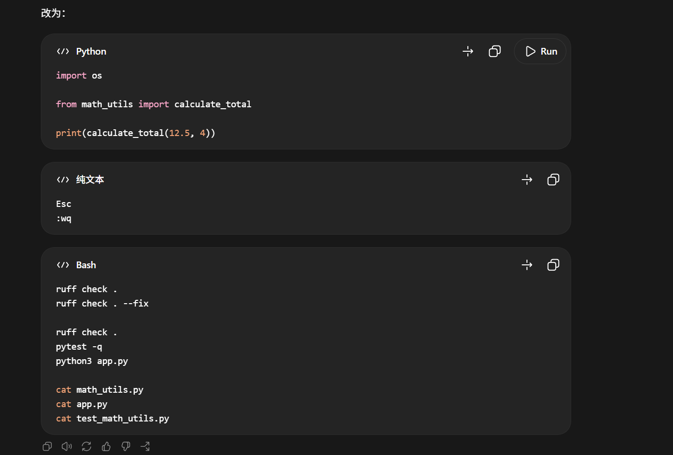

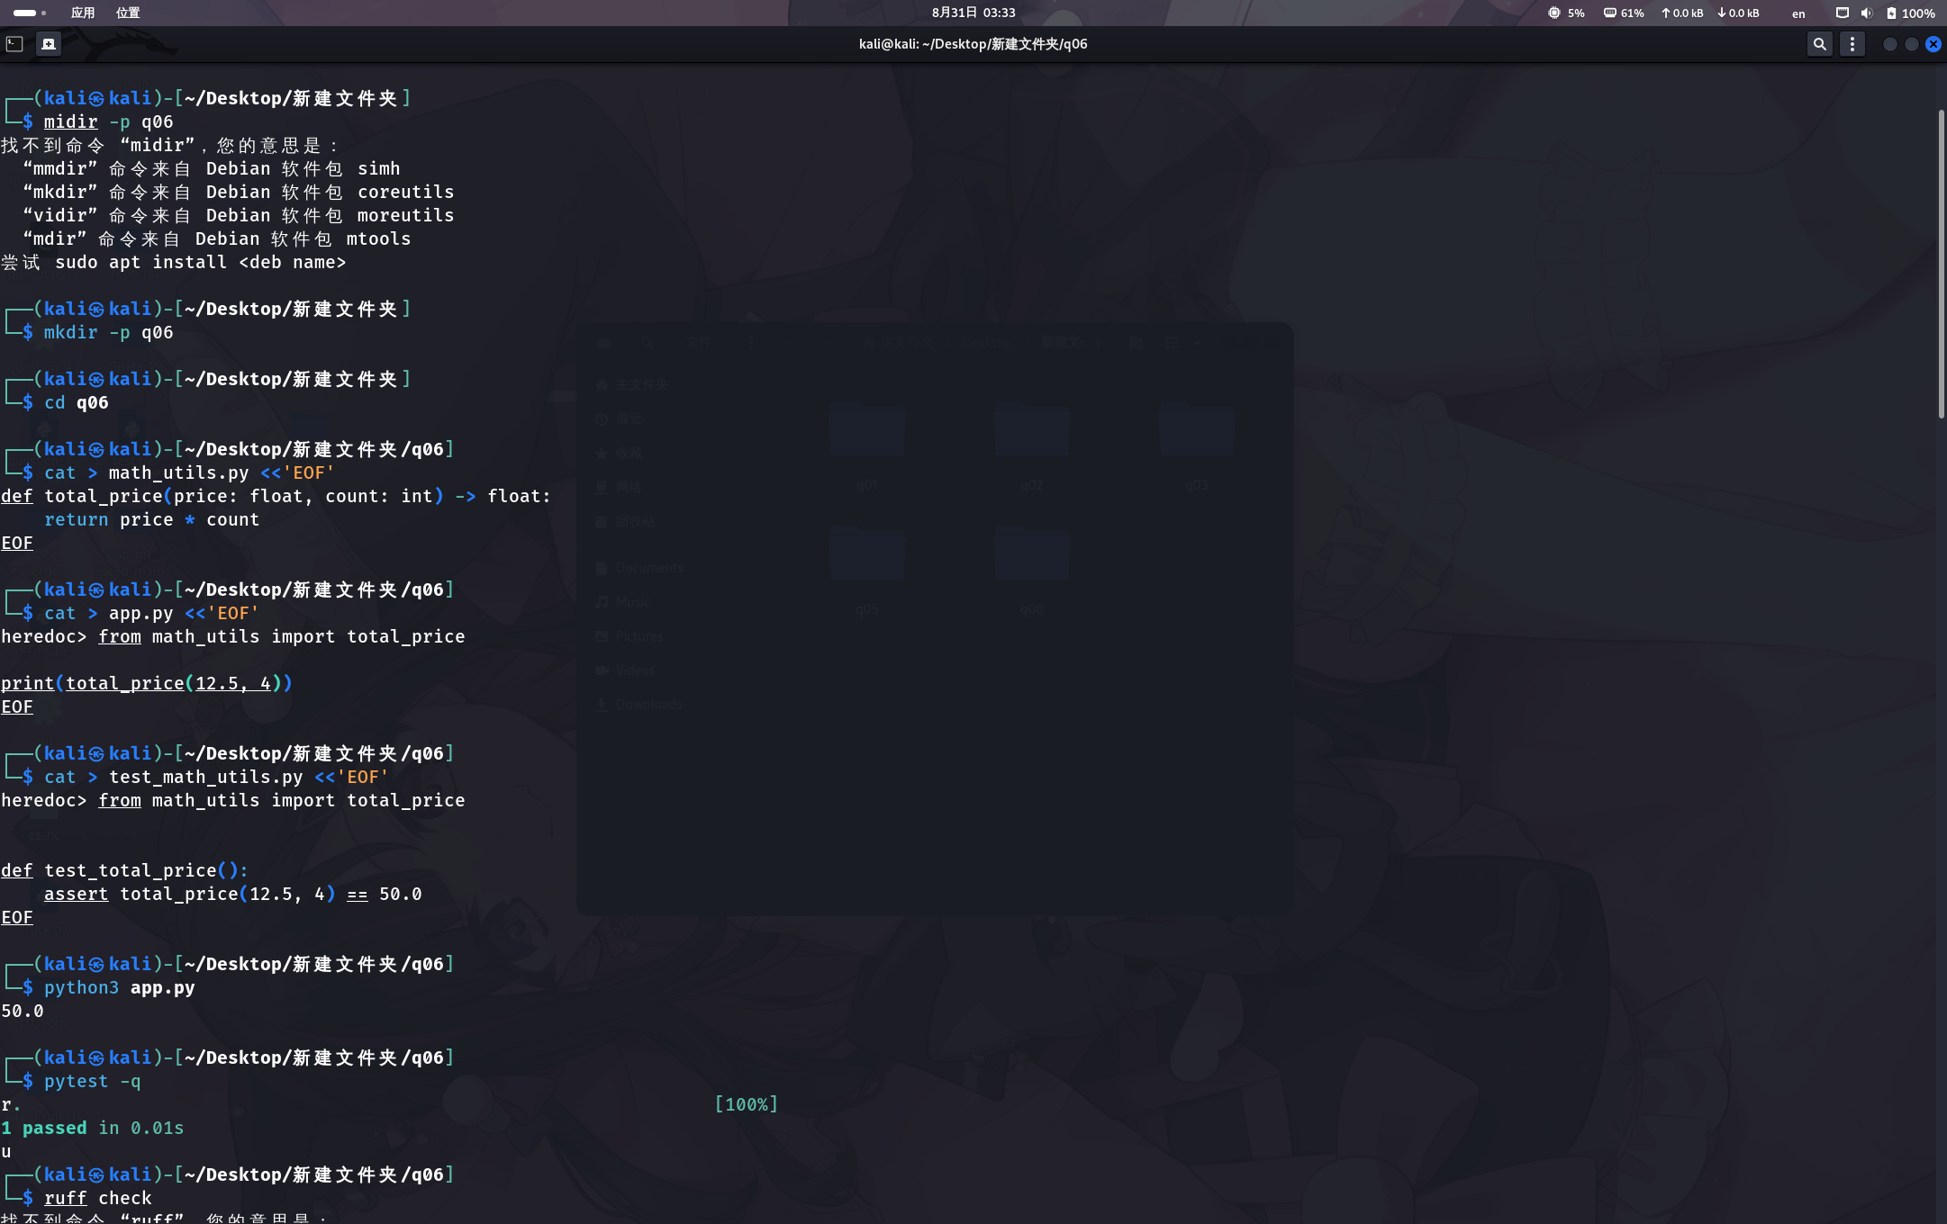

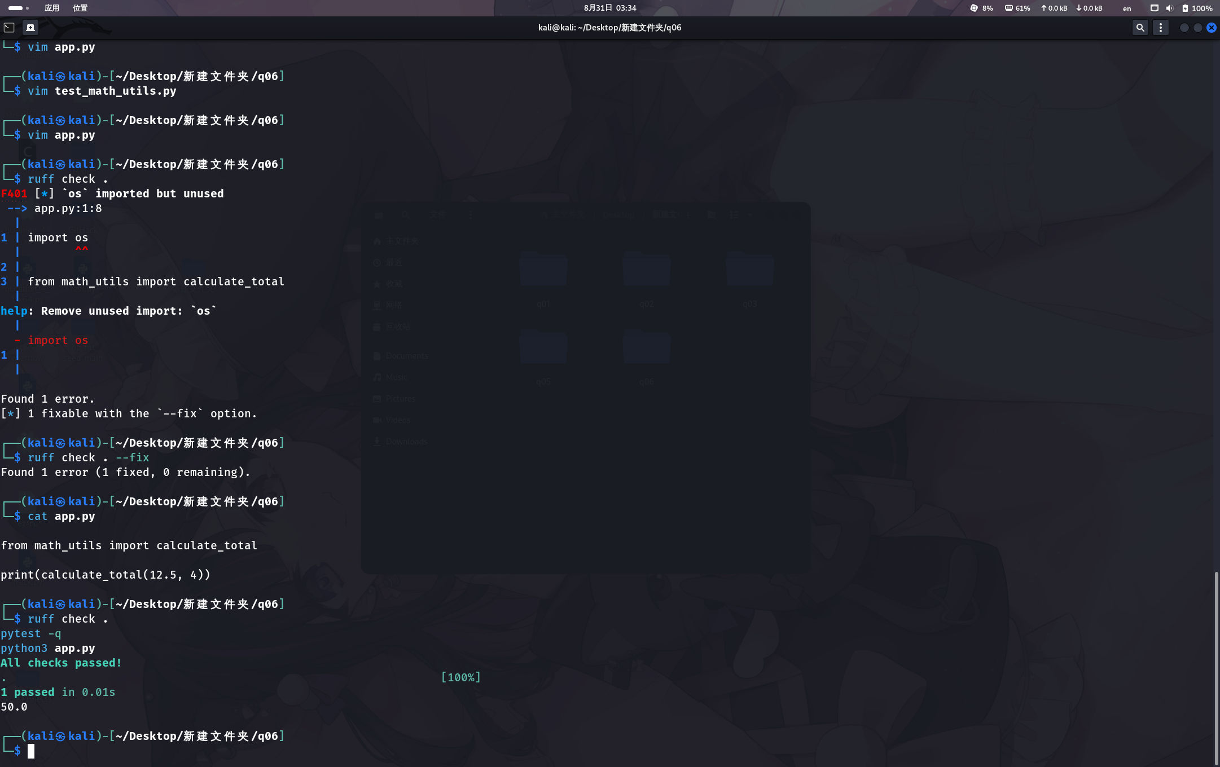

Q07

mkdir -p q07
cd q07

cat > merge_sort.py <<'EOF'
def merge(left, right):
result = []
i = j = 0
while i < len(left) and j < len(right):
if left[i] <= right[j]:
result.append(left[i]); i += 1
else:
result.append(right[i]); j += 1
return result + left[i:] + right[j:]

def merge_sort(a):
if len(a) <= 1:
return a
m = len(a) // 2
return merge(merge_sort(a[:m]), merge_sort(a[m:]))

print(merge_sort([3, 1, 4, 1, 5, 9, 2, 6]))
EOF

python3 merge_sort.py

python3 -m pdb merge_sort.py
进入 pdb 后依次输入：
b merge
c
l
p i
p j
p left
p right
n
p i
p j
p left[i]
p right[j]
n
n
n
q
然后修复代码：
vim merge_sort.py
把：
result.append(right[i]); j += 1
改成：
result.append(right[j]); j += 1
保存退出：
Esc
:wq
继续执行：
python3 merge_sort.py

cat > test_merge_sort.py <<'EOF'
from merge_sort import merge_sort

def test_given_input():
assert merge_sort([3, 1, 4, 1, 5, 9, 2, 6]) == [1, 1, 2, 3, 4, 5, 6, 9]

def test_duplicate_elements():
assert merge_sort([4, 2, 4, 1, 2, 4]) == [1, 2, 2, 4, 4, 4]
EOF

pytest -q
最后可以把 merge_sort.py 整理成：
cat > merge_sort.py <<'EOF'
def merge(left, right):
result = []
i = j = 0
while i < len(left) and j < len(right):
if left[i] <= right[j]:
result.append(left[i]); i += 1
else:
result.append(right[j]); j += 1
return result + left[i:] + right[j:]

def merge_sort(a):
if len(a) <= 1:
return a
m = len(a) // 2
return merge(merge_sort(a[:m]), merge_sort(a[m:]))

if __name__ == "__main__":
print(merge_sort([3, 1, 4, 1, 5, 9, 2, 6]))
EOF

python3 merge_sort.py
pytest -q

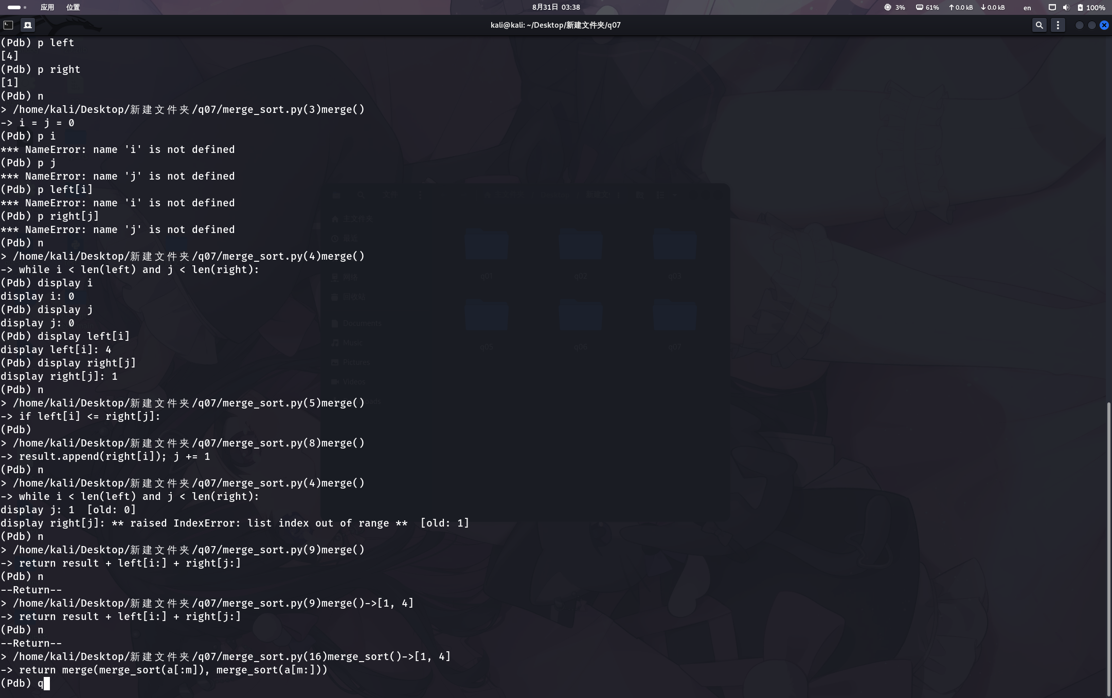

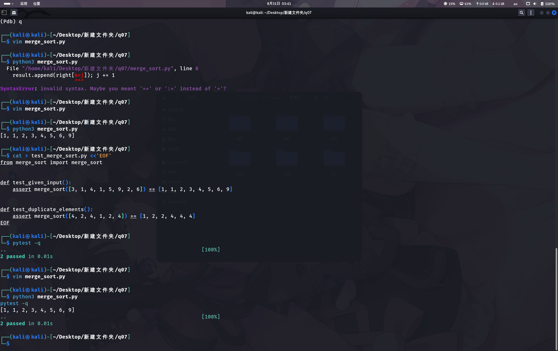

Q08

mkdir -p q08
cd q08

cat > generate_words.py <<'EOF'
import random

random.seed(20260831)
vocab = [f"w{i}" for i in range(1000)]

with open("words.txt", "w", encoding="utf-8") as f:
f.write(" ".join(random.choice(vocab) for _ in range(300000)))
EOF

cat > wordfreq.py <<'EOF'
words = open("words.txt", encoding="utf-8").read().split()
unique = []

for word in words:
if word not in unique:
unique.append(word)

print("count=", len(unique))
EOF

python3 generate_words.py
python3 wordfreq.py

cp wordfreq.py wordfreq_slow.py

/bin/bash -c 'TIMEFORMAT="%R"; time python3 wordfreq_slow.py >/dev/null' 2> slow1.txt
/bin/bash -c 'TIMEFORMAT="%R"; time python3 wordfreq_slow.py >/dev/null' 2> slow2.txt

cat slow1.txt
cat slow2.txt

python3 -m cProfile -s cumulative wordfreq_slow.py

cat > wordfreq.py <<'EOF'
words = open("words.txt", encoding="utf-8").read().split()
unique = set(words)

print("count=", len(unique))
EOF

python3 wordfreq_slow.py
python3 wordfreq.py

/bin/bash -c 'TIMEFORMAT="%R"; time python3 wordfreq.py >/dev/null' 2> fast1.txt
/bin/bash -c 'TIMEFORMAT="%R"; time python3 wordfreq.py >/dev/null' 2> fast2.txt

cat fast1.txt
cat fast2.txt

python3 - <<'EOF'
import statistics

slow = [
float(open("slow1.txt").read().strip()),
float(open("slow2.txt").read().strip()),
]

fast = [
float(open("fast1.txt").read().strip()),
float(open("fast2.txt").read().strip()),
]

slow_median = statistics.median(slow)
fast_median = statistics.median(fast)
speedup = slow_median / fast_median

print("优化前两次耗时:", slow)
print("优化后两次耗时:", fast)
print("优化前中位数:", slow_median, "秒")
print("优化后中位数:", fast_median, "秒")
print("加速比:", speedup)
EOF

echo "===== 原程序 ====="
cat wordfreq_slow.py

echo "===== 优化后 ====="
cat wordfreq.py

echo "===== 原程序运行 ====="
python3 wordfreq_slow.py

echo "===== 优化后运行 ====="
python3 wordfreq.py

echo "===== 原程序耗时 ====="
cat slow1.txt
cat slow2.txt

echo "===== 优化后耗时 ====="
cat fast1.txt
cat fast2.txt

