AstraStack
User Manual

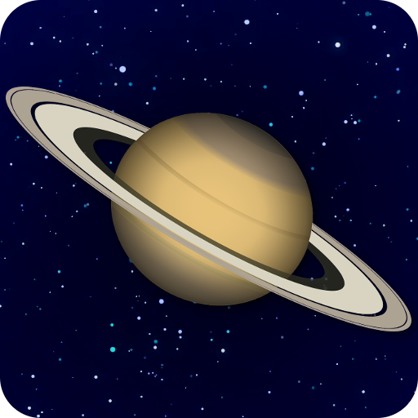

Created by David Turner
Website
Table of Contents
1 Introduction 3
2 User Interface 3
2.1 Load Tab 3
2.2 Align Tab 4
2.3 Stack Tab 6
2.4 Process Tab 7

Introduction
AstraStack is an easy to use application used to stack videos or images of planets, the sun, moon, deep sky objects and more. Stacking is a technique used to improve the quality of the image by aligning each frame and then averaging the best frames to create a low noise version of the image which can then be sharpened.

User Interface
The user interface is split into two main sections, the left side panel and the image frame. The side panel contains all of the options for configuring the alignment, stacking, and processing. The image frame displays the current frame. Below the image frame is a frame slider which is used to specify which frame to display.
Some options are available in the top bar:
- CPUs: Sets the number of CPUs to use during most steps. This number defaults to half the number of cpu threads you have.
- Color: What color mode the source file should be interpreted as. ‘Auto’ is the default and will attempt to guess which color mode the file is, but if the colors look incorrect, then you can select it manually in the drop down. Bayered images are supported and by default a faster but slightly lower quality debayering algorithm is used. Variable Number of Gradients (VNG) debayering can be selected manually and may result in a slightly sharper image with fewer artifacts, though is much slower than the default. When a debayering option is manually selected, it will be remembered the next time AstraStack is run.

Load Tab
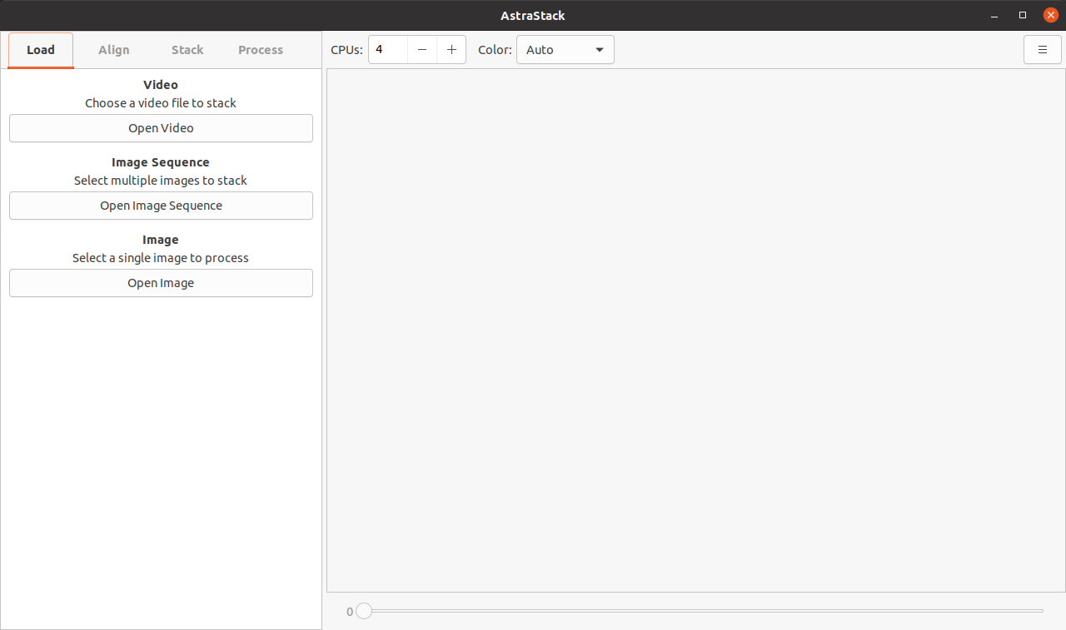
The load tab is where you will open a file to process. There are three ways of opening files:
- Open Video: Choose this option to open a video file to stack. Most common formats (avi, mov, mp4) and codecs should be supported.
- Image Sequence: Choose this option to open multiple images to stack images. Use the shift or ctrl button on the keyboard in the file chooser dialog to select multiple files. The files will ordered when loaded, so numbering the files like 0001.png ... 9999.png is recommended.
- Image: Choose this option to load a single image. This option skips the align & stack steps and goes straight to the process Tab.
When choosing option 1 or 2, the frames will be ranked based on their ‘sharpness’. The sharpest frame will be chosen as the default ‘reference frame’ going forward.

Align Tab
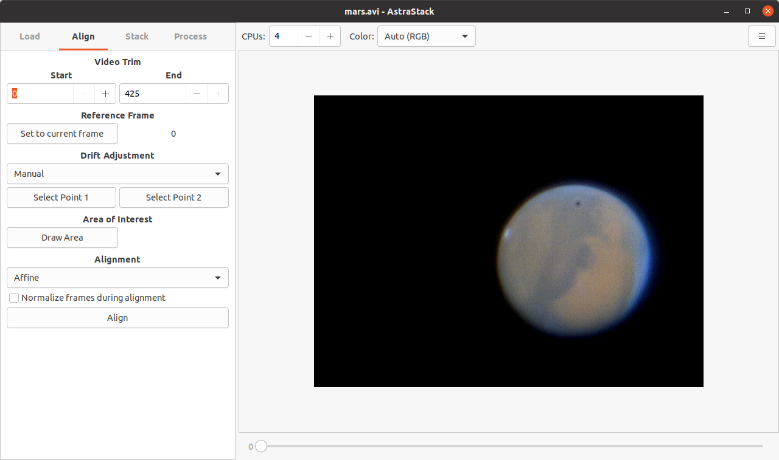
The align tab is where the alignment of the frames can be configured. The options are detailed below:
- Video Trim: The start and end range can be specified. This can be useful if the beginning or end of the video is of poor quality, and will not be used while aligning.
- Reference Frame: This is the frame that will be used to compare all other frames with. Other frames will be translated so that they aligned with the reference frame, and are also ranked based on their similarity to the reference. Use the frame slider to select a frame and then click the Set to current frame button. It is recommended to select the sharpest frame.
- Drift Adjustment: If the object drifts across the frame, then this can help get a more accurate alignment.
  - None: Do no t do any drift adjustments
  - Center of Gravity: This option is good for planetary objects and will move the object roughly to the center of the frame. This probably will not work as well if at all for surfaces.
  - Manual: Two points can be set at the start and end position of the object. Click the Select Point 1 and then click on a feature of the object, and then do the same for the Select Point 2 button. You can use the frame slider to see how well the point follows object feature. The points don’t need to be exact since the alignment still occurs afterwords. To reset the points, right click the buttons. Note that the drifting does crop the stacked image.
- Area of Interest: If you only want to align a certain portion of the frame, you can use this to draw a rectangle around the feature you are focusing on. Click the Draw Area button and then draw the rectangle on the frame. The area of interest will remain stationary unless drift adjustment points are specified. This area will also be used to determine the frame similarity. To reset the area of interest, right click the button. Note that this does not crop the frame.
- Alignment: This determines what sort of transformation will be applied for the alignment. The available options are:
  - None: will skip the alignment entirely. Useful for already aligned videos/sequences.
  - Translation
  - Rigid Body (Translation + Rotation)
  - Scaled Rotation (Translation + Rotation + Scaling)
  - Affine (Translation + Rotation + Scaling + Shearing)
Experimentation may be needed to determine the best option for each video.
- Normalize frames during alignment: Choose this option if there is a difference in brightness between frames. This will help to reduce the impact of the brightness changes in particular with the frame similarity. This doesn’t actually change the brightness when stacking, only during the alignment and frame similarity.
Click the Align button to apply the alignment options to the frames. When complete the stack tab will be displayed.

Stack Tab
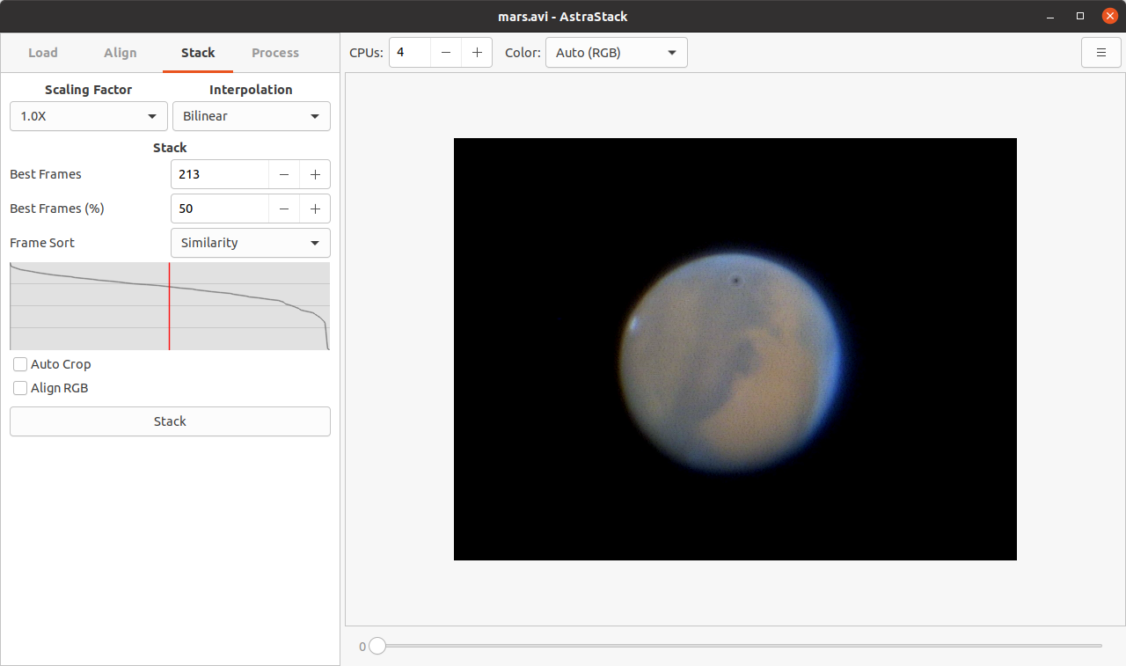
The stack tab is where the stacking of the frames can be configured. The frames are sorted based on their frame similarity to the reference frame. The options are detailed below:
- Scaling Factor: If you want to resize the image in addition to stacking, you can specify by how much to resize the image.
- Interpolation: Specifies the algorithm used for the transformation and resizing.
  - Nearest Neighbor: Fastest, but pixelated.
  - Bilinear: Fast, but may blur the image slightly.
  - Bicubic: Slow, but sharper than Linear. May introduce ringing artifacts.
  - Lanczos: Slowest, but can be sharper than Bicubic. May introduce ripple artifacts.
Experimentation may be needed to determine the best option.
- Stack: Here you can specify how many frames to stack. You can either specify an absolute number of best frames, or the percentage of best frames.
- Frame Sort: Changes how the frames are sorted.
  - Similarity: Sorts based on the similarity to the reference frame.
  - Quality: Sorts based on the quality of the frames
  - Similarity + Quality: Sorts based on both the similarity and quality.
- Auto Crop: The alignment will typically crop the image to some extent depending on how much movement occurs. Uncheck this option to disable the cropping and use the reference frame as a ‘background’ to any part of the frame which is missing.
- Align RGB: Aligns the color channels of the image to reduce the effect of chromatic aberrations.
Click the Stack button to apply the stack options to the frames. When complete, the process tab will be displayed.

Process Tab
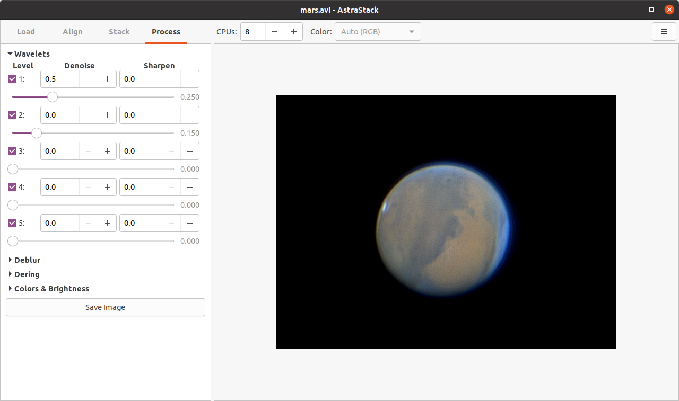
The process tab allows for sharpening and other basic color & brightness controls, as well as saving the image. The sharpening uses wavelets.
- Wavelets: There are 5 levels of wavelets to choose from. The lower levels (ie. Level 1) are for enhancing fine details, while higher levels (ie. Level 5) are for enhancing the larger details. Which levels you use will require experimentation. Generally it is best to start with layer 1 and continue down until the effects are no longer desirable.
  - Level: The level of wavelet. Adjust the slider to increase the wavelet intensity. Uncheck the box next to the level to disable any changes to the layer.
  - Denoise: Applies a gaussian blur to the wavelet layer. The number represents the radius of the blur.
  - Sharpen: Applies an unsharp mask to the wavelet layer to make the wavelet appear sharper. This may introduce slight ringing artifacts. The number represents the radius of the unsharp mask.
- Deblur: Applies a Wiener Deconvolution filter to the image. This can be used to adjust for imperfect focus, seeing or motion blur. The deblur uses a Point Spread Function (PSF) which can be configured with 4 different types of PSF.
  - Circular: A circle with a given radius.
  - Gaussian: A Gaussian/Moffat distribution with a given radius and spread. Generally speaking lower spreads would represent the best seeing conditions, and the higher values would be poor seeing.
  - Linear: If Circular and Gaussian are not specified then this will behave a simple line segment with a given distance and angle. If Circular or Gaussian are specified though it will stretch the PSF by the given amount and angle. This can be used to account for small amounts of motion blur. This probably won’t work well for large amounts of motion blur however.
  - Custom: A custom image representing the PSF can be selected from your computer. The image can be no larger than 100x100.
Each type of PSF has an amount which is the strength of the deblur. Higher values will result in a sharper image, but can add noise. Values below about 10 will actually result in a blur, which could actually be used as a denoise instead of a deblur. With deblurring there is typically a sweet spot for the radius value where if it is too low or too high it will not look right, so treat the radius slider almost like a focuser knob and slide it left/right until it looks sharpest. Results may vary but sometimes just a slight amount of Gaussian deblur can boost the sharpness.
- Dering: Used primary to create a star mask to the image where areas of high contrast (ie. Stars) will be excluded from the wavelets and debluring. The following options are available
  - Adaptive threshold: Raise this value to ignore areas of high contrast areas when sharpening.
  - Dark threshold: Raise this value to ignore dark areas when sharpening.
  - Bright threshold: Raise this value to ignore bright areas when sharpening.
  - Size: Grows the area ignored by the dark/bright thresholds.
  - Blend: How much to blend the mask.
  - Only show mask: Show the resulting mask in the image frame.
- Colors & Brightness
  - Black Level: Controls the where the black level is. Increasing this value darkens the overall image.
  - Gamma: Controls the mid-tones of the image.
  - Value: Adjusts the brightness of the image.
  - Red: Adjusts the red intensity.
  - Green: Adjusts the green intensity.
  - Blue: Adjusts the blue intensity.
  - Saturation: Adjusts the color intensity.
Click the Save button to save the final processed image.
On the save screen there is an option to save as an 8-bit/channel image (default), or a 16-bit/channel image. If you plan on processing the image further at a later date, then 16-bit would be the option to go with, but if it is the final image, then 8-bit would be perfectly fine. Note that for 16-bit images, only PNG and TIFF images are supported.

