LECTURES

Lecture 9/23: Sluter Revolution

-big changes in art sometime between 1400-1500
-a lot of movement of ideas and people between South (Italy) and North (Netherlands, Germany)
-tradition thought of art movement as starting in Italy and then spreading north
-prevalent art form in France→ gothic art: not realistic art; pictogram; not to scale
-Italy resistant to gothic art; instead, there was return of humanism, back to classical style

-Claus Sluter (from Wikipedia): early Netherlandish sculpture who pioneered northern realism. The works of Claus Sluter infuse realism with spirituality and monumental grandeur. His influence was extensive among both painters and sculptors of 15th-century northern Europe (van Eyck!). He restored the monumental scale and naturalism of the classical era to figural sculpture. His later work is highly emotional, using facial expressions, figural stance, and drapery; this can be particularly seen in the heavy folds of cloth that so many later imitators draped around their figures.

LECTURE 2
(nothing happened in lecture 1…seriously)

Enlightenment – idea of rebirth of classical age, light reentering, culture as having been recovered from antiquity (not quite right → middle ages were much more enlightening in some respects…great deal of contiguity from antiquity through the middle ages

Poet Virgil, for instance, was never lost and what is interesting is that Virgil is nothing like a Christian but in the Middle Ages some of his texts were reinterpreted in a Christian fashion.

Return to antiquity is not necessarily an abandonment of Christianity…important to understand

Important book → Presence and Lightness – history of image before era of art, implies that era of art is before modern times which is why we start in 1400s what is meant by that is that before that the notion of art as an activity separate from everything else did not exist.

They did not mean what we mean they meant MAKING things…idea of an artist, a person whose concern is primarily to make things of aesthetic interest and for aesthetic contemplation is something that did not exist before the renaissance.

Works of art had a role → help you pray or something. Idolatry

Certain images are not regarded as art but rather as images used in various rituals

Vasari – only describes artists who are dead in the first edition of his “textbook” but then in the second edition he introduces artists who are alive

Michelangelo – shows a consciousness of the importance of history

What is tradition why do we talk about the western tradition?

Word literally means something like…what is passed on

Involved in an enterprise that involves drawing → drawing means just that, but it also means intention or thinking

Drawing becomes thinking instrument of all these artists – THINKING VISUALLY THROUGH GRAPHIC PROCESS OF DRAWING

Way of transmitting ideas from one person to another

There is a whole intellectual framework that takes place in this time around notion of artist.

Anecdotes about Achilles…asking someone with shoes to criticize his

APPEAL OF GOING TO EXPERTS OUTSIDE OF ART TO SEE IF YOU’RE GETTING IT RIGHT

Room where commencement takes place

DELAROCHE AMPITHEATER OF THE ECOLE DES BEAUX ARTS 1842

Antiquity, and then all the other artists…

Very few medieval (by middle of 19th century people are warming up to idea that MA wasn’t so bad after all but still…)

What this makes visible is idea that art has a history but it is a history which is present

There will be change in the way that art is translated and the way in which artistic practice is learned in the renaissance or in the 16th century…

Tradition in the MA → Art is strictly through teaching

You go to baker or sculptor (grinding, papers etc) and then you figure out how to do stuff (draw figures and stories and eventually you’re one your own)

BACCIO BARDINELLI’s ACADEMY

Vasalius (1514 1564) De Humani corporis fabrica 1543)

It’s a masterpiece of art

HES REPRESENTING A SKELETON REALLY WELL but there’s also a whole moral aspect independent from the strictly scientific purpose of the treatus

Another plate represents the muscle groups of the body. Anatomy is important in order to understand how body looks and BUT MORE IMPORTANTLY How it works!

Jacques Louis David teaching studio by Cohereau

Jean Cousin Book of Perspective 1560…he shows diagrams that explain how you do a proper spatial construction on the plant service

Whole idea
Treatise about images of gods and here are som

TEACHING OF ART BECOMES MUCH MORE ELABORATE AND A MUCH MORE INTELLECTUAL PURSUIT THAN IT HAS BEEN BEFORE
Peroginio on the right

Had a famous pupil who became more famous RAPHAEL

You can see that you still have a painter assistant relationship where Raphael has pretty much borrowed the composition from his teacher, but he improves it.

If you reverse it you can see how closely the body is modeled on the statue on the left…one of the great examples of ancient classical art of antiquity.

CEZANNE AFTER DELACROIX…..DELACROIX MEDEA 1834

Never studied with Delacroix but D for C was already an artist from the canon

VERY CONSCIOUS of the past DELACROIX HIMSELF

He’s sort of aping this other one ANDREA DEL SARTO CHARITY 1517 (weaving figures into a pyramid)

Earlier on….

Michelangelo CELING SIXTINE CHAPEL CEILING EXPULSION OF ADAM AND EVE

Painted around 1510

Characteristically M isn’t satisfied with allusions to the immediate past….he goes and studies something from 1428 (almost 100 years old for him)

MASSACCIO BRANCACCI CHAPEL 1428

Look at adam and Eve ITS CLEAR THAT IT TRANSPOSES EXPRESSIVE POSE OF ADAM FROM A PREVIOUS THING (so…everybody studies something that came before and uses it to enrich his own thing and make it new)

HAA is about continuity and change continuity and progress

Notion of progress modernity IDEAS AND RULES

Printmaking also makes it possible to make compositions or designs

One great difference between lit and art (invention of printing is central to modern era)

By the time you have printing the text is everywhere (compositions available everywhere) and RAPHAEL KNEW THAT WELL

JUDGEMENT OF PARIS – designs it specifically to be a print (isn’t colored etc)

Trojan war → has to do with human body and beauty of women…demonstration of artist’s ability to represent body

Now Raphael himself has a model

Roman sarcophagus relief reset at the Villa Medici in Romed

Peter Paul Rubens in the 17th century is very conscious of his model…model of Raphael

One of the most curious

ANTOINE WATTEAU

Very clear that this guy is also conscsious of Raphael’s model because the figure is facing away and leaning to the right a little

Academic painter….and then RENOIR copies HIM

Edouard Manet Lunch on the Grass 1863

Napoleon III decided that there would be an exhibition where people who were turned down by corrupt jury in nacould exhibit paintings tional competition

Manet paints scandalous thing (naked woman in presence of clothed

AND OMGOMGOMGOMGOMG

HE COPIED THE RAPHAEL THING ORGANIZING IT EXACTLY LIKE THE RAPHAEL THING

People like Manet say no we are the ones who really get Raphael because we have actually studied it and though we update it for today it follows from the tradition

Picasso Les Demoiselles d’Avignon 1907

Group of women presenting themselves in fact very much the way the three goddesses

When one looks at the sketches you have these male figures who enter the room

Lecture 3 Sluter Revolution
Art Around 1400: The Sluter Revolution

Dialogue between Southern Europe (Italy) and Northern (Netherlands, Germany)—France in between

Changes seen as mostly from Italy
    - So engrained is this idea that people discuss Donatello first over Sluter although Sluter was first
- Psalter St.Louis (king Louis IX): mid 13th century (high pt of gothic art)
  - Italy resistant because of roman influence
  - Ornate frame, but the light lines inside imply clouds—the outside
  - Story of Abraham and Isaac
  - Ornate letter B: David looking out castle on Sheeba, David praying to Christ
  - Telling a story but not as we’re used to (by no means realistic or natural)
- Simone Martini (1280-1344)
  - Frontispiece of a copy of Servius’ commentary on Virgil Belonguing to Petrarch (1304-1374)
  - Refers to the 3 works of Virgil: sheep, farmer, soldier
  - Virgil dressed in antique fashion—return to antique
- Royal Front Portal of Chapel—medival
- Charterhouse of Champmol: Poarch 1390s
  - When Charles IV died, his succession caused the Hundred Years War
  - Jean II le Bon captured by British and made prisoner when Charles V was 19.
  - Charles V really reconstructed the kingdom
  - Charles VI weak: child when V died so country ruled mostly by brothers.
    - Jean duc de Berry
    - Philippe he Hardi duc de Bourgogne
    - Louis duc d’Anjou
  - Dukes of Burgundy and Dijon paid for
  - Sculptures done mostly by Claus Sluter (trained in North but most work in Dijon)
    - Great originality and power
    - Sculptures independent from architecture—no longer just like columns
      - Overlap their support
      - Freedom of movement
      - Sculptures communicate with one another—a scenario
        - Center (virgin Mary and JC), on the left (the duke), on right (the duchess)
        - Points to Duke but looks at Duchess
        - Fluidity: they’re not all facing front independent of each other like before
        - The Duke and Duchess in physical/real likeness while Virgin and Saint based on ideal types
        - Less concentration on world of God and more concentration on human world, real likeness, the place of humans in the world.
- Statues of Charles V and Jeanne de Bourbon 1370
  - Less acute, but still physical likeness shown
- The Golden Horse 1404
  - Gift of Isabeau de Baviere to her husband king Charles VI for New Year 1504
  - Art but also like treasure (gold, jewels, etc.)—like cash reserve
  - Given to a pilgrimage church in Germany: therefore didn’t cash it in
  - Made of gold, pearls, ruby, sapphire
  - Mary, child JC, lamb of St. John
- Psalter of Saint Louis: Battle of Jericho and Abraham
- The Book of Hours of Jean de Berry (a book of prayers)
  - The Duke praying to the Virgin and child
    - Duke introduced by John the Baptist
    - The Duke is portrayed in likeness
    - Simpler and grander than the manuscript paintings before
  - Jacquemart de Hesdin 1400
    - Carrying of cross by Christ
    - Used the same arrangement as Simone Martini sienese in Avignon 1330s (but changed details)
- Tres riches Heures for Jean de Berry left unfinished 1416 by Limbourgh brothers
  - January: the Duke’s Banquet
  - February: cold, can see inside the house warming themselves by the fire (very realistic depiction esp compared to the Psalter—showing as we live)
- Boucicault Book of Hours Flight to Egypt
- Book of Hours of Marshal Boucicault c.1410 Adoration of the Amci and Nativity
  - The manger turned around for the images—to represent 3D on flat images
  - Aiming for a sort of perspective
- The Meeting of the Magi with the Chateau of Mehun-sur-Yevre

Lecture 4: Jan van Eyck
Jan Van Eyck Lecture
Van Eyck is considered to be first of painters, prince of painters
Ghent Alterpiece: Early 1430s
- First painting that has his name/dates, Largest he ever made (~5m)
- Represents God, Virgin, St. John, Adam and Eve, saints, sacrificial lamb on altar
- Altar with iconography, celebrates salvation
How do we understand novelty, what was appreciated in him by contemporaries?
- The way he captured precious materials and texture, gold brocade—Christ is wearing a tiara that has unpredecented meticuous details, Sense of splendor
JVE- hired by Philip of Burgundy
Embroiderer- Thierry du Chastel, brought to burgundy as best embroiderer of Paris
TDC- virtually unkown in the history of art; embroidery is not really considered art
15th century: embroidered art sets tone, which JVE tried to match
Embroidery
- Altarpiece had two panels: Dossel (on top) and Antependium (suspended)
- Embroidery- a good embroiderer can capture almost as much detail as a painter
- Use 2 techniques:
1) Needle painting: for faces and hands, exposed parts of body. Simple stitch, very densely packed layer of silk over underground (linen). Basically, you apply something on top of linen. Allows for very detailed surface. I.e., the face of St. John. All kinds of details are possible.
2) For textiles, vestments, background, use shaded gold. Cover lineen with gold from side to side. Use silk. Narrow distance between stitches so more or less gold shimmers through (the wider the distance, the more gold, light, the less distance, the darker it is)
Because of this technique, lots of embroidery has been lost (moths!)
Combination of 2 techniques → variety of effects
Lots of detail in embroidery—tone of body, muscles very precise.
Drawing of embroidery: schematization of the way volume has been attained. Shows direction of stitches; helps suggest form and volume
Picture depends on shifting light and position.
Thierry Du Chastel
- Duke—conflict with the countess of Holland à Duel. TDC asked to embroider things for horses for duel (never happens). Has 3 months to finish. Put in charge of a lot of artists
- The pope gave Philip a gift. Image of Christ bleeding
- Sacred host of Dijon- both this and embroidery given to the Order of the Fleece
50 people working on it
24 smaller panels with prophests/apostles + 2 central ones = 26
Every panel has 2 pieces - Applique + Figure
TDC did the figures in the main panel
Juxtapose impage of trinity with one of the virgin, child and john. Each has a different feel
Right panel (Virgin)= 1430s (?), old-fashioned stylistically.
Left panel= on cutting edge. So left panel really good to accommodate host
Hand of virgin-can see bones, forces aplied to womb, extension of arm
Christ displays his wounds, on back of hand, in palm, on feet
Burgundy- wanted embroidered pieces, spent a lot of money on them
Painting
- Actually, painting tries to mimic effects of embroidery
- JVE- expert in rendering tecture. Succeeds in conveying the wealth of brocade.
- Painting is cheaper, oil pigment allows for better representation.
Lecture 5
* Embroidery was medium of choice for duke of ?
* Henri du chastel - embroiderer or the duke
* Juxtaposed it with van eyck
o Depreciation of precious materials shifts towards the appreciation of the depiction of precious materials
+ Suggests tremendous wealth towards a fraction of the cost
* Today explore how painting is able to outdo embroidery
* Rogier van der weyden
o Almost as good as van eyck
+ Inw hat is now Belgium
+ "deposition" - mid 1430s(?)
# Deposition of christ from church
# Virgin is in blue, mary magdalene on right, saint john holding christ
# Meant to be representation of really shallow box of sorts - everyone pushed together, ground ends at edge as well
+ One of his first major works
+ Van eyck - depends of the depiction of texture, der weyden - master of psychological death and movement of protagonist
# Somehow the movement reflects their inner state
# One of possible authors of drawing for embroidery
* Face is quite simialr, as is his whole body very close in idea as in the embroidery
* This is a narrative painting vs a painting that depicts (?)
* Trinity - high practice to sacrifice ??
* Here this is a sacred narrative
o Required of an artist in 15th century
o Depiction of this narratie is confined in this suggestion of a physical spacve
o At the tangent of expanding narrative and confined space that he displayed his genius
o Skull, hand of virgin, and foot of st john - indicates virgin is suffering with christ
+ Suggest deeper level of meaning nad understanding whether they are there or not
+ Magdalene - coneys this kidn of despair that has talen hold of her - her arm position and the mantle falling from her shoulder
+ Virgin is really undone - has fainted, her garb is coming apart, her hair falling out
+ Magdalen also come undone with scarf falling bc she came running
+ Christ is wearing the same scarf with the same ruffles as virgina nd magdalene -
# Mother takes off her veal and covers him, was naked before
# Blood is inside the cloth - died b4 was covered by magdalene or th evirgin
* Suggestion of narrative depends to some extent on
* Movement is impossible in embroidery
* Back to top of handout
o Van eyck
o 1434-1436
o Inscription runs around painting, mentioning man who comissioned the painting, as well as the author and who commissioned it
o Guy who commissioned it - in white, was a cannon
+ An eclesiastical bureaucrat
+ Kneeling and reintroduced by his name-saint, George
+ Left - st Donatian's church - more prominent position, to the right of the virgin
o Chartreuse of champmol
+ Duke of burgundy kneeling, praying to the virginand child, introduced by patron saint, john the baptist
+ Iconogrpahyis essentially the same
# Diff medium
# N the case of sleuter, figures are isolated - integrated only in that they are set in the same framework
# Van eyck - hold their places
* Space in which they are seems to reflect ?
o Commissioned for a church in city of burge that no longer exists
o Painting itself positions the painter
+ Code of arms are inscribed in the frames - the commissioner
+ Portrait also included
# Van eyck's ability to portray living men
# First to paint self portrait?
+ Portrait of man - nicolo albergati - painted this portrait 3 yrs after they met
# Van eyck made drawing in preparation for portrait
* Done in silver point
* In the margin he made annotation explaining what he had seen - eyes brown with grey rim around him - used annotation to make the portrait
# This exactness with each van eyck captures this that holds the painting together and makes a poin about its essence
# Van eyck always observed nature when made his paintings
# Applied also to the texture of the objects that are within the painting - for example cain killing able and sanson killing the lion sculptures on the throne of the virgin
# Observation of the world
+ This realism is what we understand to be the very essence of the painting of van eyck (new chapter in realism)
# Carpet - can see loose ends, and the bends on the step
# Used for objects like the capitol - would expect it with
* Hope f salvation
* Abraham - prefiguration of eucharist - bread and wine
# Realism in garb of saint donatian - clasp, morse holding his cape
* Stones, gold rendered with such precision outdoing reality
* Can distinguish the 2, 3 layers of velvet on his cape as well - outdoes reality again
* Uses realism to underscore the location
o Some of th eobjects can be linked to ?
+ Description of processional cross is simialr to the one depicted here
# Depicts st donatian not only with his picture in the painting, but other objects that represent him
+ 4th layer in which vaneyck infused painting with realism
# How realism contributes to levels of meaning
* Sth unreal - reflections
* St george - military saint, a knight - always depicted in armor
* Fantastic armor that sets this knight apart from the others
* Interesting helmet with funny shape spiraling inwards and the feathers on top
* If look closer can actually see reflection on his hat of the virgin and christ
o Forges link btw 2 of th eprotagonists of this painting
* Reflection also works outwards
o If look at shield, find another reflection - it's sth not seen in the painting - suggests an onlooker ble gard, red hat and face, holding up hands, red stockings
o Wth his reflection, van eyck dimished the threshold btw picture and life (?)
o Boundary neglected by reflection on his shield
* When can we psotition this narrative in time?
o In paradise - architecture? Christ? Intercessor (saints)?
o Needs aid of saints in order to get in touch with virgin?
o Is it representation of man in his own surroundings, in st donatian's church?
+ Not really
o It represents this sort of wishful thinking of state he would like to be
+ Be in presence of virign and through her get access to her child
+ Van eyck - evil to conjure up a figure that represents a situation he wishes for himself
+ In the end, it's the presence and closeness btw a man who wants eternal life and the personw ho will give him that that is represented here
+ Iconography here seems to be true
+ Van eyck and his contemporaries who praise him - master in represneting the real world (in 16th century his is just possible)
# Able to do this with a specific purpose
# Van eyck is completely realiant upon the observatoion of th eworld
o The book he is holding - he has been reading
+ Inerprested as signifiying that he was reading, had a vision, and van eyck painted that vision - simplistic notion
+ What is most remarkable we cannot read the book
# Must have been on purpose - woul dhave been easy for him to depict real text, even behind th etext where it would have been expected for the tex tto be blown up
# Expression of the idea tat this painting is highly reliant on the experience of the real world
# Realistic notion, idea of religion
* Being on the presence of the virgina nd saints was desired

- Lecture 6: Stephen Wolohojian
- Maccio and the Brancacci Chapel

- Italy around 1400
  - Really Rome in a symbolic and literal way
  - In the 14th and 15th cent, Rome very vibrant place, seat of incredible power of church
  - Florence: 200min N of Rome
    - Vibrant city
    - Giotto (c.1277-1337), Bardi Chapel, c.1320, Scenes from the Life of St. Francis
      - Fresco
      - With the advent of urbanism in Italian peninsula, Francescan, Dominican, etc. were urban orders who came to these urban/mercantile areas.
        - Became centers to show off oppulence and also centers for showing off art
      - Expensive buildings to build
      - A kind of condominium system: you could own a part of the chapel, pay for its upkeep, and even sell it later
        - The spaces closer to the altar more expensive
        - Burial chapels: very important to have (secure a place in heaven)
- Masaccio (Tommaso di Ser Giovanni), 1401-28/29?
  - Transformed how we imagined painters—mutually informed by mathematicians, physicians, etc.
- The Pisa Altarpiece (Maesta), 1426, originally in Santa Maria del Carmine, Pisa
  - Central image of Virgin with baby Christ
    - Monumentality of Virgin figure: as if she has actual weight
    - Virgin sitting on a throne
    - Christ taking grace from his mother’s hand: symbolizes eucharist
      - Christ squeezing and eating grapes
      - Virgin showing the savior (Christ) to the beholder
    - Light being broken and locked—shadows.
  - The image of Christ on cross
    - Meant to be hung above the Madonna
    - You complete the experience
      - Therefore, Masaccio painted Christ with “no neck” since you would be looking up at the painting, and that’s what you would see if Christ were hanging
- The Trinity, 1426-27, Florence, Snata Maria Novella, possibly commissioned by Domenico Lenzi and his wife
  - Fresco
  - Mathematical
  - Virgin Mary and St. John on either side of base of cross
  - Then the patrons of the painting are at the feet of Mary and John
  - No chapels
  - Dialogue between thesis and antithesis playing important role
    - Your presence necessary to complete the process of looking
  - The Lenzi’s still in real space, and then beyond is the fictional space
    - Mathematical construct made by an architect in 1450
  - 1435: Alberti theorized this in writing
  - A chapel built 25 years later copied the “architecture” of the painting and actually built it
  - Roman classical feel
- The Brancacci Chapel
  - How monuments serve as academies for future artists
  - Imitation of Rome
  - Stories from St. Peter
  - Space as dynamic
    - Stories on two levels (we’re focusing on upper register and micracle of St. Peter)
  - May have been begun by Masolino and continued by Masaccio
  - There must be an established plan
  - In upper register, on one side have old testament
    - (Adam and Eve in paradise painted by Masolino)
      - except for the darker skin of Adam, not much difference in anatomy description of Eve
    - Expulsion on other side by Masaccio
      - Actually in psychological turmoil
      - Real world made visible by the shadows: these figures are now experiencing our real world
      - Dialogue: Adam holding his head (he should have been thinking), Eve is all sadness/rage (rethinking of the sculpture of Modest Venus
        - Christianity looking to antiquity for inspiration
    - Panoramic image of Tribute money
      - Christ telling Peter
      - Entire narrative set on one stage to give us our own investment in the reading
      - Scene on other side by Masolino, the point of focus useless in telling us the progress of narrative
      - But in the Tribute money picture, the progression of narrative clear
      - Eyes all in line, and heads all in row—like in classic roman sculpture panels
      - The wood—stump infers to cross—completely the story began by expulsion.

Lecture 7: Leonardo Da Vinci: Art and Science
Prof. Frank Fehrenbach – Tuesday October 7th

- There was a close connection between Leonardo’s art and his biography
- He was born in Vinci – Anchiano
  - Father was a notary – Was very close to ruling family
  - Mother was young unmarried peasant
    - His father accepted him as a child
- Leonardo finished elementary school but never went to middle school
  - No training in Latin, Algebra, Geometry
    - Hinted towards a very strong inclination to art at a very young age
- 1466 – 14 year old Leonardo worked in famous workshops of Florence
- Pope John XXIII was buried in Florence and Leonardo’s master Medici was commissioned to create his tomb
- 1481 – Leonardo accepted demand of Medici to leave Florence and go to Milan
- Sforza Monument – Brought Leonardo closer to Duke of Milan
- Leonardo Defined Himself as a creator of war techniques
  - Art was actually the last skill he recognized
  - Digression from contemporary expression’s of Leonardo the painter
- Leonardo had problems running an autonomous workshop
  - Autonomy reveals his need to experiment
    - Escaped the competitive spirit of Florence so that he could experiment
- After Milan – Leonardo went to Venice
  - Richest city in Rome
  - Venice had no charismatic leader
    - Led to Leonardo going back to Venice
- 1516 – Moved back to France
  - Worked for King Francis the IV
  - Leonardo became fierce competitor in politics
- 1519 – Leonardo died in the arms of the king
- Leonardo was fascinated by motion and movement and had a fascination with properties of vision
  - Was obsessed with movement
- In Leonardo’s scientific endeavors, he tried to explain everything in terms of motion
  - Hydrology – Observations of the rules of fluids in motion, w/ or without obstacles and denser elements
  - Anatomy – Human bodies complicated dynamics – blood flow, muscle movement, brain
    - Draws the arm and neck of an old man from several viewpoints
  - Embryo Studies – Leonardo was also obsessed with this
  - Botanical studies – Studies plants
  - Optical Studies – Became dynamics of space and reflection/refraction
  - Physics – Struggles for years to understand impetus for external bodies moved by force and their movement
- Leonardo defines painting as a representation of movement
  - Painting is philosophy because it deals with motion
  - Leonardo believed that a great painting could represent motion
- Adoration of Magi
  - Left the painting unfinished
  - Basic Idea – pushes perspective elements in middle ground
  - People in the middle create circular space around Madonna with children in center
- 1495 – Leonardo received his most prestigious commission
  - Was to paint a fresco of a great battle but never finished it
- The last Supper
  - Fresco that emphasizes the movement of Christ’s apostles after he has just told them he would be betrayed
    - Sent shockwaves through the apostles
  - The individuals in the painting seem to large and powerful
    - Leads to new conception of monuments – People much larger
- Perspective of color
  - The more distant an object is the more blue it should be painted with and the more contours it should have
    - Should not be clear depiction of something far off in the distance
      - Sfumato – Reduction of distinctive contours – reduces inflammation
      - Leads to much more realistic depiction
- 6 Inerva da Baci
  - Almost full faced with a very opaque mood
  - Indefinable expression -> thoughtlessness/sadness
  - Oscillation of the soul
- Ceceila Galterani
  - Emergence of a smile on her face
- Mona Lisa
  - Combination of interest in dynamics and interpretations of the facial expression
    - She is looking at us but not looking at us
  - 2 halves of the face very different
    - Paradoxical unity of timelessness and time
- Draftsmanship
  - Nymphia – Instability of attitudes
    - Curved hatching
  - Drawing became an experimental field

Lecture 8: Albrecht Durer

- Professor Joseph Leo Koerner: Albrecht Durer’s Model

- Albrecht Durer: iconical master
  - He was audacious enough to represent himself as Chirst
  - No artist before him had so global a reach
    - The rhino print served as the standard for rhinos
- Tehcniques of turning vision of world into crafted paintings
  - Also sending pictures into the world
  - Prints in renaissance in North: how paintings made
- Printing change how messages both verbal and printed were conveyed
- Was first artist to brand his products
  - Put himself in everything he created
  - Always a form of self-portraiture: work crafter to show the skill and character of the artist
    - Speaking of “a Picasso”, “a Warhol” following in Durer’s footsteps
    - Artist as celebrity
  - Nuremberg had been central to German identity
    - Symbolic center of Holy Roman Empire: treasures displayed periodically to public
    - Durer lived in Nuremberg’s golden age
    - Reich synonymous to the city’s treasures
    - Hero of this golden age
    - Even his physical body revered as in the form of saints
      - Fellow artists exhumed him and took casts of his face and cut a lock of his hair.
      - His hair was very important to his self image and to his self-portraits—hair demonstrates skill in texture
      - Supreme master of perfect, descriptive lines!
- Self-portraits
  - About 13 in total
  - Nude self-portrait first in art history
  - During the process of drawing himself
    - He was drawing to work out a specific posture—himself as a convenient model
  - Melancoly: during the period seen as malady of self
  - 1500: the optimism of the Northern Renaissance focused on himself
    - seems balanced and symmetrical
    - paints him front and center instead of turned slightly so that could present himself in the fashion of an icon of Christ
      - same ideal porportions as in iconography
      - even changed his hair color to brown to look more like JC
      - rather than likening himself to Christ,
        - According to myth, Christ made images of himself in print “sweat-cloth”—the true image of Christ
        - Now the reality is made not found—Northern Renaissance artists shook up the image of Christ
        - Durer depicted himself in the stage of his life when he was “perfect”
      - The tuft of fur in between his fingers is the climax of the picture—not looking out at us, but touching himself
        - Seemingly directed towards us, but rather towards himself inspecting, thinking of, touching himself
- Background
  - Of 18 siblings, only one to survive
  - Nuremberg: local industries striving
    - First paper mill in Europe: importance of printing
    - Protectionist trade deals made illegal so that many foreign traders came (father came from Hungary)
  - Father and mother had high hopes for him because of his potential
    - Father: goldsmith, one of the most valued worksmen of the time
    - Durer showed precocious talent
  - When barely 13, done his first self-portrait in silver-point
    - 1484: done ”when I was still a boy”—suggests he was writing for posterity
    - earliest child’s drawing know in art
    - “genius: god-given source”—as Durer himself described his talent
  - Father wanted Durer to be a goldsmith, but let him be an apprentice to an artist with the biggest workshop in Nuremberg
    - Nuremberg chronicles was one of the biggest projects undertaken in workshop
      - Fueled Durer’s passion in collecting and intellectual curiosity of world around him
  - Went on to Schongauer’s workshop
    - Durer went on to learn his techniques (S was also trained as goldsmith) and then quickly surpassed
  - Self-portrait, Hand-Study, Pillow
    - Taking graphic world into image
    - 2D to 3D back to 2D
  - travel lasted for 4 years
    - important lessons abroad
      - economics of art
  - when returned home, had one of the biggest business deals of his life
    - wife came with 200 florins—small fortune at the time
    - Dowry bought him workshop, social status from a daughter of a local important man
      - But he was never close to Agnes
  - Soon traveled to Italy
    - Durer able to merge German and Italian traditions
    - Venice, lodged in the German house
      - Captured clash of cultures in Nuremberg and Italian Woman
    - Italian nudes drew him
      - Experiemented in Italian style nudes
      - Believed that Italians got their secret skills from antiquity (Anceint Rome)
        - Andrea Mantega, Dead Christ
        - Drew copies of Andrea Mantega but also made it his own by making lines his own
    - Italian perspective
      - Linear perspective: like an open window
      - Illustrated the process and wrote instructions
    - Especially relished in the exceptional position Italian artists in Italy vs. how artists treated in Germany
      - In Italy—arts seen as liberal arts
    - The 498 self-portrait depictes him in flowery clothing—as a gentleman—as he wanted to be seen, with the window looking southward toward Italy
  - Apocalypse series 1496-8 (the end of the world)
    - First book illustrated by a famous artist
    - Made Durer extremely famous
    - Printing press revolutionized information but also the dissemination of the book
    - Before the printing press artists
      - Multiplied the artist’s efforts and his audience
      - Invented the idea of an “arts market”
        - Embraced the new invention and prosper
        - Throughout his life, Durer was plagued by plagarism
        - Durer’s monogram was the final stamp of his fame—his trademark
        - But his greatest trademark was himself—even images of Christ (this one is of him suffering because I was sick while painting this, etc)
  - By 1505, Venice treated him as a celebrity
  - Went to Netherlands to sell his prints to make profit
    - But actually lost money because of his less practical purposes
      - New world artifacts
    - Antwerp welcomed him as a celebrity
  - Durer was very curious: nature, the mythic, the novel
    - First to submit his nature studies as finished works of art
    - Made prints turning folklore into images
    - Durer’s focus on nature affected artists after him
      - Animate the painting/scene with nature
      - Landscape as the central of panel
  - In Durer, art and science were one
    - Tried to uncover the secret of beauty
      - Thought was mathematical, but search ended with no resolution and resignation
      - Search for ideal type: like Apollo, Christian myths (transposes Apollo’s figure into Adam)
        - Durer’s student turns Adam’s image into image of death because through Adam, we are born and die
    - Studies of how the body works wit measures and geometry
  - There was a pessimism in Durer as well as exhibited by his students
    - Melencolia
    - Durer described himself as melencolic as geniuses should be
    - Dream vision of apocalyptic vision in water colors
      - Anxiety
    - Contracted malaria in netherlands and died from it.
- Paradox: tried to make his own trademark but also to create a bigger market for his art.
- The ultimate marvel wa shimself

Lecture 9: Bruegel
October 14, 2008 Professor Joseph Leo Koerner

Pieter Bruegel and the Invention of Everyday Life
Pieter Bruegel, Peasant Wedding, 1568, oil on panel, Vienna
Albrecht Dürer, Virgin and Child at the Foot of a Tree, with Studies of the Artist’s Left
Hand and Drapery, front and back of a single sheet, 1491-2, pen and ink, London
Raphael, Virgin and Child with St. John the Baptist, c. 1505, oil on panel, Vienna
Pieter Bruegel, Peasant Dance, 1568, oil on panel, Vienna
Pieter Bruegel, Children’s Games, 1560, oil on panel, Vienna
Pieter Bruegel, The Tower of Babel, 15590-60, oil on panel, Vienna
Pieter Bruegel, Peasant and Bird-Nester, 1568, oil on panel, Vienna
Pieter Bruegel, Hunters in the Snow, 1565, oil on panel, Vienna
Pieter Bruegel (and Shop?), The Fall of Icarus, oil on canvas perhaps transferred from panel, c. 1558, Brussels
Pieter Bruegel, Adoration of the Magi in the Snow, 1563, oil on panel, Wintertur

INTRO TO BRUEGAL
- Pieter Bruegel, Christ Carrying the Cross, 1564, oil on panel, Vienna
- What event is taking place here? - We know a biblical event is taking place here because of the title but we can't find it immediately - Where's Waldo piece.
- Exact center - Christ carrying the cross.
- Mourners in the foreground of the painting - stand out due to typical Biblical dress. Different than the rest of the figures in the painting.
- Eventually we see Golgatha (the dark circle in the upper right). Dark circling birds - torture wheel.
- This whole process of discovering what the picture is about is a SLOW one - the story Bruegal paints is about the impulse to LOOK
- Impulse to look for the story of the painting rhymes with the human impulse to star at suffering (e.g. traffic slowing to look at car accidents, Monty Python scene, children gathering to watch Christ's crucifixion)
- This story is told through a formal qualities (Professor calls it a formal echo) - the form of the painting (as always) relates to its subject matter
- Example: up-close upper right corner of the painting: the torture wheel matches the position of the onlookers. Cruel curiousity is indeed Christ's torment, not just the physical act of being crucified.
- Another example: Microscopic effects being magnified. March of people around the center of the painting. The earth has scars from this march - circle has been worn down - history is constantly being repeated. This is not a mythical story - everyday life - grinding indifference.
  - + Matches with a new scientific understanding of the geological formation of the earth during the time.
- Bruegal seems to have a extremely pessimistic worldview. How did he get here?

Rogier van der Weyden, Descent from the Cross, c. 1435-8, oil on panel, Madrid
Pieter Bruegel, Peasant and Bird-Nester, 1568, oil on panel, Vienna
- Joannes and Lucas van Doetecum after Pieter Bruegel, Prospectus Tybertinus (View of Tivoli), 1555-6,
- Engraving

BRUEGAL BIOGRAPHY

- Very shady biography.
- Birth myths
- Option 1: Born into peasantry. Portrays peasants well.
- Option 2: Born into wealth. Cosmopolitan world traveler. Interested in peasantry because he was held from peasantry.
- Interested in the relationship between human creativity and natural creativity.
- Ethnographic curiosity or curious ethnographer?
Pieter Bruegel, Peasant Wedding, 1568, oil on panel, Vienna
Pieter Bruegel, Alpine Landscape, 1553, pen and brown ink, Paris
Pieter Bruegel, Mountain Landscape with Italian Cloister, 1552, pen and brown ink, Berlin
Pieter Bruegel, Vie of Reggio in Calabria (Italy), c. 1552, pen and ink, Rotterdam

- How we first meet Bruegal - landscapes of a world traveler. These are landscapes of land south of Rome

ANTWERP AND ITS IMPORTANT IN BRUEGAL'S ART

- Mechisedech van Hooren, View of Antwerp, 1562, engraving

- Frans Huys after Pieter Bruegel, Armed Three Master with Daedalus and Icarus, 1561-2, engraving and etching
- From Antwerp - at the time the trade capital of Europe. Cultivated an atmosphere of laissez-faire. Economic connection to Bruegal's art?
- Frans Hogenberg, World Map, hand-colored engraving, from Abraham Ortelius’ Theatrum Orbis Terrarum (Anterp 1570)
- We know that he returned to Antwerp around 1554 - dear friends with mapmakers.
Geography - creation of worldview. Creation of atlases.
Pieter Aertsen, Butcher’s Stall, 1551, oil on panel, Upsala
Giorgio Ghisi after Michelangelo, Last Judgement, 1550, engraving
- The humanism in action in Antwerp - open, creative minds. Revival of the Classics. Beginning of large scale publishing - Bible in many languages. Critical minds at work.
- Over 300 artist workshps.
- Divided by subject matter: portraits, landscapes, historical art, sausage art.
- Bundles of projects without patrons - distancing of the sacred. Works could be done with freedom from patron's desires - thus, the Butcher's stall.

BRUEGAL - LANDSCAPIST AND IMITATOR OF HIERONYMOUS BOSCH.

- Joannes and Lucas van Doetecum after Pieter Bruegel, The Large Alpine Landscape,
- 1555-6, engraving
- Traditional strength of North European Art: landscapes.
- Importance of the Alps. Not viewed as a beautiful thing. Strange - grotesque. Monsterous. Related to sin.

Pieter Bruegel, Lust, 1557, pen and brown ink, Brussels
Hieronymus Bosch, Garden of Delights, c. 1505, oil on panels, Madrid

- Bruegal may have obtained some of his pessimistic worldview from Bosch. Disparities, fantastical creatures, nightmares, devilish tree man.
- Garden of Delights has no known story - just an unbounded, lustful utopia, a "no place."
- Hieronymus Bosch (and Shop), Seven Deadly Sins and Last Four Things, c. 1490, Madrid
- Inscription: "Beware, beware: God sees all."
- Eye of God - 7 sins. World is sin. All god sees is sin. The dead, the damned, final judgment.
- We are no longer the viewers of art - we are being watched.
Hieronymus Bosch (and Shop), The Peddler, closed state of the Hay Wain Triptych, c. 1510, oil on panel, Madrid
Hieronymus Bosch (and Shop), The Hay Wain Triptych, open state, c. 1510, oil on panel, Madrid

- The importance of everyday life to both Bosch and Bruegal.
- Everyday life is shown and then obliterated:
- Everyman = pedler. Hay = nothingness.
- Pessimistic worlview but everyday life has an important place.

Hieronymus Bosch, Temptation of St. Anthony, c. 1515, oil on panels, Lisbon
Pieter Bruegel, Big Fish Eat Little Fish, c. 1556, pen and brush with gray and blank ink, Vienna

+ Pieter van der Heyden after Pieter Bruegel, Big Fish Eat Little Fish, 1557, engraving
Hieronymus Bosch, Last Judgement, c. 1505, oil on panels, Vienna + Pieter Bruegel, Triumph of Death, c. 1562, oil on panel, Madrid

- What did Bruegal get from Bosch? Comparison.
- Macabre themes. Hellish space. Creatures, devlish.
- We see a structure but fall into details.
- Contrast:
- Bosch: framework: a sacred history.
- Bruegal: no grand framework. Human (not cosmic) world.
- Humanism of Bruegal
- Religio - religion has human bondage. Gods are things made, not discovered.
Pieter Bruegel, Netherlandish Proverbs, 1559, oil on panel, Berlin

THE MATURE BRUEGAL - FOUR PAINTINGS

Pieter Bruegel, Children’s Games, 1560, oil on panel, Vienna
Pieter Bruegel, Battle between Carnival and Lent, 1559, oil on panel, Vienna
Franz Hogenberg, Battle Between Carnival and Lent, 1558, etching
Pieter Bruegel, Dark Day, 1565, oil on panel, Vienna
Pieter Bruegel, Hunters in the Snow, 1565, oil on panel, Vienna
Pieter Bruegel, Winter Landscape with Bird-Trap, oil on panel, Brussels

- Games --> Proverbs --> Customs (all fabricated)
- Play --> Language --> Usage.
- Developmental in some important sense.
- Games and play : first step
- Proverbs: fundamental language of our worl.d Encyclopedic paintings. Atlas of human culture.
- Customs: culture in an active form. Stable world plus details. Collections.
- Battle between Carnival and Lent.
- Combat.
- Peasant culture --> how peasantry puts together its spectacle.
  - + Carnival: fat butcher. Mask. Jousting.
  - + Lent: anorexic nun. Trudging peasants.
- Amplifies the real. Boy (shoes, eating, marching).
- Breaking tradition: how carnival and lent unfold. How people actually behave.
- Boogie man in the bakery. The devil is not a metaphysical category - he's a creation.
  - + Tavern and feasting versus the church.
- Part of the inventive tradition. Civil war - humanists. Inner faith is true but customs are created and thus should be tolerated.
- Philosophy of Flanders. Pluralistic Philosophy.
- Artists destroyed images of Christianity.
- Bruegal as a poet of the fabricated nature of human life. Inventor of the human.
- Places the human on a gigantic canvas.
- Hunters in Snow.
- Tracks, frozen ocean - accessibility of the rest of the world.
- Hibernation - winter makes landscape into a map.
- World is separated from us - abstraction.
- Winter Landscape with Bird-Trap.
- Birds and figures on ice - same size, same idea.
- Humans in a large bird trap.
- Bruegal shows us the mechanism of the trap.

PAINTINGS

Michelangelo Buonarroti, The Fall and Expulsion of Adam and Eve (from the Sistine Chapel), 1509-10

In the final panel of this sequence Michelangelo shows two contrasting scenes, that of Adam and Eve taking fruit from the forbidden tree, Eve trustingly taking it from the hand of the Serpent and Adam eagerly picking it for himself; and their banishment from the Garden of Eden, where they have lived in the company of God, to the world outside where they have to fend for themselves and experience death.
The painting is illustrative of the concept of tradition. Michelangelo was clearly inspired by Masaccio. MASSACCIO BRANCACCI CHAPEL 1428. ITS CLEAR THAT IT TRANSPOSES EXPRESSIVE POSE OF ADAM FROM A PREVIOUS THING (so…everybody studies something that came before and uses it to enrich his own thing and make it new)

Masaccio (Tommaso di Ser Giovanni), The Expulsion of Adam and Eve from Paradise, 1426-1428
In 1424 the "duo preciso e noto" ("well and known duo") of Masaccio and Masolino was commissioned by the powerful and rich Felice Brancacci to execute a cycle of frescoes for the Brancacci Chapel in the church of Santa Maria del Carmine in Florence. The theme of the frescoes in the little chapel was to be the "Histories of St. Peter". The genius of Masaccio shows clearly in these frescoes. In the "Resurrection of the Son of Theophilus", he painted a pavement in perspective, framed by large buildings to obtain a depth of field and three-dimensional space in which the figures are placed proportionate to their surroundings. In this he was a pioneer in applying the newly discovered rules of perspective. When it was cleaned, Tommaso Masaccio's fresco of The Expulsion (1426–1427) lost the added fig leaves. Masaccio's scenes show his reference to Giotto especially. The Expulsion from the Garden of Eden, depicting a distressed Adam and Eve nude, had a huge influence on Michelangelo.
Pablo Picasso, Les Demoiselles d’Avignon, 1907 - (The Young Ladies of Avignon) is a large oil painting by Pablo Picasso that depicts five prostitutes in a brothel from Avinyó street (Barcelona). The eye-catching painting is one of Picasso's most famous, widely considered to be a seminal work in the early development of Cubism. It has been argued that the painting was a reaction to Henri Matisse's paintings Le bonheur de vivre and Blue Nude.^{[1]} Its resemblance to Cezanne's Les Grandes Baigneuses and El Greco's Opening of the Fifth Seal was discussed by later commentators.

5. Unidentified French artists, West Portal of Chartres Cathedral, ca. 1200
-gothic
-column statues (Sluter will escape this)
-statues independent of each other

6. Claus Sluter, Portal of the Cartreuse of Champmol, with portraits of Philip the Bold and Margaret of Flanders, ca. 1400
-organized like Chartres Cathedral, but sculpture very different
-statues very independent of architecture; no longer columns
-statues form a scene and interact w/ each other
-flowing drapery (see notes on Sluter)
-Duke and Duchess realistic; true to life portraits

7. Calus Sluter, Portal of the Chartreuse of Champmol, Madonna and Child, ca. 1400
-saints still idealized
-Virgin Mary gazes at Duchess, but points to the Duke (interaction among statues)
-lots of flowing drapery (see notes on Sluter)

8. Unidentified Parisian artist, The Golden Horse, ca. 1400
-gold and enamel with pearls and jewels→ highly valuable!; similar pieces were all probably melted down
-natural representation
-tenderness and emotions in figures

9. Jacquemart de Hesdin, Christ Carrying the Cross, from a Book of Hours made for Duke of Berry, ca. 1400
-manuscript paintings were highly valuable at time
-artist who painted scene must have been familiar with work by Simone Martini since composition of figures is similar

10. Simone Martini, Christ Carrying the Cross, 1330s
-Italian tradition
-dense and energetic composition
-figures disproportionately large w/ respect to architecture
-artist’s sense of narrative shown through realistic details and strong characterization of certain figures

11 Master of the Boucicaut Hours, Flight into Egypt, from a Book of Hours (Prayerbook), made for the Marshall Boucicaut, ca. 1400
Light, landscape with rising sun, mountains, sheep, fairly conventional trees (not like squiggles from 13th century manuscript). New look at outside world. Also, note that in the manuscript, the painter is called the Boucicault master.

12 Master of the Boucicaut Hours, Adoration of the Magi, from a Book of Hours (Prayerbook), made for the Marshall Boucicaut, ca. 1400
Same structure/building as the one in The Nativity but from a different angle—the manger is till to the left of the bed, but turned around. Boucicaut is coming up with a new way of representing 3-D space on a plain piece of paper, in a very convincing way. He’s aiming at representing space, doing something new. It is a far cry from the scientific perspective developed in italy 20-30 yrs later, but it is clear he is aiming at that kind of thing.

13 Master of the Boucicaut Hours, The Nativity, from a Book of Hours (Prayerbook), made for the
Christ child on sumptuous bed, more appropriate to his standing. Same interpretation as #12. Marshall Boucicaut, ca. 1400

14 The Limbourg Brothers, January, Très riches Heures, (The Very Rich Book of Hours), made for Jean, the Duke of Berry, ca. 1410
Room with tapestries. The duke’s banquet—on left, Duke at table. Temptation of Christ by devil. Very accurate depiction of a building, even though it looks fantastical. An 18th century picture of the building verifies it.

15 The Limbourg Brothers, February, Très riches Heures, (The Very Rich Book of Hours), made for Jean, the Duke of Berry, ca. 1410
Can see inside of house, people by fire. Artist shows everything, which is a big break if you compare it to the 13th century painting of the “B.” New way of looking at the world and representing it as it appears.

Jan and Hubert van Eyck, The Ghent Altarpiece (The Adoration of the Lamb), ca. 1426-1435
- •First work he signed and dated
- •Popularized use of oil instead of tempera
- •Iconography = celebrating salvation
- •Great ability to capture TEXTURE/detail (enabled by oil) 􀃆 observe head and tiara/crown on Christ
- •Northern art 􀃆 focuses on detail/texture to create illusion of nature vs
- Southern art 􀃆 focuses on representing nature with scientific accuracy (perspective lines, knowledge of anatomy, and laws of foreshortening 􀃆 Influence of Brunelleschi)
- Early Netherlandish polyptych panel painting
- Panel painting layer upon layer of gesso (primer 􀃆absorbent primer coat for panel painting with tempera paints) would be applied
- Medium options that time:
  - • Tempera, an egg-yolk medium. 􀃆 mixture of pigment and eggyolk, the paint was applied in very small strokes. 􀃆 dries quickly and is not conducive to mistakes, each stroke had to be perfect each time. This exacting perfection shaped the nature and style of the art produced.
  - The colors, which are painted over each other, resemble a pastel when unvarnished, and are deeper colors when varnished tempera paintings rarely have the deep color saturation that oil paintings can achieve. On the other hand, tempera colors do not change over time.
  - • 15th century oil painting was developed. allowed the exceptional detail of Early Netherlandish art.
- • Note: canvas became the more popular support medium in the 16th C

Thierry du Chastel and collaborators, Altarpieces of the Order of the Golden Fleece, consisting of a dossal and an antependium, 1432-1433
- •Embroiderer
- •Went to Burgundy court same year as Van Eyck
- •Shading, texture and detail comparable to painting, can say that is outdoes it!
- •Techniques:
  - Needle painting = for faces and hands (closely packed clusters) 􀃆 allows for greater detail/shading
    - On head of St John
    - Upper body of Christ, his head 􀃆 super detailed, muscles/shading/tone
    - Soft facial expression
    - Position of light changes the color/shading
  - “Shaded gold” (Nue or couching stitches) = for architectural background
    - Thorned crown
    - Throne
    - Direction of stitches􀃆 help suggest volume and form muscles, as well as expression of Christ’s face
    - Gives plasticity to body
    - When stitch in a different direction 􀃆 changes the effect of light

ANTEPEDIUM (silk)
    - •Different sewer 􀃆 tell from different style
    - • Virgin’s hand is wobbly, not bony/ structural like Christ’s (more real)
    - •More old-fashioned, Dossal is more modern
    - Referring to Dossal:
    - •These copes were probably produced in the workshop of Thierry du Chastel, an embroider
    - who originally came from Paris. The vestment, worn at the prayer services of the order of the
    - Golden Fleece, may be regarded as an artistic response to the Ghent Altarpiece by the van
    - Eyck brothers, completed in 1432. 􀃆 compare crowns
    - • … The figures of the Deesis on the hoods of the copes are variations of the
    - corresponding figures on the open Ghent Altarpiece probably created by Hubert
    - van Eyck
    - • Derivative of other works (Campin’s Trinity or van Eyck’s Ghent altarpiece)?
    - • Actually, no 􀃆 embroidery much more highly regarded (painting= poor
    - man’s embroidery?)
    - • ** Shift from Chastel to van Eyck 􀃆 shift from focus on costly materials

Jan van Eyck, "The Madonna of Canon Joris van der Paele" (1434-1436), oil on panel
    - •Shift from focus on costly materials (embroidery) to REPRESENTATION of costly materials
    - • Van Eyck does this seamlessly
    - •Focuses on texture, instead of just a narrative
    - •Observation of the world􀃆 leads to this realism:
    - • Can see loose, runny ends on the rug
    - • Cracks of the rug due to the stairs
    - •The Attention to detail, texture and lighting􀃆 hides inconsistencies in space 􀃆 instead,
    - creates intricate relationships b/w objects
    - • Tassels 􀃆 great detail
    - •Has coat of arms
    - •Includes portrait of patron?
    - •St Donatian: patron of his church
    - • Materialistic vision of religion 􀃆 luxurious cope (costly fabric in reality 􀃆 but
    - cheap in painting!)
    - •St George: canon’s patron saint
    - • Lifting up knee close to canon 􀃆 serves to explain spatial relationship thru
    - physical contact b/w the figures (Alberti 􀃆 space is understood as a series of
    - relationships betweens figures and objects) 􀃆 EX: carpet extends towards the
    - viewers
    - •Light uncovers even more details:
    - • Can see reflection of Mary and child in helmet of St. George 􀃆 forges link
    - between 2 protagonists
    - • Reflection of bystander in shield 􀃆 extends painting out to the real world
    - •Van Eyck = master of pragmatic fiction (master of representing real world)
    - •Figures are not isolated in their own space, like in Sluter’s architecture

Rogier van der Weyden, The Descent from the Cross or Deposition, ca. 1435
    - Weyden􀃆 master of psychological depth/ movement
Compare to: Thierry du Chastel. Altarpieces of the Order of the Golden Fleece (1432-1433) DOSSAL
How Painting outdoes embroidery? 􀃆 conjure fictional world
    - (silk)
    - • Dynamic pics
    - • Movements of figures reflect inner state
    - • Box is encasing scene
    - • Depiction of narrative confined in suggestion of physical space
    - • Tension b/w expanding narrative in confining space
    - • Shallow space emphasizes intense emotions
    - • 2D painting pretending to be 3D carved altarpice
    - • Details on the head 􀃆 comparable
    - • BUT Chastel’s Christ has open eyes􀃆 living entity
    - • Weyden’s Christ has close eyes = dead 􀃆 narrative/ historical truth that
    - he sacrificed his life to save mankind
    - • Observe the skull, and details on foot and hands 􀃆 suggest that Mary is suffering
    - with Christ
    - • In her fall, her body takes on the same shape as her son's, implying that
    - her suffering is close to his.
    - • Mary Magdalene 􀃆 posture and body gestures suggests that despair has taken
    - over her
    - • Cloth of Virgin and Magdalene = same as cloth wrapped around Christ
    - • When Christ taken off, cloth was then wrapped after 􀃆 suggested by the
    - semi-transparency of the cloth (oil effect), can see blood behind the cloth

Giotto, Confirmation of the Rule of Saint Francis, ca. 1325

•The later 16th century biographer Giorgio Vasari says of him "...He made a decisive break with the
...Byzantine style, and brought to life the great art of painting as we know it today, introducing the
technique of drawing accurately from life, which had been neglected for more than two hundred years.
•Translated gothic sculpture onto painting
•Illusion of depth on flat surface
•Greater attention given by Giotto to expression in the human figures and the simpler, better integrated
architectural forms
• Depiction of the human face and of human emotion in both expression and gesture
• Giotto's compositions later influenced Masaccio's Cappella Brancacci.
The Brancacci Chapel, c. 1424-27, Florence, Santa Maria del Carmine,
--Artists: May have been begun by Masolino (Tommaso di Cristofano di Fino, 1383-c. 1440), c.1424,
continued by Masaccio, 1425-27. (Later damaged; repaired by Filippino Lippi in the 1480s).
--Patron: generally believed to be Felice Brancacci
•14th C 􀃆 Rome still center of the church
• Churches 􀃆 large space with large stories/ yards of long narratives being worked out
(must walk around to read narratives)
• Used symbolic elements to display narratives (old testament one side and new on the
other)
•Florence•
Franciscan church
• Pictorial decoration form roof to floor
• *Frescoes in the great basilicas (related to urbanism and the bringing of religion into the
city)
• Vast expensive buildings
• People bought chapels (burial) 􀃆 way for churches to get money to expand

HAA 10 Midterm
Images
Lecture 6: Masaccio
- My lecture notes are incorporated into each of the image descriptions. However I will give an overview of the ideas of the material presented
- The images for this lecture that I covered are #21-26
- Rome was the center of Italy, Catholic Church, and Renaissance
- Edifices throughout the city were decorated with biblical narratives in cyclical form. The architecture allowed the viewer to physically walk/move throughout the space and interact with the art
- Florence: The Giotto Bardi Chapel c 1320.
- Franciscan church covered in frescos; it reflects the period’s infatuation with the medium.
- Frescos are also associated with urbanism= During this time there was a movement from the countryside to the city
- Basilica
- There was often a divide between the altar and area accessible to the public
- On the sides of the Basilica there were often chapels purchased by wealthy families that were used for burial, masses, and other religious ceremonies
- Masaccio
- aka Tommaso di Ser Giovanni (1401-1428)
- Had only 4-5 years of work, thus there is a limited collection of his work
- One of the first artists to integrate a variety of fields (e.g. math, geometry, and architecture) into his work
- One of the contributors to the Brancacci Chapel
- Others include Masolino and Michaelangelo
- The chapel depicts biblical narratives and in particular unfolds the life of St. Peter
- Christ on Cross: 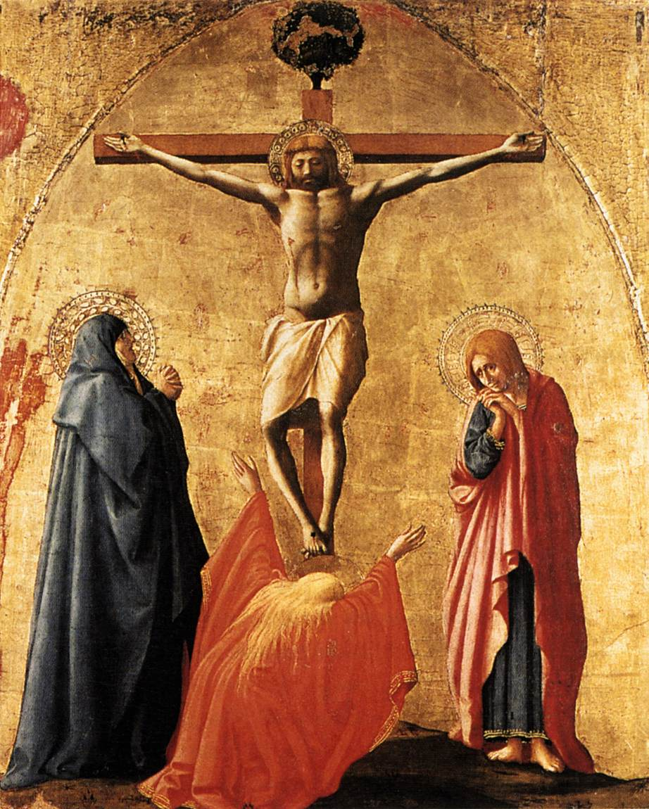
- Distorted image of Christ in which he appears to have no neck
- But it was designed to be represent the viewer’s perspective if he were actually standing below the cross looking up at Jesus
21. Masolino (Tommaso di Cristofano di Fino)
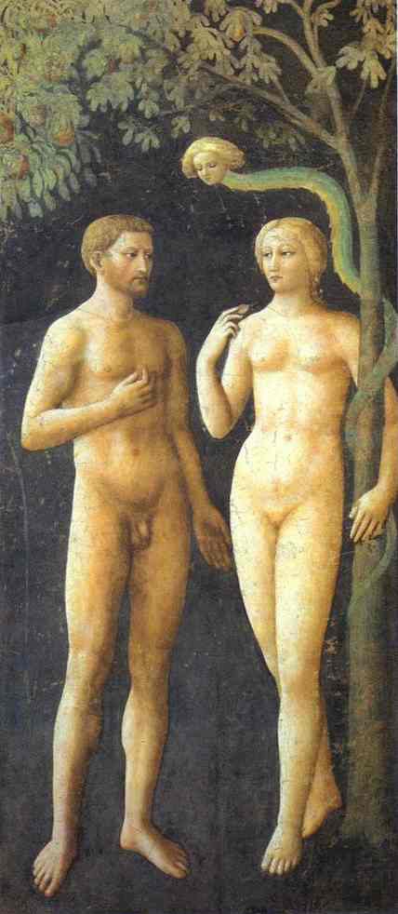
Adam and Eve Before the Fall (ca. 1424)
- Fresco in the Brancacci Chapel that depicts the temptation of Adam and Eve, located on the upper register
- Adam stands to the left of Eve, while her right arm is wrapped around a fig tree. The devil is embodied as a green snake with a human head and is entwined in the branches of the fig tree. The fresco is constructed around a center point towards which Eve and Adam face. The figures lie within the plane of the wall; there is little recession
- Masolino’s personal style significantly differs from that of Massaccio, but there is still a sense of idealization of the classical form of the human body. Masolino’s depiction of the human body is less defined and muscular. The figures express little to no emotion.

22. Masaccio (Tommaso di Ser Giovanni)
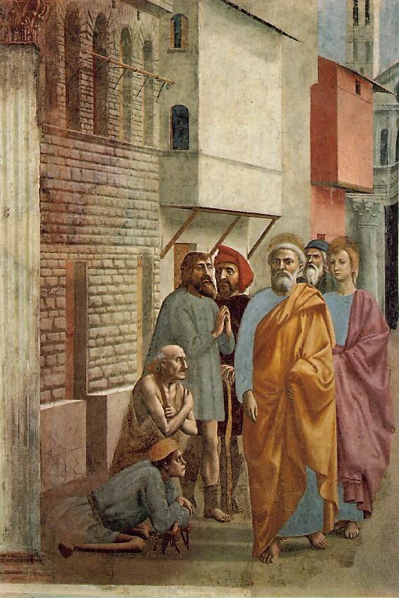
Saint Peter Healing with his Shadow (ca. 1426-1427)
- Fresco in the Brancacci Chapel that depicts Saint Peter walking along city streets lined with the poor and crippled
- Masaccio carefully aligns the shadow as if it were cast by the natural light entering the chapel’s window, allowing the viewer to feel as if the event were literally occurring in the chapel
- The perspective and linear alignment of the heads and edifices creates a realistic sense of depth and recession

23. Masaccio (Tommaso di Ser Giovanni)
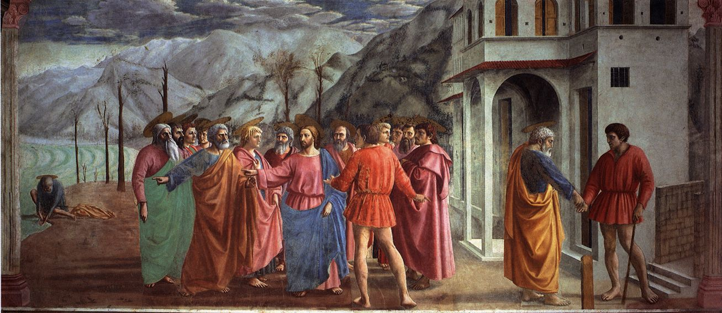
The Tribute Money (ca. 1426-1427)
- Large panoramic fresco in the Brancacci Chapel that depicts the tale of the tax collector and Jesus Christ
- Both the subjective and linear focal point is Jesus: not only does he take up the center space of the plane, all of the lines within the image converge on him.
- There are three elements to the fresco (left to right): the fisher getting the coin from the fish’s mouth, Jesus and his apostles facing the tax collector, and St. Peter paying the tax collector.
- The circular formation of Jesus and his apostles gives a sense of dialogue, conference, and “logic”.
- The symmetry and form of the figures, including the drapery, were inspired by Romanesque sculptures and reliefs. Masaccio took the stance and composition used in classical art and transposed it into this setting.

24. Masaccio (Tommaso di Ser Giovanni)
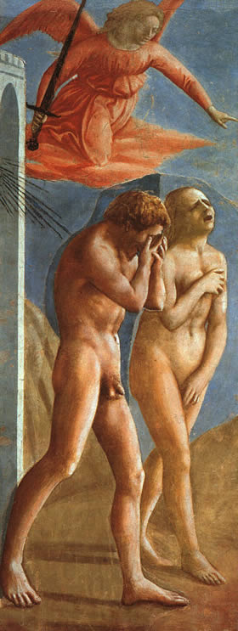
The Expulsion from the Garden, ca. 1426-1427
- Fresco in the Brancacci Chapel that depicts the weeping and lamenting Adam and Eve chased out of the Garden of Eden by an angel brandishing a sword.
- The shadows in this fresco also follow the natural light in the chapel, allowing the viewer to feel as if he shares the space with the figures.
- Adam is shown lamenting with his head and hand, while Eve is portrayed in a pose inspired by a famous sculpture of Venus. (Eve’s left arm covers her pelvis while her right arm lays across her chest)
- Here again we see Masaccio using sculpture to inspire his work. Interestingly he’s using ancient Greek mythology for a Christian work
- Connection: Inspires Michaelangelo’s depiction of the Expulsion (1509-10).

25. Masaccio (Tommaso di Ser Giovanni)
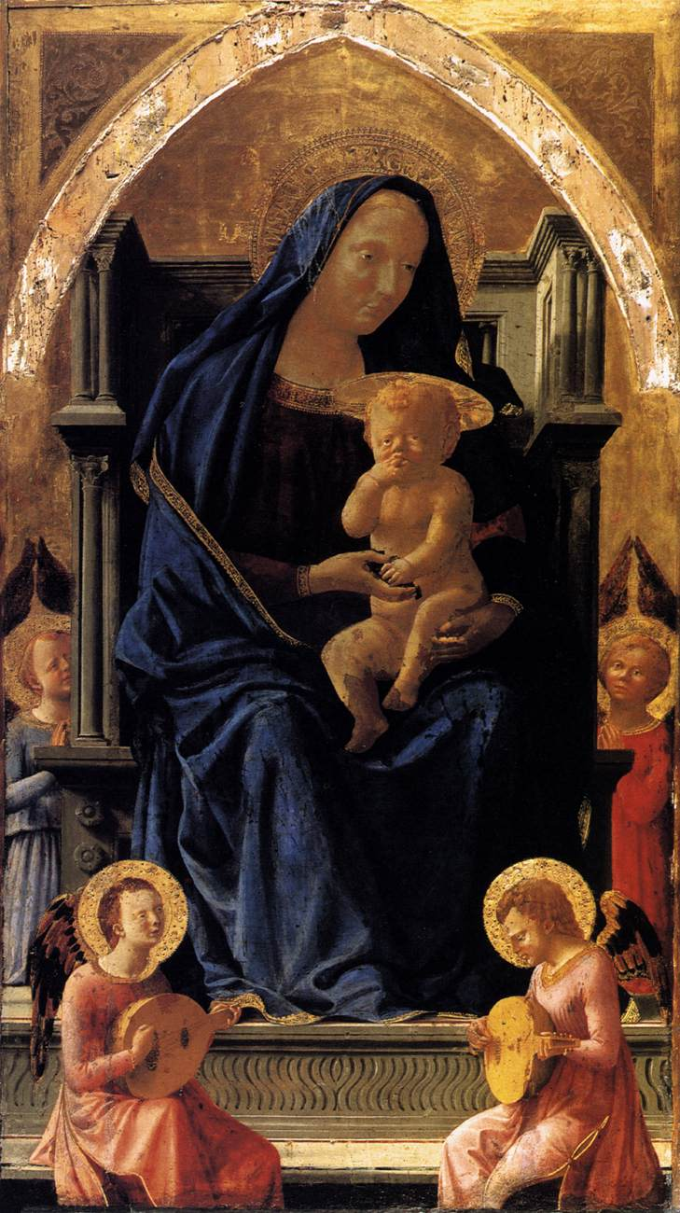
Maesta (Madonna and Child Enthroned), ca.1426-1427
- Centerpiece of the Brancacci Chapel; placed below the window
- In the image the Virgin sits on a large thrown with baby Jesus on her lap and angels at her feet. As she feeds the child grapes, she is simultaneously offering the viewer the body and blood of Jesus Christ.
- She sits on a throne that is columnar in form; it is unlike traditional Christian thrones
- The robust Virgin takes up the majority of the plane; her garb is carefully detailed with fluid drapery
- Shadows on the ground suggest that there were other figures flanking on either side of her.

26. Masaccio (Tommaso di Ser Giovanni)
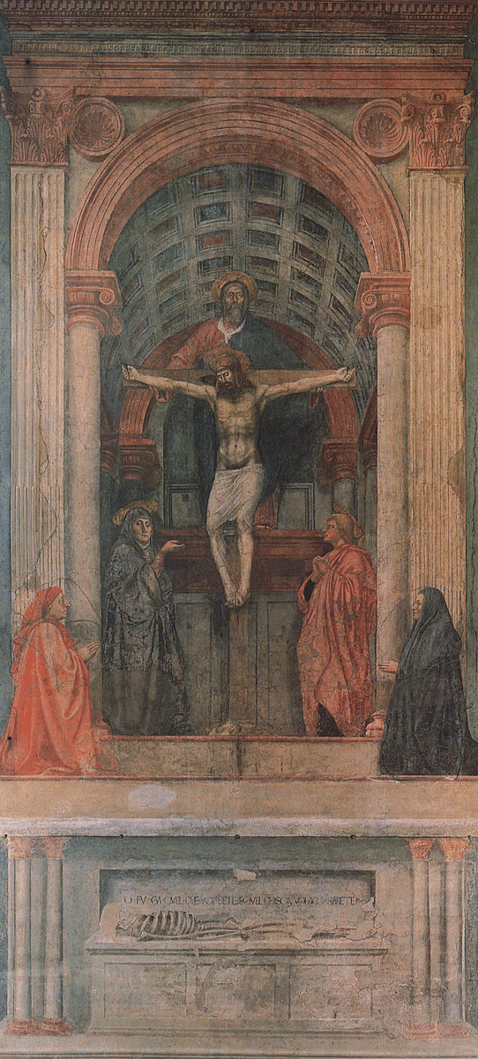

Trinity with the Virgin, St. John the Evangelist, and Donors, 1428
- Fresco in Church (not chapel) depicting Jesus on the crufix flanked by St. John and the patrons (common theme) of the painting. At the bottom of the fresco a skeleton lies over a coffin with an engraving that warns the viewer that one day he shall be in the same position.
- Possibly one of Masaccio’s greatest works. For this fresco he collaborated with a mathematician and used the panel and pinhole trick to achieve the correct perspective.
- For the fresco, Masaccio details distinct spaces: one for Jesus Christ and the saints, another for the Donors, and another for the skeleton.
- To separate the human world from that of Christ, the donors are on a lower level closer to the viewer.
- Composition of the painting urges the viewer to look upwards towards the heavens.

27) Albrecht Dürer, Self-Portrait, 1500
Oil on Panel.German artists, he paints himself as Christ. This was painted at the golden age of the Renaissance. We know this is an icon because of the frontal pose. The symmetrical composition further evokes a religous icon. The inscription in latin names himself “Albrecht Durer at 28 years old”, as well as his trademark symbol on th eleft side. There are religious undertones as he portrays himiself as a perfect image of the maker [think of veronica’s cloth, with the perfect imprint of christ]

28) Albrecht Dürer, Rhinoceros, 1515
Woodcut. The realism in which German painter and printmaker Durer portrayed this rhinocerous hints at his skill and training in draftsmanship. This image was a widely disseminated picture of a Rhinocerous. The woodcut becasem the model of rhinso in teh mid-20th century, attesting to Durer’s global reach.

29) Albrecht Dürer, Self-Portrait, 1494
Oil on vellum. Albrecht Durer portray himsel with realism and in many different costumes. This image has striking detail of his hair and costume. There is a reflection on self and his mastery of self portrature.

30) Albrecht Dürer, Nude Self-Portrait, ca. 1503
pen and brush in black ink, with white on green-grounded paper. One of the firs known nude self portraits. He studied himself and used his own pdoy as a model This is left unfinished, perhaps signifying that he did not know himself completely. There was also an expression of melancholy and he often thought of himself as having this deep sadness.

31) Albrecht Dürer, Self-Portrait, ca. 1492
Pen and ink. This self portrait is significant because he uses his own hand as a model. He draws from life; later he will use this same pose in other religous paintings [Holy family, Christ, etc]. Often he incorporated his own poses and features into artwork. This shows his process of studying himself as a starting experimental point fo rhis other works.

32) Albrecht Dürer, Self-Portrait at the Age of Thirteen, 1484
Silverpoint. This is his earliest known portrait and oldest surviving work. It shows his apprenticeship to his father [a goldsmith] at the time, because he uses the same pose as seen in his father’s self portrait. At a young age he was talented and knew how to draw, as draftsmenship was necessary to teh trade of a goldsmith.

33) Albrecht Dürer, Portrait of Agnes Dürer née Frey, 1494
Pen and black ink. This is a picture of his wife which he presents looking quite plain/uninteresting. His marriage was one that benefited him professionally as she was the daugher of nobility. He gained status and connection, and was able to open up a new workshop. She seemed to be a very withdrawn bride.

34) Albrecht Dürer, Self-Portrait, 1498
This Durer self portrait is significant because it marks his portrayl of himself as a noble person. He is in costume and the background seem to portray the landscape of the south . This marks his many travels, esepcaily to Venice (Italy) to study Renaissance figures. The artist thus took on a higher role, in which art is nobililty. An artist could be respected for their higher status as exceptional individuals with genius.

35) Albrecht Dürer, Four Horsemen of the Apocalypse, from Apocalypse series, 1496-1498
This woodcut was part of the Apocalyse series, a set of prints taht was used to launch his career. This was one of teh first books publishe dand illustrated by an artist. The theme is teh end of the world, as many believed the world would end in 1500. Durer portrays the uniamiginable physicality of the 4 horsemen from descriptions of the story is found in the Bible (Book of Revelations). This helped him gain notiriety and was celebrated as a celebrety later in Venice.

36) Albrecht Dürer, Melencolia I , 1514
This print is considered a reflection of Durer’s emotions and psychological state. There is a sense of the pibolar. The other figure in the print points at the seed of his melacholoy.

37) Albrecht Dürer, Dream Vision, 1523
Pen and ink and watercolor. This is a page from Durer’s diary, in which he accounts his fear of the world ending. He had a nightmare the night before and takes down what he sees, as the world ending in a flood. This reflects his connection with his personal feelings of melancholy . He used his diary and artwork as a reflection on self.

38) Sandro Botticelli, Portrait of Guiliano de’ Medici - 1476-77
http://upload.wikimedia.org/wikipedia/commons/9/98/Giuliano_de%27_Medici_by_Sandro_Botticelli.jpeg
- Guiliano was the younger brother of Lorenzo and they were the ruling family of Medici
- Other families in the noble ranks grew tired of their rule and attempted to overthrow them
  - Attacked Guiliano at a church mass killing him but his brother escaped and resumed rule of Medici
- Image of Guiliano as a very stately nobleman
- Dressed in red robe
- Seems to have a look of disappointment looking down and away from the viewer
- Very defined face with medium length curly hair
- Open window in the background allowing some light to enter into the room
- bird perched on a tree branch that touches the windowsill
- Guiliano is depicted through a window as if we are looking into his personal side

39) Leonardo Da Vinci, Study for the Sforza Monument, 1494
http://www.davincisketches.com/viewimage.cfm?image=/Equestrian/Leo130.jpg
- Leonardo used sketches to experiment and study for painting and work that he was preparing for
- Sketches a side view of a horse and a breast view of the horse
- Also makes a point to draw the horses hind legs at several points during the course of a movement
  - Was studying the horses leg position as it moves forward
    - Did this to understand how it moves so that when he depicts it in the actual monument, it will have a moving effect
- Leonardo was commissioned by Load Ludovico of Milan to create the world's largest statue, a work which was to depict General Francesco Sforza mounted on horseback

40) Leonardo Da Vinci, Self Portrait, 1515
http://www.aspectart.com/gfx/article_images/da_vinci/self_portrait_large.jpg
- Depicts himself as a content old man
- Long flowing hair with a partially bald head
- A long beard
- He looks to be staring at the image of himself
- Choice of colors is interestingly monochromatic
  - Makes me believe that he was practicing with this self portrait sketch for a larger work
- Not really much going on here

41) Leonardo Da Vinci, Projects for Bridges, 1485
- This image is a sketch of a bridge that was ahead of its time and used engineering principles which are used to this day
- The bridge was never built but it displays his genius in the engineering sciences
- It also once again shows his love for experimentation
  - One of his most expressive ways of doing so is through sketches which he makes popular amongst artists of the time

42) Leonardo Da Vinci, Map with the Planned Diversion of Arno, 1503
- Though Leonardo was a genius in many respects, he was not perfect
- This map was created as a project in which Leonardo was going divert the river Arno from the opposing forces who were using it as a water supply
  - This would have forced them to retreat without water to live off
- Project was commissioned by the king as he believed in Da Vinci’s engineering genius
  - Project ended up failing miserably
- Was a great embarrassment for Leonardo

43) Leonardo Da Vinci, Hydrology, 1495
- This was a sketch of Leonardo’s early studies in hydrology - the motion/movement of fluid freely, with an obstacle, and dense liquids
- This particular image shows two streams of water falling
- Both detail Leonardo’s perception of its movement

44) Leonardo Da Vinci, Adda Landscape, 1512
- This sketch’s main attribute is the look of flowing water in the river
- Leonardo also uses perspective in the photo in which he creates images that are further off in the distance as much smaller than the objects that are closer to us

45) Leonardo Da Vinci, Proportions of Man, after Virtuvius 1490
- Da Vinci was actually a pioneer in the realm of physiology and is working to understand the movement of humans as depicted on paper through another one of his sketches
- This particular sketch is one that many still use today
- With this image you can picture the limbs of a human moving on the sketch as they are drawn in a circle that is continuous and would follow the path of the circle

Professor Fehrenbach went through all six of these paintings quite quickly, mostly as examples of a common theme in Leonardo da Vinci’s work – a dedication to movement. The following notes might be applied to each work; specifics for each work are recorded at the bottom.

Motion, Movement, Dynamics

- A common thread throughout Leonardo’s body of work was a fascination with movement. He defined visual art as visual movement.
- The reason Leonardo valued painting and drawing was because he thought it was a medium that could capture movement meaningfully.
- "Painting is philosophy because it deals with motion."
- For Leonardo, static painting was not a snapshot but a dynamic medium.
- Crucial to Leonardo’s study of motion, movement and dynamics was an unfailing dedication to accurate anatomy. He thought that anatomy and movement couldn’t be understood without each other.
- He dissected dead bodies to accurately portray the human form. He thought that the depiction of a body needed to work from the skeleton to the muscles to the skin and finally to the clothes.
- Furthermore, all of his anatomical sketches essentially feature moment. He thought that the human body was essentially a thing that moves.
- Leonardo thought that character manifests itself in physical features. We can read the signs of human bodies over time.
- He thought that emotions (which were also movements) left marks and scars over time. A lot can be understood about a person from looking at their anatomy.
- Bodies are not a timeless frame of reference.

Leonardo da Vinci, Proportions of a Man (after Vitruvius), c. 1490. Page from sketchbook.
* A study of the movement and proportion, and combination of the two, of the human body.
* Takes on a cinematographical look – the body is portrayed between states.

Leonardo da Vinci, Embryological Studies, c. 1505-1515. Page from sketchbook.
* An anatomical study obsessed with movement.
* Numerous pictures of embryos – accurate drawings of even their anatomy.
* During a time when da Vinci was trying to learn about the growth of the human body
* Rendering of the human fetus, as he imagined it at the time
* “lifelike” presentation, though with modern science, we know that this is untrue

Leonardo da Vinci, Portrait Study of an Old Man, c. 1505. Page from sketchbook.
* Good example of how the emotion of movements wears on the human body.
* A face in motion.
* Machinery depicted at the bottom of the painting. Shows Leonardo’s connection between technology and movement – every piece of technology is a potential agent for movement.
* During the period where da Vinci was obsessed with human growth
* He was also interested in the effect of the sun and nutrition
* Shadows created by shading help to create the effect of age
* In the same style as his studies of fluid motion

Leonardo da Vinci, Anatomy of the Arm and Neck, c. 1508. Page from sketchbook.
* Based off the muscles of a 100 year old man.
* Experiments with changing view points to understand how the muscles might look when moving.
* Tried to explain the human body as growth, metabolism, blood flow
o Proportions of Man after Vitruvius (homo quadratus) 1419
o Anatomy of the arm and neck 1508
+ Experiments of changing viewpoints of the same motion, but the viewer must also be set in motion
+ Renderings of the blood’s movement in the heart
o Also obsessed with the growth and development of a human in birth
* Character shows itself in bodily features in the softer more flexible parts of a bodily figure through emotion

Leonardo da Vinci, Studies of the Movement of Blood in the Heart, c. 1510. Page from sketchbook.
- Here, the organ is barely depicted. The movement of the blood defines the functionality of the heart and thus, for Leonardo, defines the heart in and of itself.
* Da Vinci tried to show how he thought blood moved through the heart
* Each small detailed drawing of the heart is his attempt to define fluid movement
* Linear quality of the drawing—simulates movement through curved lines

Leonardo da Vinci, Botanical Study, c. 1505. Page from sketchbook.
* Plants were also objects of movement for Leonardo.
* Products of the sun and its movement. Growth.
* “Anatomy” of plants was also of great importance.

50Leonardo da Vinci, Botanical study, ca. 1505

* In his quest to learn more about growth, he also looked at natural growth in branches
* The curved lines suggest movement and growth

Leonardo da Vinci, Virgin and Child with Saint Anne, 1510-13

* Virgin with Child and Saint Anne, 1510-13
o Probably not related to a commission
o Represented very dynamically
o At the very moment when Christ is trying to separate himself from his mother’s leg
+ When compared with Masaccio and others, the dynamism is compared with the order of the former paintings
o Raphael followed in direct paraphrase to the one that Leonardo did
o Relationship between color and perspective—the bluer the figure is, the further it is away
+ Acceptance of subjectivity in the viewer
+ There are completely governed by scientific rules
+ The reduction of distinctive contours transforms a painting to show less the less realistic it becomes—sfumato
# Used to depict far away objects

Leonardo da Vinci, The Last Supper, 1495-98

* The Last Supper, 1495-97, Milan, fresco
o Shows movement
o Back and forth of movement to Christ’s announcement shows the division among the apostles
o Compared to others which are more static without as much movement and emotion
o Figures seem too large

Leonardo da Vinci, Mona Lisa, 1503-1506

* Female portraiture was in general was a new genre
o Formula for it was the representation of the figure in profile in the 15th century
+ E.g. Domenico…
o Early portraits of Leonardo of women, very exposed face and opaque face like a woman—strangely cast eyes and indiscriminate expression—motions of the mind represented
+ Ginevra de Benci (portrait of some lady)
+ Portrait of Cecilia Gallerani
# Shows her in a state of beginning to smile
# Encountering another presence
# Turned 180
+ Mona Lisa—Portrait of a Lady
# Looking at us, but not
# Traces of a smile
# Two sides of face different from each other
# Paining is about a paradoxical unity between timelessness and time

54Leonardo da Vinci, Deluge, 1517-1518

* Draftsman—a master with a pure form of movement
o Dancing and pointing Nymphs
o Curved hatching instead of diagonal
+ Study of the Kneeling Leda
+ Shows the motion and such of the figure
o Drawing became an experimental field
o Culminated in deluge series

55Pieter Bruegel, Childrens’ Games, 1560

Pieter Bruegel, Fight between Carnival and Lent, 1559

Pieter Bruegel, Hunters in Snow, 1565

Pieter Bruegel, Peasant Dance, ca. 1568

Pieter Bruegel, Peasant Wedding, ca. 1568

Hieronymus Bosch, The Garden of Earthly Delights, ca. 1500

Robert Campin and Assistants, The Mérode Altarpiece, 1425-28
Triptych. This is closely analyzed for the symbolism present in the picture by Meyer Schapiro. The center piece is of a Annunciation, the left an image of the patron, and the right an image of Joseph. He is depicted as an old man working on a mousetrap. This is a symbol for the trapping of the devil through the seed of Jesus.

Gustave Courbet
Le Puits Noir,
ca. 1864
Oil on Canvas framed on wood
- NOTE: THIS IS NOT THE ACTUAL PAINTING: Courbet made several depictions of the same scene from different angles. I put this slide here to remind you of the real painting that is in the Sackler. They look very similar, but they are NOT identical.
- This piece was reviewed in section during the week of medium and its effects
- In this landscape image Courbet depicts a winding stream through the woodlands/valley.
- With the oil paint he is able to capture the natural effect of light on the glistening water, as well as the shading of the trees. By using gradation and varying the detail of his brushstrokes he is able to achieve a sense of depth and realism. As the viewer scans the image from foreground to background, the brush strokes become less distinguishable and the leaves and trees become somewhat muddled. Unlike other mediums, the oil allows Courbet to capture the natural light and add texture to the image; it enables him to manipulate hue, saturation, and value much more easily than other mediums such as tempera.

63. Bernardo Daddi
Christ on the Cross
1334
- This is a three panel altarpiece; the center panel depicts the crucifixion of Christ with three mourners.
- To produce the piece the artist had to carve the altarpiece, prime the surface, sketch the surface, add gold leaf, and then paint using tempera (egg based)
- The image has a matte finish that is characteristic of tempera. With tempera it is very difficult to layer (as in Le Puits Noir) and very difficult to add shading and gradation.

64. Workshop of Jacob de Wit
Autumn Represented by Putti
1745-1750
- No Image: This piece hangs on the back wall of the room in the Sackler where we have section. It is the uppermost artwork
- This piece depicts a scene of cherub-like figures as they prepare and consume wine: to the right of the plane there is set of dancing figures; at the center a cherub sits on a barrel of wine, and in the background a cherub is climbing what appears to be the pit for stomping the grapes.
- This is a depiction of a depiction→ It is a painting of a sculpture. This parallels a theme throughout the Renaissance: Depiction of expensive materials
- The effect is achieved through manipulation of the shading, saturation, and hue of the oil painting. This once again underscores how oil allows artists to be versatile and create a number of perspective and depth effects.

65. Christian Seybold
Portrait of an Old Woman
1749-1750
- No Image: This piece hangs on the left wall of the Sackler section room.
- This is an oil on copper that depicts the portrait of an older woman. This is not a portrait, most likely an exercise for the artist in which he practiced how to depict wrinkles on the face. (The giveaway is that this is a very unflattering painting. Even though it has an overall appealing aesthetic, no patron in the 18th Century would have had her portrait done with so many wrinkles).
- The oil on copper gives the painting a unique shiny and metallic finish that gives her flesh a realistic tone and glow.
George Inness, October Noon, 1891, Oil on prepared millboard
• Textured brushwork/ feathery makes scene blurry with light movement
(windy)
• Layering of paint
• Sense of distance large landscape with road leading into the painting and
a small figure towards the end
• Atmospheric effect (static vs. dynamic areas) (detail vs. vague)

Reginald Marsh, Beach Scene, 1932, Mezzo-fresco (lime wash on plaster)
• Fresco need to work fast (1 day) because colors change when dry at
different times can see a band across painting
• Painting into plaster lasts longer
• Big, loose brushstrokes makes it look livelier/windier (sense of action)
• CHEAP medium

Jasper Johns, Study with Two Balls, 1957, Encaustic (hot wax and pigment)
• Newspaper as painting surface experimental work
• Can sense tension by the bowing of the lines next to balls creating
pressure on the sides (as if a real ball in space would!)
– Uses a representation of physics to make it more realistic
– Plays with primary / secondary colors
– Bottom not finished.

Unknown, Tabernacle with a Flagellation, 15th century

70 Giovanni Battista Piranesi, The Drawbridge, n.d.

Josef Albers, Homage to the Square, 1972

Marcantonio Raimondi after Raphael, The Judgment of Paris, 1517-20

Paulus Pontius after Rubens, The Carrying of the Cross, 1637

These two engravings were compared during Section Four to highlight developments in art form and technique. Raimondi’s work is planar, as all of the figures in the foreground are the same size. It includes multiple scenes; the groups of people seem to be engaging in separate, unrelated activities. The central figure holding up a cloak draws the reader’s attention because she stands alone, unlike the rest, but is the same size as they are. The figures are full-bodied. The engraving’s depth is created by the use of visible, horizontal lines. In contrast, Pontius’s work recedes: the figures become smaller as the viewer’s eye travels up the hill. The viewer is immediately drawn to the large cross at the center of engraving, where Jesus is. The artist uses cross-hatching to show both depth and musculature in the scene and figures. The engraving is open, as opposed to closed, since some figures are only partly within the frame. Further, in contrast to the Raimondi piece, here the figures cannot be separated; a unified event involving all of the characters centered upon Christ is occurring. The viewer’s eye also cannot physically separate the figures; they intertwine and overlap, unlike those pictured by Raimondi.

READINGS

“Muscipula Diaboli,” The Symbolism of the Merode Altarpiece (1945)
By Meyer Schapiro
    - -in Merode Altarpice, Joseph appears as an artisan who fashions mousetraps
    - -Master of Flemalle (who painted Merode Altarpiece) believed to have “unmistakable disposition to the domestic, the intimate and the tiny; his pictures represent a cozy, well kept bourgeois world”
    - -author of article argues that mousetrap has a deeper theological meaning that would have been obvious in the minds of Christians in the Middle Ages
    - -mousetrap= “human flesh of Christ is a bait for the devil, who, in seizing it, bring about his own ruin”
    - -iconography in Annunciation panel further point to the mousetrap as a theological metaphor
    - -tiny naked figure of child bearing cross and descending towards Virgin
    - -passage of rays through glass= miraculous insemination
    - -door, window, towel, basin, lilies, candle all hold hidden religious meaning
    - -so altarpiece contains human career of Christ→ from entrance into world through Virgin to becoming bait for the Devil
    - -propaganda for the cult of Joseph?
    - -Joseph depicted as old man→ pointing to Mary’s virginity
    - -he was one of the main figures in the divine plot of deceive the devil
    - -mice were also considered erotic in middle ages
    - -this altarpiece was a forerunner of the Boschian instruments in which the diabolical, the ingenious, and the sinfully erotic are combined
    - -those w/ unchaste thoughts will be trapped→ intrinsic meaning: new awareness of self, repression of desire

Iconography by Panofsky (1962)
-concerns itself with the subject matter or meaning of the works of art as opposed to their form
-3 strata:
1. primary: forms, line, color (ex. female figure dressed in white)→ pre-iconographical description
2. secondary: motifs, themes, getting what something represents (ex. this female figure represents Venus) → iconographical analysis
3. intrinsic meaning: reveal basic attitude of nation, period, class, or religion (ex. this depiction of Venus is characteristic of Italian High Renaissance) → iconographical interpretation

Petrus Christus’s Our Lady of the Dry Tree
By Hugo van der Velden (1997)
    - -unusual iconography of painting (15 A’s suspended from branch of tree) was derived from miraculous image which was held in high esteem in Bruges
    - -painting originally thought to allude to Ezekiel 17.24, allegory, where Mary is described metaphorically as an act of God, who grafted a branch from the Tree of Life onto a barren trunk
    - -van der Velden argues that iconography of painting is not based on allegory and is not symbolic allusion to Immaculate Conception; no intrinsic meaning→ actual image on tree
    - -suggests that confraternity of Our Lady of the Dry Tree was dedicated to a miraculous image of the Virgin
    - -this image of Mary was first suspended on a dry (dead) tree when it produced a miracle; then taken down and placed on altar
    - -very typical at that time to suspend images on trees; also present was pagan worship of trees
    - -painting must symbolize setting of image of Mary on altar
    - -A might be abbreviation for Ave Maria
    - -A could also signify Arbor

Giorgio Vasari, Painting

* Drawing and painting should be learned by practicing from natural objects, such as the nude figure and studying the motion of muscles and such
* Good methods in art—groups, characterization of figures (old v. Young)
* Pictures should be in harmonius unity with figures that are further away receeding into the background by shading and colour
* Fresco method—done while the plaster is wet, very difficult and exact practice, requires quick work, colours change when dry, most durable of all methods
* Tempera—egg paint
* Gesso—coating on canvas to strengthen it and make it stiff to paint on—preps the canvas—usually done with animal glue of some sort
* Oil paint—oil (linseed or walnut) mixed with pigments from natural materials
* Painting with oil on walls requires coats of oil until it doesn’t absorb anymore
* Painting on stone is easier and doesn’t require as much

Meiss, Light and Perspective

* The fifteenth century was most known for the development of linear perspective
* The last half of the fifteenth century was notably advanced in the depiction of light
* Fire and light is used more in the fifteenth century to represent religious symbols
* The conception of Christ is often depicted as light through a window, as the Virgin was likened to a window in a metaphor
* This is seen in the Merode altarpiece

Wolfflin: Principles of Art History

specific “principles” are necessary because of the need for establishing a firm basis of the classifications of art history (not a value judgment, but classifications of style)

-we must interpret art within its own terms/context (time period, region, etc)

-three kinds of style:

-individual

-national

-time period

-though it is possible for even artists born at the same time and in the same place to have different styles, there are “certain thoughts that can only be thought at certain stages of development” and so Pollack could not have done his work if he was born in 16th century Italy, for example

-Style is unique to the artist, and the same scene will be rendered differently by different people, this is particularly evident when the subjects are from the artist’s imagination

-Thus, Botticelli paints women in a distinctive way, and color and line are often distinguishable between different artists

-individual artists with their personal styles can also be compared in groups, i.e. the style of the school or the country (i.e. Dutch subtlety vs. Flemish massiveness)

-these are categorizations that are only apparent when you are able to compare larger groups of artists to each other

-there are also distinct categories that can be drawn in terms of time period (called the “period” style)

-not all kinds of art are possible at all times (an artist is influenced by what has come before him)

-analysis of the stages of the High Renaissance/ terms for formal analysis:

-linear to painterly style

-plane to recession (classical art reduces the parts of a total form to a sequence of planes, while the baroque emphasizes depth)

- closed to open form (classical art is more closed, baroque is more loose and open)

-multiplicity to unity (in classical art, the single parts of a painting maintain independence, while in “primitive” art there is anarchy, and the spectator moves from one part to the next)

-absolute vs. relative clarity (this mostly refers to subject matter)

-these formal terms are important because they represent a specific schema within which we can talk about works of art, beauty, representation of forms, etc. taken as a whole, they also represent a logical progression of art (linear vision had to come before the painterly)

Schapiro: Style

* Style – constant form in the art of an individual or group
* Meaning for different people:
o Archaeologist – motif
o Historian – essential object of investigation
o Philosopher of history – manifestation of culture as a whole
o Critic – value term.
* Style if peculiar to a period of a culture
* Style refers to three aspects – form elements or motifs, form relationships, and qualities
* Change in thinking about different types of art – primitive art was not true art
* Art is an evidence of the basic unity of mankind
* New styles actually recall primitive art
* Variation within style is important to remember
o Another exception is the difference between the marginal and dominant fields in certain arts
* Individuals can also produce works with different styles
o For example, work of the same man in different arts
* Group style – contains elements that belong to different historical strata
* Can also compare styles of arts of the same period in different media – for example, Baroque
o Broad guiding idea to “impose a common form upon the most varied contexts”
* Organic conception of style – biological growth of forms
o Each stage has its own style
o Can break up Western development into medieval and modern
* Wolfflin’s model – five pairs of polar terms through which he defined the opposed styles of the two period (Renaissance versus Baroque)
o Linear versus painterly
o Parallel versus diagonal
o Closed versus open
o Composite versus fused
o Clear versus unclear
* Weaknesses of his model:
o Difficult to fit Mannerism, modern art into scheme
* Frankl – model of development which combines dual polar structure with cyclical pattern
o Recurrent movement between style of Being and style of Becoming
o Within each style, three stages – preclassic, classic, and postclassic
* Representation of natural forms has been a goal in the arts of many cultures
* Riegl – tried to embrace artistic development as a single continuous process

Move from representation based on vision of the object to representation of the whole perceptual field as distant continuum

