Background
One of the threats to the survival of orangutan populations in the wild is the massive expansion of palm oil plantations in Borneo and Sumatra. We’re creating an interactive platform to raise awareness for the plight of the orangutan and where consumers can not only track the decline of these great apes but also validate that both their financial investments and purchases are ethical choices for this species survival. The palm oil industry only thrives as long as there is a demand for palm oil .
Objective/Purpose
- To create a visualize to see if there is a relationship between the orangutan population and location of palm oil mills

Dataset:

- Global forest watch dataset of the palm oil factory
http://data.globalforestwatch.org/datasets/683f1bb1d88e4fe99df38e3e60b1d0d8_6/data?geometry=39.916%2C-14.030%2C158.481%2C16.363

- Orangutan extinction by area in Borneo and Sumatra
http://data.globalforestwatch.org/datasets/683f1bb1d88e4fe99df38e3e60b1d0d8_6/data?geometry=102.211%2C2.587%2C118.899%2C6.419

- Overall decline in population of the orangutan
https://www.grida.no/resources/8338

https://www.grida.no/resources/8340

Palm oil Mills
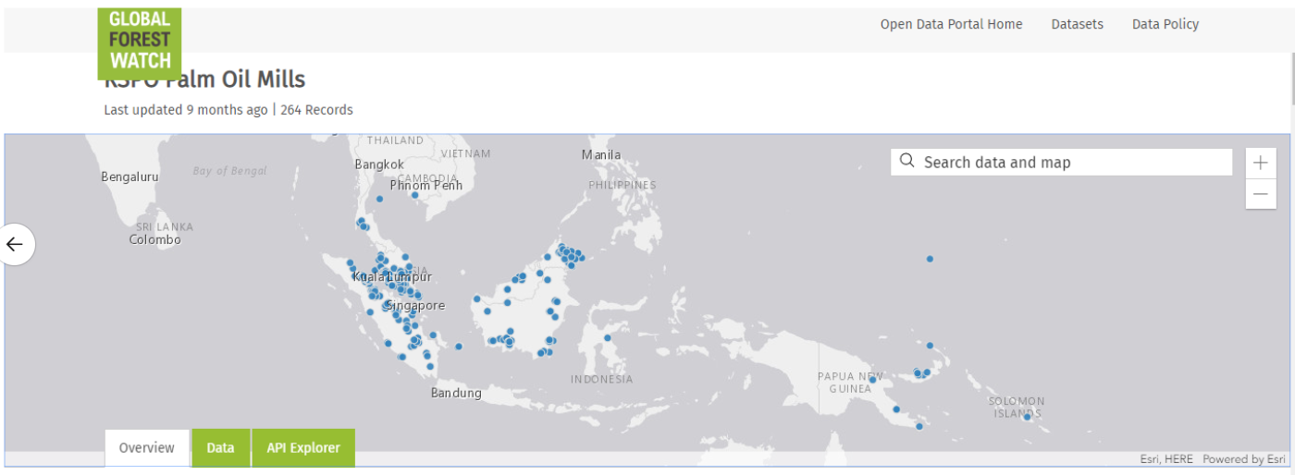

Orangutan

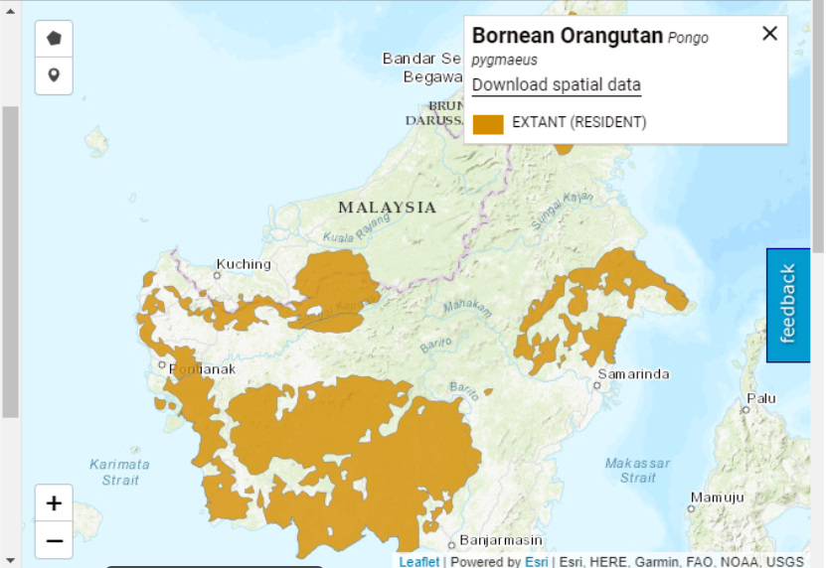
Final output
The final output is to have an interactive map in the background related to the decline of the orangutan and the rise of palm oil mills.
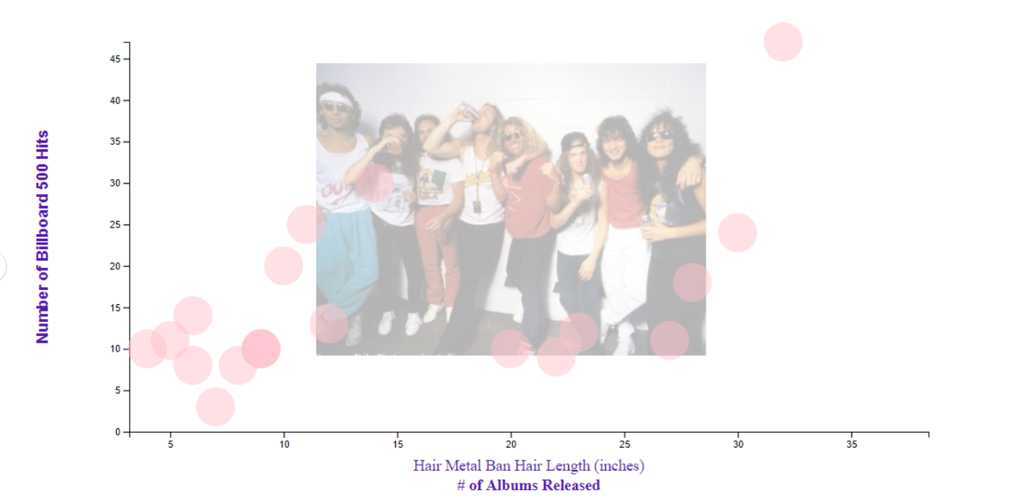

GitHub Link for project - https://github.com/FinanceJunky/Orangutan_Project

APP.PY DASHBOARD BLUEPRINT

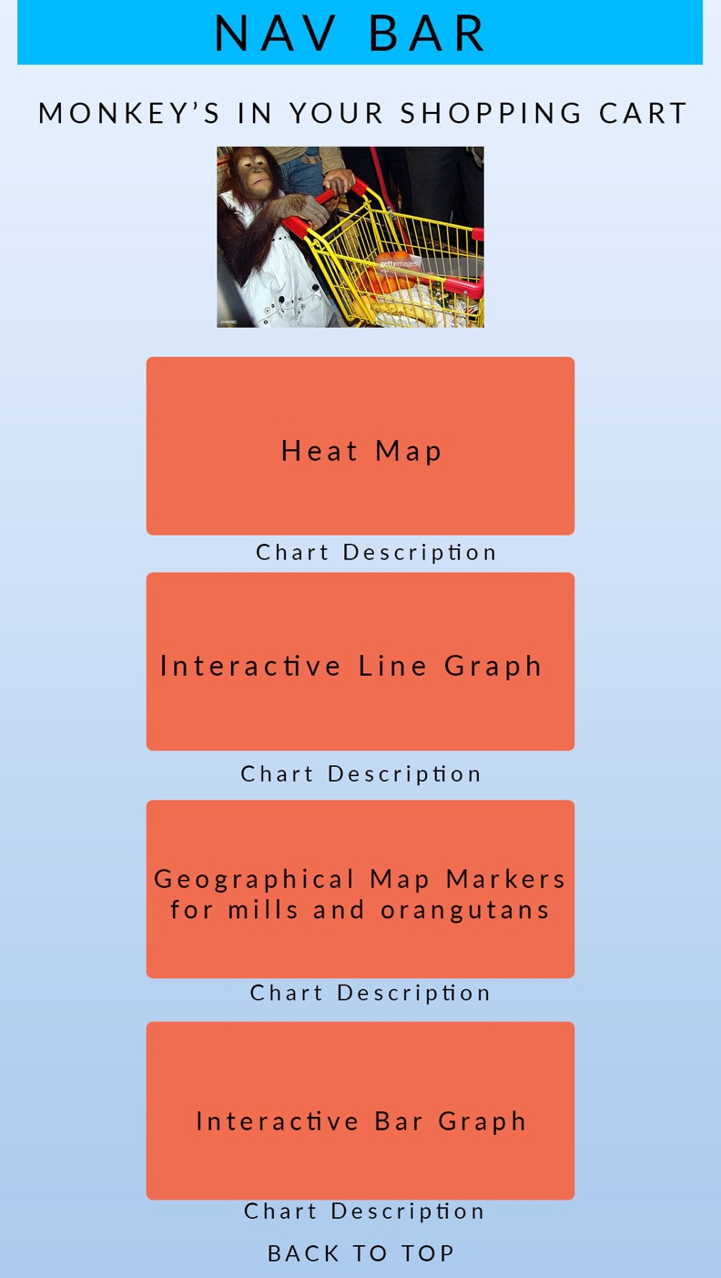

GROUP MEMBERS:

Donald Stegman
Hena Venu
Godwin Thomas
Akuete Kpodar

