This visualization presents the price level mean for each state in the dataset.

Ha: The number of reviews is dependent on the price of the meals served at a restaurant.

P value is 0.

Therefore, we would normally reject the null hypothesis.

However, knowing that the R-squared is 0.001 this dataset is useless because no linear relationship exists. This is illustrated below:

Created using the Seaborn Library

The relationship was recognizable when I graphed the price range vs the review count.

It is a Normal Distribution

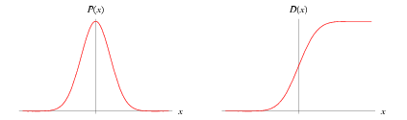

A normal distribution in a [variate](http://mathworld.wolfram.com/Variate.html) X with [mean](http://mathworld.wolfram.com/Mean.html) mu and [variance](http://mathworld.wolfram.com/Variance.html) sigma^2 is a statistic distribution with [probability density function](http://mathworld.wolfram.com/ProbabilityDensityFunction.html)

|  |  |
| --- | --- |
| P(x)=1/(sigmasqrt(2pi))e^(-(x-mu)^2/(2sigma^2)) |  |

on the domain x in (-infty,infty).

<http://mathworld.wolfram.com/NormalDistribution.html>