**KickStarter.com**

**Project Trends**

**and Analysis**

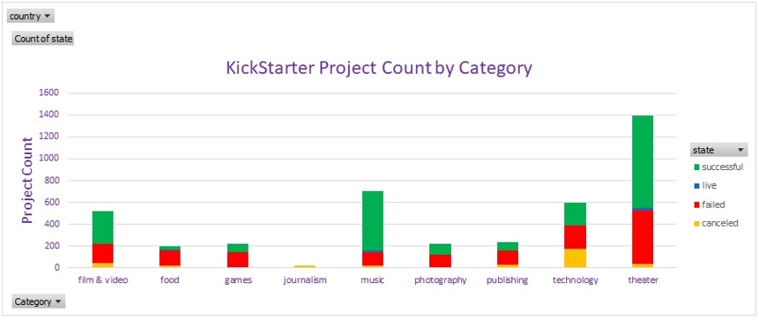Music, film & video, and theater projects are the most successfully funded. However, because the data sample for various project categories is so small, little can be concluded about the type of projects that will successfully reach funded status.

Data seems to suggest that a documentary project on a rock band that sponsors and sells hardware would reach a wider crowdfunding source and be incredibly successful.

Seriously though: Rock music, documentary films, hardware projects are noteworthy as they all have 100 percent success rates. There are others also successful, but all of the data presented are again severely limited in sample size for conclusions to be drawn. In the theatrical space, plays have had the greatest success and failure of all sub-categories. In stark contrast, animation, food truck, video game, and web projects have unilaterally failed or been cancelled.

Highest correlation between successfully funded projects occurs just as summer begins in the month of May. Among the unsuccessful projects, the sample shows a quad-modal count of greatest failure recurring in the months of January, June, July, and October. Finally, the relationship of KickStarter project monthly starts that were inevitably cancelled is unremarkable.

Initial inspection of the data reveals expected outcomes relative to projects requesting a smaller funded cost to greater success. Diving deeper though, success and failure rates for larger fund requests are approximately 40 to 50 percent for projects demanding 5,000 to 44,999 dollars. Finally, no surprises: projects requiring the largest funding also have the highest rate of failure.

**Concluding Remarks**

**and recommendations**:

Given the data, careful consideration should be given to the type of projects and investment amount required in order to ensure a successful funding outcome. Limited dataset sample size supports a cautious approach, especially for ventures needed larger outlays from funding sources. Projects requiring more capital at start up should leverage funding through an alternative source. Consideration should be given to reaching a carefully selected audience of investors. Venture capital, limited partnerships, or targeted institutional investors should be sourced for these larger projects to be successfully funded. While KickStarter offers crowdsourcing through a grassroots investment approach, there are many other ways to research any given projects appeal to both investment and consumer markets.