**Concluding Data analysis: Heroes of Pymoli**

First, Consideration should be given toward targeted gender marketing to women.

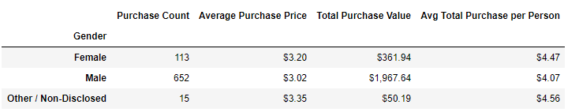

Total in-game purchases were significantly smaller from women because the population of female players making purchases is much lower. Limitation in further analysis broaching this subject is caused by not knowing the total game player population information. We only know the information reported by purchasers.

Second, because the age of gamers falls between three category ranges that are: 15-19, 20-24, and 25-29, as shown below:

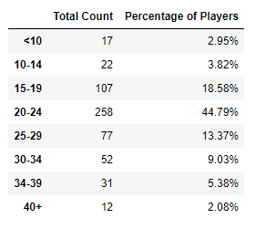

an in-game invitation protocol for inviting other friends to play, “Heroes of Pymoli” should use text messaging or other app message sharing media as the medium for invitations to play the game are most frequent communication for this age demographic. More players/purchasing players are needed to increase game revenues. Game invitations could include a unique link tied to the Screen Name of the referring friend. Recommend that players be incentivized to refer/challenge friends to play, perhaps a unique or popular item could be given when 5 friends have made their first in-game purchase. Metrics for success should be devised before this option is pursued.

Third, additional in-game items should be released regularly to ensure continued purchases. Consideration should be given to creating items that run out, I.e. have a limited number of uses or time that they are available. Thus, facilitating a need of return purchases.

Lastly, if this venture’s profits are favorable to plan, consideration should be made to developing Heroes of Pymoli 2. We are limited by not knowing game costs.