Backend tasks to do
- Campus Registration Module
- Add Data in the General Settings
http://localhost:8000/schsettings
- Update Database with the following
campus_chief_name -> nullable
campus_chief_contact-> nullable
campus_chief_email-> nullable
campus_it_name-> nullable
campus_it_contact-> nullable
campus_it_email-> nullable
- Get Province First from our data.
- List out District a/c to the Province.
- List out Local Level a/c to the District.
- Get the value in Affiliating University
Tribhuvan University(TU)
Purbanchal Univeristy(PU)
Kathmandu University(KU)
Pokhara University (PU)
Lumbini Buddhist University (LBU)
Nepal Sanskrit University (NSU)
- Get the value in Level of Study.
Bachelors
Bachelors & Masters
- Save data to the database.
- Get the Old data like saved data while updating as this is Update only section.
- Show the data of the Added Faculty and Program from the place at the button below File Upload Path.

- Student Management Module
http://localhost:8000/student/create
- Save the data from the Create method to the database.
- Get the Program a/c to the Faculty selected.
- Create drop down in Admission Year and have the value as static for now.
2076
2077
2078
2079
2080
2081
2082
- In Religion, create a drop down and add theses static values or you can get it from the controller by saving it somewhere with the ID so that the in Report it is easy to work.
Hinduism
Buddhism
Islam
Christianity
Kirat (indigenous animistic faith)
Jainism
Sikhism
Others

- In Caste add drop down with following static values or you can get it from the controller so that the in Report it is easy to work.
Brahmin
Chhetri
Dalit
Janajati
Kami
Limbu
Madhesi
Magar
Muslim
Newar
Rai
Sarki
Tamang
Tharu
Others
- Hide the following in the database dynamically or in the view
- Student Admission
- House
- Height
- Weight
- Measurement Date
- Province
- Province
- Transport Details
- Hostel Details
- In Student Address Details, when the below button
If Permanent Address Is Current Address
this is clicked then the data from the Current Address should fill the values there.
- In Miscellaneous Details
- Hide IFSC Code
- Previous Level of Study : Get values as belows in there.
SEE/SLC
+2
Bachelors
Masters
CTEVT
- Previous Board/University/College: Get the static values as:
Tribhuvan University(TU)
Pokhara University(PU)
Purbanchal University(PU)
Kathmandu University(KU)
Nepal Sankrit University
- Upload Documents
- The files are not getting uploaded.
(note: It is the same issue everywhere where image has to be uploaded, only the Student Photo is working)

http://localhost:8000/student/search
- Filter Students According to Academic Level, Faculty and Program.
- In the list remove province

http://localhost:8000/student/edit/4
- Store the updated value to the database.
- There is an issue in the Student edit page
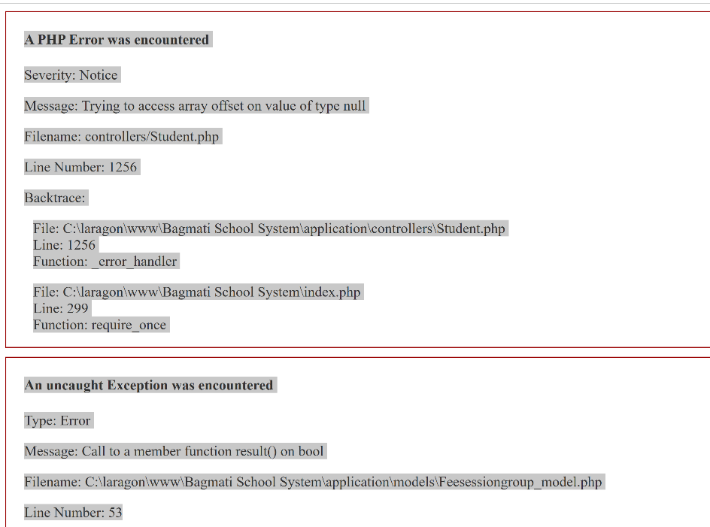

- Academic Level Module (Class)
- Modify the Duration to the dropdown of Bachelors and Masters. Leave it static for now, we can work on it later and move it on top of Academic Level.
- Instead we treat this as the 1st Year, 2nd Year, and so on.
- Program Setup Module
- Make the Title, Academic Level and Faculty required

- In Human Resource Staff Module, add:
- In Database
For Basic Information
- firstnameNp
- middlenameNp
- lastnameNp
- disability status -> Get it like the Student module, like in Category
- religion
- caste
- edj

For Current Address
- DistrictCur
- ProvinceCur
- LocalLevelCur
- wardCur
For Permanent Address
- DistrictPer
- ProvincePer
- LocalLevelPer
- wardPer
For Images
- citizenship->nullable
- nationalId->nullable
For Academic Information, previous one
- previousLevelOfStudy[]
- previousBoard[]
- previousInstitute[]
- previousRegNo[]

- In controllers, add the structure
- In view, add the fields for the things updated in the database like in Student.

- Academics
- Class Timetable
- Add Program in there and get the datas accordingly.
- Assign Class Teacher
- Add Program in there and get the datas accordingly.
- Promote Students
- Add Program in there and get the datas accordingly.
- Subject Groups
- Add Program in there and get the datas accordingly.

- Fees Collection
    - Collect Fees
- Add Program in there and get the datas accordingly.
- There is some minor error, when you try to get the data.
    - Search Dues Fees
- Add Program in there and get the datas accordingly.
    - Fees Carry Forward
- Add Program in there and get the datas accordingly.
- Examinations
    - Exam Result
- Add Program in there and get the datas accordingly.
    - Print Admit Card
- Add Program in there and get the datas accordingly.
    - Print Marksheet
- Add Program in there and get the datas accordingly.

- Reports
- Modify Reports like this
a. Student Enrollment/Registration Detail Report By F.Y/Batch: Name(Full), RollNo, District, Local Level, ethnicity, Gender, Age, Batch Year, Faculty, Level, Program etc
b. Total no of students by Faculty and gender
c. Total no of students by Faculty and ethnicity
d. Total no of students by level and Gender
e. Total no of students by Program and Gender
f. Total no of students by Program, ethnicity and gender
g. Total no of students by District, ethnicity and gender
h. Total no of students by Province, ethnicity and gender
i. Total no of students by Faculty, level, Program and Local Level/Municipality
j. Total no of graduated Students by Faculty, program, gender and Caste Ethnicity
k. Student Pass Rates (%) by level, Faculty and Gender
l. Teachers and Staff Detail information by Name, position, Qualification, Job Type, and Appointment details.
m. Total no of Teachers and Staff by ethnicity and gender
n. Total no of Teachers and Staff by position, Job Type and gender
o. Campus enrollment summary report by Level, Faculty, Program, Gender and caste ethnicity
p. Total no of Dropout students by gender,program.

- HEMIS Reporting
  - Analytics Module and Dashboard
  - Data Analytics: Provides insights and analytics based on the collected data such as Student enrollment, Graduated etc.
  - Dashboard: The Infographic Dashboard should provide a graphical and tabular variety of summary and yearly trend analysis Information related to Student Enrollment, Graduated Students, and recent active academic year Level, Faculty-student enrollment, and status of Teachers and Staff information.
  - Type of Report:
  - Standard Reports: Generates predefined reports for various stakeholders eg Student detail Reports by F.Y, Level, Faculty, Program Gender, Caste ethnicity, etc with export report option (PDF/Excel).
  - Custom Reports: Allows users to create custom reports based on specific criteria such as Student enrollment statistics by F.Y, Level, Faculty, Program etc with data filters export report option (PDF/Excel).

- Fees Collection
    - Collect Fees
- Add Program in there and get the datas accordingly.
- There is some minor error, when you try to get the data.
    - Search Dues Fees
- Add Program in there and get the datas accordingly.
    - Fees Carry Forward
- Add Program in there and get the datas accordingly.
- Examinations
    - Exam Result
- Add Program in there and get the datas accordingly.
    - Print Admit Card
- Add Program in there and get the datas accordingly.
    - Print Marksheet
- Add Program in there and get the datas accordingly.

Changes to be done
Porgram and Faculty should have direct relation like many to many so that when in the search when we select the Program after selecting faculty it is showing all of Bachleors of Education.
      - Student Create
http://localhost:8000/student/create
When the data doesn’t get saved and the form refreshes some of the values are not coming.
- Faculty
- Program
- Gender
- Temporary Province
- Temporary District
- Temporary Local Level
- Temporary Ward No
- Permanent Province
- Permanent District
- Permanent Local Level
- Permanent Ward No
- Upload Documents
      - Student Edit
- All datas are not there.
- The design needs to be fixed
      - Student Search
localhost:8000/student/search

      - Multi Class
http://localhost:8000/student/multiclass
- After we Search, it shows up with student details, Selected Program needs to be added.

Issues and the things to do
2082-01-12

Login Page
- The url for the admin login needs to be shortened and it should open in “/admin”.

Dashboard
- Charts and Data in the dashboard.
- Counts
- Faculty
- Programs
- Graduates
- Dropouts
- Total Students
- Male
- Female
- Total Staffs
- Charts
I. Bar diagram comparing students enrolled in different Programs
- No. of Male students according to the program
- No. of Female students according to the program

II. Bar diagram a/c to year
- Enrollment, Graduated and dropout student numbers.

III. Pie chart
- Total number of Active students according to the Caste

IV. Pie chart
- Student and teacher Ratio (Use the code from the Report http://localhost:8000/report/student_teacher_ratio )

Student Information
- Student Details
http://localhost:8000/student/search
- In here, all the programs are getting rendered.
- Student Graduated Module

Fees Collection
- Fees Master, add the Filtering for Program.
http://localhost:8000/admin/feemaster/assign/1
This is in the Fee Master, when we create a fee master and there is assign button when clicked takes us there.
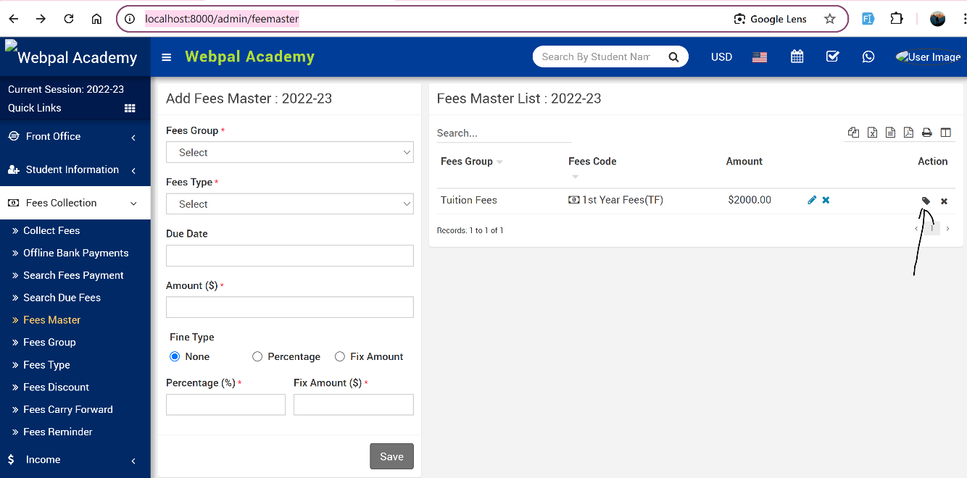

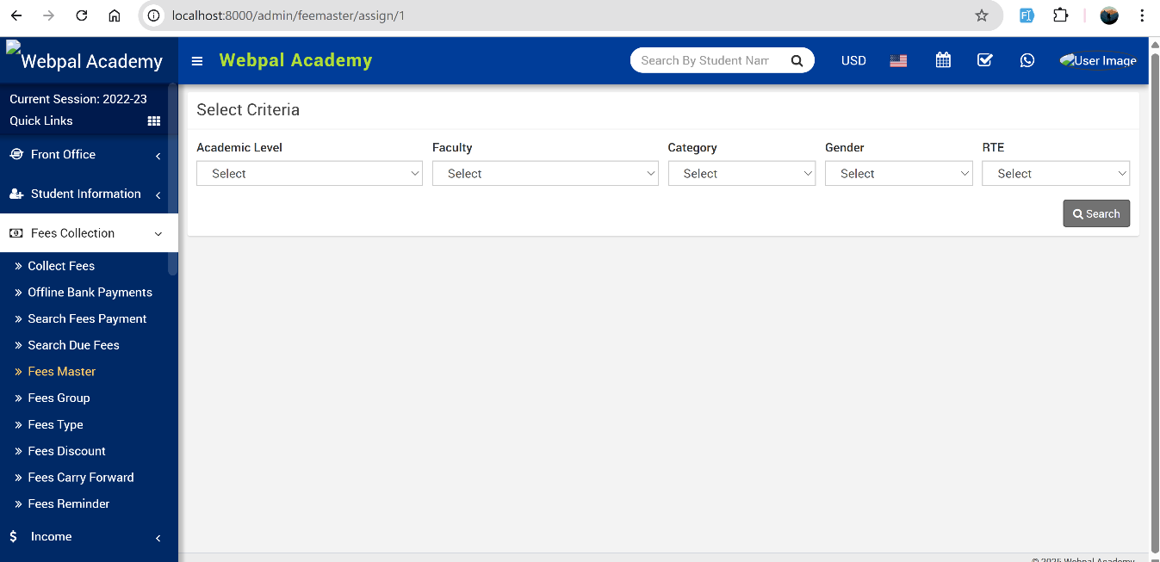

Attendance
- Student Attendance
- Add the Program Filtering there
- Approve Leave
- Add the Program Filtering there
- Attendance by Date
- Add the Program Filtering there

Online Examinations
- Question bank
- Add the Program Filtering there

Academics
- Class Timetable
http://localhost:8000/admin/timetable/create
- Add the Program Filtering there
- http://localhost:8000/admin/timetable/create
- Add the Program Filtering on this.
- Add the database column to save the Program Id in there so that the class timetable is set for that program.
- Subject Group
- Add the Program Filtering
- Add the Program in the database
- Academic Level
- Change the url from “/classes” to “/academiclevel”
- Programs
- Hide Session Type and Total Sessions
- Wile selecting the Academic Level, lets maintain a many to many relation as for instance:
The program Bachelors of Education of Faculty of Education of Bachelors has 4 years and if we could select for the Academic Level it is associated with it will be better and when choosing a program it won’t show all the Programs name for each year but only the one associated in that faculty.
- In programs edit, the Total Sessions field is required, please make it nullable and hide it from the view.
- Promote Students
- Append the Degree name in the Academic Level. 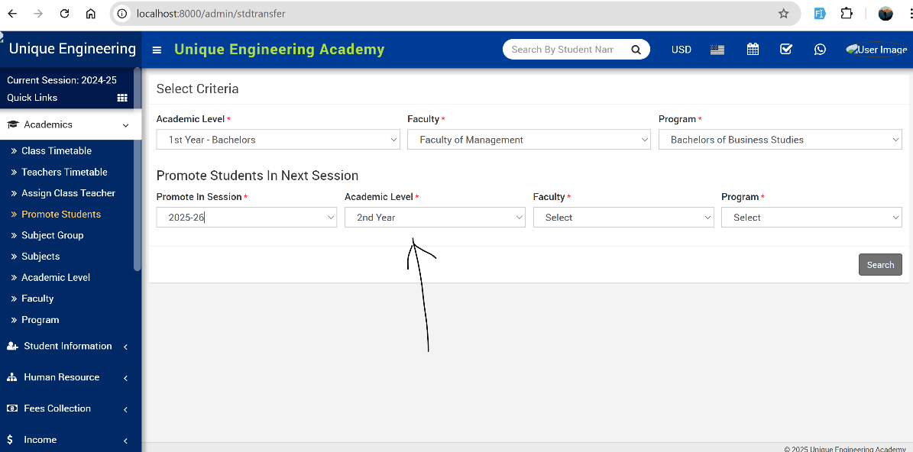

- Student Graduate Modal
- Add One more field for the Student with the values as Dropout and Graduated.
- Just like Student Search or Promote Students, have a filter of the Academic Level, Faculty and Program.
- Filter the students.
- Have a design similar like Promote students and we can check multiple students and selecting students, we can add the if the student has Graduated or dropped out.

Lesson Plan
- Hide the Whole Menu

Homework
- Hide the Whole menu

E-library
- Add Student
http://localhost:8000/admin/member/student
- Filter a/c to Program

Transport
- Hide Transport

Hostel
- Hide Hostel

Certificate
- Generate Certificate
http://localhost:8000/admin/generatecertificate
- Add Program Filtering
- Generate ID Card
http://localhost:8000/admin/generateidcard/search
- Add Program Filtering

Report
- Student Information
- Student Report
http://localhost:8000/report/studentreport
- Same issue as the Student Search with the program, only show the program related to that Academic Level and Faculty.
- Show the Student Count as well like in our last system
- Academic Level, Faculty & Program Report
http://localhost:8000/report/classsectionreport
- Add Program as well and show the student count data accordingly.

