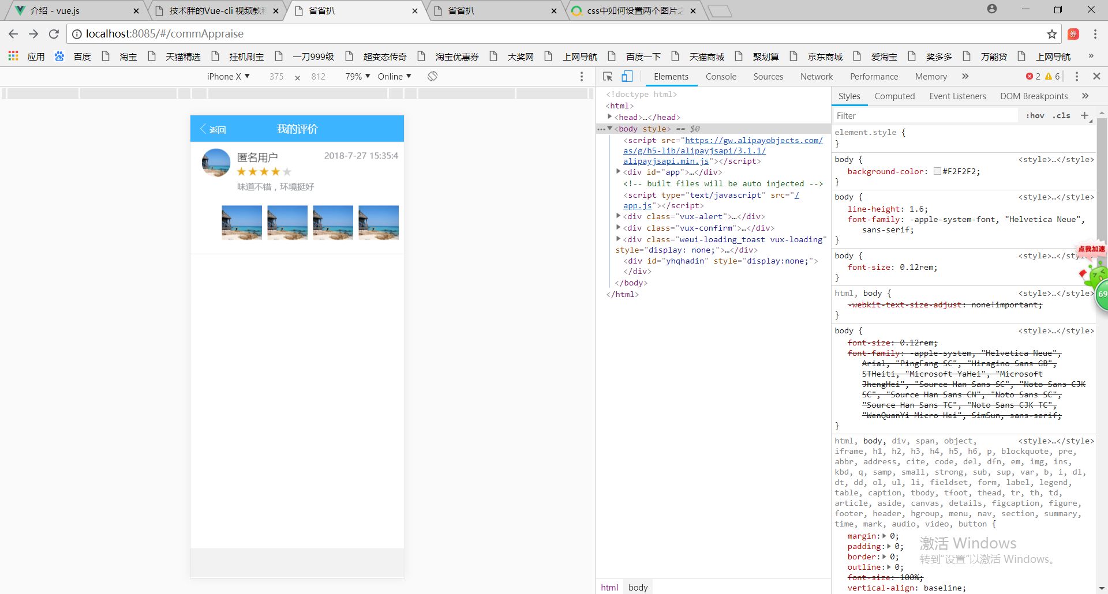<template>
<div>
<x-header :left-options="{showBack: true}" class="xheader">我的评价</x-header> //插入我的评价有返回蓝色的插槽
<div class="content">
<scroller v-if="list.length > 0" lock-x height="-100" scrollbar-y @on-pulldown-loading="onScrollTop" ref="scroller"
:scroll-bottom-offst="20" :pulldown-config="{content:'',downContent:'',upContent:'',loadingContent:'Loading……'}" // 1.v-if 根据所等于的值是否为真决定它是否加载2v-bind的缩写为：Loading……为true显示为false时显示
<div class="box2">
<div class="item" v-for="(pass, index) in list" :key="index" @click="toEdit(pass.id)">
<div class="wh-l" ><img :key="pass.accountUrl" class="qiege"/></div>
<div class="wh-l" style="width: 80.2%;" >
<div class="hezi"><p class="idnoni">{{pass.accountName}}</p></div>
<div ><p class="idnol">{{pass.accountTime}}</p></div>
<br>
<div style="clear:both;"></div>
<div class="idno" v-for="(item, index) in pass.score" :key="index"><img src="../../../static/images/start.jpg" class="picture1"/></div>
<div class="idno" v-for="(item, index) in (5 - pass.score)" :key="index"><img src="../../../static/images/start no fill.jpg" class="picture1"/></div>
<br>
<div class="hezi"><p class="idnowei">{{pass.remark}}</p></div>
</div>
<div style="clear:both;"></div>
<div>
<div class="wh-2" v-for="(item, index) in pass.imgUrl" :key="index" v-if="index < 4"><img src="../../../static/images/pic22-3.jpg" class="picture"/></div>
</div>
</div>
</div>
</scroller>
<!-- 暂无数据展示 -->
<div style="margin-left: 40%;" v-if="list.length===0&&!loading">
<img src="../../../static/images/nodata.png" style="width:80px;height:80px;vertical-align:middle;margin-right:6px" /><br/>
<span style="color: #F6A624">暂无数据</span>
</div>
</div>
</div>
</template>

<script>
import { Swiper, Grid, GridItem, XHeader, Cell, Group, XButton, Scroller, LoadMore, Loading, Confirm } from 'vux'

export default {
components: {
Swiper,
Grid,
GridItem,
XHeader,
Cell,
Group,
XButton,
Scroller,
LoadMore,
Loading,
Confirm
},
data () {
return {
list: [],
loading: false, // 等待动画
pageNum: 0, // 数据加载
pageSize: 5,
total: 0,
showLoading: true,
delId: '',
showConfirm: false
}
},
methods: {
initList () {
this.loading = true
var that = this
var params = {
token: this.user.token,
accountId: this.user.accountId
}
this.$http.post('/mlm/shop/recommend/getListbySql.htm', params).then(response => {
var resBody = response.body
if (resBody.isSuccess === 0) {
this.list = []
for (var i = 0; i < resBody.result.estimates.length; i++) {
var imgUrl = resBody.result.estimates[i].imgUrl.split('|')
this.list.push({
shopId: resBody.result.estimates[i].shopId,
accountId: resBody.result.estimates[i].accountId,
accountName: resBody.result.estimates[i].accountName,
accountUrl: resBody.result.estimates[i].accountUrl,
accountTime: resBody.result.estimates[i].accountTime,
productId: resBody.result.estimates[i].productId,
productName: resBody.result.estimates[i].productName,
remark: resBody.result.estimates[i].remark,
reply: resBody.result.estimates[i].reply,
imgUrl: imgUrl,
score: resBody.result.estimates[i].score
})
}
this.loading = false
this.total = resBody.result.totalElements
} else if (resBody.isSuccess === 2) {
this.$vux.alert.show({
title: '提示',
content: '登录超时，请重新登录！',
onHide () {
that.$router.push({path: '/login'})
}
})
} else {
this.$vux.alert.show({
title: '提示',
content: resBody.errorMsg,
onHide () {
console.log(resBody.errorMsg)
}
})
}
this.loading = false
this.$vux.loading.hide()
})
},
reload () {
this.pageNum = 0
this.total = 0
this.list = []
this.initList()
},
// 下拉刷新
onScrollTop () {
this.$nextTick(() => {
setTimeout(() => {
this.$refs.scroller.donePulldown()
// 刷新列表
this.list = []
this.initList()
}, 2000)
})
},
onScrollBottom () {
if (this.loading) {
// do nothing
} else {
this.loading = true
setTimeout(() => {
if (this.list.length < this.total) {
this.initList()
}
this.loading = false
}, 2000)
}
},
toEdit (id) {
this.$router.push({path: '/addCommPass/' + id})
},
onCancel () {
this.showConfirm = false
},
showDelConfirm (id) {
this.delId = id
this.showConfirm = true
}
},
mounted () {
var user = sessionStorage.getItem('user')
if (user) {
user = JSON.parse(user)
this.user = user.account
this.$vux.loading.show({
text: 'Loading'
})
this.initList()
} else {
this.$router.push({path: '/login'})
}
}
}
</script>

<style scoped>
.vux-header{
position: fixed !important;
top:0px;
z-index: 2;
width: 100%;
}
.content {
background-color: #FFFFFF;
font-size: 15px;
}
.item {
padding: 10px;
height: 150px;
border-bottom: 1px solid #D9D9D9;
}
.wh-l {
float: left;
height: 100px;
padding-left: 10px;
}
.wh-2 {
float: right;
height: 50px;
padding-left: 10px;
}
.wh-r{
float: right;
height: 50px;
width: 8%
}
.icon {
width: 20px;
height: 20px;
margin-right: 20px;
}
.btn{
bottom: 0px;
width: 100%;
position: absolute;
}
.def {
color: #409EFF;margin-left: 5px;
}
.idno {
color: #909399;
float:left;
width:40;
height:40;
font-size: 15px;
}
.idnowei {
color: #909399;
float:left;
width:40;
height:40;
font-size: 13px;
margin-top: -10px
}
.idnoni {
color: #0f0f0fd8;
float:left;
width:40;
height:40;
margin-left: 0px;
font-size: 16px;
font-weight: 525
}
.idnol{
color: #909399;
float:right;
font-size: 13px;
margin-top: 5px
}
.qiege {
width:50px;
height:50px;
border-radius:50%;
overflow:hidden;
margin-left: -10px
}
.picture {
width:65.5px;
height:60px;
overflow:hidden;
float: right;
margin-top: -22px
}
.picture1 {
width:15px;
height:15px;
overflow:hidden;
float: right;
}
.hezi {
margin-left: 2px
}

</style>

