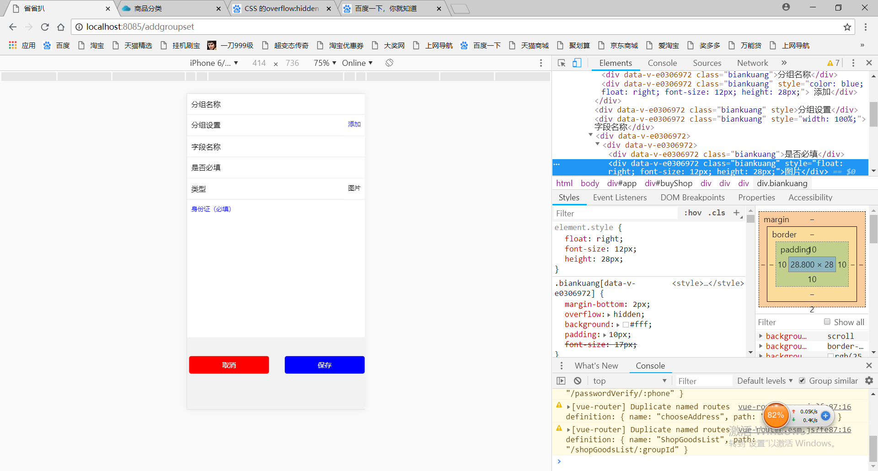
代码
<template>
<div id="buyShop">
<div style="padding-bottom: 5em;">
<div>
<div class="biankuang">分组名称</div>
<div style="color:blue;float:right;font-size:12px;height:28px;" class="biankuang"> 添加</div>
</div>
<div class="biankuang">分组设置</div>
<div style="width:100%;" class="biankuang">字段名称</div>
<div>
<div><div class="biankuang">是否必填</div>
<div style="float:right;font-size:12px;height:28px;" class="biankuang">图片</div>
</div>
</div>
<div class="biankuang">类型</div>
<div style=" margin-bottom: 2px;width:100%;height:300px;overflow: hidden;color:blue;background: #fff;padding: 10px;" >身份证（必填）</div><br>
<div style="margin-top:20px">
<button style="width:45%;background-color: red;float:left;color:#fff;border-radius:5px;padding:10px 15px;font-size:16px;margin-left:5px;">取消</button>
<button style="width:45%;background-color: blue;float:right;color:#fff;border-radius:5px;padding:10px 15px;font-size:16px;margin-left:5px;">保存</button>
</div>
</div>
</div>
</template>
<script>
export default {}
</script>

<style scoped>
.biankuang {
margin-bottom: 2px;
overflow: hidden;
background: #fff;
padding: 10px;
font-size:17px;
}
</style>

1按钮属性的设置
2排版在最两边
3每一格灰色条纹的设计

