createTimeStr (operationtime) {
if (operationtime) {
var d = new Date(operationtime)
var year = d.getFullYear()
var month = ((d.getMonth() + 1) < 10 ? '0' + (d.getMonth() + 1) : (d.getMonth() + 1))
var date = (d.getDate() < 10 ? '0' + d.getDate() : d.getDate())
var hour = (d.getHours() < 10 ? '0' + d.getHours() : d.getHours())
var minute = (d.getMinutes() < 10 ? '0' + d.getMinutes() : d.getMinutes())
var second = (d.getSeconds() < 10 ? '0' + d.getSeconds() : d.getSeconds())
return year + '-' + month + '-' + date + ' ' + hour + ':' + minute + ':' + second
} else {
return ''
}
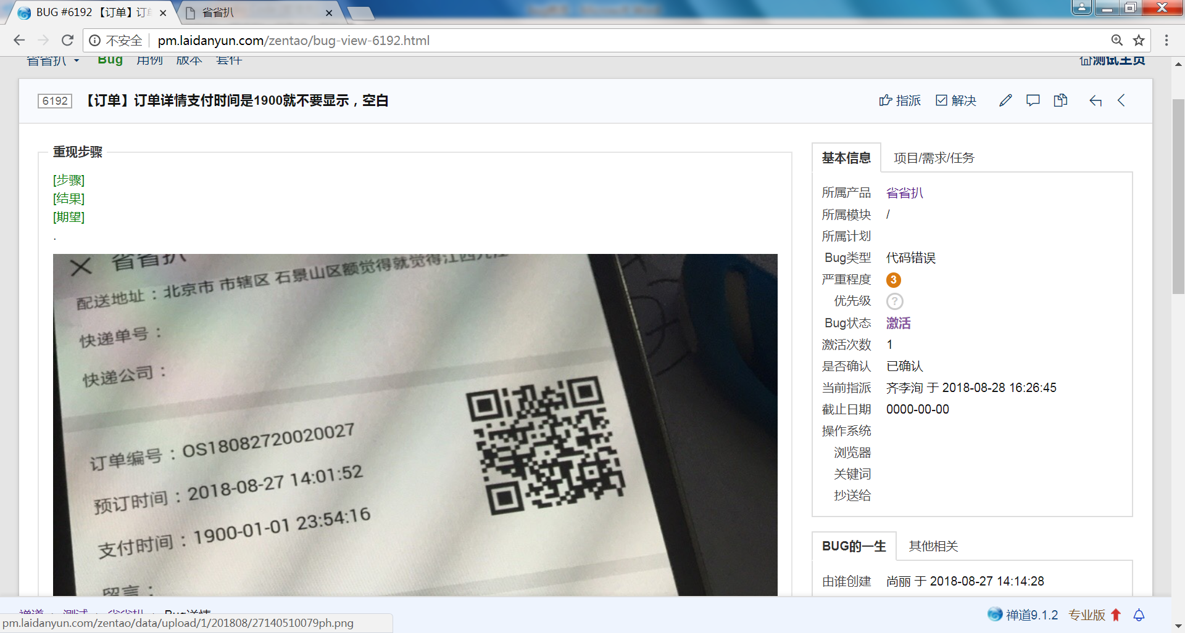
else {
return ''
}
如果传递的时间为空就返回空
2没有图片使用v-if判断图片的长度imgs.length>0来判断

