- 设计页面截图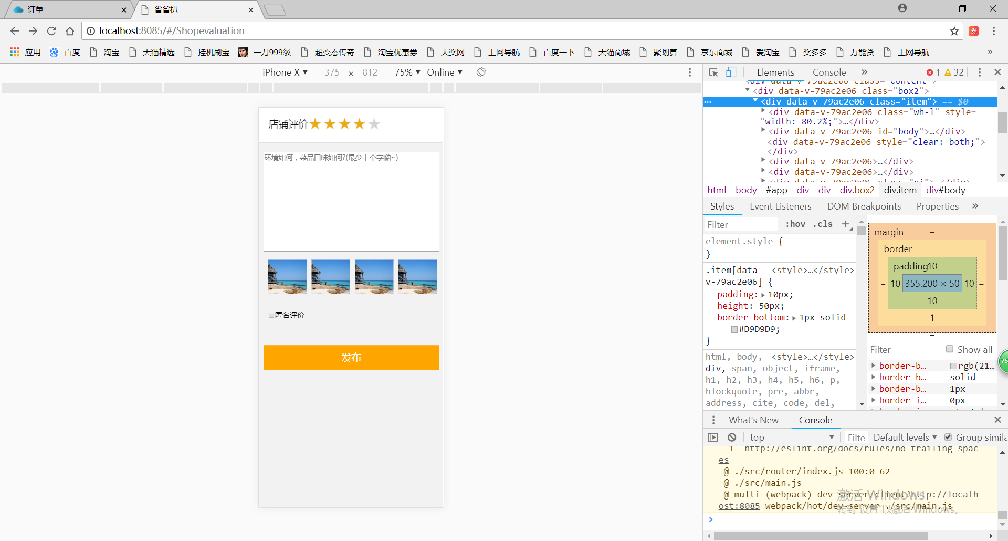
- 所写的代码.文件名称：Shopevaluation.vue
<template>
<div>
<div class="content">
<div class="box2">
<div class="item" >
<div class="wh-l" style="width: 80.2%;" >
<div class="hezi"><p class="idnoni"></p></div>
<div ><p class="idnol"></p></div>
<br>
<div style="clear:both;"></div>
<div class="idnodi">店铺评价</div>
<div class="idno" ><img src="../../../static/images/start.jpg" class="picture1"/></div>
<div class="idno" ><img src="../../../static/images/start.jpg" class="picture1"/></div>
<div class="idno" ><img src="../../../static/images/start.jpg" class="picture1"/></div>
<div class="idno" ><img src="../../../static/images/start.jpg" class="picture1"/></div>
<div class="idno" ><img src="../../../static/images/start no fill.jpg" class="picture1"/></div>
<br>
<div class="hezi"><p class="idnowei"></p></div>
</div><div id="body">
<textarea name="text" placeholder="环境如何，菜品口味如何?(最少十个字喲~)" style="height:200px;width:355px;" ></textarea>
</div>

<div style="clear:both;"></div>
<div>
<div class="wh-2" ><img src="../../../static/images/pic22-3.jpg" class="picture"/></div>
<div class="wh-2" ><img src="../../../static/images/pic22-3.jpg" class="picture"/></div>
<div class="wh-2" ><img src="../../../static/images/pic22-3.jpg" class="picture"/></div>
<div class="wh-2" ><img src="../../../static/images/pic22-3.jpg" class="picture"/></div>
</div>
<div><button></button></div>
<div class="ni"> <label><input type="checkbox" >匿名评价 </label></div>
<div><button style = "height:50px;width:356px;font-size:20px;background-color:orange;color:white;margin-top:50px" type="submit">发布</button></div>
</div>
</div>
</div>
</div>
</template>

<script>
export default {
}
</script>

<style scoped>
.vux-header{
position: fixed !important;
top:0px;
z-index: 2;
width: 100%;
}
.content {
background-color: #FFFFFF;
font-size: 15px;
}
.item {
padding: 10px;
height: 50px;
border-bottom: 1px solid #D9D9D9;
}
.wh-l {
float: left;
height: 80px;
padding-left: 10px;
}
.wh-2 {
float:left;
height: 50px;
padding-left: 10px;
}
.wh-r{
float: right;
height: 50px;
width: 8%
}
.icon {
width: 20px;
height: 20px;
margin-right: 20px;
}
.btn{
bottom: 0px;
width: 100%;
position: absolute;
}
.def {
color: #409EFF;margin-left: 5px;
}
.idno {
color: #161616;
float:left;
width:40;
height:40;
font-size: 20px;
margin-top: -15px;
}
.idnodi {
color: #161616;
float:left;
width:40;
height:40;
font-size: 20px;
margin-top: -17px;
}
.idnowei {
color: #909399;
float:left;
width:40;
height:40;
font-size: 13px;
margin-top: -10px
}
.idnoni {
color: #0f0f0fd8;
float:left;
width:40;
height:40;
margin-left: 0px;
font-size: 16px;
font-weight: 525
}
.idnol{
color: #909399;
float:right;
font-size: 13px;
margin-top: 5px
}
.qiege {
width:50px;
height:50px;
border-radius:50%;
overflow:hidden;
margin-left: -10px
}
.picture {
width:78.95px;
height:70px;
overflow:hidden;
float: right;
margin-top: 10px;
margin-left: -1px;
}
.picture1 {
width:30px;
height:30px;
overflow:hidden;
float: right;
}
.hezi {
margin-left: 2px
}
.ni {
float:left;
margin-top:60px ;
margin-left:10px ;

}

</style>

- 一些设计的问题
（1）;文本框和文本域与不同。 <textarea name="text" placeholder="环境如何，菜品口味如何?(最少十个字喲~)" style="height:200px;width:355px;" ></textarea>
（2）为了能移动div，从而使按顺序上下依次排列.上边是浮动的时候，下边也应该浮动。从而好用margin- 等指令：例如上面四张图片和匿名发布的排列
.picture {
width:78.95px;
height:70px;
overflow:hidden;
float: right;
margin-top: 10px;
margin-left: -1px;
}
.ni {
float:left;
margin-top:60px ;
margin-left:10px ;
并且上下浮动是要加上<div style="clear:both;"></div>
不会发生浮动到下一行重叠的现象

（3）加属性的话，先加一个div再 加一个class或直接写一个style在上面例如把一段文字直接加在divzhong

