**START CODE: J18CUSA8E6N062315014880T**

1st) Separate code into sub categories and validate (check If 24 of size and the hours and dates):

Format Code: **J18C** [0, 3] “UPU identifier [0,0] + Format Identifier [1, 3]”

Issuer Code: **USA** [4,6]

Equipment Identifier: **8E6** [7, 9]

Item Priority: **N** [10,10]

Month: **06** [11, 12]

Day: **23** [13, 14]

**SERIAL NUMBER**

Hour: **15** [15, 16]

Minute in increments of 10: **0** [17, 17] (ranges from 0 to 5)

Item Number Part: **14880** [18, 22] (can’t be higher than 16383)

Tracking Indicator: **T** [23, 23]

2nd) Convert code to binary representation using these different tables

%cc = ("0" => 35, "1" => 34, "2" => 33, "3" => 32, "4" => 31, "5" => 30,

        "6" => 29, "7" => 28, "8" => 27, "9" => 26, "A" => 25, "B" => 24,

        "C" => 23, "D" => 22, "E" => 21, "F" => 20, "G" => 19, "H" => 18,

        "I" => 17, "J" => 16, "K" => 15, "L" => 14, "M" => 13, "N" => 12,

        "O" => 11, "P" => 10, "Q" => 9, "R" => 8, "S" => 7, "T" => 6,

        "U" => 5, "V" => 4, "W" => 3, "X" => 2, "Y" => 1, "Z" => 0);

* Predefined code conversion table for converting the Issuer Code (z to a, 9 to 0)

%pc = ("N" => "00", "L" => "01", "H" => "10", "U" => "11");

* For converting the Item Priority

%tc = ("T" => "00", "F" => "01", "D" => "10", "N" => "11");

* For converting the Tracking Indicator.

# **J18C** -> 0010 (1) / 4 bits

    # **USA** | From the cc table: U: 5, S: 7, A: 25 | 1600*5+40*7+25 -> 0010000001110001 (2) / 16 bits

    # **8E6** | Direct conversion from hexadecimal to binary -> 100011100110 (3) / 12 bits

    # **N** | From the pc table -> 00 (4) /2 bits

    # **06 23 15 0 14880** | The serial number is converted with a series of calculations |

16384 * (5120 * (**06**-1) + 160x**23** + 6 * **15** + **0**) + **14880** -> 011100101011101011101000100000 (5) / 30 b

    # **T** | From the tc table -> 00 (6) / 2bits

RESULT is: (1).(2).(3).(4).(5 from the most significant bit count 20 bits).(6).(the rest of the bits from 5) ->

001000100000011100011000111001100001110010101110101110001000100000 /66 b

3rd) Finish the code to binary conversion

$leftsync = "010110";               #l is 22

$rightsync = "100110";              #38 decimal

* Predefined codes to be inserted in the binary code.

From the least significant bit, count 12 bits and insert the rightsync:

001000100000011100011000111001100001110010101110101110100110001000100000

From the most significant bit, count 12 bits and insert the leftsync:

001000100000010110011100011000111001100001110010101110101110100110001000100000 / 78 bi

4th) Convert the binary code to decimal

Create a list of 12 zeros: {0,0,0,0,0,0,0,0,0,0,0,0}

Starting from the least significant bit, in groups of 6 bits, convert the binary groups to decimal numbers and append them to the list:

100000 -> 32

001000 -> 8

….

Final result:

{0,0,0,0,0,0,0,0,0,0,0,0, 32, 8, 38, 46, 46, 50, 33, 57, 24, 28, 22, 32, 8} / 13 non zero numbers

Then, until the list has exactly 63 elements, zeros are appended to the list:

C: {0, 0, 0, 0, 0, 0, 0, 0, 0, 0, 0, 0, 32, 8, 38, 46, 46, 50, 33, 57, 24, 28, 22, 32, 8, 0, 0, 0, 0, 0, 0, 0, 0, 0, 0, 0, 0, 0, 0, 0, 0, 0, 0, 0, 0, 0, 0, 0, 0, 0, 0, 0, 0, 0, 0, 0, 0, 0, 0, 0, 0, 0, 0}

5th) Calculate Reed-Solomon error correction

….

Final result (R): {16, 43, 31, 52, 29, 49, 6, 31, 7, 8, 13, 35}

6th) Convert to Bars:

my @dectobars = ("FFF", "FFA", "FFD", "FFT", "FAF", "FAA", "FAD", "FAT",

                    "FDF", "FDA", "FDD","FDT", "FTF", "FTA", "FTD", "FTT",

                    "AFF", "AFA", "AFD", "AFT", "AAF", "AAA", "AAD", "AAT",

                    "ADF", "ADA", "ADD", "ADT", "ATF", "ATA", "ATD", "ATT",

                    "DFF", "DFA", "DFD", "DFT", "DAF", "DAA", "DAD", "DAT",

                    "DDF", "DDA", "DDD", "DDT", "DTF", "DTA", "DTD", "DTT",

                    "TFF", "TFA", "TFD", "TFT", "TAF", "TAA", "TAD", "TAT",

                    "TDF", "TDA", "TDD", "TDT", "TTF", "TTA", "TTD", "TTT");

* Conversion table of decimal numbers to bar code combinations.

Convert to bars the elements at the indices 12, 13, 14 of the decimals list:

C[12] = 32 -> DFF

C[13] = 8 -> FDF

C[14] = 38 -> DAD

Push these values in reverse order:

* DAD FDF DFF

$length = 75;

$cvalue = 13;

Then, convert the Reed-Solomon Calculations (R) to bars and insert them in reverse:

R[0] = 16 -> AFF

R[1] = 43 -> DDT

…

* DFT FTA FDF FAT ATT FAD TFA ATA TAF ATT DDT AFF DAD FDF DFF

Finally, convert the remaining numbers in the decimal list that are not zero to bars:

C[15] = 46 -> DTD

C[16] = 46 -> DTD

…

* FDF DFF AAD ATF ADF TDA DFA TFD DTD DTD DFT FTA FDF FAT ATT FAD TFA ATA TAF ATT DDT AFF DAD FDF DFF

7th) Final Remarks

FDF **does not** mark the format code (J18C -> 0010 meaning there are 6-4=2 bits that can change this combination)

The final barcode combination has 25 groups of 3 bars. In these 25 groups (numerated from 0 to 24) the ones between the interval [10, 21] are used for the Reed-Solomon error detection (marked with underline).

Further, the groups 2 (counting from 0) and 22 are the leftsync and rightsync codewords, respectively.

To convert back (naïve way) delete the Reed-Solomon, leftsync and rightsync bars and convert to decimal:

FDF DFF ATF ADF TDA DFA TFD DTD DTD FDF DFF -> 8, 32, 28, 24, 57, 33, 50, 46, 46, 8, 32

Then convert back to binary:

8, 32, 28, 24, 57, 33, 50, 46, 46, 8, 32 -> 001000100000011100011000111001100001110010101110101110001000100000

TODO: CONVERT USING REED-SOLOMON ERROR DETECTION

Converting the serial number back:

011100101011101011101000100000 -> 481212960 in decimal

481212960 / 16 384 = 29 370 + 14 880 / 16 384 -> Item Number

29 370 / 5120 = 5 + 3770 / 5120 -> month -1

3 770 / 160 = 23 + 90 / 160 -> day

90 / 6 = 15 + 0 / 16 -> hour and minute

# GALOIS FIELD

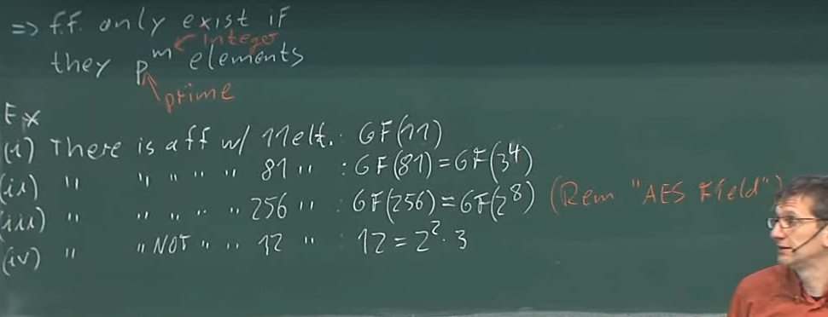

Figure - Finite field dimensions.

You can’t make, for example, a finite field of 12 element because it doesn’t follow the rule: p^n where p is a prime number. There exist prime fields (size p) and extension fields (size p^n).

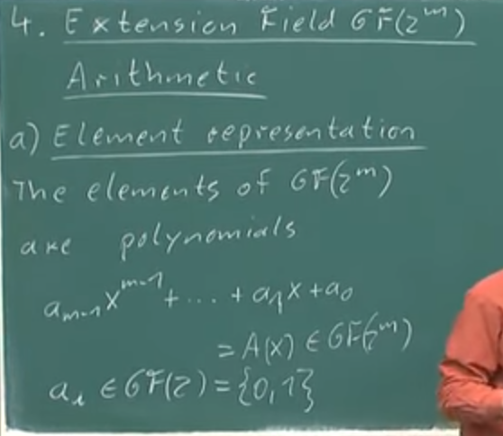

Figure - Extension fields element representation.

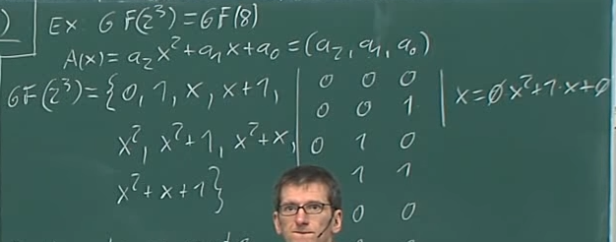

Figure - Example of a extension field.

Irreducible polynomials are “prime polynomials” or polynomials that you can’t divide. In a prime field, multiplication and division is done with a modulo of a prime number. In an extension field, you use the irreducible polynomials. The irreducible polynomials can only be divided by 1 and themselves.

## Extension fields operations.

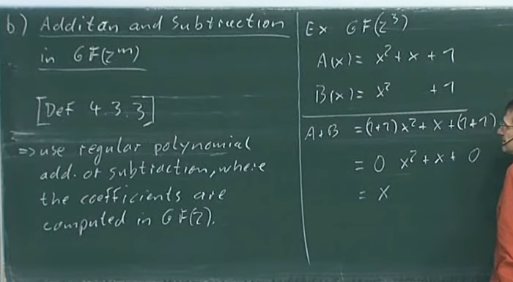

Figure - How to add and subtract in an extension field.

Adding and subtracting are the same operations, and are very easy to compute. (EXCLUSIVE OR / XOR between two elements).



Figure - Multiplication on extension fields ( P(x) is an irreducible polynomial that belongs in the field)

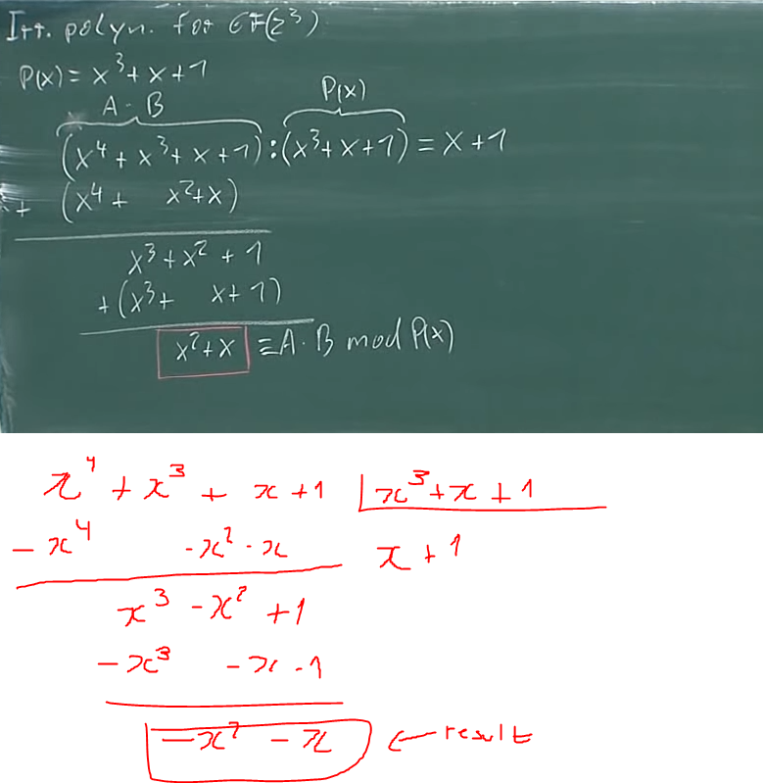

## Examples

Galois field polynomial representation example:

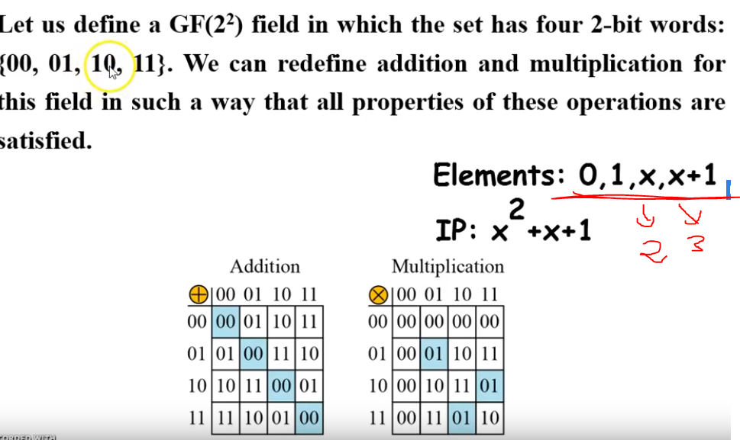

In this picture we can see the multiplication results don’t make sense, because up until now we have only seen prime galois fields. For example, if we do 10 * 11 (mod 4(dec)) we get 6 mod( 4) = 2 which is not what we get on the multiplication table (the multiplication table shows 01 not 10). This is done so with the multiplication operation on extension fields.

## What does this mean for S18-C?

The encoder uses a galois field of the size 2^6 = 64 (each code word is comprised of 6 bits).

The irreducible polynomial is = x^6+x+1 = 67 = (2^6 + 2 +1)