  - Programming exercise

DeepQ AI agent for the pong game
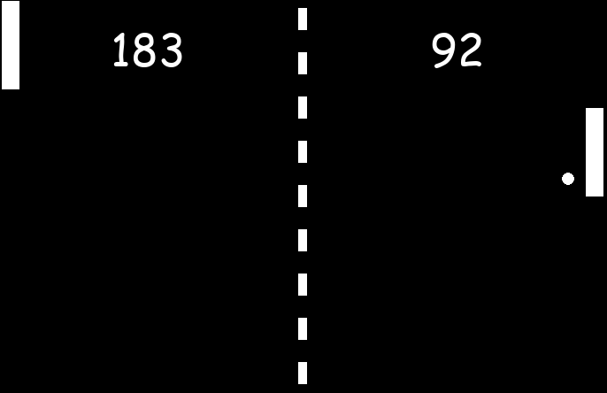
- Play the original pong game „pong_human_original.py“ to get a feeling for the game
- In the file pong_rl_environment.py, you will find a complete machine learning environment for the pong game. The ML environment already takes care of calculating rewards and returning the state of the game.

How are the rewards given? Explain!

How is the state given? Explain!

You can generate a new game by calling the constructor of the pong_environment:

env=pong_environment(render=True)
a single step forward is then done by
positiondata, reward, rewardleft, done=env.one_step(actionrightpaddle)
#action=0 paddle moves up
#action=1 paddle moves down
#action=2 do nothing
- A complete and very general deep-Q AI agent class is given in the file deepQ_agent.py.Try to understand the code and its parameters!
An agent can be created by
agent=my_agent(input_neurons,output_neurons,loadmodel,trainme)

loadmodel = True #existing model is loaded
trainme = False #no training, just play

- Write a new code, where you import the environment and the agent. Generate an environment and an agent object and initialize the system.

Level 1: Write a code that trains an AI agent for playing the pong game human vs. AI
Level 2: Write a code that trains two AIs that are playing against each other.

Tipps:
The get_action function predicts the next action and already implements the epsilon greedy strategy:

newaction =agent.get_action(states)

The agent is trained on a batch that is randomly chosen from ist memory. Add items to the agents memory by:

agent.memory.append((state,action,reward,nextstate,done))

Train the agent with the function:

agent.train()

Futher general notes:
- In a game with moving objects, the AI needs to know the velocity of the objects. It is likely not not good enough to store only a single time-step in state and nextstate.
- The training needs quite a lot of time!

